HOMEPAGE

About us page

Contact us page

FAQ Page

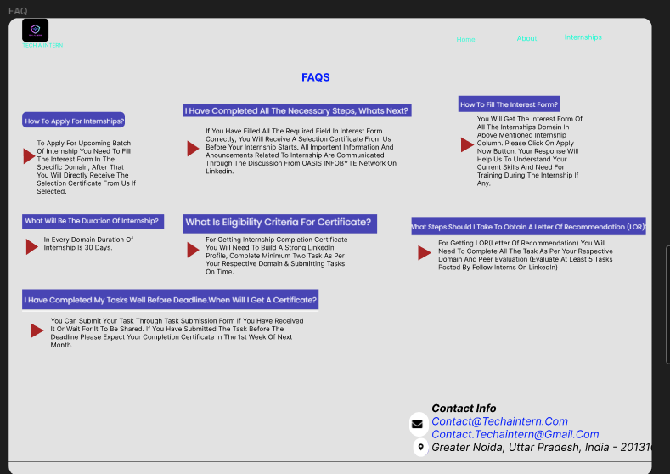

INTERNSHIPS PAGES

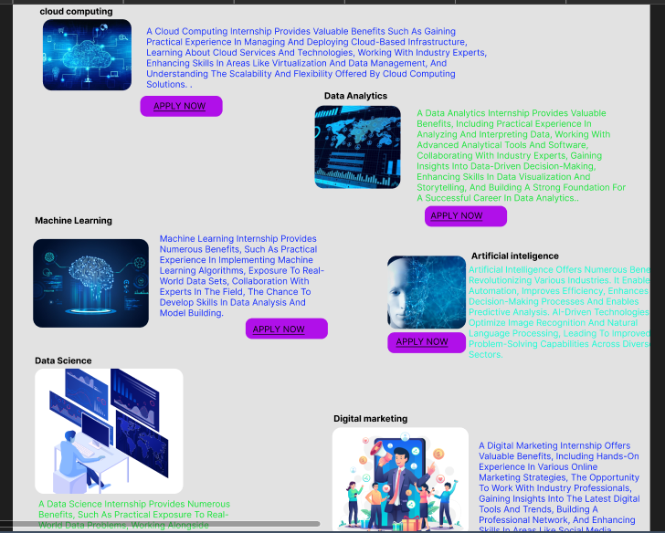

TASK1- WEBSITE REDESIGN