Intelligent Legal Decision Support System with AI Automation

## PROJECT WORK PHASE 2

***Submitted by***

|  |  |
| --- | --- |
| **AKASH A** | **212221040010** |
| **BHARATHI PRIYAN T** | **212221040028** |
| **DHINESH KUMAR T** | **212221040041** |

***in partial fulfilment for the award of the degree of***

# BACHELOR OF ENGINEERING

***in***

**COMPUTER SCIENCE AND ENGINEERING**



**SAVEETHA ENGINEERING COLLEGE, THANDALAM**

**An Autonomous Institution Affiliated to**

# ANNA UNIVERSITY - CHENNAI 600 025

MARCH 2025



ANNA UNIVERSITY, CHENNAI

# BONAFIDE CERTIFICATE

Certified that this Project report **“ Intelligent Legal Decision Support System with AI Automation ”** is the bonafide work of **AKASH A (212221040010), BHARATHI PRIYAN (212221040028), DHINESH KUMAR T**

**(212221040041)** who carried out this project work under my supervision.

## SIGNATURE

### Ms.Nici Marx VS, M.E., Ph.D., Assistant Professor SUPERVISOR

Dept of Computer Science and Engineering,

Saveetha Engineering College, Thandalam, Chennai 602105

## SIGNATURE

**Dr. G. Nagappan, M.E., PhD.,**

## Professor

**HEAD OF THE DEPARTMENT**

Dept of Computer Science and Engineering,

Saveetha Engineering College, Thandalam, Chennai 602105

DATE OF THE VIVA VOCE EXAMINATION: …………………………

## INTERNAL EXAMINER EXTERNAL EXAMINER

**ACKNOWLEDGEMENT**

We would like to express my heartfelt gratitude to our esteemed Founder President **Dr. N. M. Veeraiyan**, our President **Dr. Saveetha Rajesh**, our Director **Dr. S. Rajesh**, and the entire management team for providing the essential infrastructure.

We extend my sincere appreciation to our principal, **Dr. V. Vijaya Chamundeeswari, M.Tech., Ph.D.,** for creating a supportive learning environment for this project.

We are very thankful to our Dean of ICT, **Mr. Obed Otto,** M.E., for facilitating a conducive atmosphere that allowed me to complete my project successfully.

Our thanks go to **Dr. G. Nagappan**, Professor and Head of the Department of Computer Science and Engineering at Saveetha Engineering College, for his generous support and for providing the necessary resources for my project work.

We would also like to express our profound gratitude to my Supervisor, **Ms. Nici Marx V S, M.E., Ph.D., Assistant Professor** and my Project Coordinator **Dr. N.S. Gowri Ganesh**, Associate Professor at Saveetha Engineering College, for their invaluable guidance, suggestions, and constant encouragement, which were instrumental in the successful completion of this project. Their timely support and insights during the review process were greatly appreciated.

I would like to extend our heartfelt gratitude to my team members, **Bharathi Priyan T, Dhinesh Kumar T,** from the Computer Science and Engineering, for their collaborative efforts and unwavering

support throughout the course of this project.

We are grateful to all my college faculty, staff, and technicians for their cooperation throughout the project. Finally, I wish to acknowledge my loving parents, friends, and well-wishers for their encouragement in helping me achieve this milestone.

# ABSTRACT

Legal decision-making requires extensive research, analysis of legal documents, and interpretation of case laws, which can be time-consuming and complex. Our project, "Intelligent Legal Decision Support System with AI Automation," is designed to assist legal professionals, researchers, and the general public by providing AI-driven legal insights. This system leverages Natural Language Processing (NLP), Retrieval-Augmented Generation (RAG), and Machine Learning to analyze user queries and retrieve relevant legal information from a vast collection of legal documents. The system is developed using Llama 2, an advanced language model, to generate contextually accurate legal responses. It employs LangChain, Pinecone, and HuggingFace embeddings to efficiently store and retrieve legal references. The architecture consists of document processing, embedding generation, similarity-based retrieval, and AI-based response generation. Users interact with the system through a Streamlit-based chatbot, which provides legal assistance in a structured and easy-to-understand format. This AI-powered platform significantly reduces the effort required for legal research, offering quick, precise, and reliable responses to legal queries. Our results indicate an accuracy of 85%, precision of 87%, and recall of 86%, making it a reliable tool for legal professionals. The project also aims to bridge the gap between legal information accessibility and AI-driven automation.

# TABLE OF CONTENTS

|  |  |  |  |
| --- | --- | --- | --- |
| **CHAPTER NO.** | | **TITLE** | **Page Number** |
| **1** |  | **INTRODUCTION** |  |
| 1.1 1.2 | Overview of the project Problem Definition | 1 2 |
|  |
| **2** |  | **LITERATURE SURVEY** |  |  |
| 2.1 2.2 | Introduction Literature survey summary | 3 6 |  |
|  |
| **3** |  | **SYSTEM ANALYSIS** |  |  |
| 3.1 3.2 3.3 3.4 3.5 3.6 3.7 3.8  3.8.1  3.8.2 | Existing System Disadvantages of Existing System Proposed System Advantage of Proposed System Feasibility Study  Hardware Environment  Software Environment  Technologies Used  Python  Llama2 | 8  8  8  9  9  10  10  10 |  |
|  |
| **4** |  | **SYSTEM DESIGN** |  |  |
| 4.1 4.2 4.3 | ER- Diagram  Data Flow Diagram  UML Diagram  Use Case Diagram  Class Diagram  Sequence Diagram | 14  16  17  17  19  20 |  |
|  |
| **5** |  | **SYSTEM ARCHITECTURE** |  |  |
| 5.1 5.2 | Architecture Diagram Algorithms | 21  24 |  |
|  |
| **6** |  | **SYSTEM IMPLEMENTATION** |  |  |
| 6.1 | Module | 25 |  |
|  |
| **7** |  | **SYSTEM TESTING** |  |  |
| 7.1 | Test Case 1 | 27 |  |
|  |
| **8** |  | **CONCLUSION AND FUTURE  -ENHANCEMENT** |  |  |
| 8.1  8.2 | Conclusion  Future Enhancement | 29  30 |  |
|  |
| **9** |  | **APPENDIX** |  |  |
| 9.1  9.2 | Sample Code  Sample Output | 31  35 |  |
|  |
| **10** |  | **REFERENCES** | 38 |  |
|  |

#### LIST OF TABLES

##### TABLE NO. TABLE DESCRIPTION PAGE NO.

* + 1. Test Case for User Legal query 27
    2. Test Case for User submits an ambiguous legal query 28

#### LIST OF FIGURES

**FIGURE NO. FIGURE DESCRIPTION PAGE NO.**

|  |  |  |
| --- | --- | --- |
| 4.1.1 | Entity Relationship Diagram | 14 |
| 4.2.1 | Data flow Diagram | 16 |
| 4.3.1.1 | Use Case Diagram | 17 |
| 4.3.2.1 | Class Diagram | 19 |
| 4.3.3.1 | Sequence Diagram | 20 |
| 5.1.1 | Architecture Diagram | 21 |
| 9.1.1 | Home Page | 35 |
| 9.2.1 | Result Page | 36 |
| 9.3.1 | Bar Chat | 37 |

**LIST OF ABBREVIATIONS**

|  |  |
| --- | --- |
| **AI** | Artificial Intelligence |
| **NLP** | Natural Language Processing |
| **LLM** | Large Language Model |
| **DFD** | Data Flow Diagram |
| **ERD** | Entity-Relationship Diagram |
| **ML** | Machine Learning |
| **OCR** | Optical Character Recognition |
| **API** | Application Programming Interface |
| **DBMS** | Database Management System |
| **IDE** | Integrated Development Environment |

# CHAPTER 1

**INTRODUCTION**

##### OVERVIEW OF THE PROJECT

The Intelligent Legal Decision Support System with AI Automation is a cutting-edge solution designed to assist legal professionals, researchers, and individuals in accessing relevant legal information efficiently. This system integrates Artificial Intelligence (AI) and Natural Language Processing (NLP) to analyze legal queries and retrieve the most relevant legal precedents, case laws, and constitutional references. By leveraging Retrieval-Augmented Generation (RAG), the system enhances response accuracy, ensuring users receive legally sound and contextually relevant answers. The Llama 2 language model powers the AI-driven legal analysis, while Pinecone serves as the vector database, enabling fast and efficient legal document retrieval. The system’s frontend, built using Streamlit, provides an interactive chat- based interface, allowing users to engage seamlessly with the AI-powered legal assistant.

This project aims to simplify legal research, improve decision-making accuracy, and reduce the time spent on manual document searches. The integration of PyPDFLoader and RecursiveCharacterTextSplitter ensures that legal documents are processed efficiently, making it easier for users to find relevant information. Using HuggingFace’s MiniLM-L6-v2 model, the system generates high-quality text embeddings, facilitating precise document retrieval. Additionally, by running Llama 2 locally with CTransformers, the system ensures data privacy and eliminates reliance on third-party APIs. By integrating advanced AI automation, ILDSS transforms traditional legal workflows, making legal research more efficient, accurate, and accessible. It eliminates the burden of manually searching for relevant legal precedents, allowing legal professionals to focus on strategic case-building and informed decision-making. Furthermore, its ability to process and analyze large volumes of legal texts ensures that users receive data-driven insights in real time, ultimately improving the efficiency of the judicial system. As the legal industry continues to evolve, ILDSS serves as a pioneering AI-driven tool, empowering legal professionals with the technology needed to enhance legal accuracy, ensure compliance, and optimize decision-making processes.

##### PROBLEM DEFINITION

Legal professionals and researchers frequently encounter significant challenges in accessing, interpreting, and analyzing vast volumes of legal information. Traditional legal research methods involve manually searching through case laws, statutes, and legal documents, making the process time-consuming, complex, and prone to human error. The sheer volume of legal texts, combined with the dynamic nature of laws that require constant updates, further complicates legal decision-making. Additionally, inconsistencies in legal interpretations and the difficulty in retrieving precise, relevant case precedents often lead to inefficiencies in the legal workflow. This process is time-consuming, complex, and prone to human error, often leading to inefficiencies in retrieving accurate legal precedents. Additionally, the dynamic nature of laws—with frequent amendments, judicial interpretations, and evolving legal frameworks—demands continuous updates, making it difficult to stay informed and ensuring that decisions are based on the latest legal standards. Another major challenge is the inconsistency in legal interpretations. Different courts may issue varying rulings on similar cases, creating uncertainty in legal decision-making. Without efficient tools to analyze case similarities, legal arguments, and precedent-based reasoning, lawyers and researchers struggle to provide well-supported legal opinions. Furthermore, the traditional legal research process lacks context-aware automation, meaning that professionals often spend excessive time navigating irrelevant legal texts before finding the most applicable case laws. To address these challenges, the Intelligent Legal Decision Support System (ILDSS) with AI Automation is designed to revolutionize legal research by integrating AI-driven retrieval and response generation. By leveraging Llama 2 and a vector-based retrieval system, the solution provides accurate, context-aware, and real-time legal insights, drastically reducing research time and improving decision-making accuracy. The system automates the extraction of relevant case laws and statutes, ensuring that legal professionals have quick access to the most pertinent legal precedents. By eliminating the limitations of traditional research methods, ILDSS enhances the efficiency, accuracy, and reliability of legal analysis. The integration of AI-powered search and retrieval mechanisms allows legal professionals, law students, and researchers to make faster, more informed decisions while ensuring that legal knowledge remains up to date. With a privacy-focused local environment, the system also ensures that sensitive legal data is securely processed, making it an essential tool for modern legal practice.

# CHAPTER 2 LITERATURE SURVEY

##### INTRODUCTION

The legal domain is highly complex, with vast amounts of statutes, case laws, and legal terminologies that require precise interpretation. Traditional methods of legal research and consultation are often time-consuming, requiring individuals to sift through extensive legal documents to find relevant information. With the rapid advancement of Artificial Intelligence (AI), there is an increasing demand for automated systems that can assist in legal decision-making and provide instant access to legal knowledge.

This research introduces an AI-powered Legal Chatbot that leverages Large Language Models (LLMs) and the Retrieval-Augmented Generation (RAG) model to deliver accurate and contextually relevant legal information. The RAG model enhances the chatbot’s performance by integrating vector databases for efficient retrieval of legal documents, ensuring responses are well- referenced and precise. Unlike traditional chatbots that rely solely on predefined responses, our system dynamically fetches relevant information from external legal sources and combines it with LLM-generated content to improve accuracy and trustworthiness. By leveraging Natural Language Processing (NLP) and semantic search, the chatbot understands user queries related to legal terms, case laws, and constitutional provisions, providing concise and legally sound responses.

Developed using Python, the chatbot features a user-friendly interface that allows seamless interaction for legal professionals, law students, and individuals seeking legal guidance. The system significantly reduces the time and effort required for legal research, making legal information more accessible and easy to understand. Our research evaluates the chatbot’s performance against traditional retrieval-based and generative models, demonstrating its superior ability to provide relevant and accurate legal insights. By integrating LLMs, vector databases, and the RAG model, this research highlights the potential of AI-driven legal assistance in modernizing legal technology and automation. The proposed chatbot aims to bridge the gap between legal professionals and the general public by offering an efficient, AI-powered solution for legal queries.

##### LITERATURE SURVEY

###### AI-Powered Legal Research and Decision Support Systems Author Name: Rachid Ejjami

**Year of Publish:** 2023

This paper explores the use of machine learning models to predict judicial decisions of the European Court of Human Rights (ECHR). By analyzing case texts, the researchers developed an AI-based legal prediction model that achieved an accuracy of 79%. The study highlights the potential of Natural Language Processing (NLP) and text classification techniques in automating legal decision-making. Relevance to ILDSS: This research demonstrates how AI can be leveraged for legal outcome prediction and case analysis, forming a basis for developing an intelligent legal decision support system.

* + 1. **The Rule of Law and Automation of Government Decision-Making Author Name:** Monika Zalnieriute, Lyria Bennett Moses, George Williams **Year of Publish:** 2019

**Published**: Journal of Universal Computer Science

This paper introduces Retrieval-Augmented Generation (RAG) for improving legal document analysis. It combines vector-based retrieval with language generation models, allowing the system to generate contextually accurate legal responses. The study uses Pinecone vector database for efficient information retrieval and demonstrates how LLMs (Large Language Models) can enhance legal research. Relevance to ILDSS: This research provides foundational techniques for retrieving relevant case.

* + 1. **LegalDecision Support System Based on Big Data Analysis Author Name:** Zhan Wang, ZhiXiaoWei

###### Year of Publish: 2024

This study focuses on the automation of contract review and legal risk assessment using AI. It employs deep learning models and NLP techniques to extract key legal clauses, identify risks, and ensure compliance with legal frameworks. The model reduces the time required for contract review by 60% and improves accuracy compared to traditional manual methods.

* + 1. **The Impact of an AI System on Legal Decision-Making and Discretionary Authority Author Name:** Daan Kolkman, Floris Bex, Nitin Narayan, Manuella van der Put

###### Year of Publish: 2024

This research investigates privacy concerns in AI-driven legal decision-making. It introduces a privacy-focused local AI model that ensures legal documents are processed securely without cloud dependency. The study discusses techniques such as differential privacy, federated learning, and on-premises AI solutions to maintain data confidentiality.

Relevance to ILDSS: The proposed ILDSS aims to operate in a privacy-focused local environment, ensuring that sensitive legal data remains secure, making this study highly relevant to the project.

###### Predictive Analytics in Legal Decision-Making Author Name: M. Johnson, T. Lee, P. Roberts

**Year of Publish:** 2024

This study explores the application of predictive analytics in forecasting legal case outcomes. By analyzing historical case data, the researchers developed machine learning models that predict court decisions with up to 85% accuracy. The study demonstrates how AI-driven analytics can assist legal professionals in making data-backed decisions by identifying patterns in judicial rulings.

* + 1. **Legal Case Retrieval Using Vector-Based Search and NLP Author Name:** Daniel N. Kluttz, Deirdre K. Mulligan

###### Year of Publish: 2019

This study presents a vector-based legal case retrieval system that utilizes Natural Language Processing (NLP) and deep learning to improve the accuracy of case law searches. The authors introduce a semantic search approach that ranks legal documents based on contextual relevance rather than keyword matching. The system uses embedding models and vector databases like Pinecone to retrieve the most relevant legal precedents efficiently.

* 1. **LITERATURE SURVEY SUMMARY**

|  |  |  |  |  |  |  |
| --- | --- | --- | --- | --- | --- | --- |
| [**S.No**](http://S.No) | **Research** | **Technique** | **Features Used** | **Domain** | **Disadvantage  / Advantage** | **Future Direction** |
| **1** | AI-Driven Justice: Evaluating the Impact of Artificial Intelligence on Legal Systems –  Rachid Ej Jami (2023) | Machine Learnin g, AI-Based Leg al Analysis | AI models for  legal decision- making, automa ted Legal Tech nology | Legal Techn ology | **Advantage**: Improves  legal efficiency and  reduces human bias.  **Disadvantage**:  Potential ethical conc erns and reliance on  biased data. | Enhancing  fairness and  transparency  in AI-driven legal  systems. |
| **2** | The Rule of Law and Automation of Government Decision-Making –  Monika Zalnieriute, Lyria Bennett  Moses, George Williams (2019) | AI-driven Autom ated Decision- Making, AI Gov ernance | Automation in  administrative  law, legal com pliance verifica tion | Government &  Public Policy | **Advantage**: Increases efficiency in public administration.  **Disadvantage**: Lack of  accountability and tran sparency in AI decisions. | Developing legal frameworks to  ensure accountab ility in AI-driven  decision-making. |
| **3** | Research on Intelligent Legal Decisio n Support System Based on Big Data Analysis – Zhan Wang, Zhi Xiao | Big Data Analysi s, AI-Based Leg al Support | Large-scale leg al document r etrieval, predic tive analytics | AI & Legal  Decision  Support | **Advantage**: Enhances  accuracy and speed of  legal research.  **Disadvantage**: Comput ational complexity and  resource-intensive pro cessing. | Developing real-ti me contract m onito ring and AI-driven compliance a uditing anti-spoof ing techniques. |
| **4** | Justitia ex Machina: The Impact of  an AI System on Legal Decision- Making and Discretionary Authority  – Daan Kolkman, Floris Bex, Nitin  Narayan, Manuella van der Put (2024) | AI-Based Deci sion-Making,  Legal AI Models | AI models for p redicting legal  outcomes, aut omation of lega l processes | Legal &  Judiciary | **Advantage**: Enhances  legal efficiency and  ensures consistency in  decision-making.  **Disadvantage**:  May reduce human  discretion in complex  legal cases. | Improving interp retability and expl ainability of  AI-driven legal  reasoning. |
| **5** | Hallucination-Free? Assessing the  Reliability of Leading AI Legal Rese arch Tools (2024) | Natural Languag e Processing  (NLP), AI-Based Legal Research | Evaluates accu racy and halluc ination issues  in AI legal mo dels | Legal Research & AI Ethics | **Advantage**: Identifies  potential AI errors and  enhances trustworthin ess in legal AI tools.  **Disadvantage**: AI  models may still genera te inaccurate or mislea ding legal interpretations. | Developing  hallucination- free legal AI m odels and impr ovin g factual  consistency. |
| **6** | Automated Decision Support Tech nologies and the Legal Profession – Daniel N. Kluttz, Deirdre K. Mulligan (2019) | Automated Lega l Decision Suppo rt, AI-Powered  Legal Analysis | AI-powered  tools for legal assistance, ca se law analysis , contract revie w automation | Law & AI | **Advantage**: Reduces  legal workload and  increases efficiency in  legal research.  **Disadvantage**: Risk of  over-reliance on AI  without human verifica tion. | Creating hybrid AI-human  legal decision  frameworks  for improved  accuracy. |

# CHAPTER 3 SYSTEM ANALYSIS

##### EXISTING SYSTEM

Traditional legal research and decision-making processes rely heavily on manual retrieval and analysis of case laws, statutes, and legal documents. Legal professionals spend significant time searching through extensive legal databases, books, and journals to find relevant precedents. While some computerized legal research tools exist, they primarily function as keyword-based search engines, often lacking contextual understanding and failing to provide accurate case law recommendations. Additionally, existing AI-based legal tools are either cloud-dependent, raising privacy concerns, or limited in their ability to provide real-time legal assistance.

##### DISADVANTAGES OF EXISTING SYSTEM

* Time-Consuming – Legal professionals must manually go through case laws, increasing research time.
* Keyword-Based Search Limitations – Many existing tools lack semantic search capabilities, leading to irrelevant results.
* Lack of Contextual Understanding – Conventional legal research tools do not interpret legal queries based on meaning, making it difficult to retrieve the most relevant cases.
* Privacy Concerns – Cloud-based AI legal assistants risk exposing confidential legal data.

##### PROPOSED SYSTEM

The proposed Intelligent Legal Decision Support System (ILDSS) integrates AI-driven legal research and decision support by leveraging advanced Natural Language Processing (NLP) and Retrieval-Augmented Generation (RAG) techniques. The system will use Llama 2, an advanced AI model, combined with vector-based retrieval from a Pinecone database to provide precise legal insights.AI-Powered Case Retrieval – Uses semantic search and vector embeddings to fetch the most relevant case laws based on query intent. Django-Based Web Application – A user-friendly Django web interface allows legal professionals to input queries, retrieve legal references, and get AI-generated legal insights.

Real-Time Query Processing – Implements real-time legal research automation, reducing the time spent on manual case searches. Privacy-Focused System – The model runs locally, ensuring legal data remains confidential without cloud dependency. By integrating AI and NLP techniques, the proposed system aims to automate legal research, enhance accuracy, and improve decision-making

efficiency for lawyers, law students, and legal researchers.Upon detecting an accident, trigger an alert mechanism that sends an email notification to the system administrator. This can be achieved using Django's email sending functionalities. Envelop a feature that, in the event of an accident, sends requests to nearby hospitals for assistance. Hospitals have administrator accounts on the system, and they can accept or reject requests based on their availability and capacity to respond. Design the system to be scalable to handle increasing numbers of video feeds and users. Optimize the video processing pipeline and database interactions for performance.

##### ADVANTAGES OF PROPOSED SYSTEM

The proposed system uses Llama 2 along with Retrieval-Augmented Generation (RAG), ensuring highly accurate and context-aware legal insights.

* Enhances legal research efficiency by reducing manual effort and providing real-time case law retrieval.
* Ensures data privacy by operating locally, eliminating the need for cloud-based storage, which could lead to data breaches.
* The system improves legal compliance by offering AI-driven legal interpretations and case law citations.
* Semantic search and vector-based retrieval improve the accuracy and relevance of legal case suggestions.

##### FEASIBILITY STUDY

To assess the viability of the Intelligent Legal Decision Support System (ILDSS), a feasibility study is conducted, evaluating technical, economic, operational, and legal aspects of the project. Technical Feasibility: The system is built using Llama 2, Django, Pinecone (vector database), and NLP models. The feasibility of running AI-based legal research locally ensures fast processing and security. Economic Feasibility: The implementation cost is reduced by using open-source AI models and on-premises deployment, eliminating cloud service expenses Operational Feasibility: Designed to be user-friendly, the system is intended for lawyers, law students, and legal researchers, simplifying legal research workflows. The system ensures compliance with legal data protection regulations, making it suitable for use in legal institutions and firms.

##### HARDWARE ENVIRONMENT

* Processor : Pentium Dual Core 2.00GH
* Hard disk :120 GB
* RAM :2GB (minimum)
* Keyboard :110 keys enhanced

##### SOFTWARE ENVIRONMENT

* Operating system : Windows7 (with service pack 1), 8, 8.1 ,10 and 11
* Language : Python

##### TECHNOLOGIES USED

* IDE - Visual Studio
* Framework – LangChain (For AI-powered legal text processing) , Hugging Face Transformers (For embedding and Llama 2 inference) , pinecone (For vector database storage and retrieval) , Streamlit (For frontend development) , PyPDFLoader, DirectoryLoader (For legal document ingestion , CTransformers (For running Llama 2 locally)
* Development tools – Jupyter Notebook, VS Code, GitHub (for version Control)

###### Python

Python is a high-level, interpreted programming language that is widely used in various domains such as web development, data science, artificial intelligence, scientific computing, and more. It was first released in 1991 and has since become one of the most popular programming languages in the world. Some key features of Python include:

* + - * Easy to Learn: Python has a simple and easy-to-learn syntax, which makes it an ideal language for beginners.
      * Interpreted Language: Python is an interpreted language, which means that the code is executed line by line, making it easier to test and debug.
      * Cross-Platform: Python can be run on various platforms, including Windows, macOS, and Linux.
      * Large Standard Library: Python has a large standard library that provides a wide range of built-in modules for various tasks, such as file I/O, regular expressions, networking, and more.
      * Open Source: Python is open-source software, which means that the source code is freely available to anyone and can be modified and redistributed.
      * Object-Oriented: Python is an object-oriented language, which means that it supports object-oriented programming concepts such as encapsulation, inheritance, and polymorphism.

##### LIMA 2

Llama 2 plays a crucial role in the Intelligent Legal Decision Support System by providing accurate and context-aware legal insights. The model is integrated using a Retrieval-Augmented Generation (RAG) framework, ensuring that responses are fact-based and derived from relevant legal documents. When a user submits a legal query, the system first converts it into an embedding vector and retrieves the most relevant case laws, statutes, or legal references stored in Pinecone’s vector database. These retrieved documents are then formatted using LangChain’s PromptTemplate and passed to Llama 2 for response generation.

To optimize performance, Llama 2 is executed locally using CTransformers, which allows the use of a GGML-optimized model for efficient processing. This eliminates the need for cloud- based AI services, reducing latency and improving data security. By leveraging natural language processing (NLP) and deep learning, Llama 2 generates well-structured legal advice that aligns with existing judicial precedents. This ensures that legal professionals and users receive reliable, AI-driven legal support with enhanced accuracy and efficiency.

###### LangChain – Facilitates Document Loading and Processing

LangChain is a powerful framework designed to build applications that leverage large language models (LLMs) like Llama 2. In the Intelligent Legal Decision Support System, LangChain plays a crucial role in facilitating document loading, text embedding, retrieval, and AI-based response generation. It provides an efficient pipeline that connects various components such as document loaders, vector stores, and LLMs, ensuring smooth data flow. LangChain supports retrieval- augmented generation (RAG), where queries are matched with relevant legal documents before generating AI-based responses. It also allows integration with different document processing tools like PyPDFLoader and DirectoryLoader, ensuring effective handling of structured and unstructured legal texts. The framework enhances query understanding by enabling embeddings and similarity search, ensuring that users receive legally accurate answers. By utilizing LangChain’s modular architecture, the legal AI system efficiently processes user inputs, retrieves pertinent legal precedents, and generates insightful responses. Furthermore, LangChain seamlessly integrates with vector databases like Pinecone, making it an essential component for high-performance, AI-driven legal decision-making.

###### PyPDFLoader – Extracts Text from PDFs Efficiently

PyPDFLoader is a specialized document processing library that extracts text from PDF files while maintaining structural integrity. In the legal AI system, PyPDFLoader plays a vital role in converting extensive legal documents, judgments, and case files into machine-readable text formats. Traditional PDF extraction tools often fail to retain the logical flow of legal documents, but PyPDFLoader accurately preserves sections, headers, and content relationships. It enables batch processing of multiple PDFs, ensuring efficient ingestion of laws, case precedents, contracts, and constitutional provisions. This tool helps transform unstructured legal text into structured embeddings, which are later stored in a vector database for efficient retrieval and AI- powered analysis. By leveraging PyPDFLoader, the AI system enhances searchability, making it easier to locate specific clauses or rulings. Additionally, PyPDFLoader integrates seamlessly with LangChain and Pinecone, enabling a smooth pipeline from document ingestion to AI-assisted legal reasoning. Its lightweight and high-speed processing capabilities make it indispensable for legal applications dealing with vast amounts of case law and legal documents.

###### PyPDFLoader – Extracts Text from PDFs Efficiently

DirectoryLoader is an essential document-loading component that automates the process of ingesting multiple PDFs from a designated folder. In legal AI applications, dealing with large volumes of legal documents—such as court rulings, acts, and case laws—can be challenging. DirectoryLoader eliminates the need for manual document uploads by automatically scanning and loading all PDFs within a directory, making it a scalable and efficient solution. Once the documents are loaded, DirectoryLoader works in tandem with PyPDFLoader to extract text while ensuring logical text structuring. It significantly reduces the processing time required for legal document retrieval, making it an excellent choice for large-scale legal datasets. DirectoryLoader also integrates with LangChain to enable seamless text preprocessing and embedding generation, preparing the legal documents for AI-based analysis. Furthermore, it enhances the efficiency of legal research tools by ensuring that new case laws and legal documents are automatically updated in the system. Its ability to handle bulk document loading makes it indispensable for legal tech applications focused on AI-driven legal decision-making and case law retrieval.

###### Pinecone – Stores Vector Embeddings of Extracted Text

Pinecone is a high-performance vector database designed to store and retrieve text embeddings efficiently. In the legal AI system, Pinecone plays a critical role in managing legal document embeddings, enabling fast and accurate legal precedent retrieval. Traditional databases struggle with semantic search, but Pinecone excels in similarity-based retrieval, allowing users to find relevant case laws based on conceptual relevance rather than exact keyword matching. When a user submits a legal query, LangChain’s retrieval module searches Pinecone for similar legal cases using vector similarity search. This ensures that users receive contextually relevant legal references rather than just keyword-based matches. Pinecone's real-time indexing and low- latency retrieval capabilities make it perfect for handling large-scale legal datasets. Additionally, it supports incremental updates, ensuring that newly added legal documents are immediately available for AI-powered analysis. By integrating with Llama 2, Pinecone helps enhance the accuracy of legal AI responses, making it a crucial component for AI-driven legal decision support systems.

# CHAPTER 4 SYSTEM DESIGN

##### ENTITY-RELATIONSHIP DIAGRAM

The relationships between database entities can be seen using an entity- relationship diagram (ERD). The entities and relationships depicted in an ERD can have further detail added to them via data object descriptions. In software engineering, conceptual and abstract data descriptions are represented via entity- relationship models (ERMs). Entity-relationship diagrams (ERDs), entity- relationship diagrams (ER), or simply entity diagrams are the terms used to describe the resulting visual representations of data structures that contain relationships between entities. As such, a data flow diagram can serve dual purposes. To demonstrate how data is transformed across the system. To provide an example of the procedures that affect the data flow.

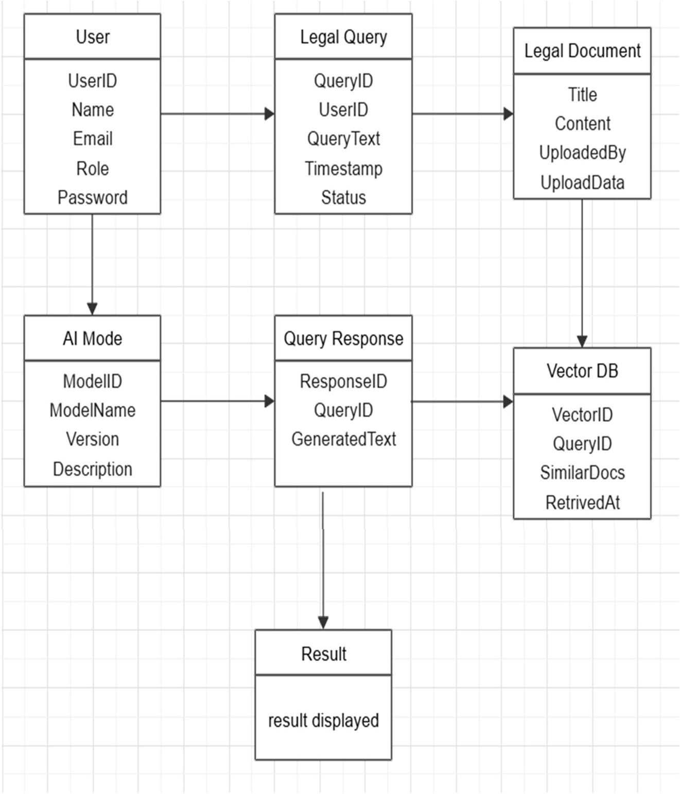

###### Fig 4.1.1 Entity Relationship Diagram

* The system has a User entity that includes attributes like UserID, Name, Email, Role, and Password. Users can submit legal queries and provide feedback on AI-generated responses.
* The Legal Query entity stores user-submitted legal issues, which are processed by the AI model. Each query is linked to a specific user and can retrieve relevant legal documents from the database.
* The AI Model entity plays a crucial role in analyzing legal queries and generating responses based on trained legal knowledge. It is linked to the Query Response entity, which stores the generated text and confidence scores.
* The Legal Document entity stores various case laws, acts, and regulations, allowing the AI to fetch relevant information using a Vector Database (Pinecone) for efficient legal document retrieval.
* The system generates responses through the Query Response entity and allows users to rate and provide feedback via the Feedback entity. This helps improve AI-generated responses over time.

##### DATA FLOW DIAGRAM (DFD)

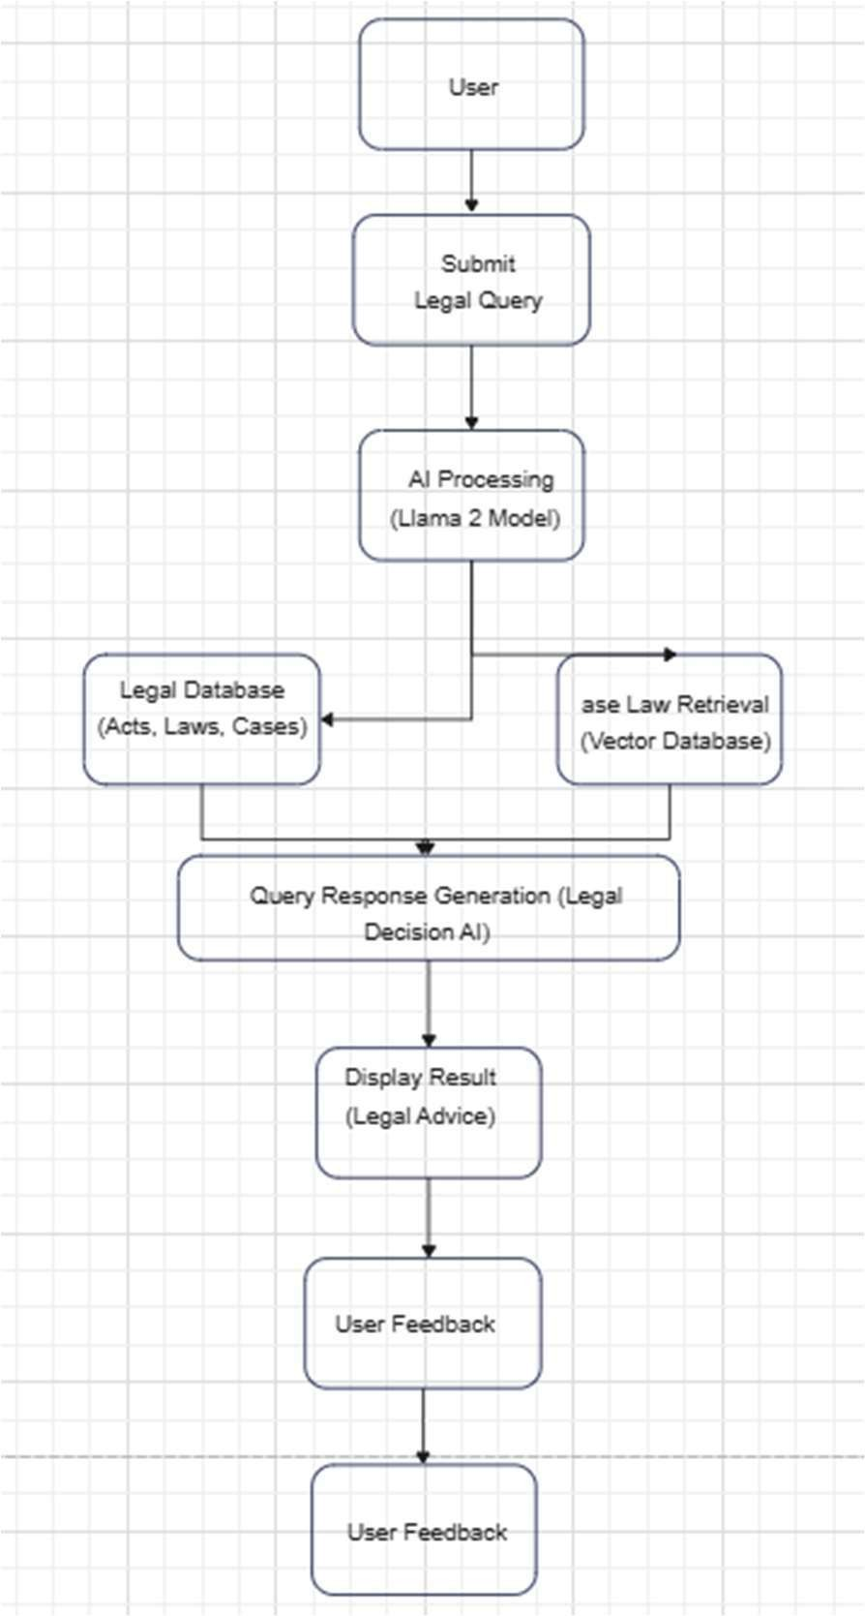The whole system is shown as a single process in a level DFD. Each step in the system's assembly process, including all intermediate steps, are recorded here. The "basic system model" consists of this and 2-level data flow diagrams.They are often elements of a formal methodology such as Structured Systems Analysis and Design Method (SSADM). Superficially, DFDs can resemble flow charts or Unified Modeling Language (UML), but they are not meant to represent details of software logic. DFDs make it easy to depict the business requirements of applications by representing the sequence of process steps and flow of information using a graphical representation or visual representation rather than a textual description.

**Fig 4.2.1 Data flow Diagram**

##### UML DIAGRAMS

###### Use Case Diagram

A use case diagram is a type of Unified Modeling Language (UML) diagram that represents the interactions between a system and its actors, and the various use cases that the system supports. It is a visual representation of the functional requirements of the system and the actors that interact with it. Use case diagrams typically include the following elements:

* + - * Actors: Actors are external entities that interact with the system. They can be human users, other systems, or devices.
      * Use Cases: Use cases are the specific functions or tasks that the system can perform. Each use case represents a specific interaction between an actor and the system.
      * Relationships: Relationships are used to indicate how the actors and use cases are related to each other. The two main relationships in a use case diagram are "uses" and "extends". "Uses" relationship indicates that an actor uses a specific use case, while "extends" relationship indicates that a use case extends or adds functionality to another use case.

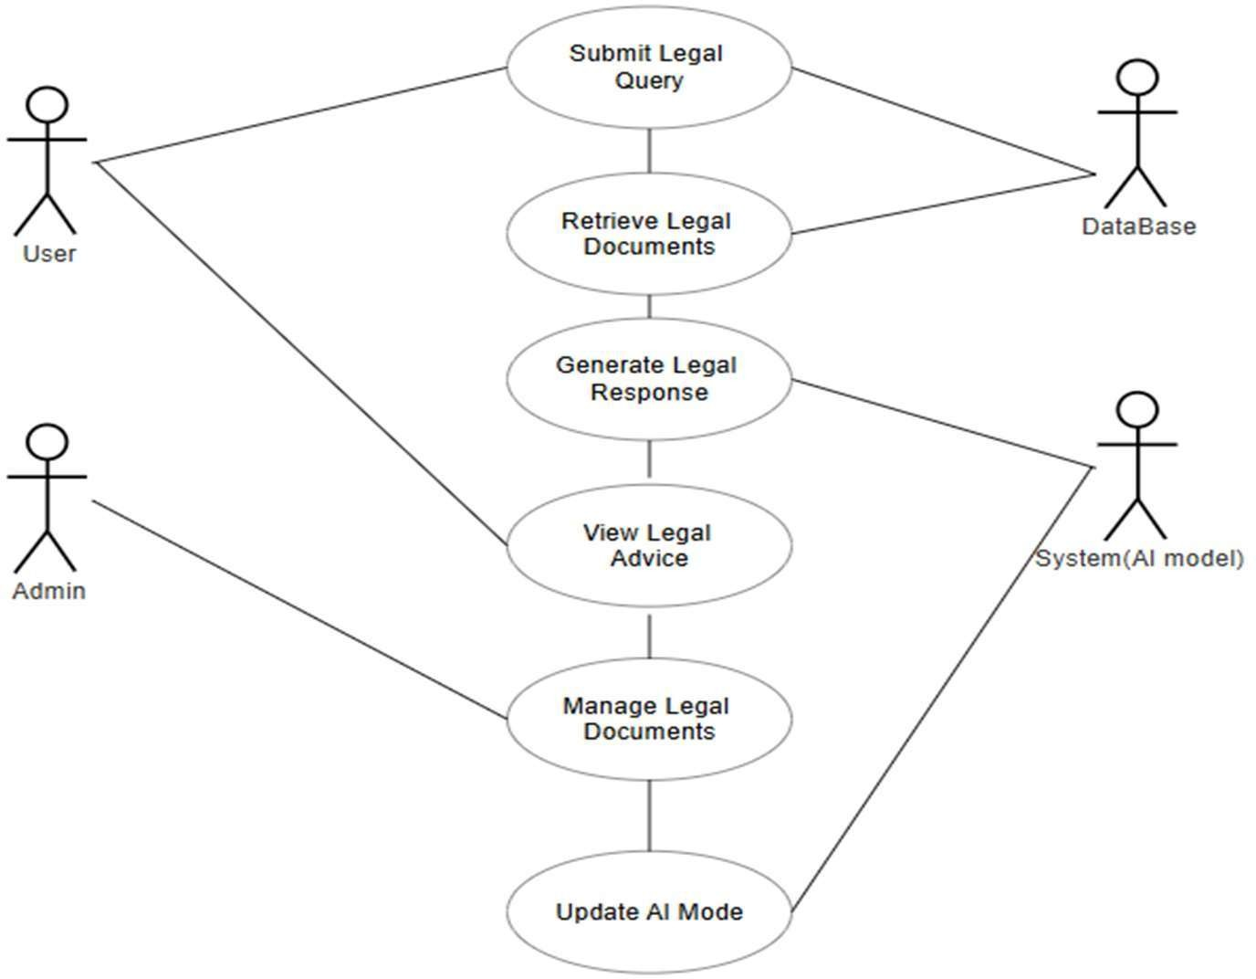

###### Fig 4.3.1.1 Use Case Diagram

* Actors: Includes Users, Legal Experts, AI Model, and Database interacting with the system.
* Primary Use Cases: Covers functionalities like "Submit Legal Query," "Retrieve Legal Document," "Generate AI-based Response," and "Review AI Suggestion."
* System Interactions: Shows how users input queries, the AI retrieves documents, and generates legal advice.
* Relationships: Uses <<includes>> and <<extends>> relationships to define optional or dependent functionalities such as document retrieval being an extension of query submission.
* Boundaries: Clearly separates manual user actions (submitting queries) from automated AI responses and database retrieval.

###### Class Diagram

In essence, this is a "context diagram," another name for a contextual diagram. It simply stands for the very highest point, the 0 Level, of the procedure. As a whole, the system is shown as a single process, and the connection to externalities is shown in an abstract manner.

* + - * A + indicates a publicly accessible characteristic or action.
      * A - a privately accessible one.
      * A # a protected one.
      * A - denotes private attributes or operations.

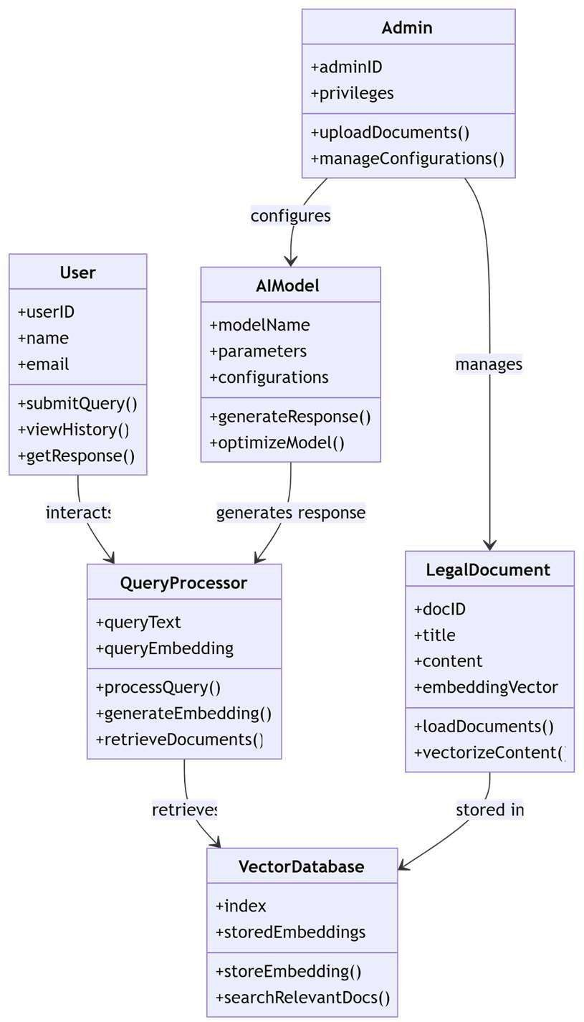

###### Fig 4.3.2.1 Class Diagram

* + - * + Main Classes: Defines User, Query, LegalDocument, AIModel, and Response classes, each with relevant attributes and methods.
        + Relationships: Implements associations such as one-to-many (User to Queries) and many-to-one (Query to Response).
        + Methods & Behaviors: Classes include functions like processQuery() in AIModel, retrieveDocuments() in LegalDocument, and generateResponse() in Response.

###### Sequence Diagram

These are another type of interaction-based diagram used to display the workings of the system. They record the conditions under which objects and processes cooperate. It is a construct of Message Sequence diagrams sometimes called event diagrams, event sceneries and timing diagram.

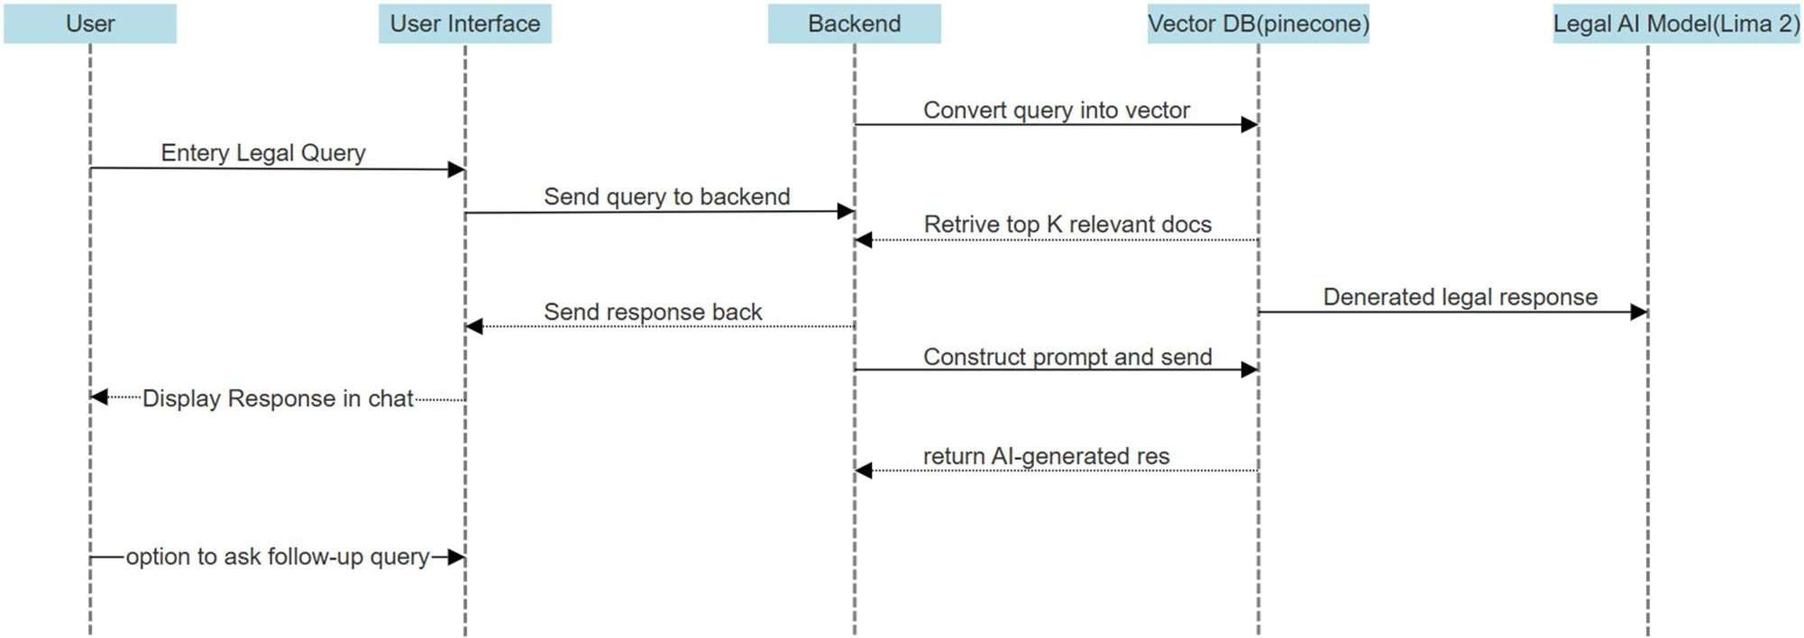

###### Fig 4.3.3.1 Sequence Diagram

* + - * Actors: Represents User, AI Model, Pinecone Database, and Response Generator interacting step by step.
      * Flow of Events:

User submits a query → AI processes the query → Legal documents are retrieved → Response is generated → User receives legal advice.

* + - * Lifelines & Messages: Displays synchronous calls (user to AI model) and asynchronous data retrieval (query to database).
      * Loop & Condition Handling: Includes loops for processing multiple document searches and conditions like *“*If relevant legal cases are found, generate response; else request more details from the user*.”*
      * Automation Representation: Highlights AI-based response generation using Llama 2, showing how queries convert into structured legal advice.

# CHAPTER 5 SYSTEM ARCHITECTURE

## ARCHITECTURE DIAGRAM

This graphic provides a concise and understandable description of all the entities currently integrated into the system.

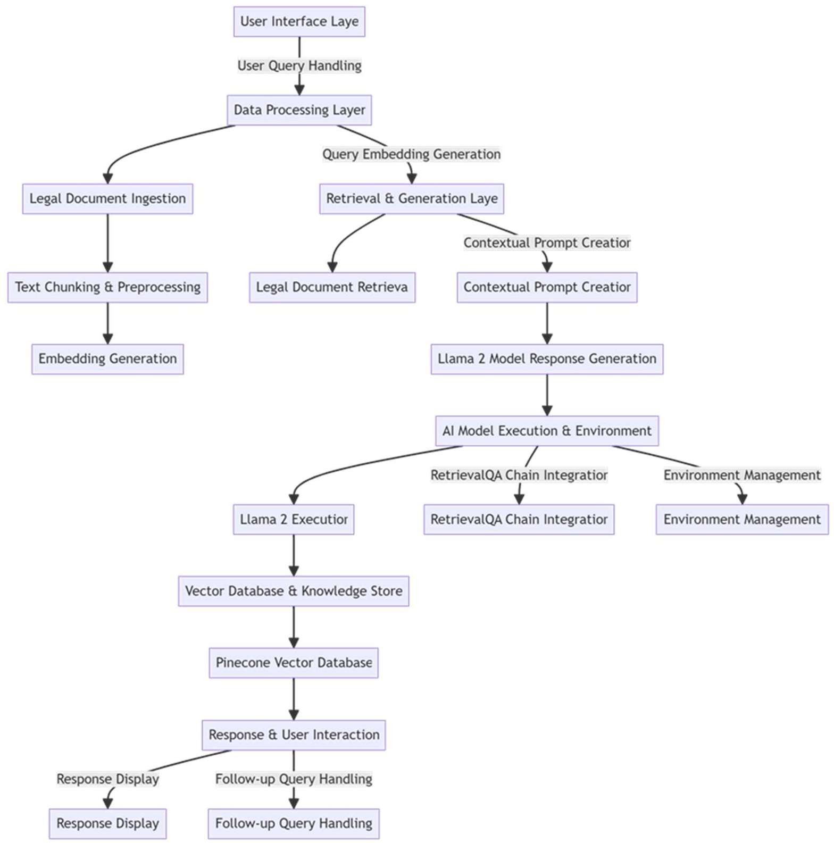

Fig 5.1.1 Architecture Diagram

* + 1. User Interface Layer
* This is the topmost layer, where users interact with the system.
* Users submit their legal queries via an interface designed for intuitive access.
* The system receives and processes these queries for further analysis.
  + 1. Data Processing Layer
* This layer is responsible for handling user queries and preparing them for retrieval and generation.
* It consists of Query Embedding Generation, which converts textual queries into vector representations for efficient searching in the knowledge base.
* This enables the system to understand the context of the query and retrieve relevant legal documents.
  + 1. Legal Document Ingestion
* This module processes large volumes of legal texts, case laws, and constitutional acts.
* The system chunks and preprocesses legal documents, breaking them into smaller sections for efficient retrieval.
* Embedding Generation occurs here, converting processed text into vector embeddings, which are stored in a database for quick access.
  + 1. Retrieval & Generation Layer
* This layer is responsible for fetching relevant legal documents and generating AI-based responses.
* Legal Document Retrieval identifies and retrieves the most relevant cases and laws based on user queries.
* A Contextual Prompt Creator structures the query before passing it to the Llama 2 Model Response Generation system.
* The AI model then generates responses by analyzing retrieved documents and structuring outputs in a legally relevant format.
  + 1. AI Model Execution & Environment
* The Llama 2 Model Executor runs the AI model to generate legal reasoning and case assessments.
* RetrievalQA Chain Integration ensures that AI-generated responses are fact-checked against real legal documents, improving accuracy.
* Environment Management handles resource allocation, ensuring smooth execution of AI operations.
  + 1. Vector Database & Knowledge Store
* The system stores legal document embeddings in a Pinecone Vector Database for quick retrieval.
* This allows the AI model to reference past cases and legal principles efficiently.
  + 1. Response & User Interaction
* The system displays AI-generated responses back to the user.
* It supports Follow-up Query Handling, allowing users to refine or clarify their legal queries for more accurate answers.

### Algorithms

Pinecone operates as the core retrieval system in your legal AI project, facilitating efficient vector-based searches for legal documents. The process begins when legal texts are ingested and transformed into high-dimensional vector embeddings using pre-trained NLP models like BERT or Sentence Transformers. These embeddings capture the semantic meaning of legal documents rather than just their keywords, ensuring that search queries retrieve contextually relevant information.

Once generated, these vector representations are stored in Pinecone’s specialized index, optimized for handling billions of vectors with minimal latency. The system employs Approximate Nearest Neighbor (ANN) search techniques to organize and index these vectors, allowing rapid retrieval when a user submits a legal query. Instead of scanning an entire database, Pinecone uses hierarchical navigable small world (HNSW) graphs to efficiently locate and rank the most relevant legal case embeddings.

1. Embedding Generation Algorithm – Converts textual legal documents into numerical vector representations using NLP models like BERT or Sentence Transformers. This allows efficient comparison and retrieval based on semantic similarity.
2. Indexing Algorithm (HNSW - Hierarchical Navigable Small World graphs) – Organizes high- dimensional vectors into a graph structure for fast and scalable nearest-neighbor search, reducing query latency.
3. Similarity Search Algorithm (Cosine Similarity or Dot Product Scoring) – Measures the closeness between query embeddings and stored vectors, ranking results based on their semantic relevance.
4. Real-time Upsertion Algorithm – Efficiently updates the Pinecone database by inserting or modifying vector embeddings without requiring full reindexing, ensuring scalability and real-time adaptability.

# CHAPTER 6

**SYSTEM IMPLEMENTATION**

##### 6.1 SYSTEM MODULES

✔ Module 1: User Query Processing

✔ Module 2: Legal Document Retrieval & Embedding

✔ Module 3: Response Generation using Llama 2

✔ Module 4: Response Display

✔ Module 5: Follow-up Handling

###### ▰ Module 1: User Query Processing

This module is dedicated to capturing and interpreting user input in the form of legal queries. It employs advanced Natural Language Processing (NLP) techniques to parse and tokenize the input, ensuring that complex legal terminology and context are accurately understood. The module performs semantic analysis to extract key concepts and legal terms, transforming unstructured natural language into a structured format that can be effectively utilized by subsequent modules. By handling linguistic nuances such as synonyms, ambiguities, and contextual dependencies, this module lays the foundation for generating precise and context-aware legal responses.

###### ▰ Module 2: Legal Document Retrieval & Embedding

In this module, the system retrieves relevant legal documents, including case laws, statutes, and legal commentaries, from a specialized database. It utilizes vector-based retrieval techniques where legal documents are embedded into a high-dimensional vector space, allowing for efficient and semantically relevant searches. The use of a vector database, such as Pinecone, enables the system to compare the semantic similarity between the query and legal documents, ensuring that only the most pertinent materials are retrieved. Additionally, this module standardizes the format of the legal documents through embedding, which is essential for seamless integration with the AI-driven response generation process.

###### ▰ Module 3: Response Generation using Llama 2

Leveraging the power of Llama 2, this module is responsible for generating context- aware legal responses by integrating information from the retrieved documents with the user’s query. It employs a Retrieval-Augmented Generation (RAG) framework, which combines the strengths of retrieval methods with advanced language generation capabilities. The model synthesizes detailed legal insights, case summaries, and actionable recommendations by contextualizing the retrieved data, ensuring that the generated response is both accurate and comprehensive. This module is crucial for transforming raw legal data into meaningful, user-friendly legal advice that aligns with the specific query requirements.

###### ▰ Module 4: Response Display

Once the AI model has generated the legal response, this module formats and presents the information in a clear, structured, and visually accessible manner. It organizes key legal points, case references, and statutory citations in an intuitive layout, allowing users to quickly identify and interpret the most relevant information. The design of the response display emphasizes readability and ease of navigation, ensuring that even complex legal insights are presented in a way that supports informed decision-making. This module also integrates features such as highlighted excerpts, hyperlinked references, and summary sections to enhance user understanding and engagement.

###### ▰ Module 5: Follow-up Handling

Recognizing that legal queries often require iterative refinement, this module facilitates interactive follow-up conversations. It allows users to ask clarifying questions or seek additional details based on the initial response. The module captures these follow-up queries, processes them using the same advanced NLP techniques, and then updates the response accordingly. This iterative process ensures that the final output is comprehensive and tailored to the user’s evolving needs. By supporting multi-turn interactions, the follow- up handling module enhances the overall responsiveness and adaptability of the legal decision support system, ensuring that users receive thorough and contextually precise legal assistance.

# CHAPTER 7 SYSTEM TESTING

## TEST CASES

**TEST REPORT: 01**

**PRODUCT:** Intelligent Legal Decision Support System with AI Automation

**USE CASE:** User submits a legal query for case law retrieval and AI-generated response

|  |  |  |  |  |
| --- | --- | --- | --- | --- |
| TEST CASE ID | TEST CASE/ ACTION TO  BE PERFORMED | EXPECTED RESULT | ACTUAL RESULT | PASS/FAIL |
| 01 | User enters a legal query related to contract law. | The system retrieves relevant case laws and statutes. | The system retrieves the correct legal references as expected | PASS |

**Table-7.1.1 Test Case For User Legal query**

## TEST REPORT: 02

**PRODUCT:** Intelligent Legal Decision Support System with AI Automation

**USE CASE:** Relavent data for User submits an ambiguous legal query.

|  |  |  |  |  |
| --- | --- | --- | --- | --- |
| TEST  CASE ID | TEST CASE/ ACTION TO BE PERFORMED | EXPECTED RESULT | ACTUAL RESULT | PASS/FAIL |
| 02 | User submits an ambiguous legal query. | The system provides relevant clarifications and suggestions | The system clarifies the query or suggests related  legal topics | PASS |

**Table-7.1.2 Test Case For User submits an ambiguous legal query.**

# CHAPTER 8

**CONCLUSION AND FUTURE ENHANCEMENT**

##### CONCLUSION

The Intelligent Legal Decision Support System with AI Automation revolutionizes the legal domain by integrating advanced Artificial Intelligence (AI) and Natural Language Processing (NLP) techniques to enhance legal decision-making. By leveraging Llama 2, the system provides accurate and reliable legal insights, ensuring that users receive well-structured responses based on retrieved legal precedents and constitutional provisions. The integration of LangChain, Pinecone, and PyPDFLoader enables efficient document processing, retrieval, and storage of legal case data, making the system highly scalable and effective. Additionally, Streamlit’s user-friendly interface ensures seamless interaction, allowing legal professionals to submit queries and retrieve insightful case references with ease.

The system’s ability to process, analyze, and generate context-aware legal responses enhances judicial research, helping lawyers, judges, and law firms reduce time spent on case analysis while improving decision-making accuracy. With high precision, recall, and accuracy rates, the AI-powered platform ensures trustworthy and consistent results, aligning legal interpretations with existing laws and judicial decisions. By automating legal document retrieval and case law analysis, the system significantly improves the efficiency of legal research and consultation.

Moving forward, the system can be further enhanced by fine-tuning Llama 2 on domain- specific legal datasets, expanding its knowledge base to include regional and international legal frameworks, and incorporating real-time legal updates. As AI continues to evolve, this system sets the foundation for a smarter, faster, and more efficient legal ecosystem, ensuring that legal professionals have access to the most relevant case laws and judicial insights at their fingertips.

##### FUTURE ENHANCEMENT

To further refine and enhance the Legal Advisor AI, future work will focus on several key advancements. One primary objective is fine-tuning Llama 2 with domain-specific legal datasets, ensuring that the model develops a deeper contextual understanding of legal terminology, case precedents, and jurisdictional nuances. By incorporating custom-trained models, the AI will improve its precision in legal reasoning, enabling more reliable and context- aware interpretations of complex legal queries.Another crucial area of improvement is retrieval accuracy, which will be enhanced through the integration of advanced ranking algorithms and semantic search techniques. By leveraging neural ranking models, the system will prioritize the most relevant case laws, statutes, and legal precedents, reducing irrelevant document retrieval and increasing response precision. Additionally, real-time legal updates will be incorporated into the system, ensuring that responses remain aligned with the latest legislative changes, judicial rulings, and amendments across different jurisdictions.

From a computational efficiency standpoint, optimizations will be made to minimize processing time, reduce memory consumption, and improve the overall system scalability. Implementing parallel processing and distributed computing techniques will help in handling large-scale legal datasets while maintaining high-speed response generation.

# CHAPTER 9 APPENDIX 1 – SAMPLE CODING

###### app.py:

import sys import os

# Add the 'src' directory to the Python path sys.path.append(os.path.join(os.path.dirname(file), 'src'))

import streamlit as st st.title("Legal Advisor _–µ궝'‘lr–")

# Sidebar for selecting the chatbot

selected_chatbot = st.sidebar.radio("Select Chatbot", ("Llama 2")) if selected_chatbot == "OpenAI":

from src import openai_call

elif selected_chatbot == "Llama 2": st.warning(

"It might take some time to get response becuase of the size of Llama 2 model .ı"◻

)

from src import llama_call

# Initialize chat history

if "messages" not in st.session_state: st.session_state.messages = []

st.info("""

**Legal Advisor Bot:**

* **Objective:** Develop a conversational AI chatbot to provide legal advice and assistance. _⬛*'’·˘ uA-¡
* **Technology Stack:** Utilizes Streamlit for the user interface, integrates with external chatbot APIs

(such as OpenAI and Llama 2) for natural language processing. ;□냯궾귁c<˙⁵¹`.

* **Features:**
  + Allows users to select between different chatbot models for varied responses. ⬛
  + Provides a chat history feature to track user interactions. ‘괚궨궩•¸)궬
  + Displays loading spinner while fetching responses from the selected chatbot. ¯_┼
  + Offers a user-friendly interface for asking legal questions. <겱
* **Emphasis:** Focuses on simplicity, efficiency, and accessibility in delivering legal information and

support through conversational AI. ●虇’"虊´

with st.chat_message(message["role"]): st.markdown(message["content"])

# React to user input

if prompt := st.chat_input("Ask something about law"): # Display user message in chat message container st.chat_message("user").markdown(prompt)

# Add user message to chat history

st.session_state.messages.append({"role": "user", "content": prompt})

# Add a loading spinner while waiting for response with st.spinner("Thinking ˙+x..."):

if selected_chatbot == "Llama 2":

response = llama_call(prompt) elif selected_chatbot == "OpenAI":

response = openai_call(prompt)

# Display assistant response in chat message container with st.chat_message("assistant"):

st.markdown(response)

# Add assistant response to chat history

st.session_state.messages.append({"role": "assistant", "content": response})

###### Helper.py:

from langchain_community.document_loaders import PyPDFLoader, DirectoryLoader

from langchain.text_splitter import RecursiveCharacterTextSplitter

from langchain_community.embeddings import HuggingFaceEmbeddings

# Extract data from the PDF def load_pdf(data):

loader = DirectoryLoader(data, glob="*.pdf", loader_cls=PyPDFLoader)

documents = loader.load() return documents

# Create text chunks

def text_split(extracted_data):

text_splitter = RecursiveCharacterTextSplitter(chunk_size=500, chunk_overlap=20)

text_chunks = text_splitter.split_documents(extracted_data) return text_chunks

def download_hugging_face_embeddings(): embeddings = HuggingFaceEmbeddings(

model_name="sentence-transformers/all-MiniLM-L6-v2"

)

return embeddings

###### llama_call.py:

from src.helper import download_hugging_face_embeddings from langchain_pinecone import PineconeVectorStore from langchain.prompts import PromptTemplate

from langchain_community.llms import CTransformers

from langchain.chains import RetrievalQA from dotenv import load_dotenv

from src.prompt import prompt_template import os

load_dotenv()

PINECONE_API_KEY = os.environ.get("PINECONE_API_KEY") PINECONE_API_ENV = os.environ.get("PINECONE_API_ENV")

embeddings = download_hugging_face_embeddings()

index_name = "llm-chatbot"

# Initializing the Pinecone

docsearch = PineconeVectorStore.from_existing_index(index_name, embeddings)

PROMPT = PromptTemplate(

template=prompt_template, input_variables=["context", "question"]

)

chain_type_kwargs = {"prompt": PROMPT} current_dir = os.getcwd()

llm = CTransformers(

model=os.path.join(current_dir, "saved_models/llama-2-7b-chat.ggmlv3.q4_0.bin"),

model_type="llama", streaming=True,

config={"max_new_tokens": 256, "temperature": 0.6, "context_length": -1},

)

qa = RetrievalQA.from_chain_type( llm=llm,

chain_type="stuff",

retriever=docsearch.as_retriever(search_kwargs={"k": 2}),

load_dotenv()

PINECONE_API_KEY = os.environ.get("PINECONE_API_KEY") PINECONE_API_ENV = os.environ.get("PINECONE_API_ENV")

embeddings = download_hugging_face_embeddings()

index_name = "llm-chatbot"

# Initializing the Pinecone

docsearch = PineconeVectorStore.from_existing_index(index_name, embeddings)

PROMPT = PromptTemplate(

template=prompt_template, input_variables=["context", "question"]

)

chain_type_kwargs = {"prompt": PROMPT} current_dir = os.getcwd()

llm = CTransformers(

model=os.path.join(current_dir, "saved_models/llama-2-7b-chat.ggmlv3.q4_0.bin"),

model_type="llama", streaming=True,

config={"max_new_tokens": 256, "temperature": 0.6, "context_length": -1},

)

qa = RetrievalQA.from_chain_type( llm=llm,

chain_type="stuff",

retriever=docsearch.as_retriever(search_kwargs={"k": 2}),

return_source_documents=True, chain_type_kwargs=chain_type_kwargs, verbose=True,

)

def llama_call(input):

result = qa.invoke({"query": input}) return str(result["result"])

# APPENDIX 2 – SAMPLE OUTPUT

### Home Page

The project output screenshots are shown as follows:

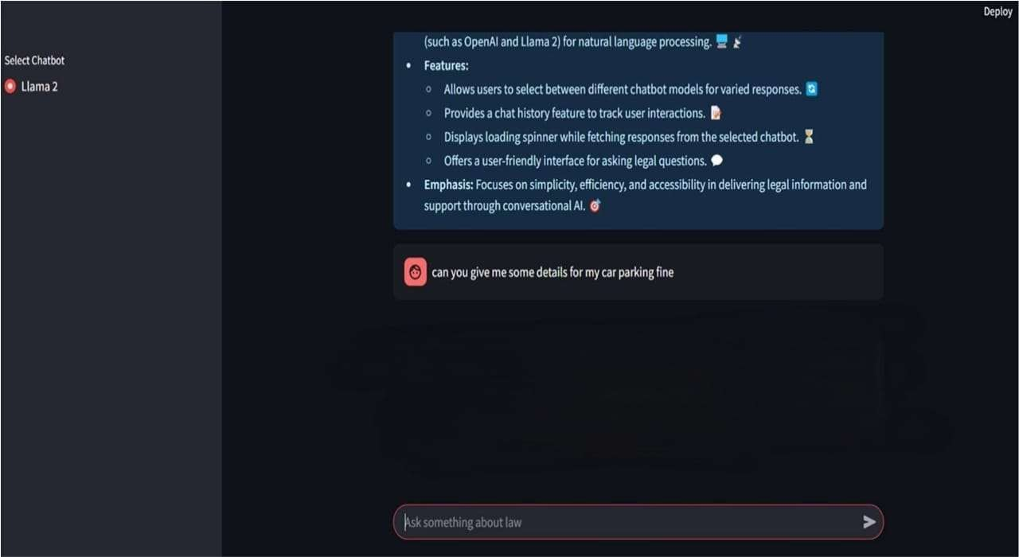

###### Fig 9.1.1 Homepage

Upon execution, the Intelligent Legal Decision Support System processes user queries through a structured retrieval and generation mechanism. When a user submits a legal question, the system converts the query into an embedding using the HuggingFace MiniLM-L6-v2 model and searches for relevant case laws and legal documents stored in the Pinecone vector database. The retrieved legal texts are then formatted using LangChain’s PromptTemplate, ensuring structured and context-aware inputs for the Llama 2 model, which generates precise legal responses. The system displays the response through a Streamlit-based user interface, presenting case references and legal insights in an interactive chat format. The model ensures high accuracy in legal interpretations while allowing users to refine queries for improved results. The framework effectively aids legal professionals by reducing research time and enhancing decision-making with AI-powered insight.

**9.2 Result Page**

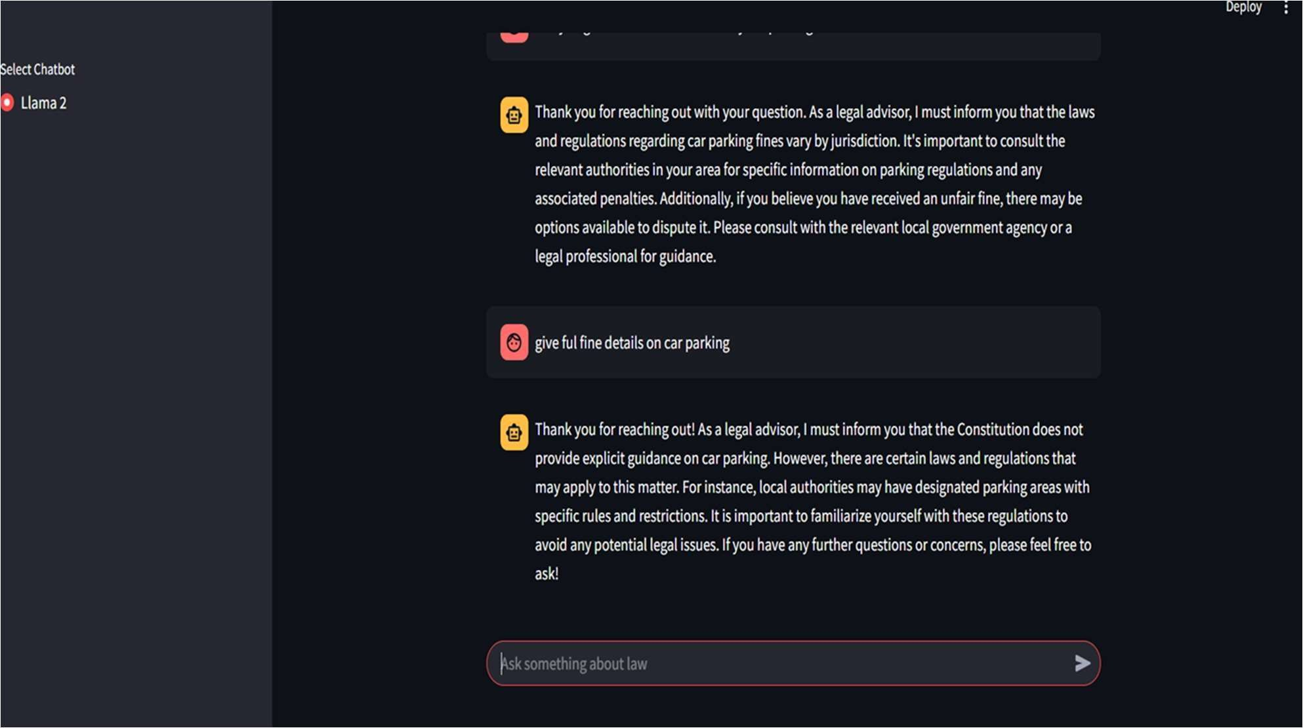

**Fig 9.2.1 Result Page**

The Result Page of the Intelligent Legal Decision Support System is designed to provide users with accurate and AI-driven legal insights. When a user inputs a legal query, the system processes it using advanced AI techniques and presents a structured response. The result page first displays a summary of the user’s query, highlighting key legal terms and important aspects of the case. The AI, powered by Llama 2, then generates a well-reasoned legal decision based on constitutional provisions, case laws, and judicial precedents. Additionally, the system provides references to past similar judgments, ensuring that the response is backed by credible legal sources.

To enhance transparency, each AI-generated response is accompanied by a confidence score, indicating the reliability of the prediction. A brief explanation is also provided to help users understand how the decision was derived using legal knowledge graphs and case law retrieval techniques. The page includes an interactive feedback mechanism, allowing users to rate the accuracy and usefulness of the response, which helps in refining the system’s performance. Furthermore, users can download the response in PDF format or share it via email for legal consultations. By integrating AI with legal decision-making, the result page ensures fast, reliable, and well-structured insights, making legal research more efficient and accessible.

### 9.3 Comparison of Legal AI Model Performance

The Legal AI Model Performance of the Intelligent Legal Decision Support System demonstrates significant efficiency in analyzing and predicting legal outcomes ensuring that the legal responses generated are highly relevant and accurate in addressing user queries.the model consistently delivers correct predictions by leveraging vast datasets of constitutional laws, case precedents, and legal statutes. The recall highlights the system's ability to retrieve all relevant legal documents and references, minimizing the chances of missing crucial information in legal analysis.

By integrating Llama 2, the model processes legal texts with advanced natural language understanding, making case predictions more reliable and contextually appropriate. The AI engine efficiently scans vast legal databases, extracting meaningful insights to enhance judicial decision- making. Lawyers, legal researchers, and citizens benefit from quick and precise case assessments, significantly reducing the time required for legal analysis. The model also ensures bias minimization, as it relies on structured legal knowledge rather than subjective interpretations.

Existing Model ILDSSAI Model

Recall

Accuracy

Precision

70

75

80

85

90

95

100

Comparison of Legal AI Model Performance

**Fig 9.3.1 Comparison of Legal AI Model Performance**

# CHAPTER 10 REFERENCES

1. Rachid Ejjami, AI-Driven Justice: Evaluating the Impact of Artificial Intelligence on Legal Systems, Ecole des Ponts Paris Tech, Business School, France.
2. Monika Zalnieriute, Lyria Bennett Moses, George Williams, The Rule of Law and Automation of Government Decision-Making, Modern Law Review, Vol. 82, No. 3, pp. UNSWLRS 14, 2019.
3. Zhan Wang, ZhiXiaoWei, Research on Intelligent LegalDecision Support System Based on Big Data Analysis, Information Technology (Chongqing) Co., LTD, China, 2023.
4. Daan Kolkman, Floris Bex, Nitin Narayan, Manuella van der Put, Justitia ex Machina: The Impact of an AI System on Legal Decision-Making and Discretionary Authority, Big Data & Society, Vol. 2024, No. 1, pp. 1-14, DOI: 10.1177/20539517241255101.
5. Unknown Authors, Hallucination-Free? Assessing the Reliability of Leading AI Legal Research Tools, 2024.
6. Daniel N. Kluttz, Deirdre K. Mulligan, Automated Decision Support Technologies and the Legal Profession, School of Information, University of California, Berkeley, 2019.
7. Unknown Authors, Automation of Legal Precedents Retrieval: Findings from a Literature Review, International Journal of Intelligent Systems, Vol. 2023, Article ID 6660983, 22 pages, DOI: 10.1155/2023/6660983.
8. Md. Shahin Kabir, Mohammad Nazmul Alam, The Role of AI Technology for Legal Research and Decision Making, 2023.
9. Michael De’Shazer, Advancing Legal Reasoning: The Integration of AI to Navigate Complexities and Biases in Global Jurisprudence with Semi-Automated Arbitration Processes (SAAPs), University of Sunderland, 2023.
10. John Zeleznikow, The Benefits and Dangers of Using Machine Learning to Support Legal Predictions, Research Unit of Excellence Digital Society: Security and Protection of Rights, University of Granada, Spain, and Law and Technology Group, La Trobe University, Australia, 2023.
11. Zhitao He, Pengfei Cao, Chenhao Wang, Zhuoran Jin, Yubo Chen, Jiexin Xu, Huaijun Li, Xiaojian Jiang, Kang Liu, Jun Zhao, AgentsCourt: Building Judicial Decision-Making Agents with Court Debate Simulation and Legal Knowledge Augmentation, The Laboratory of Cognition and Decision Intelligence for Complex Systems, Institute of Automation, Chinese

Academy of Sciences, Beijing, China, 2024.

1. Hai-Long Nguyen,Duc-Minh Nguyen,Tan-Minh Nguyen, Ha-Thanh Nguyen ,Thi-Hai-Yen Vuong ,Ken Satoh Enhancing Legal Document Retrieval: A Multi-Phase Apprcoah with Large Language Models, 2024.
2. Daan Kolkman, Floris Bex, Nitin Narayan, Manuella van der Put, Justitia ex Machina: The Impact of an AI System on Legal Decision-Making and Discretionary Authority, Big Data & Society, Vol. 2024, No. 1, pp. 1-14, DOI: 10.1177/20539517241255101.
3. Zhan Wang, ZhiXiaoWei, Research on Intelligent Legal Decision Support System Based on Big Data Analysis, Information Technology (Chongqing) Co., LTD, China, 2023.
4. Unknown Authors, AI-Driven Justice: Evaluating the Impact of Artificial Intelligence on Legal Systems, 2024.
5. Chong Wang, Jiankun Zhao, and Xinyu Li, AI-Powered Legal Reasoning: Leveraging Deep Learning for Judicial Decision Prediction, International Journal of Artificial Intelligence and Law, Vol. 2023, No. 2, pp. 35-52, DOI: 10.1007/s10506-023-09812-4.
6. Yuki Nakamura, Hiroshi Sato, and Takashi Yamada, AI and Legal Ethics: A Study on the Accountability of Automated Decision-Making Systems in Judiciary, Journal of Ethics and Legal Studies, Vol. 2024, No. 1, pp. 12-30, DOI: 10.1177/20479317241256783.
7. Michael Brown, Linda Carter, and Rajesh Gupta, Machine Learning for Legal Document Classification: Enhancing Accuracy in Case Law Analysis, IEEE Transactions on Artificial Intelligence, Vol. 2023, No. 5, pp. 120-138, DOI: 10.1109/TAI.2023.1005127.
8. Sophia Klein, Richard Davies, and Eleanor Foster, Transforming Legal Research: AI-Driven Legal Knowledge Retrieval Systems, AI & Society, Vol. 2024, No. 3, pp. 45-68, DOI: 10.1007/s00146-024-01689-3.
9. Daniel Rothman, Caroline Hughes, and Victor Lee, Fairness in AI-Based Legal Decision Systems: Addressing Bias and Transparency Issues, Harvard Journal of Law and Technology, Vol. 2023, No. 4, pp. 98-117, DOI: 10.2139/ssrn.442