GE Aviation Overview

Heading
Clickstreams for Testing Automation
View On-Hand Inventory.udc
Change Log
Date | Change Owner | Description
Table of Contents
xxxx

Responsibilities
- xxxx
- xxxx
- xxxx

Additional Setup
- xxxx
- xxxx
- xxxx
Screen Flow
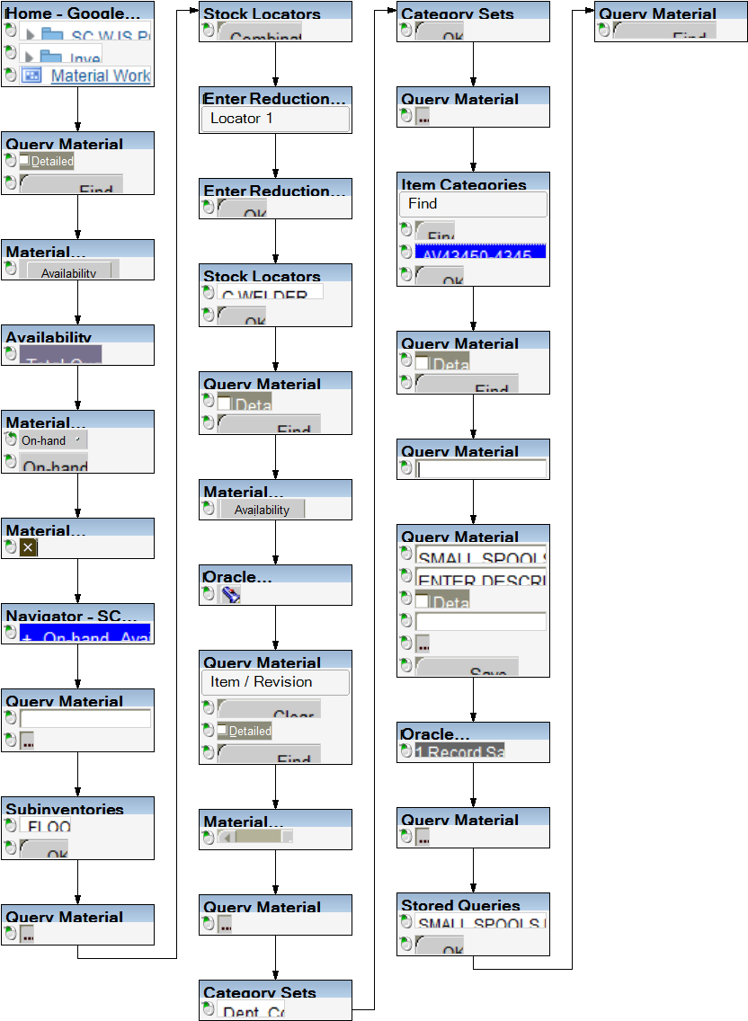
Procedure
1. Start the transaction using the menu path or transaction code.
Home - Google Chrome
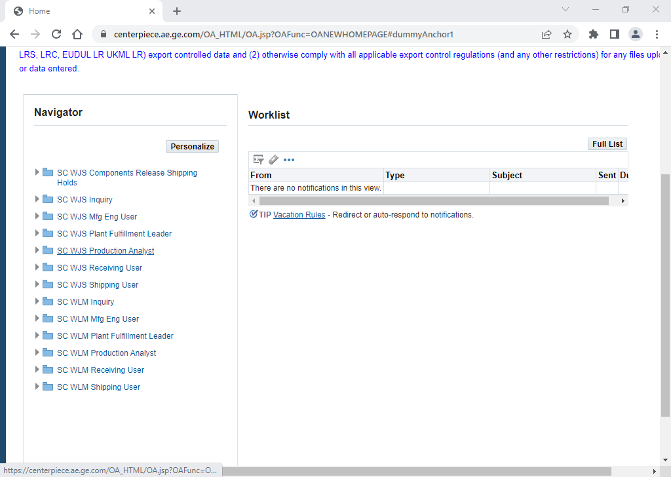
2. Choose the appropriate responsibility for your role. .
3. Click Inventory.
4. Click Material Workbench (On-Hand).
Query Material
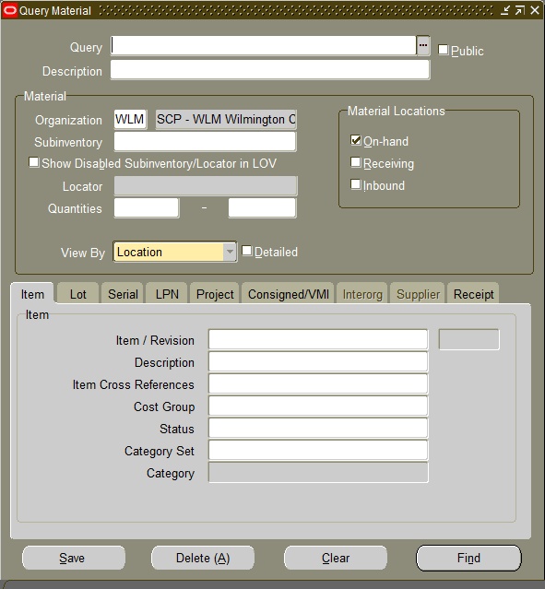
5. Explanation
 | This series of slides will show you how to view all items in a particular organization
6. Click Detailed check box .
7. Click Find button .
Material Workbench
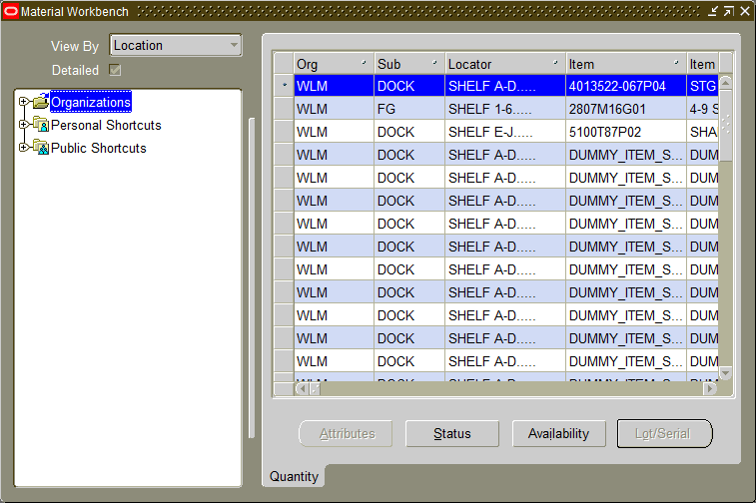
8. Click or expand the screen to see more details (i.e. qty).
Availability
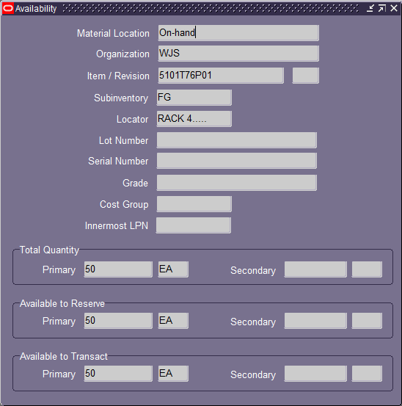
9. Click Material Location text box .
xxxx
Here is where you can view the availability of the on-hand qty.
Material Workbench
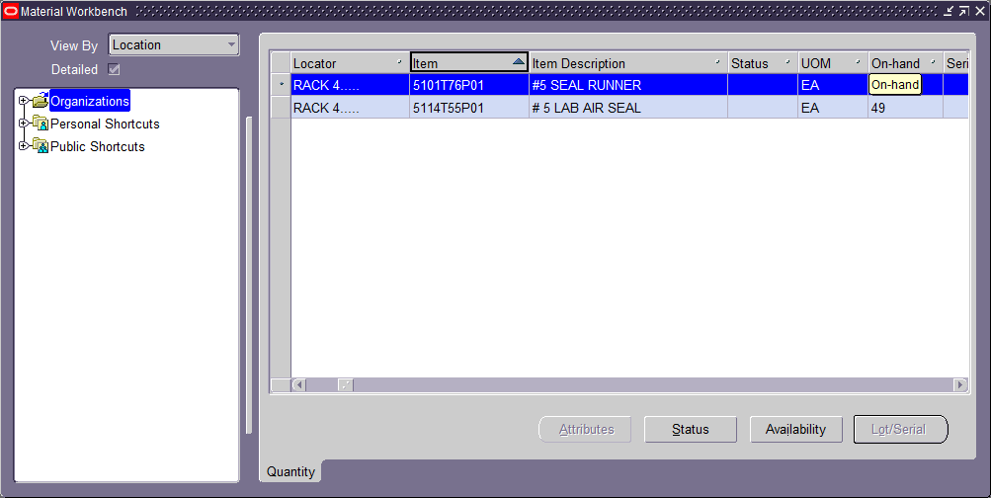
10. To customize your inventory view you can expand this window, drag and drop the desired columns into the order you prefer.
11. Click and hold to rearrange columns. A quick click will sort the column so click and hold before dragging and dropping.
Material Workbench
12. Click to exit.
Navigator - SC Inventory Super User
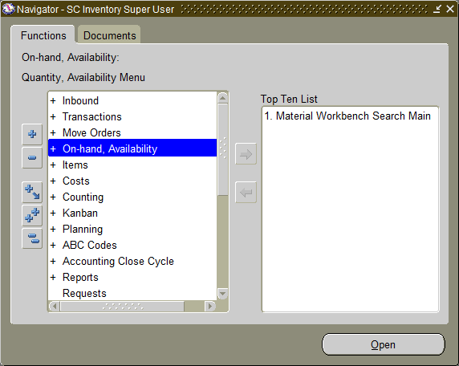
13.
Now, we will search for on-hand availability to see what is in a specific Sub-Inventory & Locator.
14. Click .
Query Material
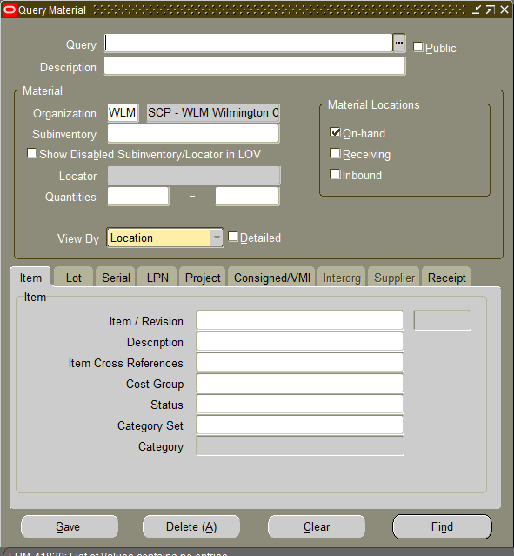
15. Click Subinventory text box .
16. Click button .
Subinventories
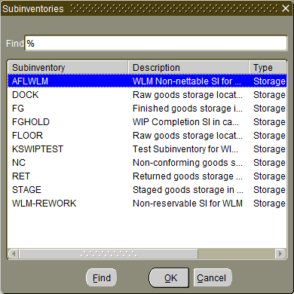
17. Click if you'd like to see on-hand availability for the FLOOR sub-inventory. You can search any sub-inventory this way.
18. Click OK button .
Query Material
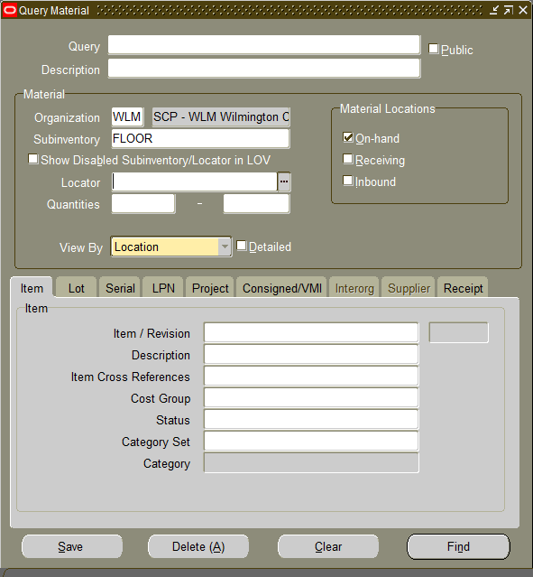
19. Click button .
Stock Locators
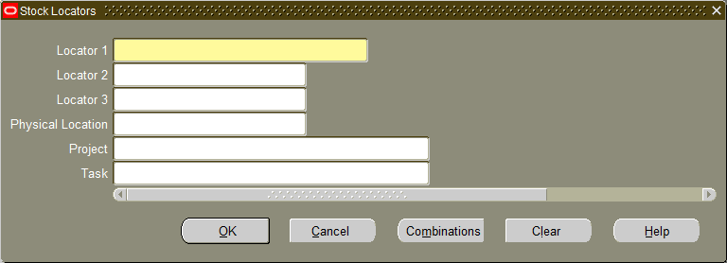
20. Click Combinations button .
Enter Reduction Criteria for Long-List
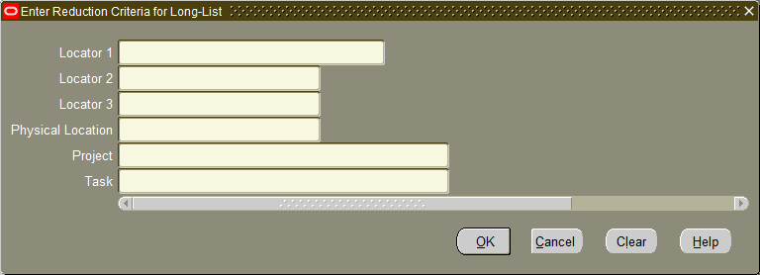
21. As required, complete/review the following fields:
Field | R/O/C | Description
Locator 1 | R | Example:  %
Enter Reduction Criteria for Long-List
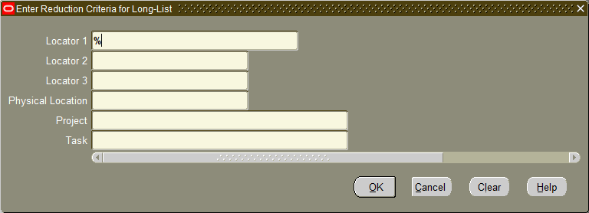
22. Click OK button .
Stock Locators
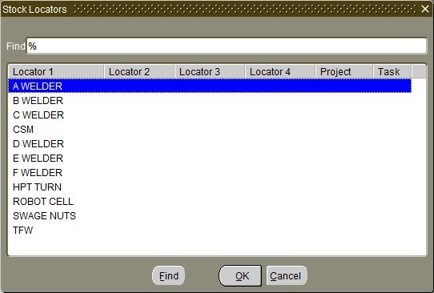
23. Click C WELDER list item . (You can do this for any locator in FLOOR).
24. Click OK button .
Query Material
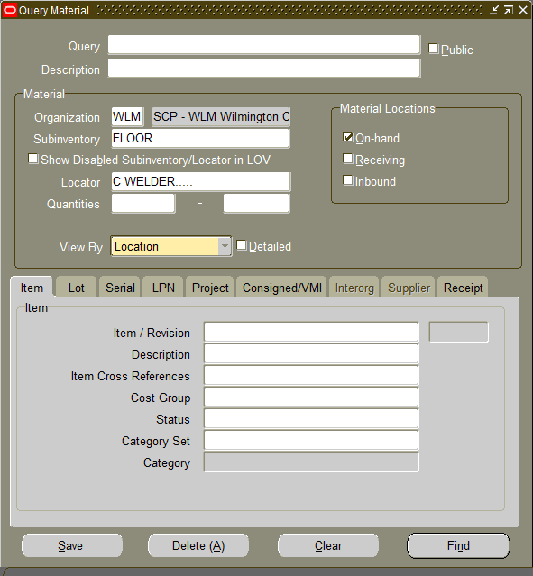
25. Click Detailed check box .
26. Click Find button .
Material Workbench
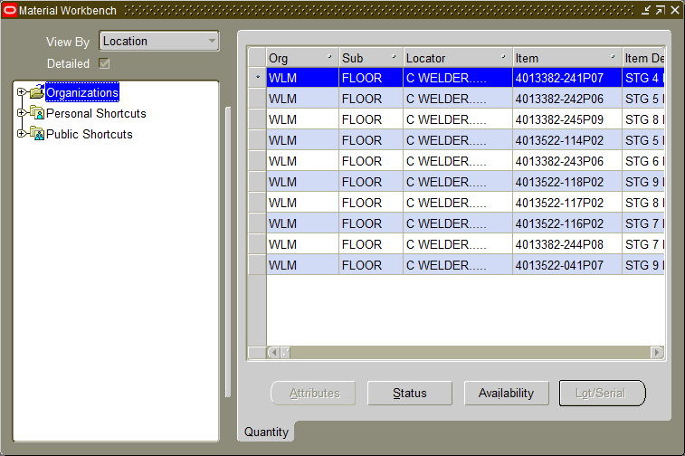
27. Click on or expand the screen to see more details, like quantity.
Oracle Applications - EVNCPAT1 Cloned from EVNCPAQ1 as of 20th June 2022
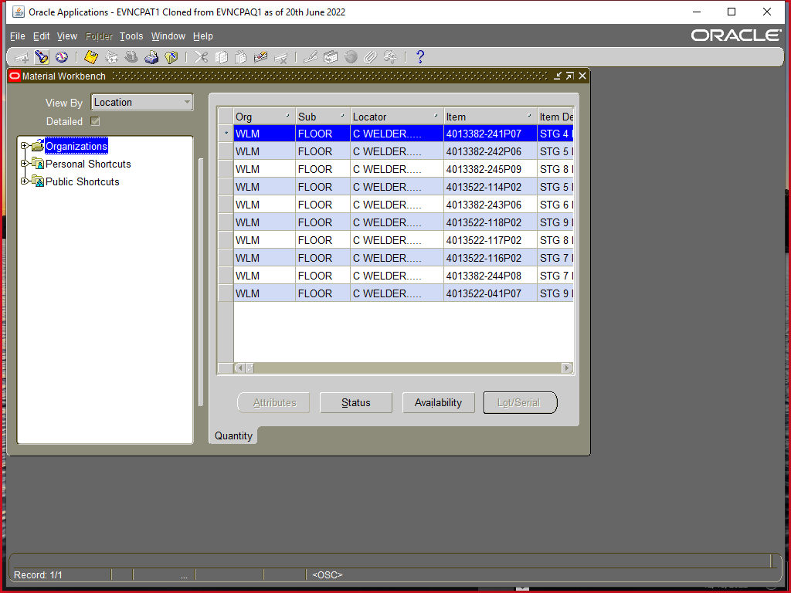
28. Click button - this is another way to get back to a "New Search" for on-hand qty
Query Material
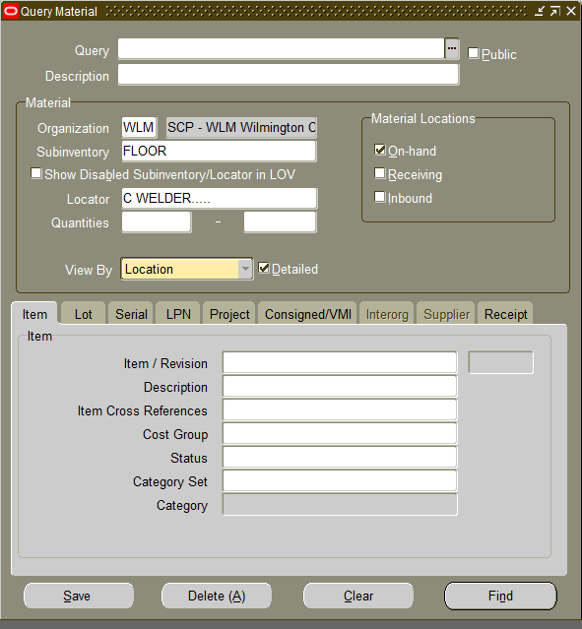
29.
Now, we will search for on-hand availability by specific Part Number.
Query Material
30. Click Clear button .
31. As required, complete/review the following fields:
Field | R/O/C | Description
Item / Revision | R | Example:  2028M42G03
32. Click Detailed check box .
33. Click Find button .
Material Workbench
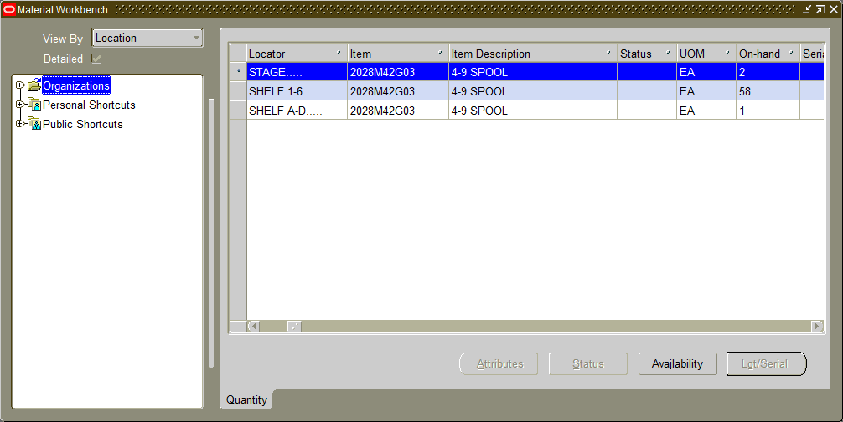
34. You can see locators, on-hand qty, and other information by scrolling to the right.
Query Material
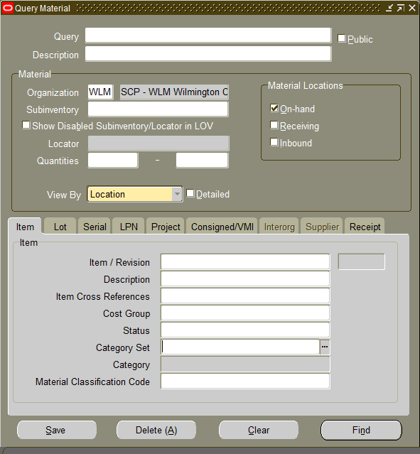
35. To search inventory by department click here and choose Dept_Code
Category Sets
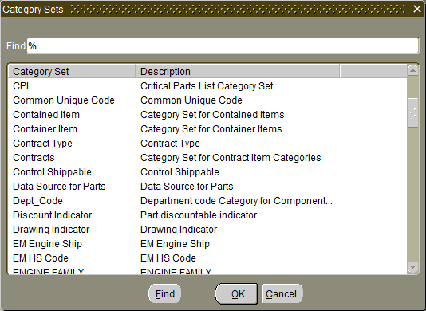
36. Select .
37. Click OK button .
Query Material
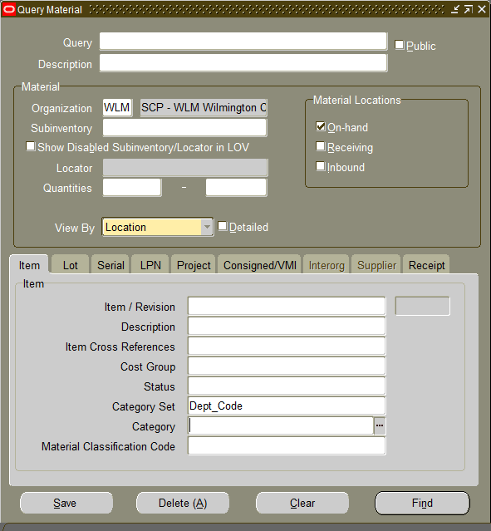
38. Click Category search .
Item Categories
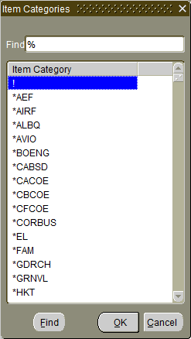
39. As required, complete/review the following fields:
Field | R/O/C | Description
Find | R | Example:  %4345%
40. Click Find button .
41. Select desired Department Code from the list.
42. Click OK button .
Query Material
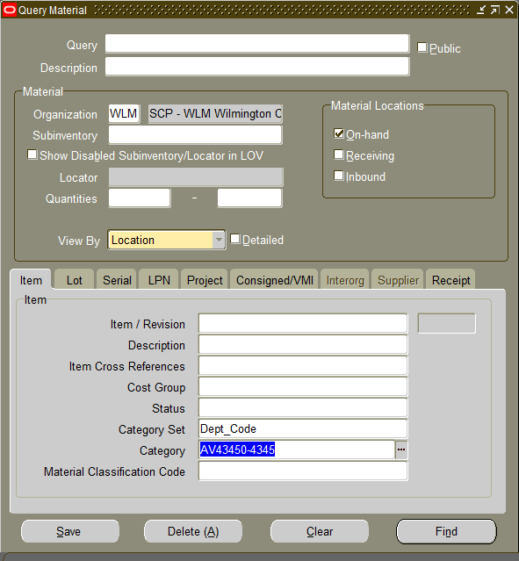
43. Click Detailed check box .
44. Click Find button .
Query Material
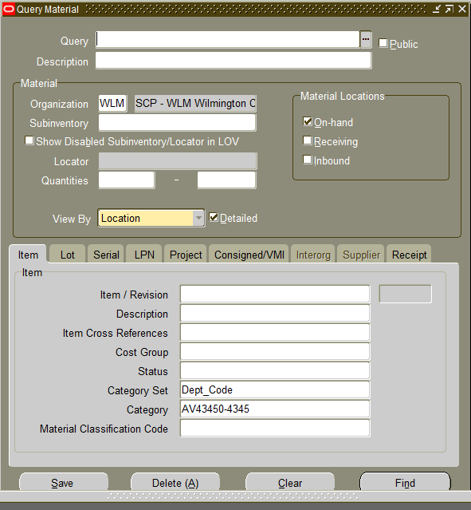
45. You can save search queries for quick access.
Query Material
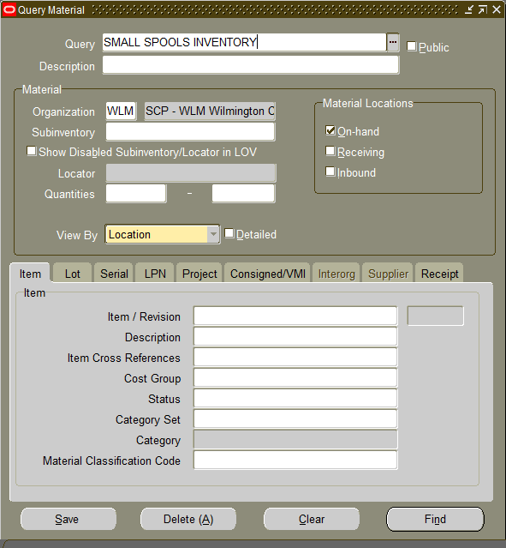
46. Enter a name for the query you want to save. .
47. Enter an optional description, not required.
48. Click Detailed check box .
49. Click Category Set text box .
50. Click button .
51. After completing the search you wish to save, click Save button .
Oracle Applications - Centerpiece OLTP T1 EM Instance OLTP - cpoltpt1 Cloned from cpoltpq1 on 28Dec2022
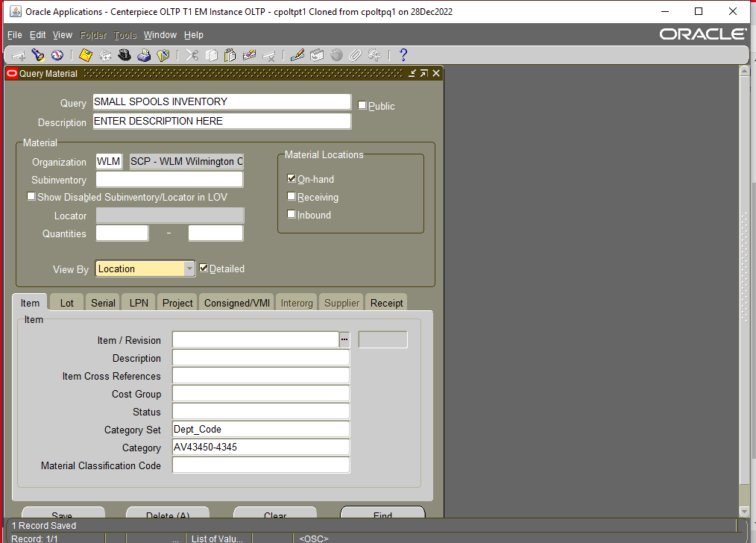
52. Confirmation .
Query Material
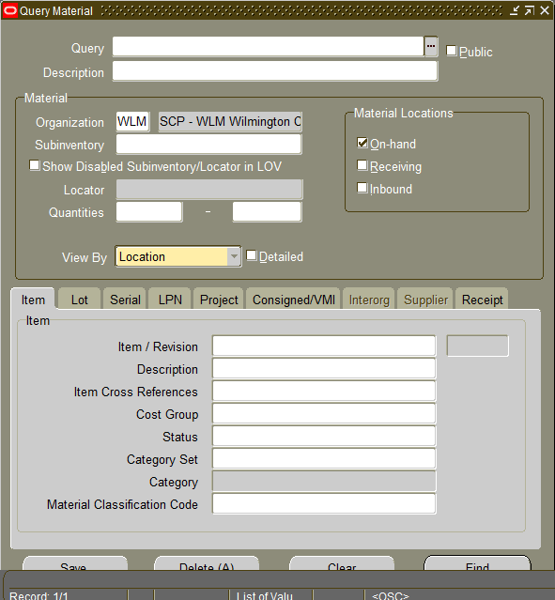
53. Saved queries can be accessed by clicking here
.
Stored Queries
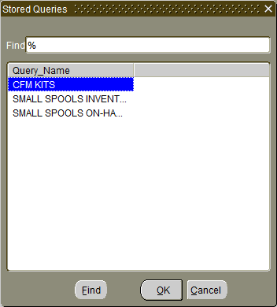
54. Click on desired query..
55. Click OK button .
Query Material
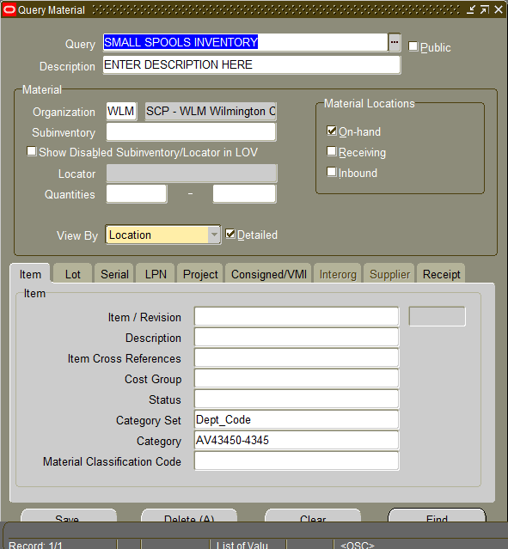
56. Execute the saved search query. .

