**Read-from-CSV**

**AIM:**

To write a python to read data from CSV files.

**ALGORITHM:**

**Step 1:**

start python.

**Step 2:**

import pandas.

**Step 3:**

the number of rows returned is defined in pandas option settins.

**Step 4:**

read the contents of the CSV file using the df.read function.

**Step 5:**

increase the maximum number of rows to display the entire dataframe.

**PROGRAM:**

import pandas as pd

df=pd.read_csv("nba.csv")

print(df.head(10))

print(df.tail())

print("Column",len(df.axes[0]))

print("Rows",len(df.axes[1]))

**OUTPUT:**

[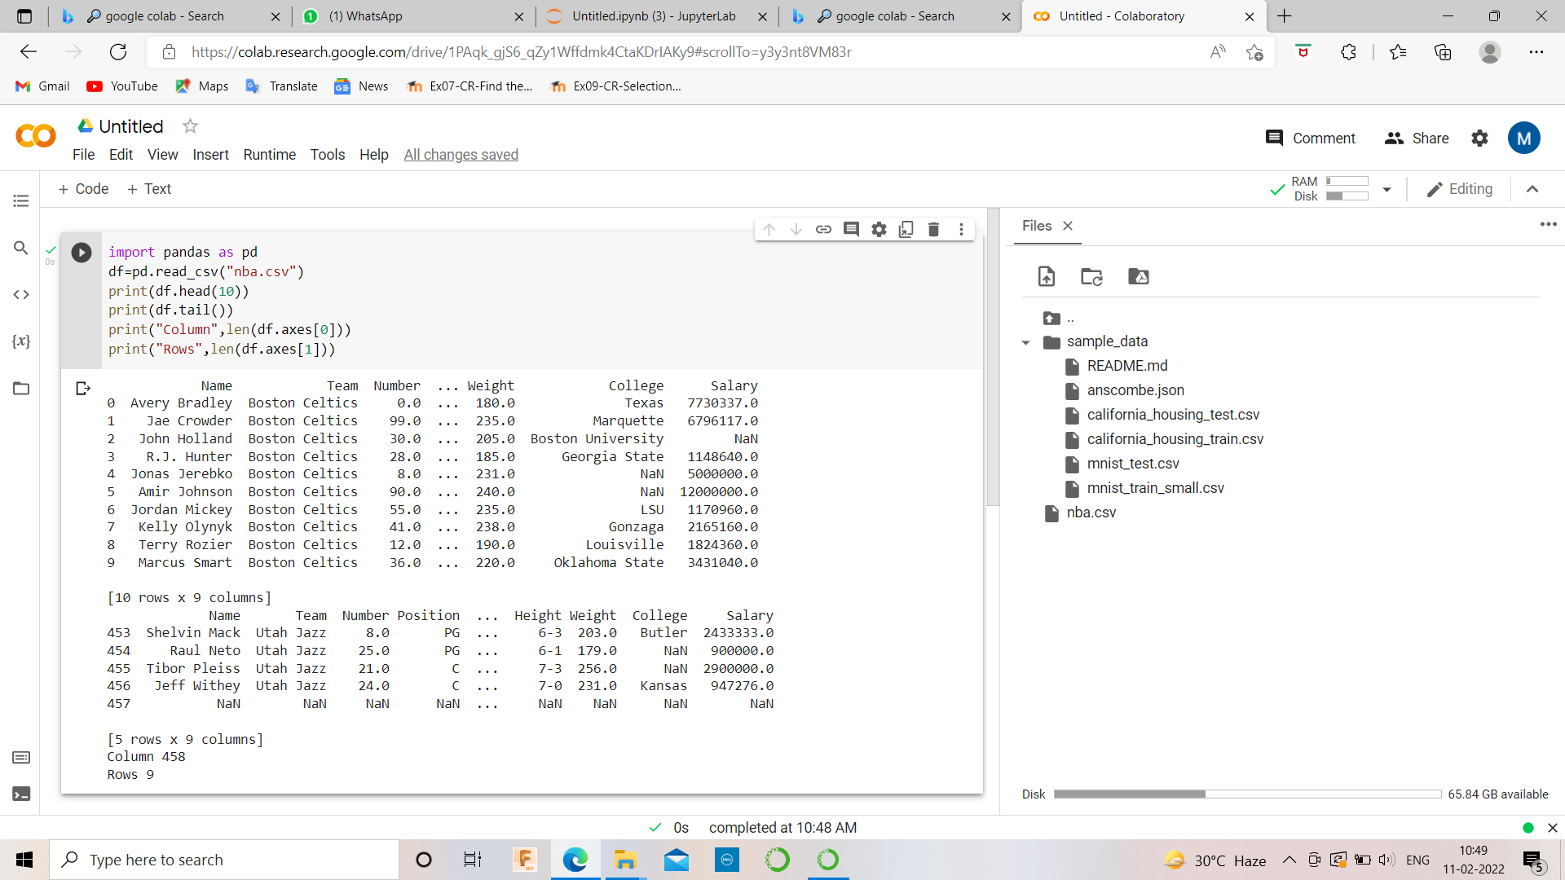](https://github.com/21005984/Read-from-CSV/blob/main/e1.png)

**RESULT:**

thus the program is written to read the csv file