Bert架构

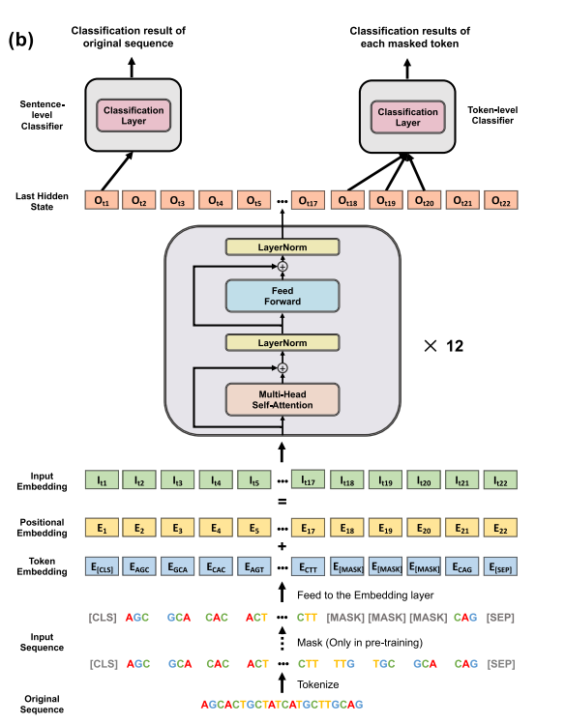 kernel-test

|  |  |  |  |  |  |
| --- | --- | --- | --- | --- | --- |
| Model | SEN(%) | SPE(%) | ACC(%) | MCC(%) | AUROC(%) |
| 48 | 82.97 | 80.62 | 81.79 | 63.60 | 88.55 |
| 96 | **85.14** | 80.98 | 83.06 | 66.18 | 88.46 |
| 194 | 84.96 | **82.07** | **83.51** | **67.06** | **89.58** |