Postman Tests for Project 1

Logging in with correct information:  
  
Input:  
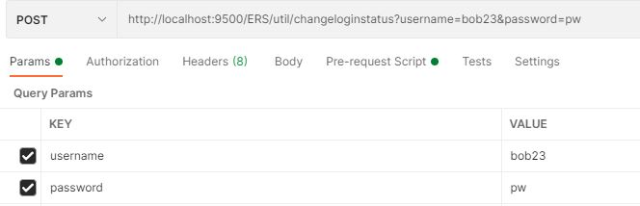  
  
Test script:  
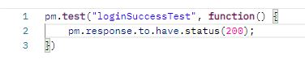  
Result:  
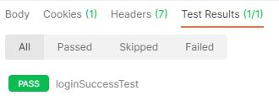

Logging in with wrong password:  
  
Input:  
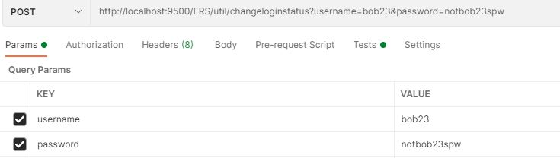  
Script:  
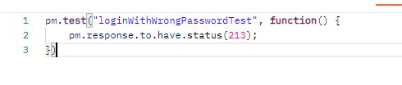  
Result:  
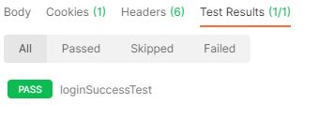  
  
  
Test creating new ticket then checking for its existence after with a GET request  
  
Test 1: Create ticket:  
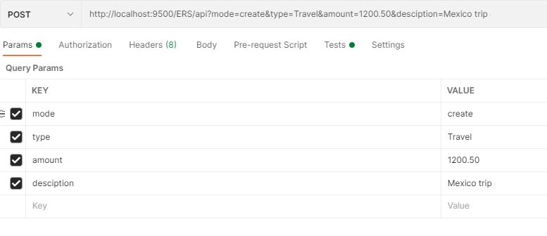  
  
Script:  
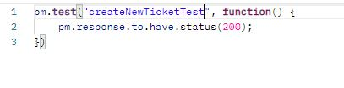  
Result:  
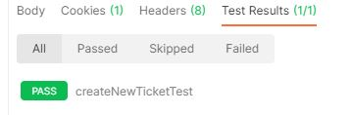  
  
Test 2: Now fetch the newly created, which I know has ticketed = 61 from checking the database  
  
Input:  
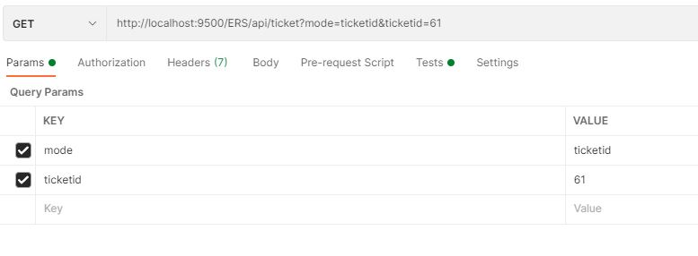  
Script:  
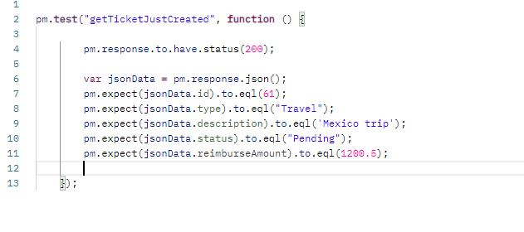  
Result:  
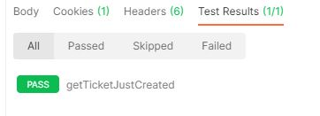

Test attempting to create new user with a username that already exists  
  
Input:  
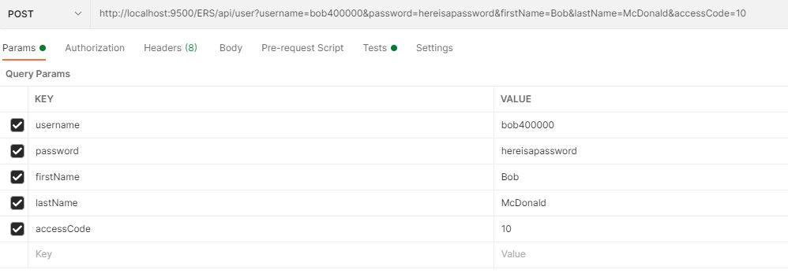  
Script:  
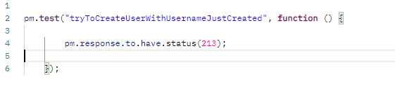  
Result:  
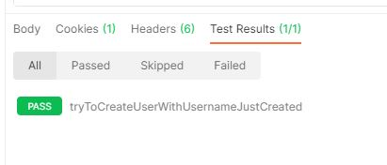  
  
Test attempting to create a user with invalid company access code:  
  
Input:  
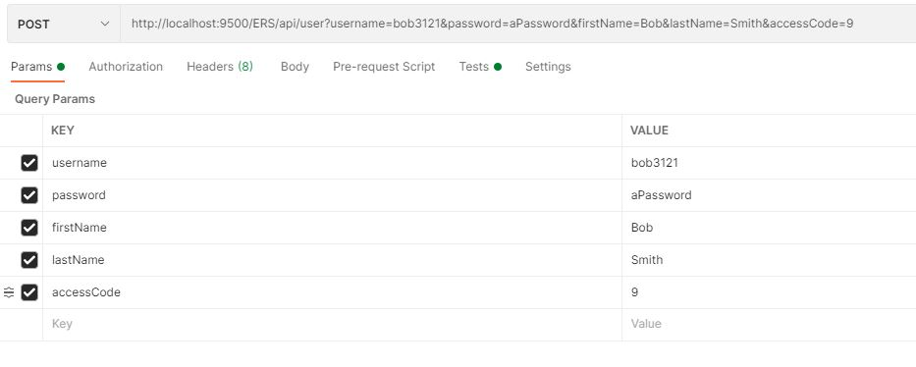  
Script:  
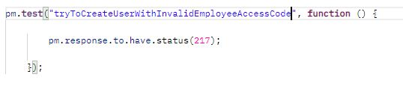  
Result:  
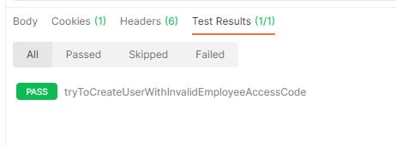

Test Creating User Successfully (Username is available, company access code is correct)  
  
Input:  
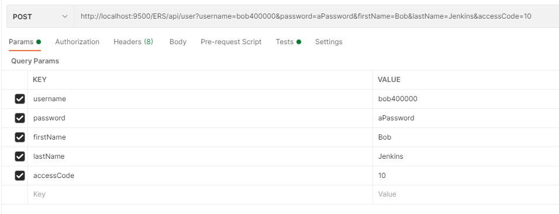  
Script:  
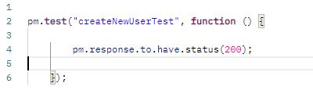  
Result:  
