HOSPITAL MANAGEMENT SYSTEM
A MINOR PROJECT REPORT
A project report submitted in partial fulfillment of the requirements for the 5th semester of the degree of
BACHELOR OF COMPUTER APPLICATIONS

In

COMPUTER SCIENCE

Submitted by
ROHAN KUMAR
Under the Supervision of

[SUPERVISOR NAME]
[SUPERVISOR DESIGNATION]


DEPARTMENT OF COMPUTER SCIENCE
ARAVALI COLLEGE OF ENGINEERING AND MANAGEMENT
FARIDABAD, HARYANA
Affiliated to J.C. Bose University of Science and Technology, YMCA, Faridabad
ACADEMIC SESSION 2026-2027

DECLARATION
I hereby declare that the work presented in this project report entitled "HOSPITAL MANAGEMENT SYSTEM", submitted towards the completion of the 5th semester of the degree of Bachelor of Computer Applications (BCA) in Computer Science at Aravali College of Engineering and Management, Faridabad (Affiliated to J.C. Bose University of Science and Technology, YMCA, Faridabad), is an authentic and original record of my own project work carried out under the supervision and guidance of [SUPERVISOR NAME], [SUPERVISOR DESIGNATION], Department of Computer Science.
I further declare that this report has not been submitted previously in part or in full for the award of any other degree, diploma, associateship, or fellowship at this or any other university or educational institution. All software libraries, tools, and reference documentation consulted have been duly cited and acknowledged in the bibliography.

Rohan Kumar
(Enrollment No-__________)

CERTIFICATE
This is to certify that the minor project report entitled "HOSPITAL MANAGEMENT SYSTEM" submitted by ROHAN KUMAR in partial fulfillment of the requirements for the 5th semester of the degree of Bachelor of Computer Applications (BCA) in Computer Science at Aravali College of Engineering and Management, Faridabad (Affiliated to J.C. Bose University of Science and Technology, YMCA, Faridabad) is an authentic record of the candidate's own work carried out under my supervision and guidance.
The project demonstrates sound software development principles, modular system design, and practical database management suitable for healthcare administration. The matter embodied in this report has not been submitted to any other university or institution for the award of any degree or diploma.
Project Supervisor
Supervisor Name
Designation
Department of Computer Science
Aravali College of Engineering and Management
Faridabad

ACKNOWLEDGEMENTS
I express my sincere gratitude and respect to my project supervisor, [SUPERVISOR NAME], [SUPERVISOR DESIGNATION], Department of Computer Science, Aravali College of Engineering and Management, for providing valuable guidance, continuous encouragement, and helpful suggestions throughout the development of this minor project. Their mentorship helped me understand practical software development and database design concepts.
I extend my heartfelt thanks to the Head of the Department and all respected faculty members of the Department of Computer Science, Aravali College of Engineering and Management, Faridabad (Affiliated to J.C. Bose University of Science and Technology, YMCA, Faridabad), for providing the computing facilities, software resources, and academic support required to complete this project.
I also thank my classmates, family, and friends for their constant encouragement and moral support during the completion of this project work.
ROHAN KUMAR
Department of Computer Science
Aravali College of Engineering and Management

ABSTRACT
Healthcare administration requires fast, organized, and error-free record management to support day-to-day clinic operations. In many traditional medical clinics, patient details, doctor appointments, and billing receipts are maintained manually on paper registers or basic spreadsheets. This manual approach frequently leads to problems such as misplaced files, long patient waiting times, calculation errors in billing, and lack of central access to medical records. To overcome these issues, this project introduces a computerized web-based Hospital Management System (HMS) developed to automate outpatient administrative workflows.
The system is built using Python with the Flask web framework, SQLite relational database, and clean HTML5/CSS3 for the user interface. It provides six core operational modules: Administrator Authentication, Executive Dashboard, Patient Registration & Search, Doctor Directory, Appointment Scheduling, and Itemized Billing with printable patient receipts. Internal technical database IDs are kept simple and readable. The application provides a reliable, easy-to-use, and affordable digital solution well suited for small to medium-sized healthcare facilities.
Keywords: Hospital Management System, Python, Flask, SQLite, Patient Records, Doctor Directory, Appointment Scheduling, Billing.

TABLE OF CONTENTS
Chapter 1: INTRODUCTION & OBJECTIVES 1
1.1 INTRODUCTION 1
1.2 PROBLEM STATEMENT & EXISTING SYSTEM 1
1.3 PROJECT GOALS & OBJECTIVES 2
1.4 SCOPE OF THE PROJECT 2
1.5 CORE SUBSYSTEMS & MODULE OVERVIEW 2
Chapter 2: SYSTEM ANALYSIS & REQUIREMENTS 4
2.1 OVERVIEW OF SYSTEM ANALYSIS 4
2.2 HARDWARE AND SOFTWARE REQUIREMENTS 4
2.3 FEASIBILITY STUDY & OPERATIONAL BENEFITS 4
Chapter 3: SYSTEM ARCHITECTURE & DESIGN 6
3.1 LAYERED ARCHITECTURE OVERVIEW 6
3.2 SYSTEM TIER DECOMPOSITION 6
3.3 ADVANTAGES OF LAYERED ARCHITECTURE 7
Chapter 4: SYSTEM DESIGN & DATABASE SPECIFICATIONS 8
4.1 USE CASE SPECIFICATIONS & ACTOR MATRIX 8
4.2 WORKFLOW LIFECYCLE & ACTIVITY FLOWCHART 10
4.3 DATA FLOW DIAGRAM (DFD LEVEL 1) 11
4.4 DATABASE DESIGN & DATA DICTIONARIES 11
Chapter 5: SYSTEM IMPLEMENTATION & WORKING 15
5.1 TECHNOLOGY STACK & ENVIRONMENT SETUP 15
5.2 ADMIN AUTHENTICATION MODULE 15
5.3 PATIENT RECORDS MANAGEMENT MODULE 15
5.4 DOCTOR DIRECTORY MODULE 16
5.5 APPOINTMENT SCHEDULING MODULE 16
5.6 BILLING & INVOICE GENERATION MODULE 16
5.7 EXECUTIVE DASHBOARD & METRICS 16
Chapter 6: CONCLUSION & FUTURE ENHANCEMENTS 17
6.1 PROJECT SUMMARY & ACHIEVEMENTS 17
6.2 SCOPE FOR FUTURE WORK 17
REFERENCES & BIBLIOGRAPHY 18

LIST OF TABLES
Table 1.1: Comparison between existing manual system and automated HMS 1
Table 1.2: Core operational modules and functional scope 3
Table 2.1: Hardware and software environment specifications 4
Table 2.2: Project feasibility analysis summary 5
Table 3.1: Layered architecture decomposition and functional roles 6
Table 4.1: Actor and system use case specification matrix 8
Table 4.2: Core activity and outpatient workflow lifecycle steps 10
Table 4.3: Patients entity data dictionary (patients table) 13
Table 4.4: Doctors entity data dictionary (doctors table) 13
Table 4.5: Appointments entity data dictionary (appointments table) 14
Table 4.6: Billing entity data dictionary (bills table) 14
Table 4.7: Users entity data dictionary (users table) 14
Table 5.1: Software development stack and runtime environment 15

LIST OF FIGURES
Figure 3.1: Four-tier layered system architecture diagram 7
Figure 4.1: UML use case diagram for hospital administration 9
Figure 4.2: Outpatient workflow activity lifecycle flowchart 10
Figure 4.3: Data flow diagram (DFD Level 1) for outpatient workflow 11
Figure 4.4: Entity-relationship (ER) diagram for database schema 12

Chapter 1
INTRODUCTION & OBJECTIVES
1.1 INTRODUCTION
Hospitals and medical clinics handle large volumes of administrative data on a daily basis. Every day, hospital staff must register incoming patients, maintain doctor schedules, assign consultation appointments, and calculate patient bills. To deliver efficient patient care, these operational processes must be managed quickly, accurately, and without clerical errors.
The Hospital Management System (HMS) developed in this project is an automated, web-based software application designed to computerize and simplify routine hospital administration. By replacing traditional manual paperwork with a centralized digital system, hospital staff can access patient records instantly, manage appointments smoothly, and generate billing invoices within seconds using a web browser.
1.2 PROBLEM STATEMENT & EXISTING SYSTEM
In many small to mid-sized hospitals and outpatient clinics, records are still maintained manually using physical notebooks, paper slips, and separate spreadsheet files. This traditional manual system suffers from several key problems:
• Slow Record Retrieval: Searching for an old patient record requires physically searching through paper files, leading to long waiting lines.
• Calculation Errors in Billing: Manual calculations of consultation charges and test fees often cause arithmetic mistakes.
• Risk of Record Loss: Paper files can be easily damaged, torn, misplaced, or destroyed due to water, moisture, or pests.
• Duplicate Entries: Writing patient information in multiple registers wastes time and leads to inconsistent records.
• Lack of Central Reporting: Hospital managers cannot easily find daily statistics like total patients seen or revenue collected without manual counting.

Table 1.1: Comparison between existing manual system and automated HMS
Parameter | Existing Manual System | Proposed Automated HMS
Record Lookup | Slow manual folder search (5-15 mins) | Instant database search (<1 sec)
Data Storage | Physical paper registers and notebooks | Centralized SQLite relational database
Billing Process | Handwritten bills prone to calculation errors | Automated, instant calculation & printable receipt
Data Safety | High risk of physical wear, damage, or loss | Secure digital storage with simple backup capability
Security & Login | Open physical access to record files | Password-protected login with session security
Daily Reports | Time-consuming manual register counting | Instant dashboard showing active patient & bill counts

1.3 PROJECT GOALS & OBJECTIVES
The main objective of this project is to develop a user-friendly, lightweight, and computerized Hospital Management System that simplifies daily clinic workflows. Key goals of the project include:
• Provide an easy-to-use web interface for hospital administrators and receptionists.
• Centralize patient registration, doctor details, appointment bookings, and billing in one system.
• Eliminate manual billing errors by automating charge calculations and providing printable receipts.
• Ensure fast search of patient records by name or contact number.
• Provide an executive dashboard summarizing daily hospital activity at a glance.
1.4 SCOPE OF THE PROJECT
The scope of this project covers the primary administrative functions of an outpatient clinic or hospital department. It includes secure login authentication, patient demographic management, doctor directory maintenance, appointment scheduling, and invoice generation. The system runs on standard personal computers using a local web server, making it affordable and accessible for small to medium healthcare centers.
1.5 CORE SUBSYSTEMS & MODULE OVERVIEW
The application is organized into six functional modules designed to handle hospital tasks systematically:

Table 1.2: Core operational modules and functional scope
Module Name | Primary Functions | Technology Used
Admin Login | Secure username and password login, session logout | Flask Session, SHA-256 Hashing
Dashboard | Summary cards showing total patients, doctors, appointments, and bills | Flask, Jinja2, SQL Aggregates
Patient Management | Register new patients, edit details, search by name/phone, delete | HTML5 Forms, SQLite Queries
Doctor Directory | Add doctors, view doctor specialties, update contact details | SQLite Relational Storage
Appointments | Schedule visits with selected doctor, update status (Scheduled/Completed) | Relational Foreign Keys, SQL JOIN
Billing & Invoicing | Generate itemized invoices, track payment status, print formal receipts | CSS Print Stylesheet, SQLite
Chapter 2
SYSTEM ANALYSIS & REQUIREMENTS
2.1 OVERVIEW OF SYSTEM ANALYSIS
System analysis involves studying the operational needs of hospital administration and defining the software and hardware requirements necessary to build an effective automated system. The goal is to ensure that the developed application fulfills user expectations, operates reliably on standard computer hardware, and requires minimal technical maintenance.
2.2 HARDWARE AND SOFTWARE REQUIREMENTS
The Hospital Management System is lightweight and does not require expensive server infrastructure. It can run on standard office desktops or laptops. The minimum and recommended requirements are listed below:

Table 2.1: Hardware and software environment specifications
Category | Component | Minimum Requirement | Recommended / Development Setup
Hardware | Processor | Intel Core i3 / AMD Ryzen 3 | Intel Core i5 (2.4 GHz or higher)
Hardware | Memory (RAM) | 4 GB RAM | 8 GB DDR4 RAM
Hardware | Storage | 500 MB free hard disk space | 256 GB / 512 GB SSD
Hardware | Display | 1024 x 768 resolution | 1920 x 1080 Full HD monitor
Software | Operating System | Windows 10 / 11, Linux, or macOS | Windows 11 (64-bit)
Software | Programming Language | Python 3.10+ | Python 3.12.0
Software | Web Framework | Flask 3.0+ | Flask 3.1.0
Software | Database Engine | SQLite 3.35+ | SQLite 3.45.0 (built into Python)
Software | Web Browser | Any modern browser (Chrome, Edge, Firefox) | Google Chrome / Microsoft Edge
2.3 FEASIBILITY STUDY & OPERATIONAL BENEFITS
A feasibility study was performed to assess whether the proposed software is practical, economical, and achievable within the constraints of a college minor project. Three key dimensions of feasibility were evaluated:
• Technical Feasibility: Python, Flask, and SQLite are mature, reliable, and well-documented technologies. Python provides built-in database support through sqlite3, eliminating the need to install and configure heavy database server software like Oracle or SQL Server.
• Operational Feasibility: The user interface is designed using standard web forms with clear buttons, search bars, and tables. Hospital staff with basic computer skills can operate the system without extensive training.
• Economic Feasibility: All programming tools, libraries, and runtime software used in this project are open source and free of cost. The hospital does not need to purchase expensive commercial licenses.

Table 2.2: Project feasibility analysis summary
Feasibility Area | Evaluation Criteria | Project Finding & Outcome
Technical Feasibility | Software stack compatibility and ease of deployment | High: Python and Flask provide rapid, lightweight web execution.
Operational Feasibility | Ease of learning and day-to-day usability for staff | High: Clean web forms, intuitive layout, zero complex commands.
Economic Feasibility | Development cost and ongoing licensing expenses | High: Zero software cost; built completely on open-source tools.
Chapter 3
SYSTEM ARCHITECTURE & DESIGN
3.1 LAYERED ARCHITECTURE OVERVIEW
Software architecture defines the overall structure and organization of software components. The Hospital Management System adopts the well-established Layered (N-Tier) Architectural Pattern. In this pattern, the application is divided into separate horizontal layers where each layer has a specific responsibility and communicates only with adjacent layers.
This separation ensures that user interface styling can be modified without altering database queries, and backend business logic can be updated without redesigning HTML pages. This modular structure makes the application clean, organized, and easy to maintain.
3.2 SYSTEM TIER DECOMPOSITION
The application is organized into four main functional tiers:
• Presentation Layer: Handles user interaction, form inputs, feedback messages, and web page layout using HTML5 templates and CSS styling.
• Application Layer: Implemented in app.py, this layer handles URL routing, receives form submissions, validates user inputs, and coordinates data flow.
• Persistence Layer: Communicates with the SQLite database (hospital.db), executing SQL queries to insert, update, retrieve, or delete records safely.
• Security Layer: Protects the system using session authentication, checks that only logged-in users access administrative pages, and hashes user passwords.

Table 3.1: Layered architecture decomposition and functional roles
Tier / Layer | Main Responsibility | Core Files & Technologies
Presentation Tier | UI display, form inputs, button actions, alerts | templates/*.html, static/css/style.css
Application Tier | URL route handlers, input validation, logic flow | app.py Python Flask route functions
Persistence Tier | Database querying, data storage, record lookups | hospital.db, SQLite parameterized queries
Security Tier | User authentication, session tracking, password hashing | Flask session, SHA-256 hashing

Figure 3.1 shows the four-tier layered architecture of the Hospital Management System, detailing how user requests pass from web browser down to the database and back.
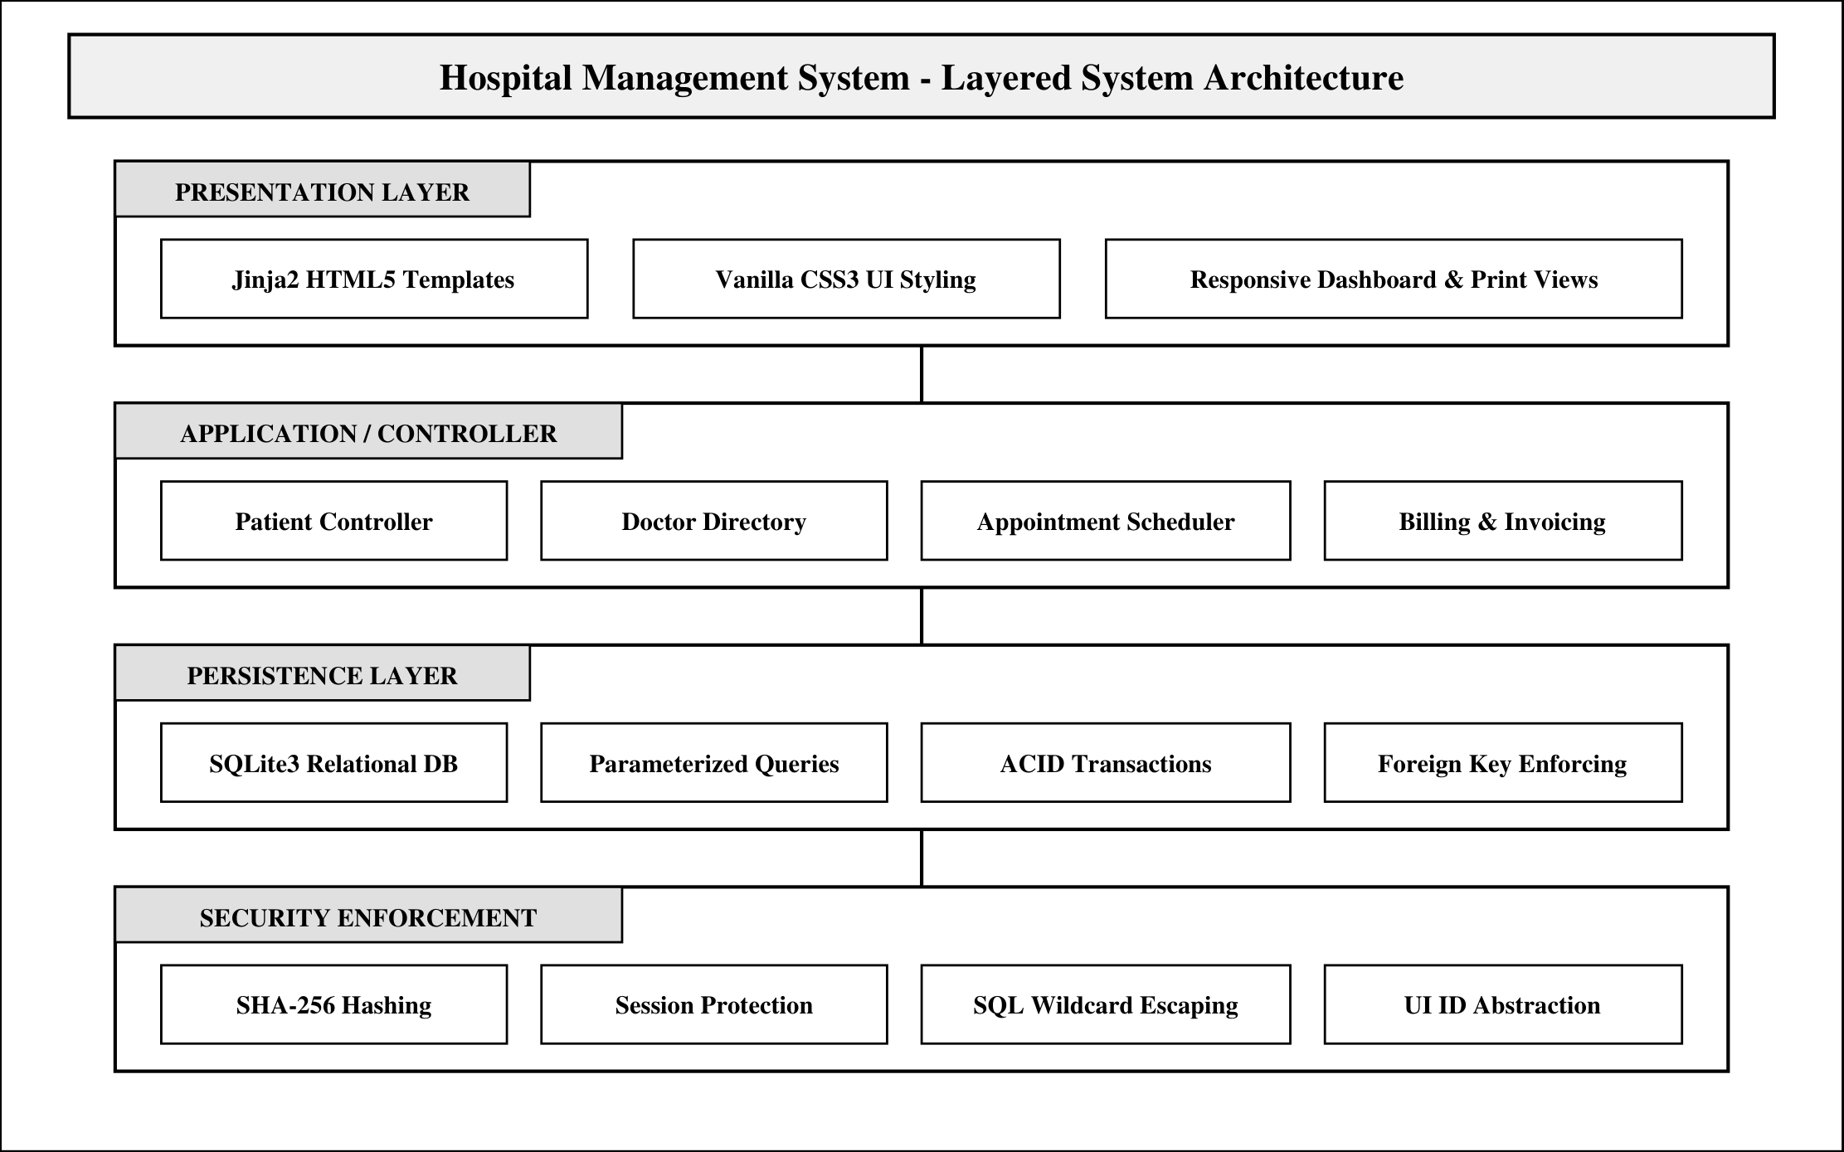
Figure 3.1: Four-tier layered system architecture diagram

3.3 ADVANTAGES OF LAYERED ARCHITECTURE
Using a layered architecture provides several important benefits for this project:
• Modularity: Each part of the application (HTML, Python code, database) is kept separate, making it easy to understand and explain.
• Ease of Maintenance: Bugs or updates in one module (such as updating billing calculations) can be resolved without affecting other modules.
• Simple Testing: Functions and database queries can be tested individually to verify correctness.
• Reusability: Common templates (like base.html) and database helper functions are reused across multiple pages.
Chapter 4
SYSTEM DESIGN & DATABASE SPECIFICATIONS
4.1 USE CASE SPECIFICATIONS & ACTOR MATRIX
In this system, the primary user is the Hospital Administrator or Front Desk Receptionist who handles daily administrative tasks. The actor-action matrix below outlines the main use cases supported by the application:

Table 4.1: Actor and system use case specification matrix
Actor | Use Case | Action / Trigger | System Response
Administrator | Login | Enters username and password | Validates credentials; opens dashboard
Administrator | Add Patient | Enters patient details in form | Inserts record into database; displays success alert
Administrator | Search Patient | Types patient name or phone number | Displays matching patient records in table
Administrator | Add Doctor | Enters doctor name and specialty | Saves doctor in database directory
Administrator | Schedule Appointment | Selects patient, doctor, date, and time | Creates appointment record with status Scheduled
Administrator | Generate Bill | Selects patient and enters charges | Creates invoice and opens printable receipt view

Figure 4.1 illustrates the UML Use Case Diagram, showing the interactions between the Administrator actor and the main features of the system.
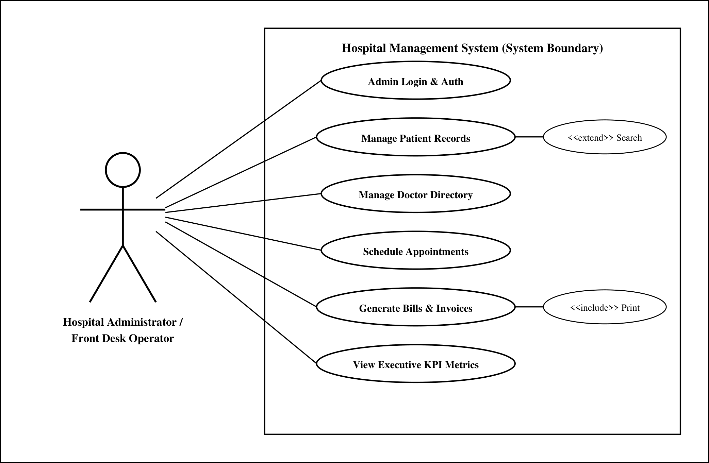
Figure 4.1: UML use case diagram for hospital administration

4.2 WORKFLOW LIFECYCLE & ACTIVITY FLOWCHART
An outpatient visit follows a standard sequence of steps from patient arrival to billing. Table 4.2 lists the workflow lifecycle, and Figure 4.2 illustrates the corresponding activity flowchart:

Table 4.2: Core activity and outpatient workflow lifecycle steps
Step No. | Workflow Stage | Operator Action | System Verification
1 | Patient Registration | Operator fills patient name, age, phone, address | Checks that name and phone are entered
2 | Appointment Booking | Operator chooses patient, doctor, date, and time | Verifies selected patient and doctor exist
3 | Doctor Consultation | Doctor conducts consultation and examination | Appointment status updated to Completed
4 | Billing & Receipt | Operator enters medical charges and generates bill | Calculates total and generates printable invoice

Figure 4.2 illustrates the outpatient workflow flowchart, tracing the process from administrator login to patient receipt generation.
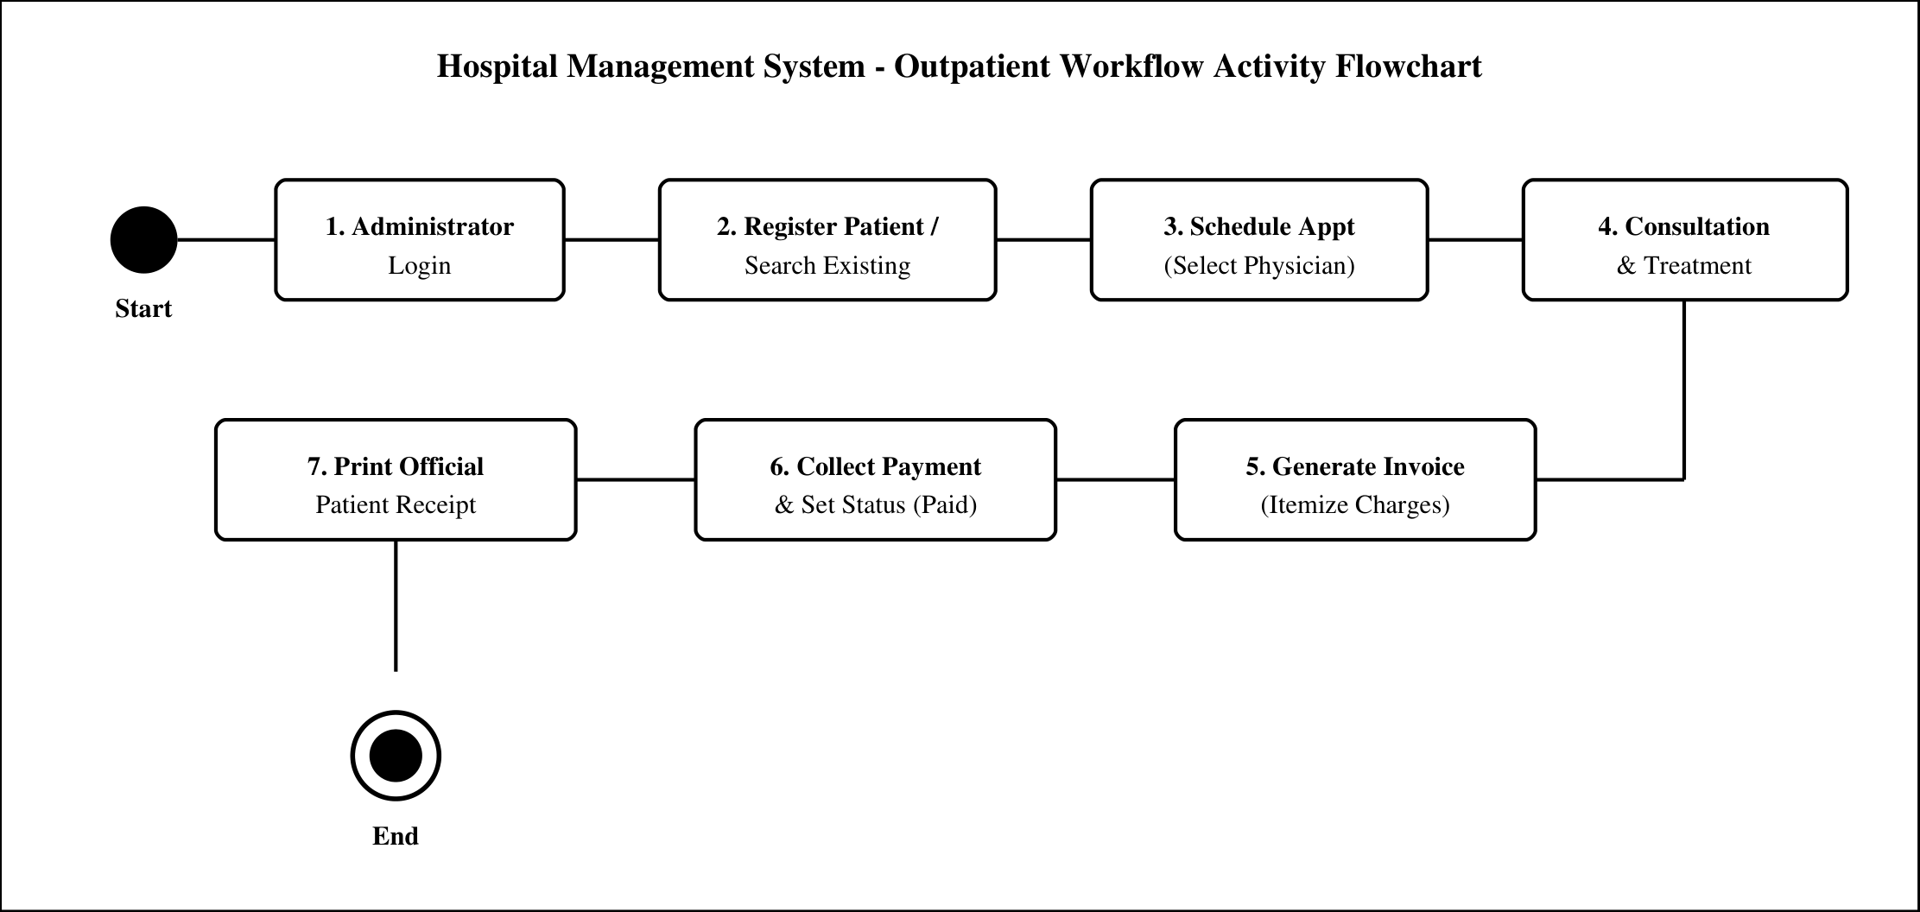
Figure 4.2: Outpatient workflow activity lifecycle flowchart

4.3 DATA FLOW DIAGRAM (DFD LEVEL 1)
A Data Flow Diagram (DFD) graphically depicts how data moves through the system, from external entities (Administrator) through processes (Registration, Scheduling, Billing) to internal data stores (Database Tables). Figure 4.3 shows the Level 1 DFD for the outpatient workflow:

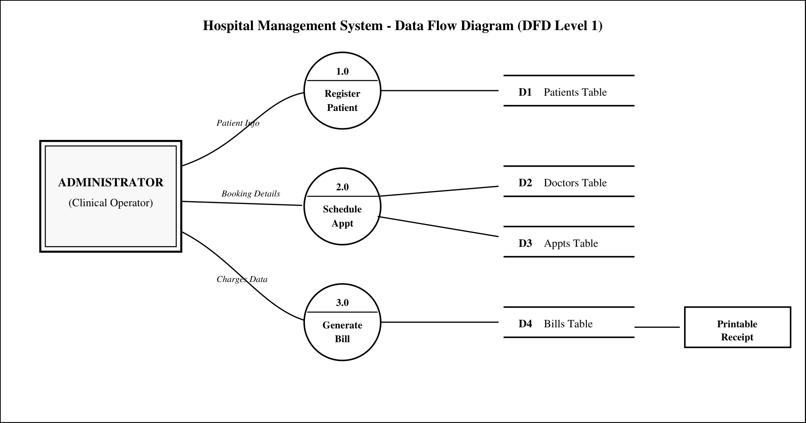
Figure 4.3: Data flow diagram (DFD Level 1) for outpatient workflow

4.4 DATABASE DESIGN & DATA DICTIONARIES
The relational database schema is stored in SQLite (hospital.db) and consists of five core tables designed according to database normalization principles (up to 3NF). Figure 4.4 illustrates the Entity-Relationship (ER) diagram, showing tables, primary keys (PK), foreign keys (FK), and relationships.
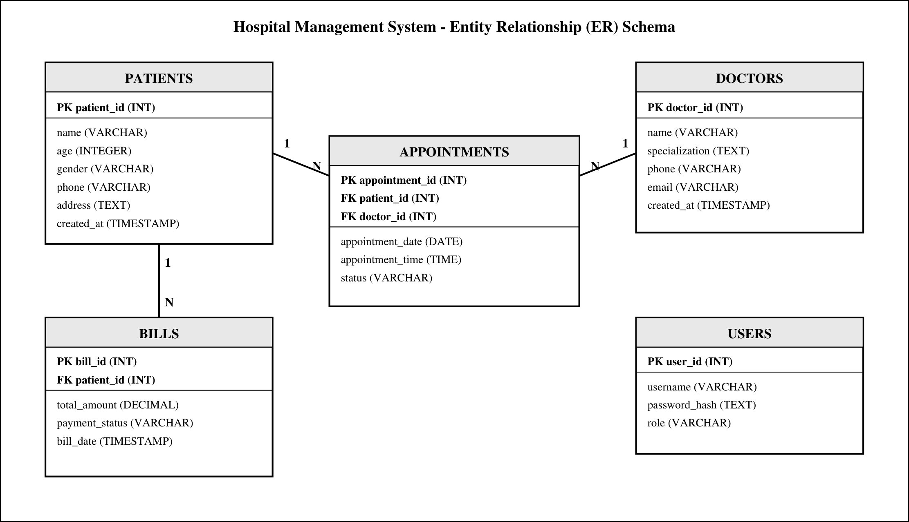
Figure 4.4: Entity-relationship (ER) diagram for database schema

4.4.1 Patients entity data dictionary
Table 4.3: Patients entity data dictionary (patients table)
Field Name | Data Type | Constraints | Description
patient_id | INTEGER | PRIMARY KEY AUTOINCREMENT | Unique identifier for patient
name | TEXT | NOT NULL | Full name of the patient
age | INTEGER | NOT NULL | Age of the patient in years
gender | TEXT | NOT NULL | Gender (Male, Female, Other)
phone | TEXT | NOT NULL | Contact phone number
address | TEXT | NOT NULL | Residential address of patient
created_at | TIMESTAMP | DEFAULT CURRENT_TIMESTAMP | Date and time of registration

4.4.2 Doctors entity data dictionary
Table 4.4: Doctors entity data dictionary (doctors table)
Field Name | Data Type | Constraints | Description
doctor_id | INTEGER | PRIMARY KEY AUTOINCREMENT | Unique identifier for doctor
name | TEXT | NOT NULL | Full name of the doctor
specialization | TEXT | NOT NULL | Medical specialty (Cardiology, Orthopedics, etc.)
phone | TEXT | NOT NULL | Contact phone number
email | TEXT | NOT NULL | Email address of doctor
created_at | TIMESTAMP | DEFAULT CURRENT_TIMESTAMP | Date and time of addition

4.4.3 Appointments entity data dictionary
Table 4.5: Appointments entity data dictionary (appointments table)
Field Name | Data Type | Constraints | Description
appointment_id | INTEGER | PRIMARY KEY AUTOINCREMENT | Unique appointment identifier
patient_id | INTEGER | FOREIGN KEY -> patients | Reference to patient
doctor_id | INTEGER | FOREIGN KEY -> doctors | Reference to assigned doctor
appointment_date | TEXT | NOT NULL | Scheduled date (YYYY-MM-DD)
appointment_time | TEXT | NOT NULL | Scheduled time slot (HH:MM)
status | TEXT | DEFAULT 'Scheduled' | Status (Scheduled, Completed, Cancelled)
4.4.4 Billing entity data dictionary
Table 4.6: Billing entity data dictionary (bills table)
Field Name | Data Type | Constraints | Description
bill_id | INTEGER | PRIMARY KEY AUTOINCREMENT | Unique invoice identifier
patient_id | INTEGER | FOREIGN KEY -> patients | Reference to patient billed
total_amount | REAL | NOT NULL | Total amount payable (INR)
payment_status | TEXT | DEFAULT 'Paid' | Payment status (Paid, Unpaid)
bill_date | TIMESTAMP | DEFAULT CURRENT_TIMESTAMP | Invoice creation timestamp
4.4.5 Users entity data dictionary
Table 4.7: Users entity data dictionary (users table)
Field Name | Data Type | Constraints | Description
user_id | INTEGER | PRIMARY KEY AUTOINCREMENT | Unique user account ID
username | TEXT | UNIQUE NOT NULL | Admin login username
password_hash | TEXT | NOT NULL | Secure SHA-256 hashed password
role | TEXT | DEFAULT 'admin' | User role (admin)
Chapter 5
SYSTEM IMPLEMENTATION & WORKING
5.1 TECHNOLOGY STACK & ENVIRONMENT SETUP
The project is developed using Python 3.12 with the Flask micro-framework and SQLite database. This stack provides high performance, clean code structure, and zero configuration requirements. Table 5.1 summarizes the technologies used:

Table 5.1: Software development stack and runtime environment
Layer | Tool / Library | Version | Role in HMS
Programming Language | Python | 3.12.0 | Core backend application development
Web Framework | Flask | 3.1.0 | URL routing, request handling, template rendering
Template Engine | Jinja2 | 3.1.4 | Dynamic HTML page generation
Database | SQLite | 3.45.0 | Embedded relational database storage
Frontend Styling | Vanilla CSS3 | Modern CSS | Custom styling and printable invoice layouts

5.2 ADMIN AUTHENTICATION MODULE
The authentication module ensures that only authorized hospital staff can access administrative pages. When an administrator enters their username and password at the `/login` page, the system hashes the entered password using SHA-256 and compares it against the stored hash in the database. If credentials match, a secure session is created. If an unauthorized user attempts to open an internal page directly, the system automatically redirects them back to the login page.
5.3 PATIENT RECORDS MANAGEMENT MODULE
The Patient module allows staff to register new patients by entering their name, age, gender, phone number, and address. Once submitted, a new record is stored in the database. The patient directory displays all registered patients in a clean table with options to edit details or view history. A built-in search bar allows the receptionist to quickly find any patient by typing their name or phone number.
5.4 DOCTOR DIRECTORY MODULE
The Doctor module maintains records of all doctors working in the hospital. The administrator can add doctors along with their medical specialties (e.g., General Medicine, Pediatrics, Cardiology, Orthopedics) and contact details. The list of active doctors is automatically used to populate doctor dropdown menus when booking patient appointments.
5.5 APPOINTMENT SCHEDULING MODULE
The Appointment module links patients with doctors for specific consultation dates and times. The receptionist selects the patient, chooses the doctor from a dropdown list, and picks the appointment date and time slot. The appointments table lists upcoming appointments with clear status indicators (Scheduled, Completed, or Cancelled). Once a patient is seen by the doctor, the receptionist updates the status to Completed.
5.6 BILLING & INVOICE GENERATION MODULE
The Billing module generates official patient invoices. The receptionist selects the patient, enters the consultation and treatment charges, and records the payment status (Paid or Unpaid). Once created, clicking 'Print Receipt' opens a clean, formal invoice view formatted specifically for paper printing, hiding web navigation bars so it can be directly handed to the patient.
5.7 EXECUTIVE DASHBOARD & METRICS
The Dashboard serves as the central control panel for the hospital administrator. Upon logging in, the dashboard immediately displays four summary statistics: Total Patients Registered, Active Doctors, Scheduled Appointments, and Total Invoices Generated. Quick action buttons allow the operator to jump directly to adding a patient, booking an appointment, or generating a bill.
Chapter 6
CONCLUSION & FUTURE ENHANCEMENTS
6.1 PROJECT SUMMARY & ACHIEVEMENTS
The Hospital Management System successfully achieves all stated project objectives. It replaces slow, error-prone manual paper registers with an efficient, easy-to-use digital system. By centralizing patient records, doctor directories, appointment bookings, and billing in a single web-based platform, the software helps clinic staff work faster and avoid clerical mistakes.
The system runs smoothly on standard computer hardware using lightweight open-source technologies (Python, Flask, and SQLite). The user interface is clean, responsive, and easy to navigate for hospital staff without requiring extensive technical training.
6.2 SCOPE FOR FUTURE WORK
While the current system fulfills all requirements for a 5th-semester BCA minor project, several practical enhancements can be added in future iterations:
• SMS and Email Alerts: Sending automated appointment reminders and billing receipts to patients via SMS or email.
• Pharmacy and Medicine Inventory: Tracking medicine stock levels, expiry dates, and automated prescription billing.
• Online Patient Portal: Allowing patients to view their appointment history and download bills from home.
• Multi-User Role Permissions: Creating separate restricted logins for doctors, receptionists, and pharmacists.
• Online Payment Integration: Adding UPI and card payment gateways (such as Razorpay or Paytm) for cashless settlements.
REFERENCES & BIBLIOGRAPHY
[1] Grinberg, M. (2018). Flask Web Development: Developing Web Applications with Python (2nd ed.). O'Reilly Media.
[2] Silberschatz, A., Korth, H. F., & Sudarshan, S. (2019). Database System Concepts (7th ed.). McGraw-Hill Education.
[3] Sommerville, I. (2015). Software Engineering (10th ed.). Pearson Education.
[4] Python Software Foundation. (2024). Python 3.12 Documentation. Available at: https://docs.python.org/3/
[5] Pallets Projects. (2024). Flask Documentation (Version 3.1.x). Available at: https://flask.palletsprojects.com/
[6] SQLite Development Team. (2024). SQLite Database Documentation. Available at: https://www.sqlite.org/docs.html
[7] World Wide Web Consortium (W3C). (2023). HTML5 & CSS3 Standards Specification. Available at: https://www.w3.org/
[8] Stallings, W. (2017). Cryptography and Network Security: Principles and Practice (7th ed.). Pearson.

