**Python Tasks – Day11**

1. **Write Python Code to print these patterns**

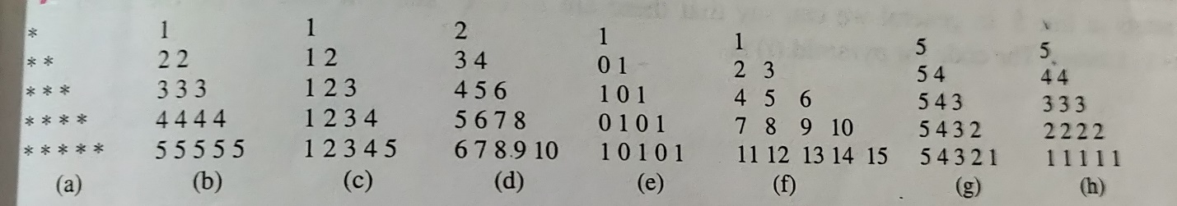

**Ans:**

n = **int**(input("Enter the number of rows"))

**for** i in range(0, n):

**for** j in range(0, i + 1):

print("* ", end="")

print()

rows = **int**(input("Enter the number of rows: "))

**for** i in range(rows+1):

**for** j in range(i):

print(i, end=" ")

print(" ")

c)

rows = **int**(input("Enter the number of rows: "))

**for** i in range(1, rows+1):

**for** j in range(1, i + 1):

print(j, end=' ')

print("")

d)

n = 2

for i in range(1, 5):

for j in range(1, i+1):

print(n, end="")

n = n * 10 + 2

print()

**e)**

n = 5

for i in range(1, n+1):

for j in range(i):

if j % 2 == 0:

print("1", end="")

else:

print("0", end="")

print()

**f)**

n = 5

num = 1

for i in range(1, n+1):

for j in range(i):

print(num, end="")

num += 1

print()

**g)**

**for i in range(5, 0, -1):**

**for j in range(5, i - 1, -1):**

**print(j, end='')**

**print()**

**h)**

**for i in range(5, 0, -1):**

**for j in range(i, 6):**

**print(i, end='')**

**print()**

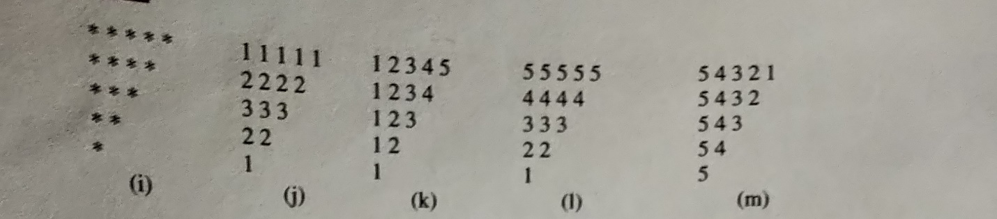

**i)**

rows = **int**(input("Enter the number of rows: "))

**for** i in range(rows + 1, 0, -1):

**for** j in range(0, i - 1):

print("*", end=' ')

print(" ")

j)

for i in range(1, 6):

for j in range(i, 6):

print(i, end='')

print()

k)

for i in range(4, 0, -1):

for j in range(1, i + 1):

print(j, end='')

print()

l)

for i in range(5, 0, -1):

for j in range(i, 0, -1):

print(i, end='')

print()

m)

for i in range(5, 0, -1):

for j in range(5, i-1, -1):

print(j, end='')

print()

1. **Write Python Code to print these patterns**

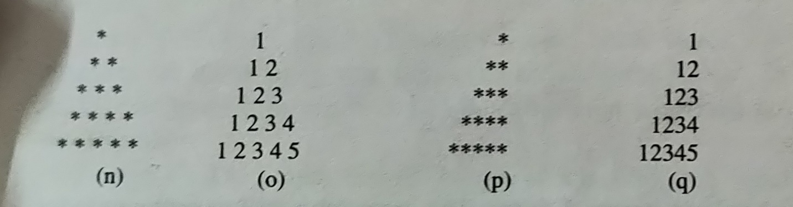

**n)**

rows = **int**(input("Enter the number of rows:"))

k = 2 * rows - 2  # It is used **for** number of spaces

**for** i in range(0, rows):

**for** j in range(0, k):

print(end=" ")

k = k - 2

**for** j in range(0, i + 1):

print("* ", end="")

print("")

o)

**n = 5**

**for i in range(1, n + 1):**

**pattern = ''**

**for j in range(1, i + 1):**

**pattern += str(j)**

**print(pattern.center(2 * n - 1))**

**p)**

rows = **int**(input("Enter the number of rows: "))

**for** i in range(rows + 1, 0, -1):

**for** j in range(0, i - 1):

print("*", end=' ')

print(" ")

Q)

n = 5

for i in range(1, n + 1):

pattern = ''

for j in range(1, i + 1):

pattern += str(j)

print(pattern.rjust(n))

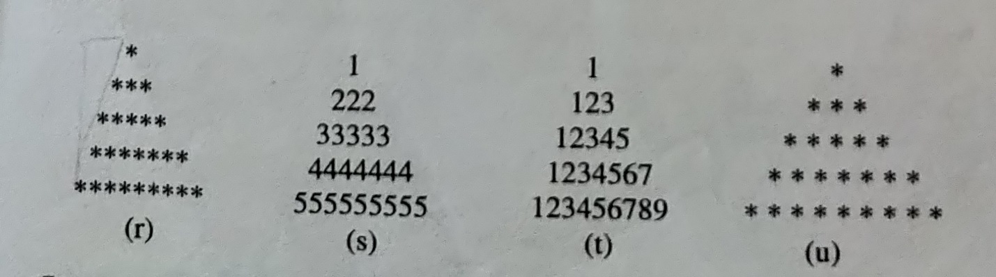

r)

n = **int**(input("Enter the number of rows: "))

m = (2 * n) - 2

**for** i in range(0, n):

**for** j in range(0, m):

print(end=" ")

m = m - 1

**for** j in range(0, i + 1):

print("* ", end=' ')

print(" ")

s)

rows = [1, 222, 3333, 4444444, 55555555]

for row in rows:

pattern = str(row)

print(pattern.center(len(str(rows[-1]))))

t)

rows = [1, 123, 1234, 12345]

max_width = len(str(rows[-1]))

for row in rows:

pattern = str(row)

print(pattern.center(max_width))

u)

n = **int**(input("Enter the number of rows: "))

m = (2 * n) - 2

**for** i in range(0, n):

**for** j in range(0, m):

print(end=" ")

m = m - 1

**for** j in range(0, i + 1):

print("* ", end=' ')

print(" ")

1. **Write Python Code to print these patterns**

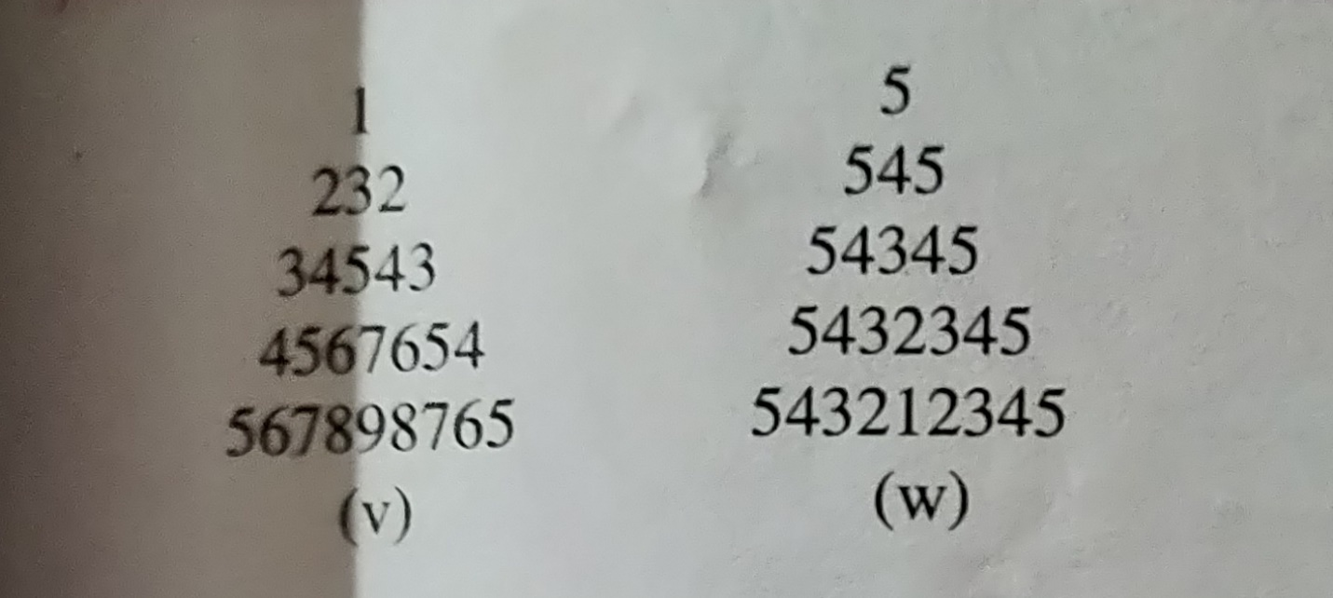

**v)**

**rows = [1, 232, 34543, 45676, 567898765]**

**max_width = len(str(rows[-1]))**

**for row in rows:**

**pattern = str(row)**

**print(pattern.center(max_width))**

**w)**

**rows = [5, 545, 54345, 5432345, 543212345]**

**max_width = len(str(rows[-1]))**

**for row in rows:**

**pattern = str(row)**

**print(pattern.center(max_width))**

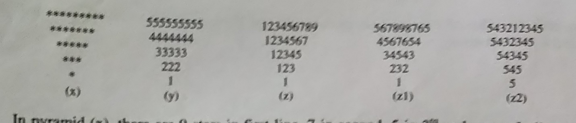

**x)**

rows = **int**(input("Enter the number of rows: "))

k = 2 * rows - 2

**for** i in range(rows, -1, -1):

**for** j in range(k, 0, -1):

        print(end=" ")

    k = k + 1

**for** j in range(0, i + 1):

        print("*", end=" ")

    print("")

y)

rows = [1, 222, 33333, 4444444, 555555555]

for row in reversed(rows):

pattern = str(row)

print(pattern)

z)

rows = [1, 123, 12345, 1234567, 123456789]

for row in reversed(rows):

pattern = ''

for i in range(1, row + 1, 2):

pattern += str(i)

print(pattern)

z1)

rows = [1, 232,34543,4567654,567898765]

for row in reversed(rows):

pattern = ''

for i in range(1, row + 1, 2):

pattern += str(i)

print(pattern)

z2)

rows = [5,545,54345,5432345,543212345]

for row in reversed(rows):

pattern = ''

for i in range(1, row + 1, 2):

pattern += str(i)

print(pattern)

1. **Write Python Code to print these patterns**

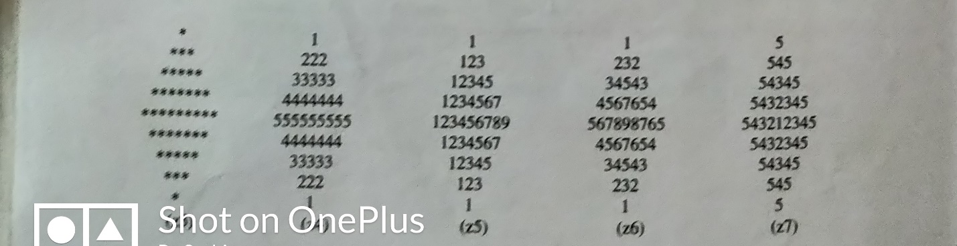

**Z3)**

rows = **int**(input("Enter the number of rows: "))

k = 2 * rows - 2

**for** i in range(0, rows):

**for** j in range(0, k):

print(end=" ")

k = k - 1

**for** j in range(0, i + 1):

print("* ", end="")

print("")

k = rows - 2

**for** i in range(rows, -1, -1):

**for** j in range(k, 0, -1):

print(end=" ")

k = k + 1

**for** j in range(0, i + 1):

print("* ", end="")

print("")

z4)

def diamondNumber(rows):

k1=1

k2=rows-1

#1St outer loop for each row in the upper half

for i in range(0,rows):

for j in range(0,rows):

if j>=k2:

print(i+1,end=”  “)

else:

print(” “,end=” “)

k2-=1

print()

for i in range(0,rows):

for j in range(0,rows):

if j>=k1:

print(rows-i-1,end=”  “)

else:

print(” “,end=” “)

k1+=1

print()

n=int(input(“Enter the number of Rows : “))

diamondNumber(n)

z5)

rows = [1, 123, 12345, 1234567, 123456789]

for row in rows:

pattern = ''

for i in range(1, row + 1, 2):

pattern += str(i)

print(pattern.center(len(str(rows[-1]))))

for row in reversed(rows[:-1]):

pattern = ''

for i in range(1, row + 1, 2):

pattern += str(i)

print(pattern.center(len(str(rows[-1]))))

z6)

rows = [1,232,34543,4567654,567898765]

for row in rows:

pattern = ''

for i in range(1, row + 1, 2):

pattern += str(i)

print(pattern.center(len(str(rows[-1]))))

for row in reversed(rows[:-1]):

pattern = ''

for i in range(1, row + 1, 2):

pattern += str(i)

print(pattern.center(len(str(rows[-1]))))

z7)

rows = [5,545,54345,543212345]

for row in rows:

pattern = ''

for i in range(1, row + 1, 2):

pattern += str(i)

print(pattern.center(len(str(rows[-1]))))

for row in reversed(rows[:-1]):

pattern = ''

for i in range(1, row + 1, 2):

pattern += str(i)

print(pattern.center(len(str(rows[-1]))))

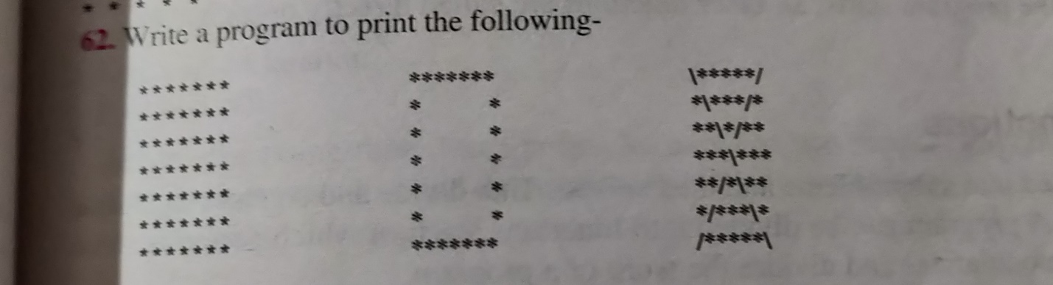

**a)**

size = 5

for i in range(0, size):

# Create a list of columns

for j in range(0, size):

print("*", end="")

print()

**b)**

size = 5

for i in range(size):

for j in range(size):

# print * completely in first and last row

# print * only in first and last position in other rows

if i == 0 or i == size - 1 or j == 0 or j == size - 1:

print('*', end='')

else:

print(' ', end='')

print()

**c)**

size = 5

for i in range(size):

for j in range(size):

# print * completely in first and last row

# print * only in first and last position in other rows

if i == 0 or i == size - 1 or j == 0 or j == size - 1:

print('*', end='')

else:

print(' ', end='')

print()

1. **Write Python Code to print these patterns**

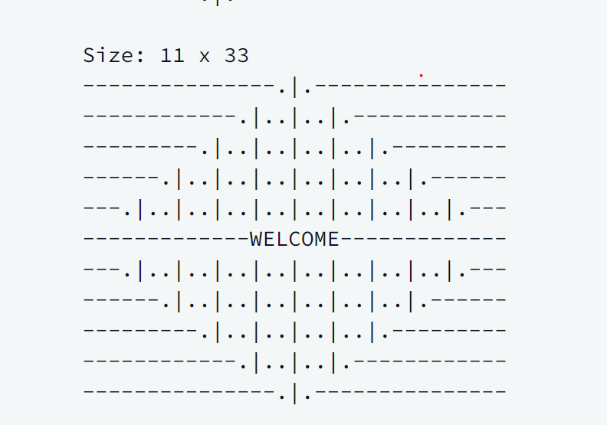

n,m= map(int,input().split())

center = n//2

count = -1

for i in range(0,n):

if i == center:

count += 2

pattern = 'WELCOME'

print(pattern.center(m,'-'))

elif i < center:

count += 2

pattern = '.|.' * count

print(pattern.center(m,'-'))

elif i > center:

count -= 2

pattern = '.|.' * count

print(pattern.center(m,'-'))

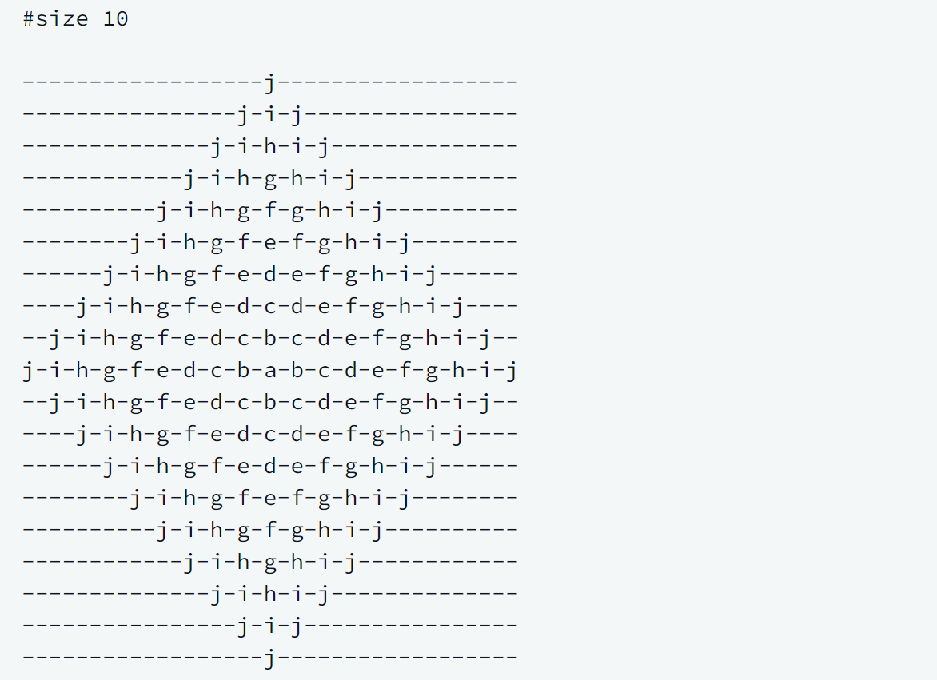

def print_rangoli(size):

# your code goes here

n=size

l1=list(map(chr,range(97,123)))

x=l1[n-1::-1]+l1[1:n]

m=len('-'.join(x))

for i in range(1,n):

print('-'.join(l1[n-1:n-i:-1]+l1[n-i:n]).center(m,'-'))

for i in range(n,0,-1):

print('-'.join(l1[n-1:n-i:-1]+l1[n-i:n]).center(m,'-'))

if __name__ == '__main__':

n = int(input())

print_rangoli(n)