Process & Decision Documentation
Emily Sharpe – 21074681
Side quest week 3

Project/Assignment Decisions
One key decision in this assignment was simplifying the gameplay mechanic to a single coin-flip interaction. Instead of implementing multiple game mechanics, I focused on a clear win/lose outcome triggered by a single user action. This allowed me to prioritize understanding and correctly implementing game states, screen routing, and UI feedback, which aligned more closely with the learning goals of Week 3.

Side Quests and A4 (Individual Work)
Keep this section brief, typically 2 to 4 sentences.
Focus on:
- One significant decision or change you made
- Why you made it
- What effect it had on the work
Examples:
- Simplifying a mechanic so it functioned correctly
- Changing an approach after something failed
- Deciding not to pursue an idea due to time or technical limitations
You are not expected to document every alternative or iteration

Role-Based Process Evidence
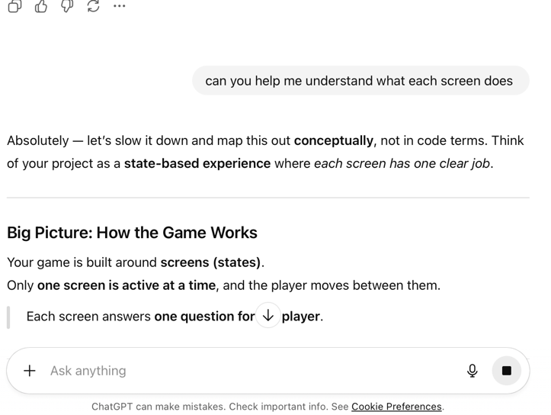

GenAI was used as a support tool during development to help plan screen flow, clarify game-state structure, and troubleshoot implementation issues in p5.js. All design decisions, coding, and visual styling were implemented and evaluated manually.

Entry Header
Name: Emily Sharpe
Role(s): designer & developer
Primary responsibility for this work: Designing and implementing the visual interface, screen flow, and interaction logic for the Heads or Tails game

Goal of Work Session
The goal of this work session was to implement a functional multi-screen p5.js project using game states, while refining the visual design of each screen to create a cohesive and playful user experience

Tools, Resources, or Inputs Used
- p5.js
- Lecture slides and Week 3 demo code
- Course notes on game states and screen routing
- ChatGPT (for debugging support and cosmetic iteration)

GenAI Documentation
Date Used: February 1st 2026
Tool Disclosure: ChatGPT (GPT-5.2)
Purpose of Use:
Used for debugging p5.js issues, clarifying game-state architecture, and iterating on cosmetic design decisions such as color schemes, button styling, and screen layout.
Summary of Interaction:
ChatGPT helped identify errors related to canvas-dependent variables, suggested clean ways to implement circular buttons, and supported iterative refinement of UI styling across screens.
Human Decision Point(s):
I evaluated and selectively applied suggestions, rejecting changes that would overcomplicate the interaction or go beyond the assignment scope. All final design and logic decisions were made manually.
Integrity & Verification Note:
All code changes were tested directly in the p5.js environment to confirm correctness. Visual decisions were reviewed against assignment requirements and lecture examples.
Scope of GenAI Use:
GenAI did not generate the full assignment or determine final design direction. It was used as a support tool for debugging and cosmetic refinement only.
Limitations or Misfires:
Some suggested solutions required adjustment to work correctly within the p5.js lifecycle, particularly regarding canvas-dependent variables such as width and height

Summary of Process (Human + Tool)
The process involved iteratively building each screen using the provided game-state architecture, then refining visual elements through testing and revision. I moved screen by screen, ensuring routing worked before adjusting colors, typography, and button styles. GenAI support was used intermittently to resolve bugs and validate design decisions, but the overall structure and pacing of the work was guided by course materials.

Decision Points & Trade-offs
A major trade-off was choosing simplicity over feature complexity. I removed unnecessary mechanics and focused on a single interaction to ensure the game states worked reliably. This decision reduced scope but improved clarity, usability, and alignment with the learning objectives

Verification & Judgement
I evaluated my decisions by repeatedly testing screen transitions, verifying visual consistency across screens, and comparing the final structure to the Week 3 demo architecture. I also checked that all interactions followed the intended user flow without unintended shortcuts.

Limitations, Dead Ends, or Open Questions

The project prioritizes structure and visual clarity over depth of gameplay. While additional mechanics or animations could be added, they were intentionally excluded to keep the scope appropriate for a Side Quest and to avoid introducing unnecessary technical complexity.

Appendix
Please include a full transcript of your conversation with the GenAI. GenAI transcripts are used for transparency and verification only and are not assessed for writing quality or completeness.
Note: If GenAI is used in another language, you must include both the original language and a translated transcript in the appendix

https://chatgpt.com/share/697f9353-01fc-800a-baa5-fdd34f31673d

