**Climate change data analysis based on World Bank Data**

Name : Ranaweera Mudiyanselage Kasuni Anuradha Ranaweera (21088776)

Link to my github repository :

For this investigation, seven nations from various continents were chosen, and the interrelationships of the following climate change parameters were investigated: total greenhouse gas emissions, forest area, arable land, rural and urban population (as a percentage of total), and GDP. The study discovered several correlations between the components, and the causes of these connections were studied as follows.

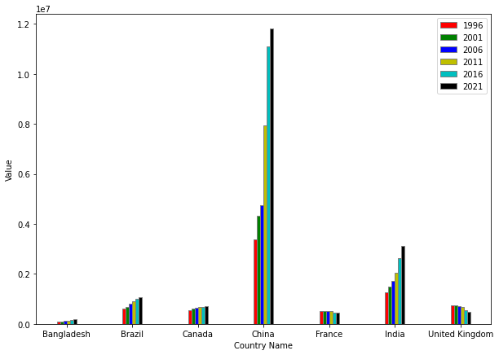

The above bar graph on greenhouse gas emissions by country was created using available data from 1996 to 2021 in five-year intervals. China is the largest producer of gases, with a rising trend with faster rates since the millennium's beginning, as shown in the GDP figure on the upper right. The rise in urban population is linked to increased gas emissions**.**

According to the correlation heatmap for China shown above, various factors contributed to economic expansion, and contemporary lifestyles resulted in increasing greenhouse gas emissions..

The "Greenhouse Gas Emissions" and "GDP" charts demonstrate that only Bangladesh has a little increase tendency, whereas all other nations analyzed have a major decrease trend. At the global level, China has the most dramatic declining trend.

This might be attributed to a number of causes, including an increase in urban population, as well as growing knowledge of the detrimental consequences of greenhouse gas emissions, which has led to a reduction in GDP.

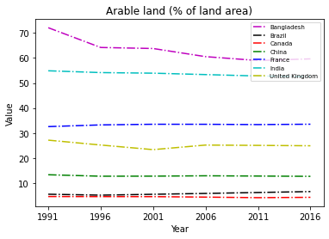

Because of the enormous surge in urban population development, Bangladesh's arable land has experienced a little decrease. Bangladesh's land area has shrunk, whereas France's arable land has increased somewhat.

In comparison, the forest area has not changed significantly, however in Bangladesh, the forest area appears to have declined, as shown by the plot on the right, which displays the ratio of the forest area to the total land area of the nations.

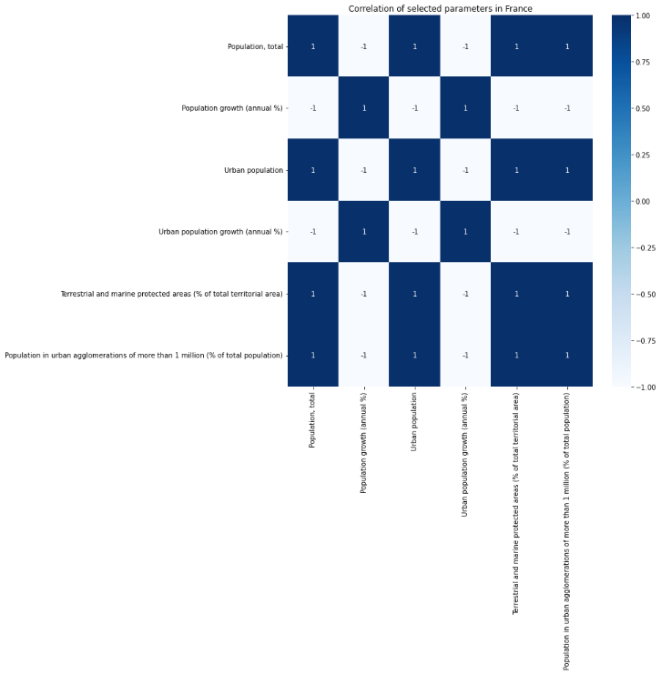

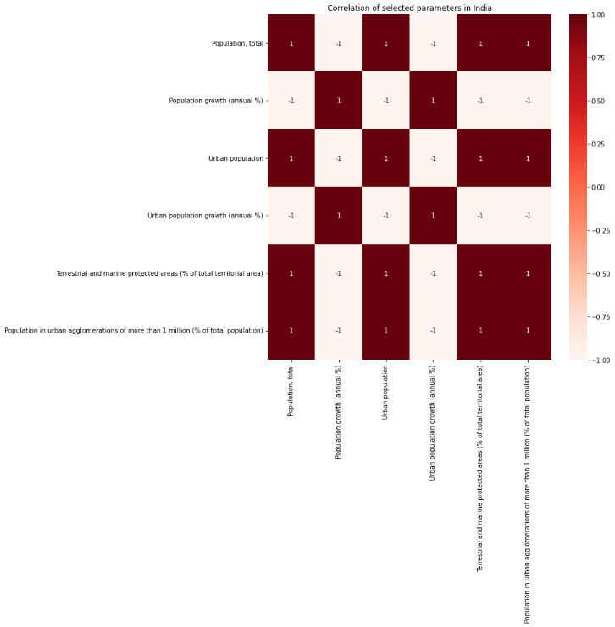

CO2 emissions in India are increasing significantly over time. The heatmap above shows that numerous areas of attention contributed to greenhouse gas emissions.

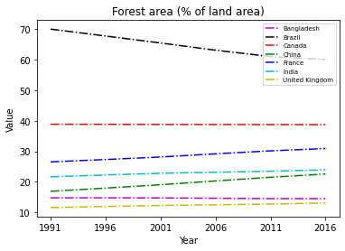

Greenhouse gas emissions are quite high in nations where forest acreage appears to be shrinking owing to deforestation. Deforestation to raise the country's GDP will have serious consequences for all living things.