AIT-524-003

Homework 10

ER Diagram:

Student Housing and Residence Life Database

1. Write a SQL code to join two tables using the WHERE statement. Explain what the query is intended to do.

***Retrieve student name and category along with his assigned supervisor phone no.***

1. Repeat problem 1 using the JOIN … USING keywords.

1. Repeat problem 1 using the JOIN … ON keywords.

1. Repeat problem 1 but add at least two conditions in the WHERE statement and use an arithmetic and a special operator. Use logical operators to combine multiple conditions. Explain what the query is intended to do.

***Retrieve student phone number with his first name and his assigned supervisor first name who is a male and an undergraduate.***

1. Repeat problem 2 but add two more conditions in the WHERE statement and use an arithmetic and a special operator which are different from the ones you used in the previous query. Use logical operators to combine multiple conditions. Explain what the query is intended to do.

***Retrieve dorm name and its price with the assigned supervisor id having dorm name starting with p or dorm price greater than 1000$.***

1. Repeat 1 using 3 tables.

***Retrieve name of student along with his admit, the service request he has put up with the service id.***

1. Repeat 6 using join.. using keywords.

***Retrieve name of student along with his admit, the service request he has put up with the service id using join..using keywords.***

1. Repeat 6 using join..on keywords.

***Retrieve name of student along with his admit, the service request he has put up with the service id using join..on keywords.***

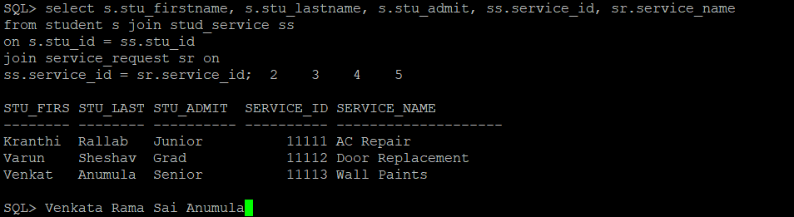

1. Repeat problem 4 but add two more conditions in the WHERE statement and use an arithmetic and a special operator which are different from the ones you used in the previous query. Use logical operators to combine multiple conditions. Explain what the query is intended to do.

***Retrieve student detail that include phone number, first name, category with the service he has request for and the unique service id given to student for the service where first name starts with V and he is a male.***

1. Write a SQL query that joins four tables using any type of join and uses both an arithmetic and special operator. Explain what the query is intended to do.

***Retrieve supervisor id, name and his assigned manager name and the type of dorm he has worked in whose first name starts with Vi or dorm number = 7778.***

