AIT-524-003

Homework Assignment 11

ER Diagram:

Student Housing and Residence Life Database

1 - 4. Write four SQL queries to join two or more tables where each query contains multiple nested single-row functions. Make sure to use different functions in each query. Explain what each query is intended to do.

***Retrieve the first name of supervisor in uppercase letters and the manager first name to whom he is working with, where first name of manager starts with uppercase letters and the rest are lowercase characters.***

2. ***Retrieve the substring of student labs for each admit type.***

3.

***Retreive the service name along with its unique id where the service name is separated by a ‘-‘.***

4.

***Retrieve the revised dorm prices if the amount of the increase will be based on following scale. Single Room 15%, double room 10%, triple room 25% showing dorm name, dorm location, dorm type, supervisor id for the dorm, original and revised prices.***

5. Write a query which is based on a single table and includes the GROUP B statement. Explain what the query is supposed to do.

***Retrieve the student’s last name, category of each student along with the number of supervisors associated with them.***

6. Repeat problem 5 but add the WHERE statement. Explain what the query is supposed to do.

***Retrieve the student’s last name, category of each student who is a Graduate along with the number of supervisors associated with them.***

7. Repeat problem 6 but add the HAVING statement. Explain what the query is supposed to do.

***Retrieve the student’s last name, category of each student who is a Graduate along with the number of supervisors associated with them are greater than equal to one.***

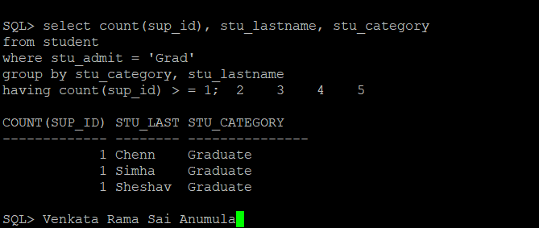

8. Write a query which is based on three tables and includes the GROUP BY, WHERE and HAVING statements. Explain what the query is supposed to do.

***Retrieve student’s first name and the service they have requested if he is Graduate or his first name is Varun having student category less than 2.***

9. Write an SQL query that uses the GROUP BY ROLL statement. Explain what the query is supposed to do.

***Retrieve sum of dorm price based on its location and dorm name and list out the subtotal of the dorm price based on location and its name using group by roll statement.***

10. Write an SQL query that uses the GROUP BY CUBE statement. Explain what the query is supposed to do.

***Retrieve sum of dorm price based on its location and dorm name and list out the subtotal of the dorm price based on location and its name using group by cube statement.***

