**AIT-524-003**

**Homework 5**

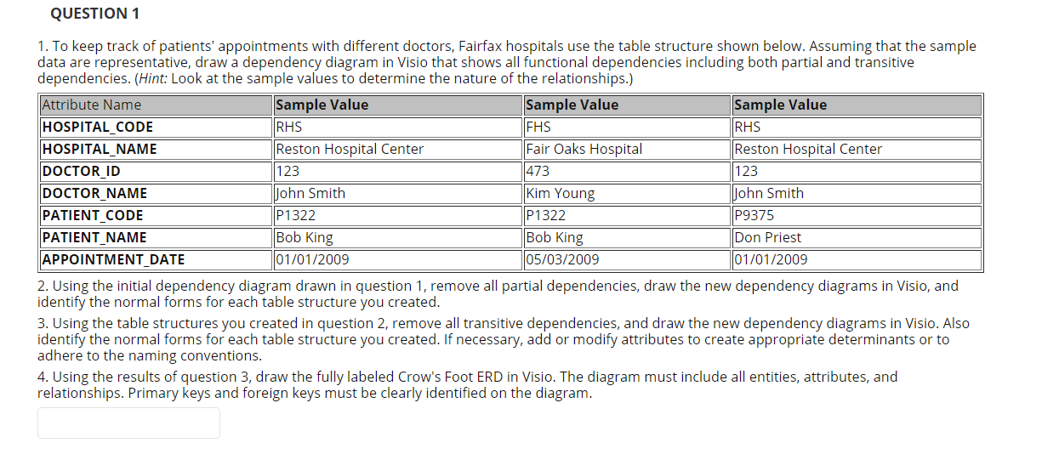

1. A screenshot of a cell phone

   Description automatically generated
2. Partial dependencies are removed, 2NF is achieved.

HOSPITAL TABLE, DOCTOR TABLE, HOSPITAL_DOCTOR TABLE.

HOSPITAL TABLE  
DOCTOR TABLE

HOSPITAL_DOCTOR TABLE

1. Now, transitive dependencies are removed. 3NF is achieved.

HOSPITAL TABLE  
DOCTOR TABLE  
PATIENT TABLE

DOCTOR_PATIENT TABLE(BRIDGING TABLE)

1. ERD Diagram.

