AIT-524-003

Homework 9

ER Diagram:

Student Housing and Residence Life Database:

Manager table:

Supervisor table:

Student table:

Service_Request table:

Stud_Service table:

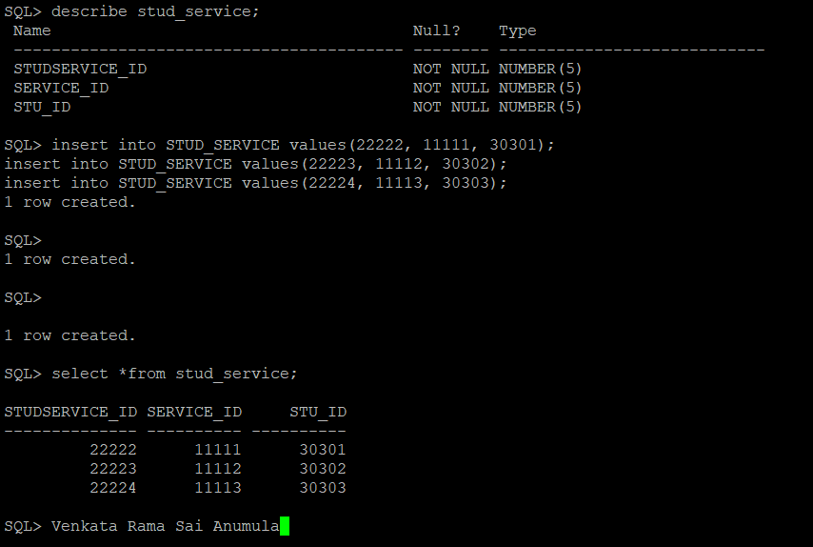

Dorm table:

Sup_Dorm table:

Undergraduate table:

Graduate table:

