Expense Reimbursement System

# Executive Summary

The Expense Reimbursement System (ERS) will manage the process of reimbursing employees for expenses incurred while on company time. All employees in the company can login and submit requests for reimbursement and view their past tickets and pending requests. Finance managers can log in and view all reimbursement requests and past history for all employees in the company. Finance managers are authorized to approve and deny requests for expense reimbursement.

**State-chart Diagram (Reimbursement Statuses)**

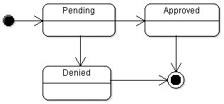

**Reimbursement Types**

Employees must select the type of reimbursement as: LODGING, TRAVEL, FOOD, or OTHER.

**Table Diagram**

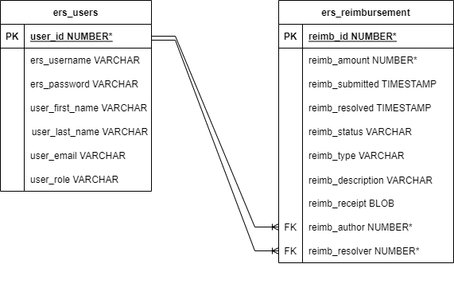

**Use Case Diagram**

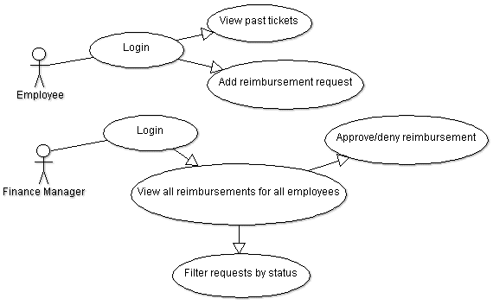

**Activity Diagram**

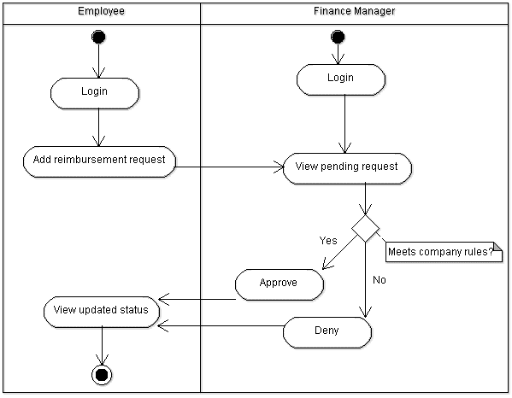

# Technical Requirements

* The back-end system shall connect to a Postgres database
* The backend shall also use Javalin technology for processing incoming HTTP requests and providing an appropriate HTTP response for each endpoint
* The front-end view can use HTML, CSS, and JavaScript (multi-page application) that uses the Fetch API to call server-side (backend) components
* Passwords shall be hashed and securely stored in the database
* Users can upload a document or image of their receipt when submitting reimbursements
* Logging using Logback should be utilized
* **Unit testing code coverage using JUnit 5 for the Service layer should achieve at least 80-90% coverage**
* **Selenium tests for all major functionality (logging in as a user, logging out, submitting a reimbursement, logging in as a finance manager, approving a reimbursement, denying a reimbursement) should be accomplished**