**MANUAL SUN_PROJECT**

1 Database 2

2 Main packages 4

3 Endpoints 5

3.1 City 5

3.1.1 Get the list of Ukrainian cities, supported by application 5

3.1.2 Add a new city with the following parameters: name, latitude, longitude 6

3.2 Eventtime 7

3.2.1 Retrieve sunrise time 7

3.2.2 Retrieve sunset time 8

3.2.3 Retrieve sunrise and sunset time 9

4 Unit tests 11

# 1 Database

Requered: MySql

Name database: testdb

Name database:

.. sun_project_1\src\main\resources\application.properties



This should be user data connection:

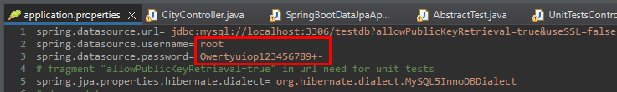

Table used: cities

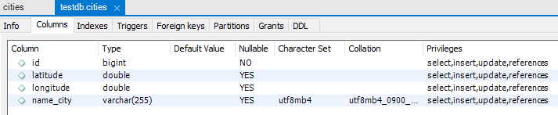

Data for testing:

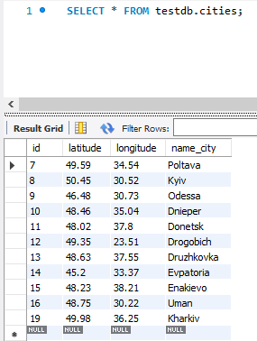

# 2 Main packages

* com.martynenko.spring.datajpa – contain main class of application – SpringBootDataJpaApplication.java;
* com.martynenko.spring.datajpa.controller – contain class-controller with api endpoints – CityController.java;
* com.martynenko.spring.datajpa.model – contain class-model of data – City.java;
* com.martynenko.spring.datajpa.repository – contain interface for operations with database – CityRepository.java;
* com.martynenko.spring.datajpa.response_model – contain class-models response external api (<https://sunrise-sunset.org/api>) – CommonModelExternalResponse.java includes instance of ModelDataResults.java.

# 3 Endpoints

## 3.1 City

### 3.1.1 Get the list of Ukrainian cities, supported by application

|  |  |
| --- | --- |
| Type | GET |
| Path link | /api/cities/all |
| Example link | http://localhost:8080/api/cities/all |
| Parameters | |
| No parameters |  |
| Responses | |
| Response content type | application/json |
| 200 | successful operation |
| 204 | app city list is empty |
| 500 | internal server error |
| Example value of response | {  "id": 35,  "nameCity": "Kharkiv",  "latCity": 49.98,  "longCity": 36.25  } |

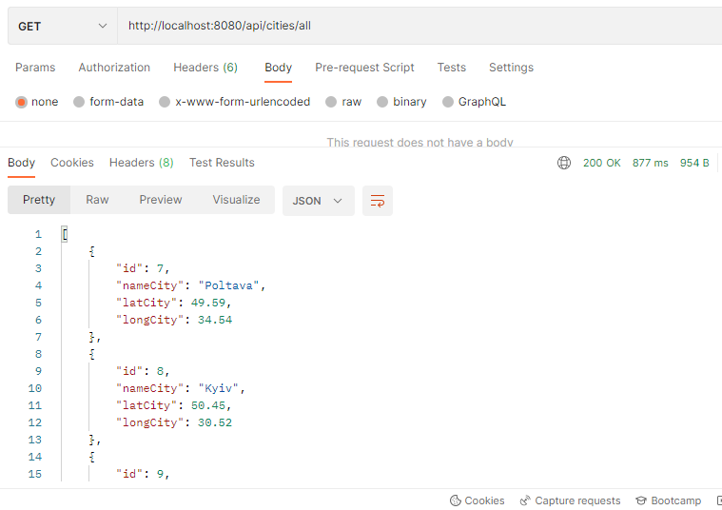

### 3.1.2 Add a new city with the following parameters: name, latitude, longitude

|  |  |
| --- | --- |
| Type | POST |
| Path link | /api/cities |
| Example link | http://localhost:8080/api/cities |
| Parameters | |
| nameCity (String) | the name of the added city |
| latCity(Float) | the latitude of the added city |
| longCity(Float) | the longitude of the added city |
| Example value of request | {  "nameCity": "test",  "latCity": 48.23,  "longCity": 38.21  } |
| Responses | |
| Response content type | application/json |
| 201 | successful created |
| 400 | parameter error |
| 500 | internal server error |
| Example value of response | {  "id": 36,  "nameCity": "test",  "latCity": 48.23,  "longCity": 38.21  } |

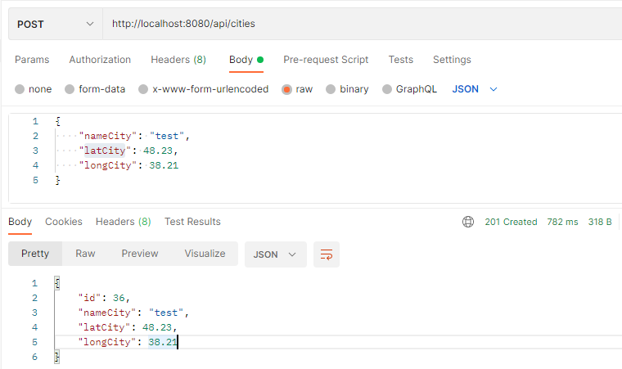

## 3.2 Eventtime

### 3.2.1 Retrieve sunrise time

|  |  |
| --- | --- |
| Type | GET |
| Path link | /api/cities |
| Example link | http://localhost:8080/api/cities?nameCities=Odessa,Donetsk&event=sunrise |
| Parameters | |
| nameCities (list of strings separated by comma) | list of cities |
| event (String) | event type (here must be “sunrise”) |
| Responses | |
| Response content type | application/json |
| 200 | successful operation |
| 204 | - parameter error;  - parameters are empty or not send;  - the application does not contain the city you are looking for;  - external service error. |
| 500 | internal server error |
| Example value of response | [  {  "typeEvent": "sunrise",  "nameCity": "Odessa",  "timeEvent": "2:02:21 AM"  },  {  "typeEvent": "sunrise",  "nameCity": "Donetsk",  "timeEvent": "1:27:09 AM"  }  ] |

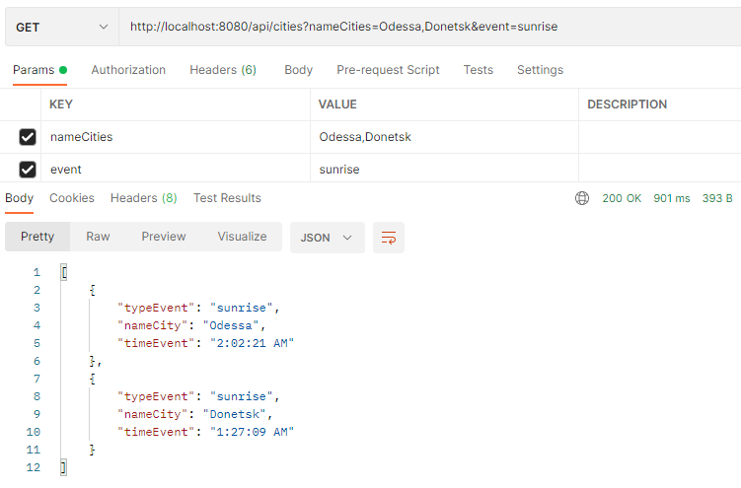

### 3.2.2 Retrieve sunset time

|  |  |
| --- | --- |
| Type | GET |
| Path link | /api/cities |
| Example link | http://localhost:8080/api/cities?nameCities=Odessa,Donetsk&event=sunset |
| Parameters | |
| nameCities (list of strings separated by comma) | list of cities |
| event (String) | event type (here must be “sunset”) |
| Responses | |
| Response content type | application/json |
| 200 | successful operation |
| 204 | - parameter error;  - parameters are empty or not send;  - the application does not contain the city you are looking for;  - external service error. |
| 500 | internal server error |
| Example value of response | [  {  "typeEvent": "sunset",  "nameCity": "Odessa",  "timeEvent": "5:55:22 PM"  },  {  "typeEvent": "sunset",  "nameCity": "Donetsk",  "timeEvent": "1:27:09 AM"  }  ] |

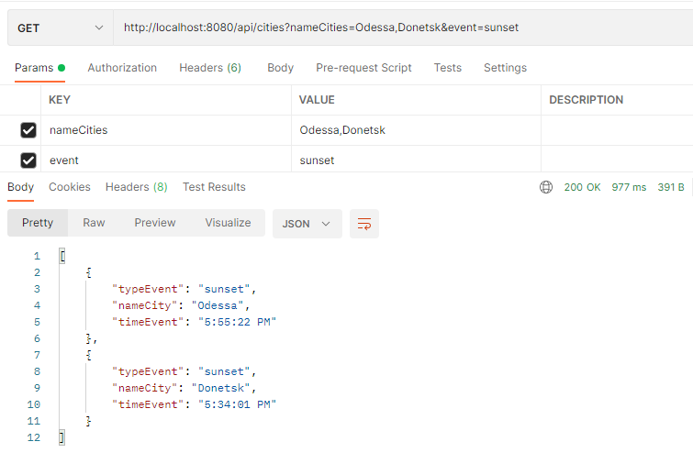

### 3.2.3 Retrieve sunrise and sunset time

|  |  |
| --- | --- |
| Type | GET |
| Path link | /api/cities |
| Example link | http://localhost:8080/api/cities?nameCities=Odessa,Donetsk&event=both |
| Parameters | |
| nameCities (list of strings separated by comma) | list of cities |
| event (String) | event type (here must be “both”) |
| Responses | |
| Response content type | application/json |
| 200 | successful operation |
| 204 | - parameter error;  - parameters are empty or not send;  - the application does not contain the city you are looking for;  - external service error. |
| 500 | internal server error |
| Example value of response | [  {  "timeSunriseEvent": "2:02:21 AM",  "timeSunsetEvent": "5:55:22 PM",  "typeEvent": "both",  "nameCity": "Odessa"  },  {  "timeSunriseEvent": "1:27:09 AM",  "timeSunsetEvent": "5:34:01 PM",  "typeEvent": "both",  "nameCity": "Donetsk"  }  ] |

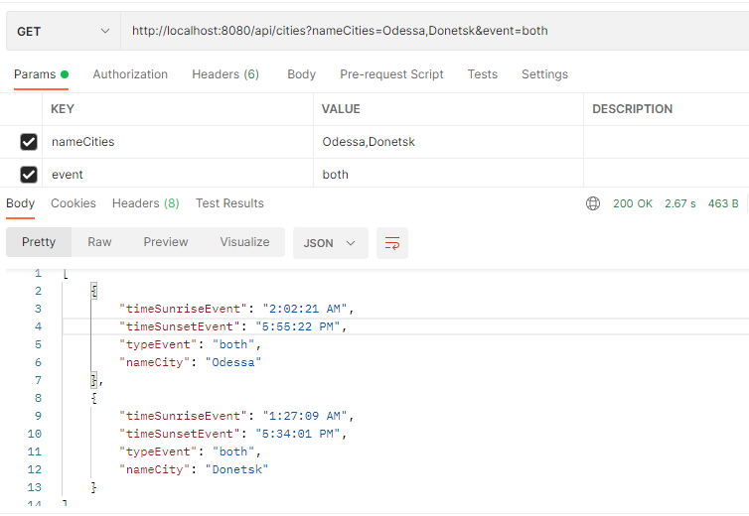

# 4 Unit tests

Package com.martynenko.spring.datajpa.repository contain class SpringBootDataJpaApplicationTests.java – testing repository operations.

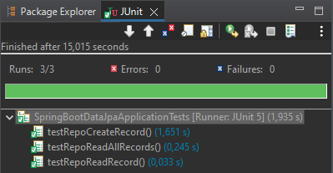

Package com.martynenko.spring.datajpa.controller contain classes: AbstractTest.java – convert string to java-object, UnitTestsController.java - testing endpoints.

