**BANGLADESH UNIVERSITY OF ENGINEERING AND TECHNOLOGY**



**Gate Driver Using HEMT GS66504B and ADuM4121A**

**Prepared by- Submitted to-**

Sagar Kumar Das **Dr.** **Cheng Zhang**

Ratul Kundu Lecturer,

MSc’22, BUET University of Manchester

**Supervised by-**

**Nadim Chowdhury Sir**

Assistant Professor, BUET

**Schematic Diagram:**

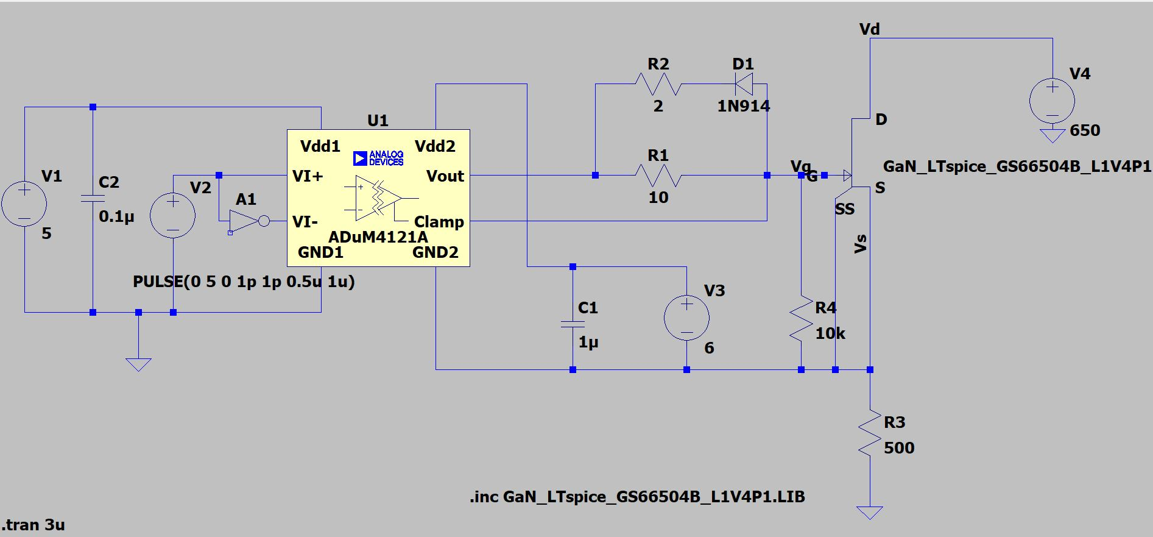

**Here,**

**VIN= 650V**

**Load Resistor = 500Ω**

**Switch_On_Current= $\frac{650}{500 }=1.3A$**

**VPulse**

**VGS**

**Output:**

At Switching Frequency = **500KHz**

Turning ON, $\frac{dv}{dt}=79.2 V/ns$ (approx.)

Turning OFF, $\frac{dv}{dt}=4.17 V/ns$ (approx.)

If, VGS=6 V 🡪 VDS=0V & I=1.3A

If, VGS=0V 🡪 VDS=650V & I=0A

**VGS VS Time:**

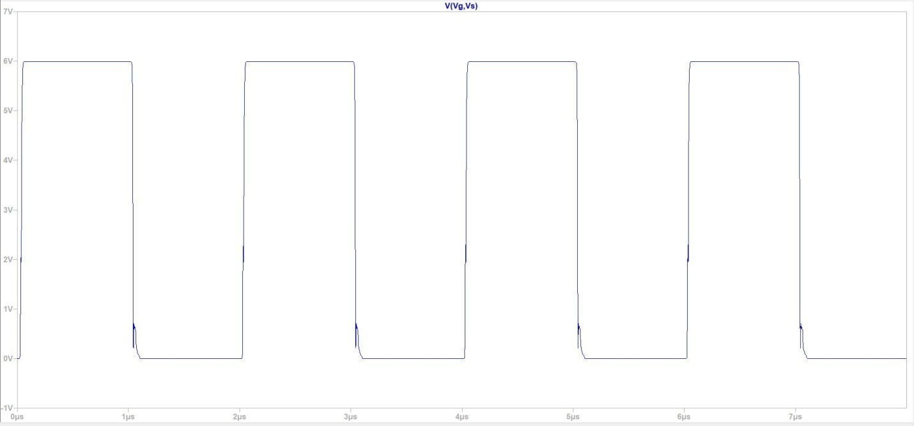

**VDS VS Time**

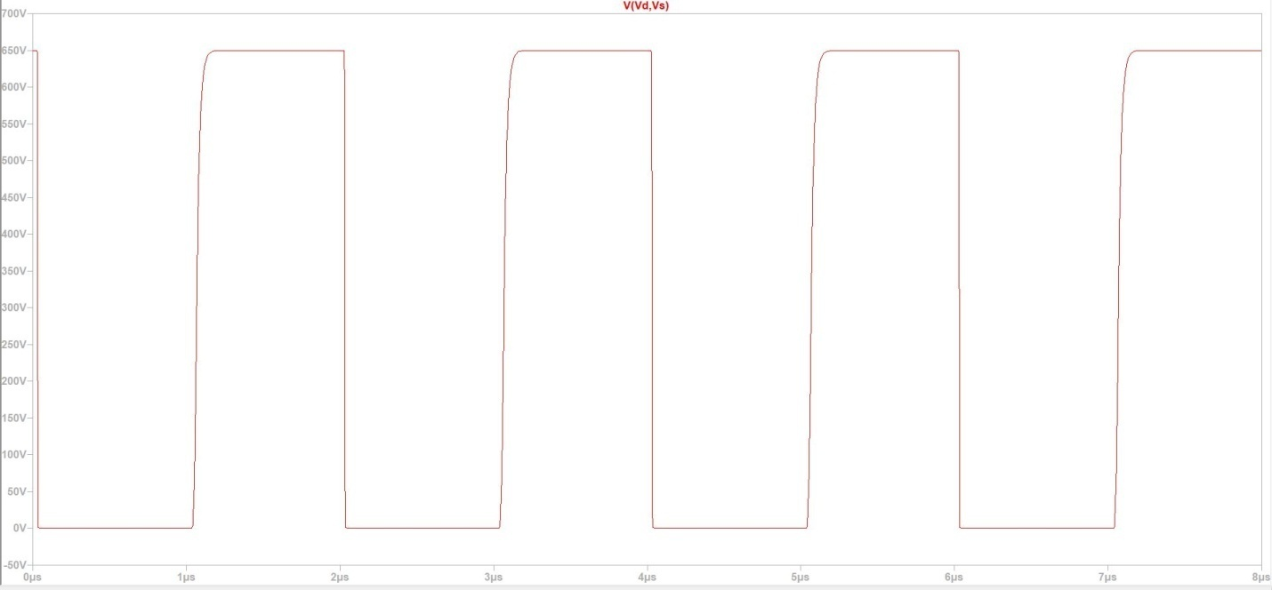

**VDS & Iload**

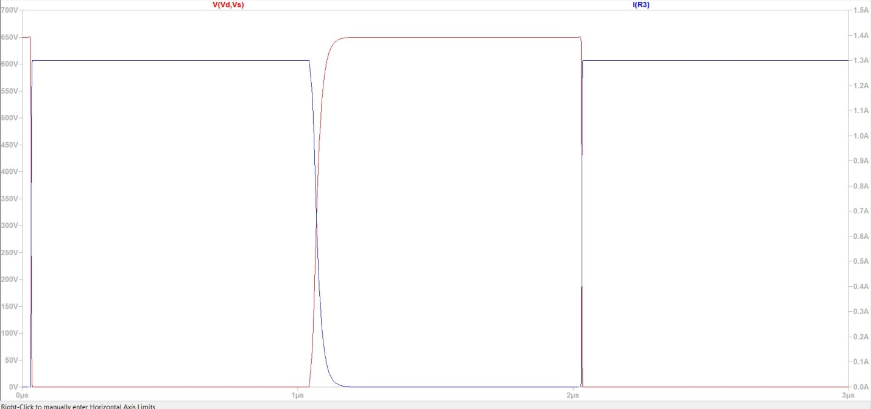

**Powerloss VS Time**

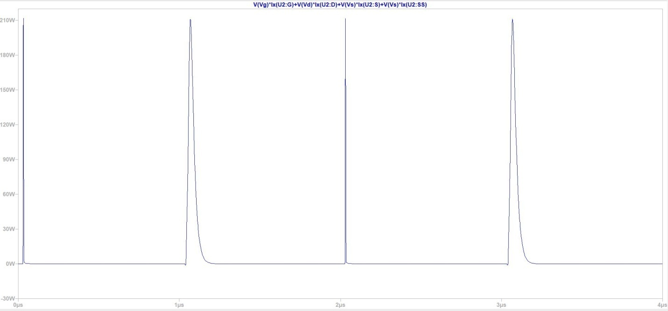

At Frequency = **1MHz**

Turning ON, $\frac{dv}{dt}=76.2 V/ns (approx.)$

Turning OFF, $\frac{dv}{dt}=4$**V/ns (approx.)**

If, VGS=6 V 🡪 VDS=0V & I=1.3A

If, VGS=0V 🡪 VDS=650V & I=0A

**VGS VS Time**

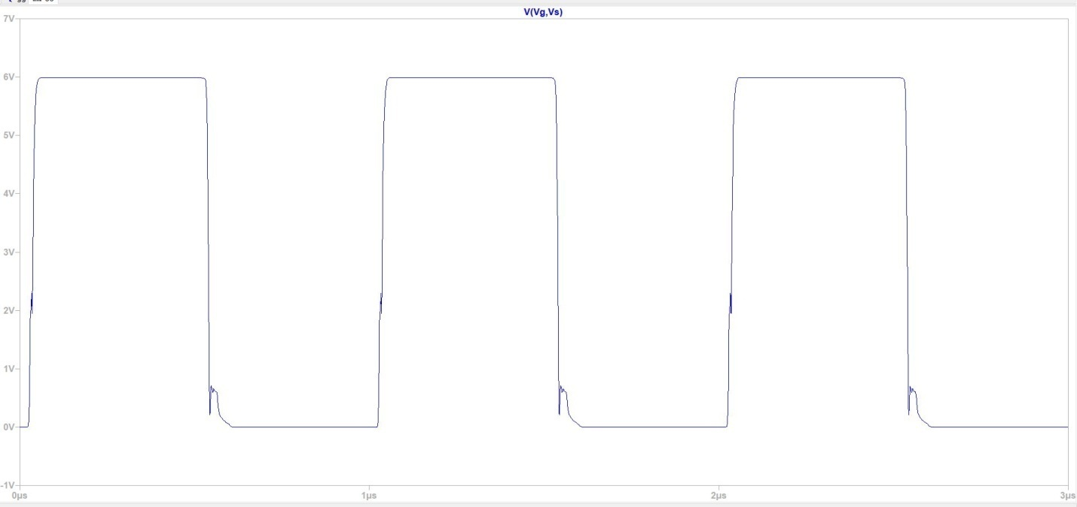

**VDS VS Time**

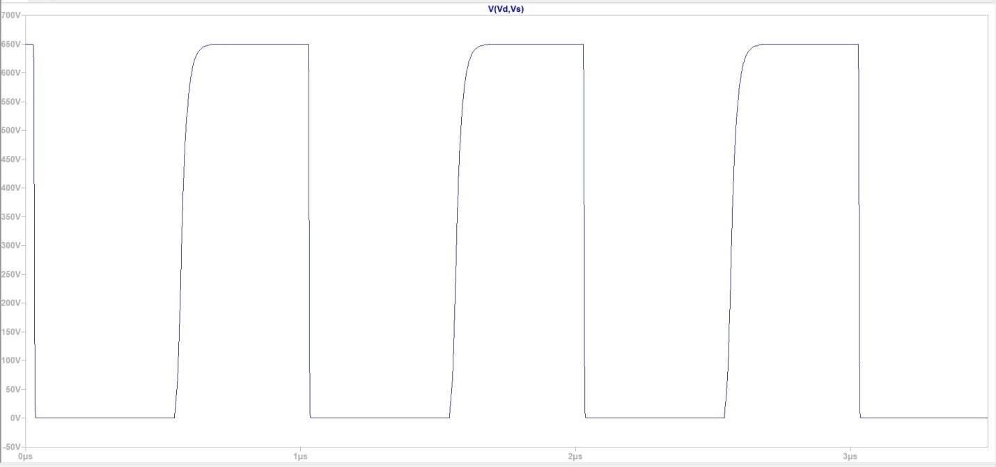

**VDS & ILoad**

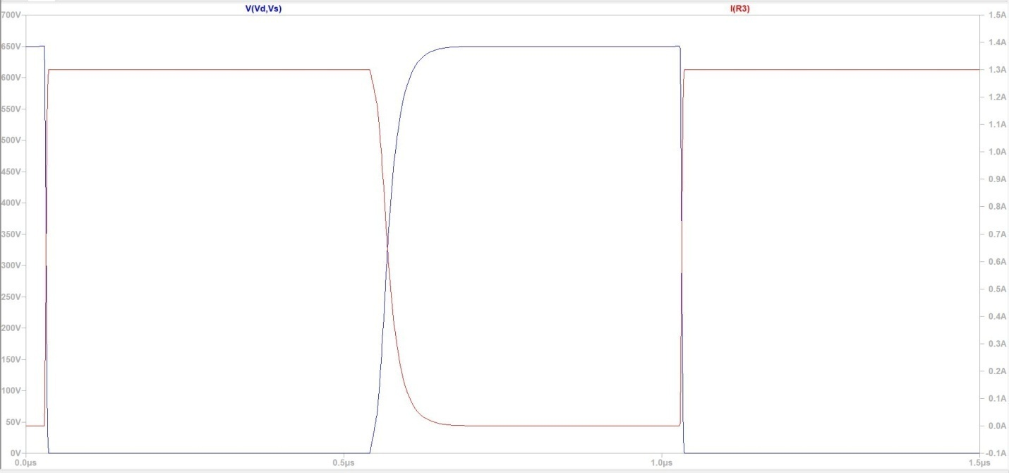

**Switching_power_losses VS Time**

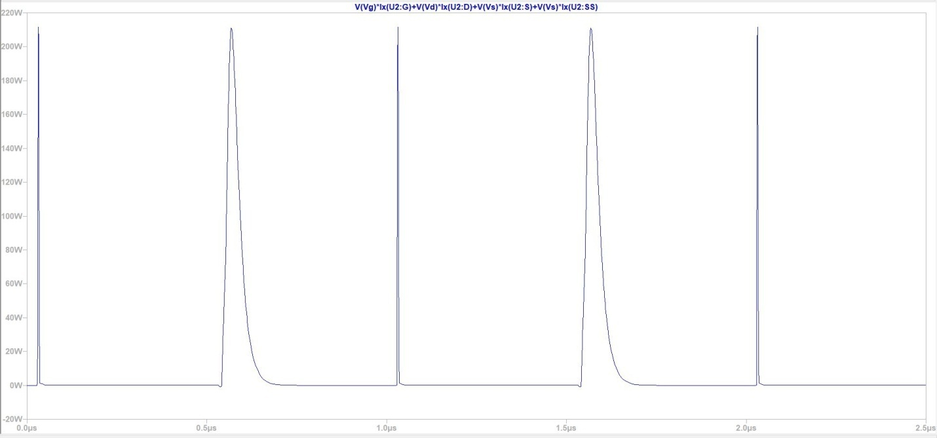

At Frequency= **10MHz**

Distorted output!!!

**VGS VS Time**

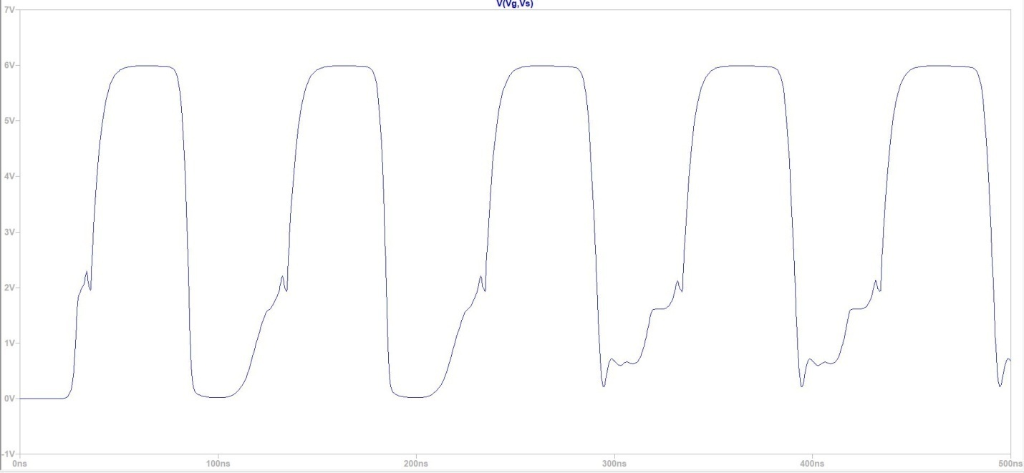

**VDS VS Time**

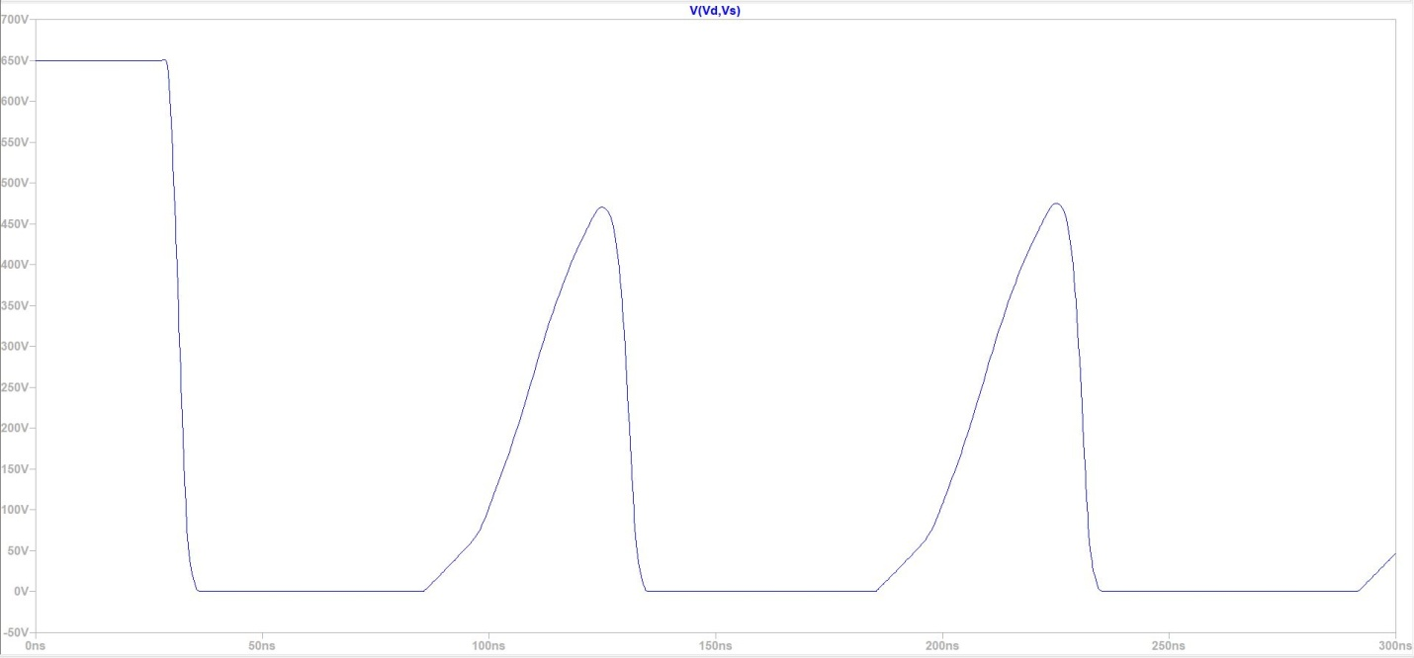

Switching_power_losses VS Time

