**BANGLADESH UNIVERSITY OF ENGINEERING AND TECHNOLOGY**



PCB Design of H-Bridge Circuit

**Prepared by-**

Sagar Kumar Das

MSc’22

BUET

Supervised by- Submitted to-

**Nadim Chowdhury Dr. Cheng Zhang**

Assistant Professor, BUETLecturer, University of Manchester

**Task**

Operating the circuit at higher frequencies &

PCB schematic drawing and the PCB layout of H-Bridge circuit with phase shifted PWM.

**Signal Generator connected H-Bridge:**

**HBridge_pwm_signal_generation.emf**

M1, M2, M3, M4 points are connected to the gate driver through VCVS with gain=5 that controls the gate to source voltage.

**At D=0.1 at f= 1MHz:**

**0.1d1m.emf**

Figure showing voltage across the output resistor with duty cycle 0.1

**At D=0.1 at f= 10MHz:**

**1m.emf**

**According to simulation on LTspice, this circuit works up to 1MHz. If frequency is over 1MHz (eg. 10MHz applied here), the circuit is not working well.**

**PCB Schematic:**

**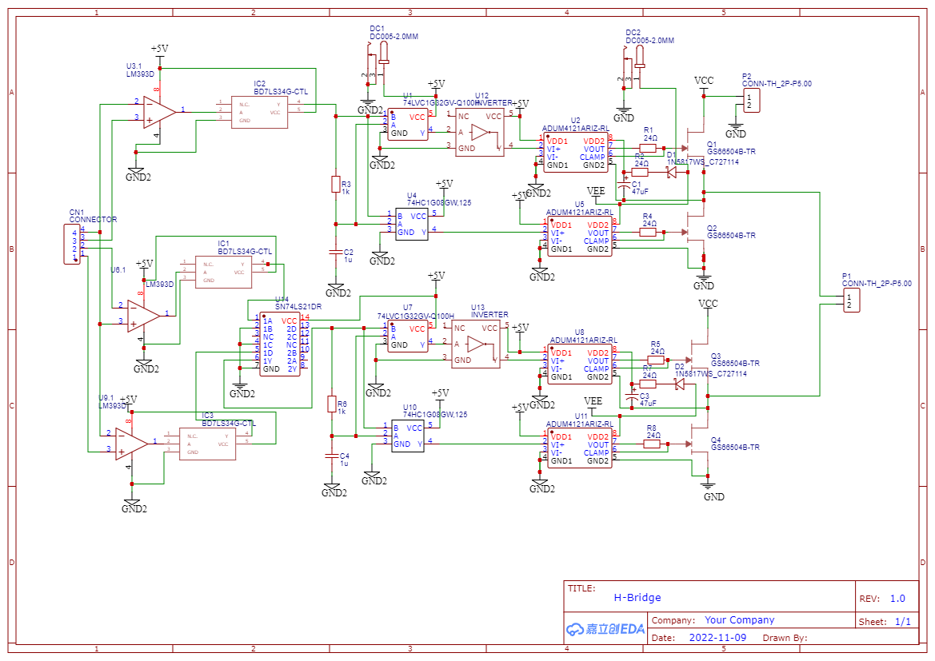**

This PCB schematic diagram is made in **EasyEDA online free software** instead of **Kicad** because of unavailibity of several footprints are missing in **Kicad** which are available in **EasyEDA** because of online software.

Though **working principle of Kicad and EasyEDA exactly same.**

**PCB Design:**

Top side:

**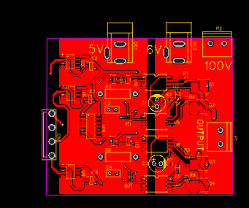**

Bottom side:

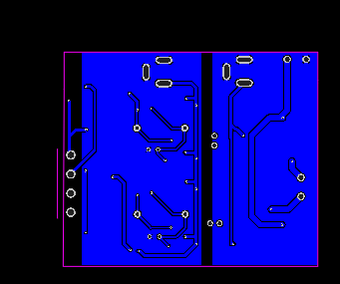

**2D view:**

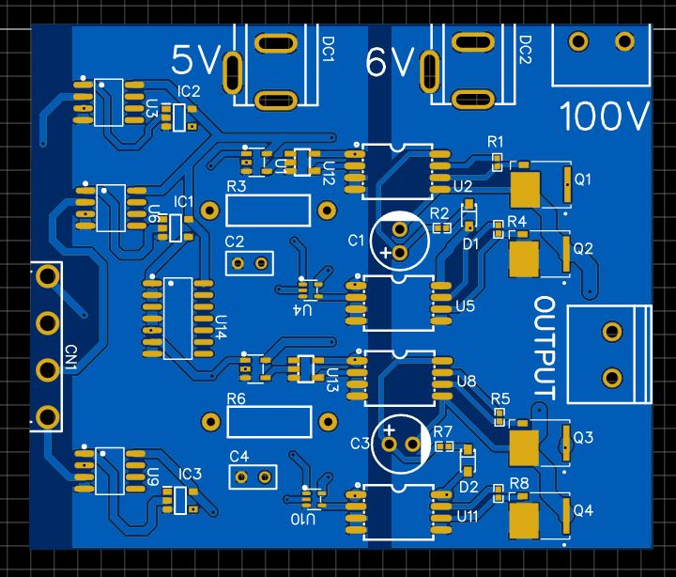

Left side and right side is isolated(separate ground).

**CN1 port for controlling voltage signal.**

**3D View:**

**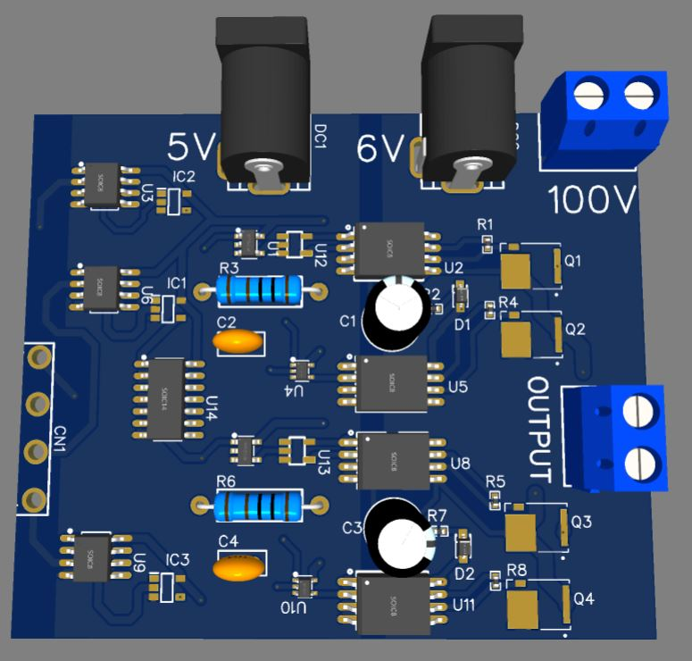**

**Here,**

**100Volt for Input of the GaN HEMT.**

**6Volt rail for supplying voltage to the gate drivers.**

**5Volt power rail for supplying voltage to the other IC’s.**

**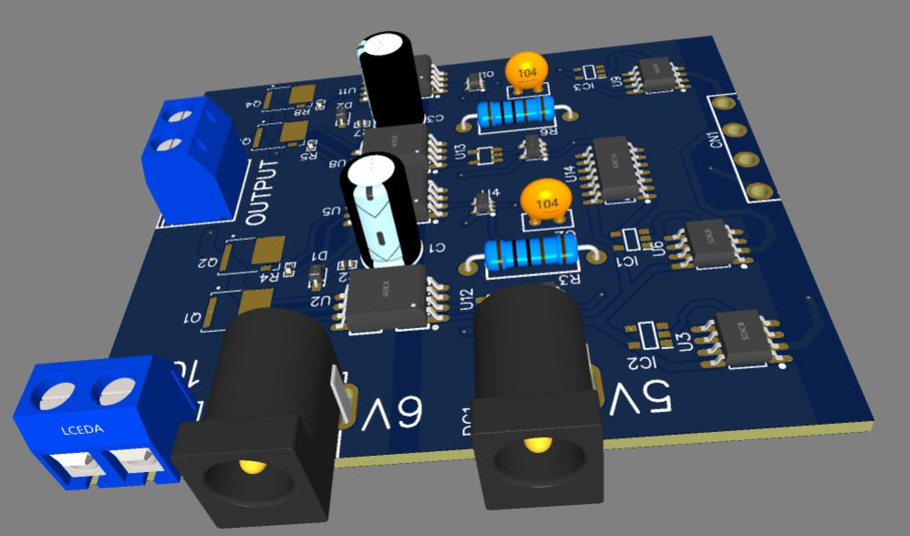**

**Bottom Side:**

**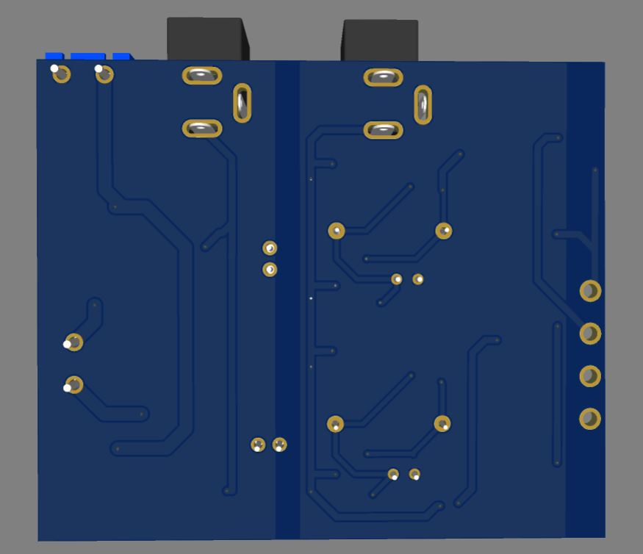**

**Summary:**

* In Kicad PCB designing software some footprints are not available. For being new in PCB design I felt devastated earlier for not getting the expected model.
* It’s also challenging to find suitable footprint for the expected PCB design.
* As ADuM4121 is a isolated gate driver and there are separate ground, previously mistakenly took single ground.
* Confused about how to power the IC’s, then got an idea to put some ports for the input voltages.

**Future Work:**

* This circuit’s PCB design is made on basis of simulation. In real circuit working some changes may be needed(eg. Values of resistor, capacitor etc).
* **ADuM4121( single driver $7.24)** which is **costly**, comparatively using **Si8271(single driver $3.93)** or **Si8273(double side driver $5.54)** is cheaper.