**G**ESTURE-**C**ONTTROLLED **S**MART **H**OME **I**NTERFACE WITH **R**EAL-**T**IME **H**AND **T**RACKING

Domala Hema1, Gullaiahgari Balakrishna Goud2, Sainoj Rithin3

Electronics and Communication Engineering

Nalla Narasimha Reddy Education Society’s Group of Institutions

1hemadomala03@gmail.com, 2balakrishna.g2003@gmail.com, 3rithinrush@gmail.com

ABSTRACT

KEYWORDS

I. INTRODUCTION

II. SYSTEM ANALYSIS

III. SYSTEM DESIGN

IV. RESULTS

V. CONCLUSION AND FUTURE WORK

REFERENCES

**A****BSTRACT:**In an age where technology continues to shape and redefine every aspect of our lives, the emerging of smart homes stands as a remarkable testament to human ingenuity and innovation. The concept of gesture-controlled smart home interface may have once belonged to the realm of science fiction, but today, it has firmly planted its roots in every reality. With seamless connectivity and cutting-edge technology, these intelligent living space redefined the way we interact with the applications.

This prototype is designed to provide a contactless and intuitive method for controlling household devices. The primary main objective is to enhance the ease of interaction with smart home system by leveraging hand gesture poses as input commands. This journey into the world of smart home gesture based interaction systems, particularly is to enhance accessibility and convenience in smart homes for further development.

**KEYWORDS**: Grid pattern recognition, hand gesture poses, Fiction, Intuitive*.*

**I. INTRODUCTION**

Smart Home automation is the remarkable progress that humans made in the fields of internet connectivity, artificial intelligence and machine learning. The concept of smart homes may seem like a product of the modern era, but its roots can be traced back to the imagination of science fiction writers and visionaries of the past, where homes with automated system that catered to their occupants every need. This work literally sowed the seeds of curiosity, inspiring generation to bring these fantastical ideas to life. The emerging of home automation is by transition from fiction to reality began with the advent of home automation where all attempts at automating household tasks were often rudimentary, focusing on simple tasks like turning lights, fan, television other appliances on and off, allowing basic control of devices through powerline communication particularly in wireless communication. This project eliminates the need for traditional switches, remotes, or voice commands by relying solely on gesture recognition technology.

Home appliances from all over the world using the cellular phone through Wi-Fi communication technology. The other is autonomy mode that makes the controller as the ability of monitoring and controlling different appliances in the home based on the response signals coming from the related sensors. [1] [2] [3].

The Primitive way to communicate with one another is through voice, with lower effort, the ideas could be an narrated with related ease, the way control circuit which processes to user instructions and controls the devices may through voice commands, voice controlled home automation system was deploys use of voice to control device [4] [5].

The majority of the growing elderly population in the U.S. and worldwide requires some level of formal or informal care due to declining health or loss of function with age, as nearly 75% of those over 60 live with one or more chronic illnesses. [6]

**II. SYSTEM ANALYSIS**

A. Literature review

**In 2007, Preemaratne, Prashan, and Q.J.I.C.V. Nguyen. [7].** In this study they proposed an efficient and skillful method which helps in differentiating the original Image and the Skin segmentation Image and normalized image by achieving classification accuracy more than 55% based on the Hand gesture. This system is designed in such a manner which capture one image frame every second and it is then segmented for skin region detection and other pre-processing before the invariant moments are calculated.

**In 2020, Islam, Md Milon, Md Repon Islam, and Md Saiful Islam. [8].** The main objective of this research that can also achieve the effective way human-computer interaction using Hand detection, tracking, and gesture recognition. Here the background subtraction, noise processing, sking segmentation using the YCrCb skin detection. The ROI is detected using the Haar cascade classifier. Then hand tracking is done using KCF and the median-flow algorithm. Finally, the processed images are converted to binary images (black and white), fed into the 2D CNN, where result of recognition with validation accuracy of 98.44%.

**In 2020, Ramya. R, and K. Srinivasan. [9].** This research concludes that the methods for communicating with PC with Hand motion to perform application. Here the main goal is to apply the machine learning algorithm for quicker motion way acknowledgment. At first Convolution Neural Network (CNN) model is to make various picture of various hand motion signals for different people. By Applying ConvNet, which is a machine learning algorithm, the input picture’s where cross confirmed, with the accuracy of 98%.

**In 2023, Sharmila. P, et al. [10].** This research presents a hybrid gesture automation model with and IoT control system modified for practical use, which enabling the conversion of hand movements based on the poses into an electrical signal for home appliance control, which enhance AI gesture-based automation with mesh detection through OpenCV which is used for an object detection and recognition on python and which uses a pyfirmata protocol.

**In 2015, Gonzalo, Pomboza-Junez, and A. Holgado-Terriza Juan. [11].** The main objective of this paper which describe the architecture model of a system which is used to addresses these interfaces to controller home appliances or to make control home automation systems. Here an armband for gesture capture called MYR® is selected in this case. Here the device combines the measurement of electrical signals produced when there is a movement of forearm and hand muscles in a pattern to detect the hand gesture, and also it is able to capture the orientation and rotation of the hand gesture movements.

**In 2018, ANAND, NIKHIL, and SHAKSHI MISHARA. [12].** In this the artists style blends traditional and modern techniques. There is a use of fast algorithm, which is used to identifying set of hand poses using images. To make use of this algorithm, MATLAB tool is required. Where MATLAB is a tool, it can be used for real time image processing by capturing an image through camera. The captured image is processed and it is compared with preloaded hand gestures. If it is matched then the data will be sent to microcontroller or a microprocessor hardware and with the help of interfaces the signals are sent to devices just same has remote control does the work.

B. The Problem Statement

Here are some of the key challenges in current home automation systems applications there are.

a) Physical Interaction Limitation. That helps For the elderly people it may difficult to control home appliances before their age [15] [13] [14].

b) Reliance on Voice Control. Using voice as an interfacing platform are several. It has a significantly decrease the need of training for operating technology and its simplification use of the service would help people with varied disabilities may can experience the technology [4], in some cases it is too hard to control some of it, only voice may not be the solution.

c) Hygiene Concerns. In automation mainly depends around the cleanliness and the maintenance of the devices and the sensors, because that are frequently touched or man come into contact with various surfaces, and based on the environmental conditions [16].

d) Complexity and Over-reliance on wireless connectivity. Using of complexity on wireless connectivity like IoT, WIFI and others. Integrating various smart devices from different producers may leads to varying protocols and standards. Regular updates and maintenance of software and firmware over multiple devices.

**III. SYSTEM DESIGN**

A. Proposed Concept

The Gesture-Controlled home automation system is designed in such a way to offer a touch-free method for controlling home appliances. The proposed system leverages machine learning to capture hand poses or hand numberings and calculate landmarks, seamlessly translating gestures into commands for controlling appliances.

This project utilizes MediaPipe to detect the number of fingers in a captured hand image within a frame, creating a virtual grid for precise input recognition [17]. Based on the detected finger count, specific applications can be controlled accordingly.

A.1. Conceptual basis of the system

In this section we highlight the practical over view of the hardware and software components used in the proposed concept.

MediaPipe is a framework that allows the users to build Artificial Intelligence (AI) and Machine Learning (ML) pipelines for processing sensory data, it is a set of libraries and tools which helps for media processing algorithms and data transformations, etc. Which consists of MediaPipe Tasks to perform a Cross-platform APIs and libraries for deploying, consist of Pretrained, ready to run models.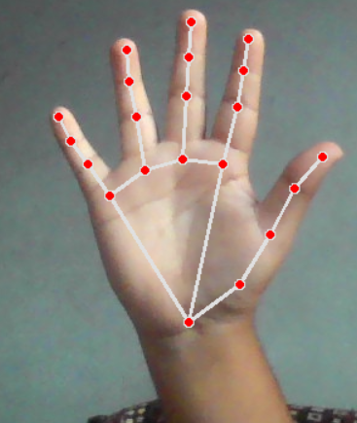The MediaPipe Hand Landmark task is used to detect the land marks of the hands in an image.

Figure 1. Hand image

Figure 2. Hand Landmarks

This task is to locate key points as shown in Figure 1. and Figure 2. of the hands and render visual effects on them in the screen. This task will be operated o image data with a Machine Learning (ML) model as a static data or a dynamic steam and the output hand landmarks image coordinates, landmarks segmentation shown in Figure 3.

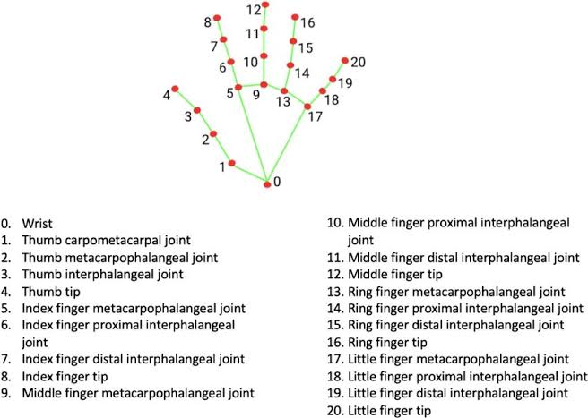

Figure 3. Hands in word coordinates (from [20])

To experience this service, we can go to google web surface or else <https://ai.google.dev.com> and then go to vision tasks and select the Hand landmark detection, it depends on the different operating system, you can select based on it click on Try it. The below Figure 4. Is the proposed design architecture which shows the interface between the input hand gesture poses and calculates the landmarks using MediaPipe and then it fetches the gestures, based on that the microcontroller Arduino UNO control the specific applications.

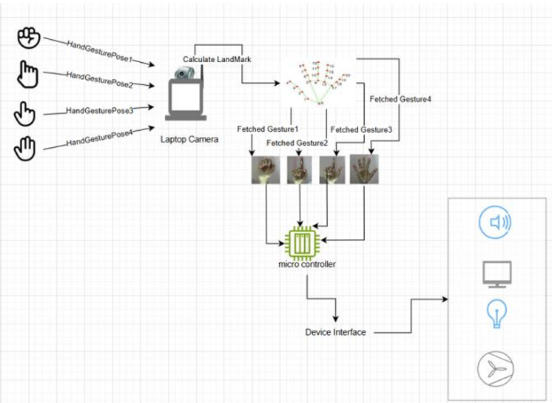

Figure 4. System Architecture

A.2.Hardware Implementation

In this proposes system to implement the hardware, we have used a laptop with integrated camera and a microcontroller (Arduino Uno), required devices interfaces such as Fan, Buzzer, and a Led we can use up to 5 devices.

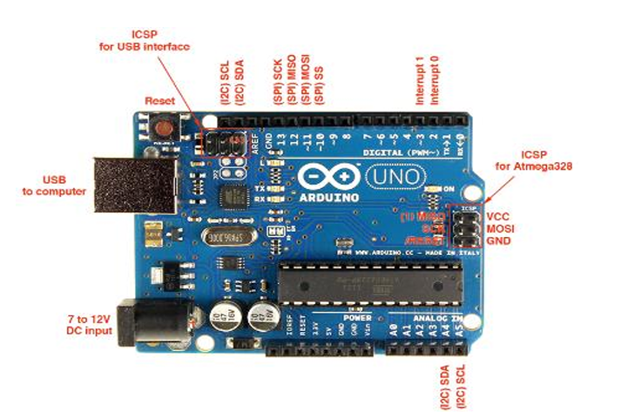Arduino Uno is a microcontroller board based on the ATmega328p. It has 14 digital I/O pins (of which 6 are used as PWM O/P), 6 analog inputs, a 16MHz resonator. The below Figure 5. Shows the details of the Uno microcontroller.

Figure 5. Arduino Uno pin Description (from [21])

Coming to software side we use Python Programming and in python code, we turn ON webcam by using OpenCV unit. By running MediaPipe’s hand detection and tracking functions, we capture 21 key landmarks on the palm, with the background represented as binary arrays 0’s and 1’s [18] [19]. An Arduino UNO microcontroller, debugged using the Firmata library, bridges the gap between OpenCV and hardware devices, allowing a Python script to seamlessly toggle connected appliances ON or OFF based on hand gestures. You can go through the code by the mentioned link: <https://github.com/21121-bala>

**IV. RESULTS**

The implementation recognizes different hand poses as input and provides specific outputs based on the detected gestures. In Figure 6. the user displays various hand poses such as ‘five’ ‘four’ ‘three’ ‘two’ ‘one’ ‘zero’, which correspond to the finger count and control different devices, as shown in the commands listed in the figure.

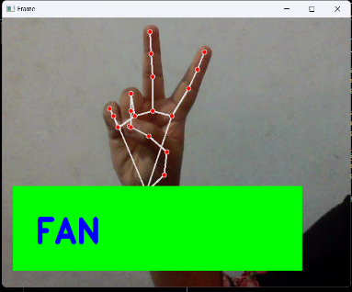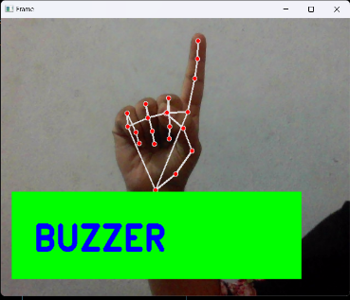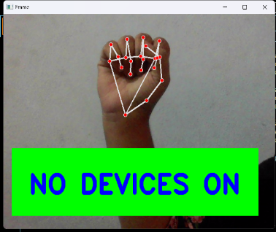

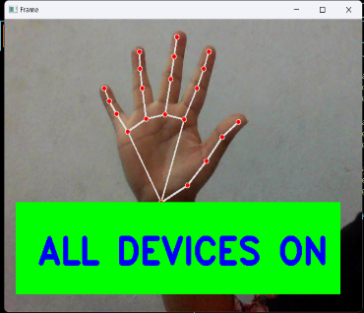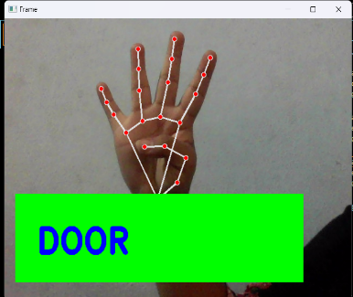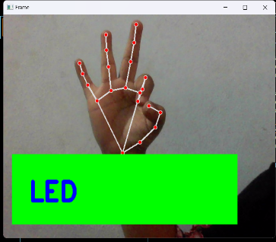

Figure 6. Recognition and Control State

This Proposed system has Pros and Cons, that depends upon the actual implementation and can be summarized as below:

1. Immediate real-time identification of hand poses from the system.
2. Slight complication in implementation as other methods and also easy to control devices.
3. Slightest delay as we transition between one gesture to another gesture.
4. Working and its performance directly depends on the hardware we use.
5. Capacity of the system is complex, then the gestures will be more to control the devices.

**V. CONCLUSION AND FUTURE WORK**

This system was successfully implemented, with no errors encountered during testing or execution. Each gesture effectively controlled the assigned devices. In the future, this approach can be expanded to control a wider range of home appliances, potentially incorporating both hands to increase the number of controllable devices. Additionally, hand gestures can be applied to various other implementations. For enhanced security and safety, the system could be integrated with a face recognition feature.

**REFERENCES**

1. Al-thobaiti, Bader MO, et al. “Design and implementation of a reliable wireless Real-Time automation system based on Arduino uno single-board microcontroller.” International journal of control, Automation and system 3.3(2014): 11-15.
2. Mowad, Mohamed Abd El-Latif, Ahmed Fathy, and Ahmed Hafez. “Smart home automated control system using android application and microcontroller.” International journal of scientific & Engineering Research 5.5 (2014): 935-939.
3. Delgado, Armando Roy, Rich Picking, and Vic Grout. “Remote-controlled home automation system with different networks technologies.” (2006).
4. Sen, Sonali, et al. “Design of an intelligent voice controlled home automation system.” International Journal of Computer and Information Engineering 121.15 (2015).
5. Obaid, Thoraya, et al. “ZigBee based voice controlled wireless smart home system.” International Journal of Wireless & Mobile Network 6.1 (2014): 47.
6. World Health Organization (WHO) details [online] Available at <https://www.who.int/disabilities/world_report/2011>.
7. Premaratne, Prashan, and Q.J.I.C.V. Nguyen, “consumer electronics control system based on hand gesture moment invariants.” IET Computer vision 1.1 (2007): 35-41.
8. Islam, Md Milon, Md Repon Islam, and Md Saiful Islam. “An efficient human computer interaction through hand gesture using deep convolution neural network.” SN Computer Science 1.4 (2020): 211.
9. Ramya. R, and K. Srinivasan. “Real time palm and finger detection for gesture recognition using convolution neural network.” Human Behaviour Analysis Using Intelligent System (2020): 1-19.
10. Shamila. P, et al. “IoT-oriented Gesture Automation with Mesh Detection Through OpenCV and pyfirmata protocol using ResNet-Mediapipe.” 2023 Innovation in power and Advanced Computing Technologies (i-PACT). IEEE, 2023.
11. Gonzalo, Pomboza-Junez, and A. Holgado-Terriza Juan. “Control of home devices based on hand gestures.” 2015 IEE 5th Internation Conference on Consumer Electronics-Berlin (ICCE-Berlin). IEEE, 2015.
12. ANAD, NIKHIL, and SHAKSHI MISHRA. “Home Automation Using Hand Gesture.” (2018).
13. Harshitaa, A.P. Hansini, and P. Asha. “Gesture based Home appliance control system for Disabled People.” 2021 second international conference on electronics and sustainable communication system (ICESC). IEE, 2021.
14. Shinde, Anuja, et al. “Smart Home automation system using IR, Bluetooth, GSM and android.” 2017 Fourth international conference on image information processing (ICIIP). Ieee, 2017.
15. Harmo, Panu, et al. “Needs and solutions-home automation and service robots for the elderly and disabled.” 2005 IEEE/RSJ international conference on intelligent robots and systems. IEEE, 2005.
16. Jacobsson, Andreas, Martin Boldt, and Bengt Carlsson. “A risk analysis of a smart home automation system.” Future Generation Computer System 56 (2016): 719:733.
17. Jayanthi. R., et al. “Vision based Hand gesture pattern recognition enabled home automation system using Internet of Things.” Design Engineering 2021.07 (2021): 8975-8990.
18. Gavale Sarita, and Yogesh Jadhav. “HAND GESTURE DETECTION USING ARDUINO AND PYTHON FOR SCREEN CONTROL.” International Journal of Engineering Applied Sciences and Technology 5 (2020): 271-276.
19. Urmee, Rehuma Akhtar, Nargis Sultana Prome, and Tarem Ahmed, “Hand Gesture-Based Home Automation System.” TENCON 2022-2022 IEEE Region 10 Conference (TENCON). IEEE, 2022.
20. MediaPipe data [online] Available at: <https://google.github.io/mediapipe/solutions/hands>.
21. Arduino information [online] Available at: <https://www.arduino.cc/en/Guide/Introduction>.