SDUWH SD308302A0 ML Lab 1

Neural Networks

Part 1: Introduction to Neural Networks

The first part of the lab this week will be reviewing the basics of neural networks.

It is preferable that you get into pairs or triplets to discuss your answers to the following questions, however you can work through the questions on your own.

**Q1. Briefly justify how artificial neural networks are biologically inspired.**

人工神经网络通过将生物神经元的树突—胞体—轴突信息流和突触可塑性抽象为数学运算来实现“生物启发”：网络中的每个节点相当于一个神经元，接收多路输入并进行加权求和，正如生物神经元通过树突接收信号并在胞体整合后发送电信号一样；连接权重模拟了突触强度，可通过训练算法不断调整，类似于生物系统中突触可塑性对学习和记忆的支撑[科学直通车](https://www.sciencedirect.com/topics/earth-and-planetary-sciences/artificial-neural-network?utm_source=chatgpt.com" \t "_blank)；而激活函数则对应神经元的放电阈值，引入非线性映射以增强网络对复杂模式的表达能力。

**Q2. Below is a diagram of the simplest neural network: a single neuron.**

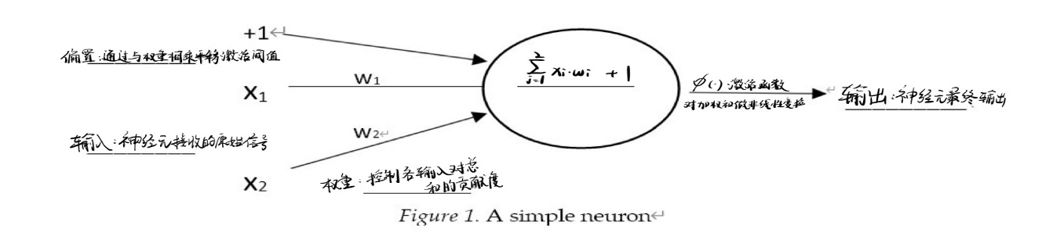**Label the diagram and describe each of the components.**

**Q3. Calculate the output from the neuron below using the following activation**

**functions with a threshold of 0.5.**

0.1

0.5

0.3

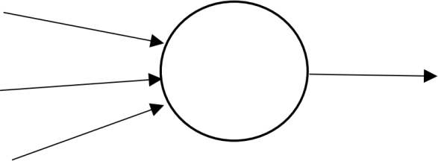

0.5

0.3

0.1

*Figure 2.* A simple neuron with inputs and weights labelled

**a. Linear:**

**b. Hard limit:**

**c. Sigmoid:**

**d. Tan-sigmoid:**

purelin(n) = n

ℎardlim(n) = {,,

n ≥ 0 n < 0

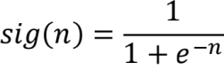

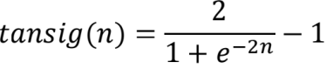

**Which of the above activation function**1**(s) allow the neuron to fire?**

**Answer:**

**b. Hard limit c. Sigmo**

**Q4. A neural network is a collection of neurons. An example of a multilayer neural**

**network is shown in Figure 3.**

**Why is the middle layer referred to as the hidden layer?**

中间层之所以被称为“隐藏层”，主要源于它在神经网络结构中既不直接接收外部输入，也不直接向外部输出，它只在网络内部进行信息处理，对使用者而言是隐藏的。

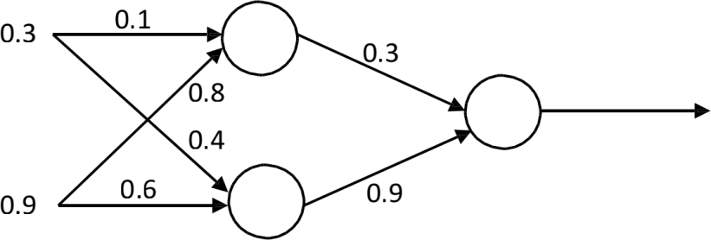

*Figure 3.* A multilayer feedforward neural network

**Q5. Calculate the output from the neural network shown in Figure 3 using the sigmoid**

**function as the activation function for the neurons.**

**Sigmoid** ： 

输入层：第一个节点输入为0.3 第二个节点输入为0.9

中间层：第一个节点输出为0.6791 第二个节点输出为0.6593

输出层：0.6893