SDUWH SD308302A0 ML Lab 3 Neural Networks Adv.

**Q1. Use pseudocode to describe the backpropagation learning algorithm and how**

**it works**

**Q2. For the neural network shown in Figure 1, with a squared error loss function,**

**perform one pass of backpropagation and calculate the new weights. Assume the target is 1 and the learning rate is 1.**

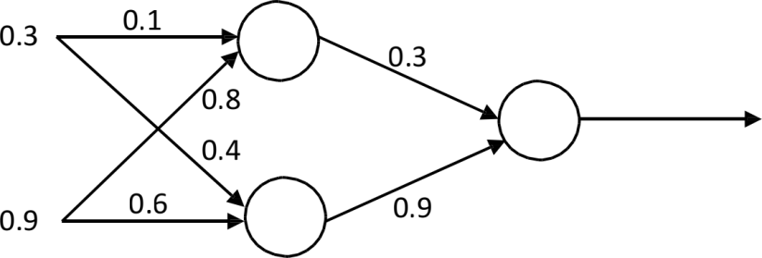

***Figure 1.* A multilayer feedforward neural network**

Hint: 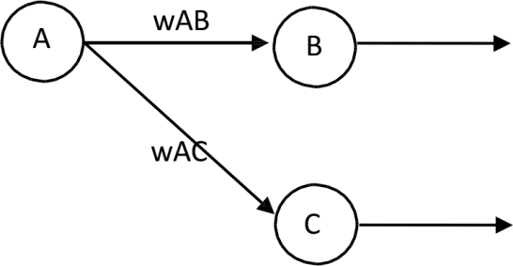

Loss function:

∑i(Target i − output i)2 Output error:



 = outputB ∗ (1 − outputB ) ∗ (outputB − TargetB )

Calculate new weights:

WAB = WAB − η ∗ outputA ∗ 

Hidden layer error:

 = outputA ∗ (1 − outputA ) ∗ 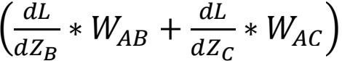

Programming Task - Using PyTorch for Regression

In this lab, you will build a model to perform regression using PyTorch. The script given is an example of building a regression model using PyTorch. It aims to build a regression

model for y = 3x + 3.

Task

Your task now is to construct a regression model for the Wine Quality data set:

<https://archive.ics.uci.edu/ml/datasets/Wine+Quality>

Familiarise yourself with the data set and perform any pre-processing or normalisation

needed. Use PyTorch to implement a regression model for the wine quality dataset and find the average error of predictions. Work on making your predictor as accurate as possible.

**Q1. How does regression differ from classifications?**

**Q2. What does your output look like?**

**Q3. Where should you define your regression model?**

**Q4. In the previous tasks we were calculating misclassification error. What error value might you use for a regression task?**