Building a Deduplication Mechanism within the Synthesis Project

Requirements
Implementation
Relational Modifications
Code Modifications
Database Unduplication Utility Pseudocode
Sequence Diagram
Further Considerations

Requirements
Currently, the Synthesis middleware only stores client transactional data in log tables. That is, each new client record that is transmitted to Synthesis is stored in a log table as a new set of linked records. All the records contain the same “export id”, so they can be maintained as a set. This works well for situations where Synthesis solely needs to act as middleware converting wire formats, to bridge systems and keep a record of these transactions.

However, if Synthesis needs to function as a data warehouse or for reporting purposes, these logged records need to be grouped by a common unique client id. An unduplication algorithm can group them, with help of a couple additional database tables which will store the groupings.

The unduplication algorithm can be built upon HUD recommendations, and for which example Java code exists at http://code.google.com/p/openciss/source/browse/src/org/pathways/openciss/shared/Match.java. This algorithm searches for weighted matches amongst the parts of the client’s name, date of birth, ethnicity, and SSN. The unduplication algorithm should have two modes: one mode as a quick task to be run whenever a new record is inserted; the second mode would be as a utility script to unduplicate the entire database to be run by an administrator when data dumps are performed, or to unduplicate data received prior to installation of the task.

Once the unduplication algorithm has been run against all records, complex reports with an unduplicated count of clients can be run against the Synthesis data warehouse, and is thereby useful for reporting to funding sources and policy makers.

Implementation
Implementation of unduplication within Synthesis will involve some additions to the relational model, as well as additional unduplication code.

Relational Modifications
The first new table (person_unique) will hold the unique client records, one active record per actual person. The second new table (person_unique_log_linkage) will hold linkages between the new unduplicated table and the logged, received client records that have arrived. So, one could run a query asking for the history of records for a given person. Also, the unique client record table (the first) contains a snapshot of the latest personal identifiers known for this person, and linking ids to the log record from whence that information was obtained. This way, there are paths between the unique, summarized table, and the supporting log records. It is both searchable, and rapidly accessed.
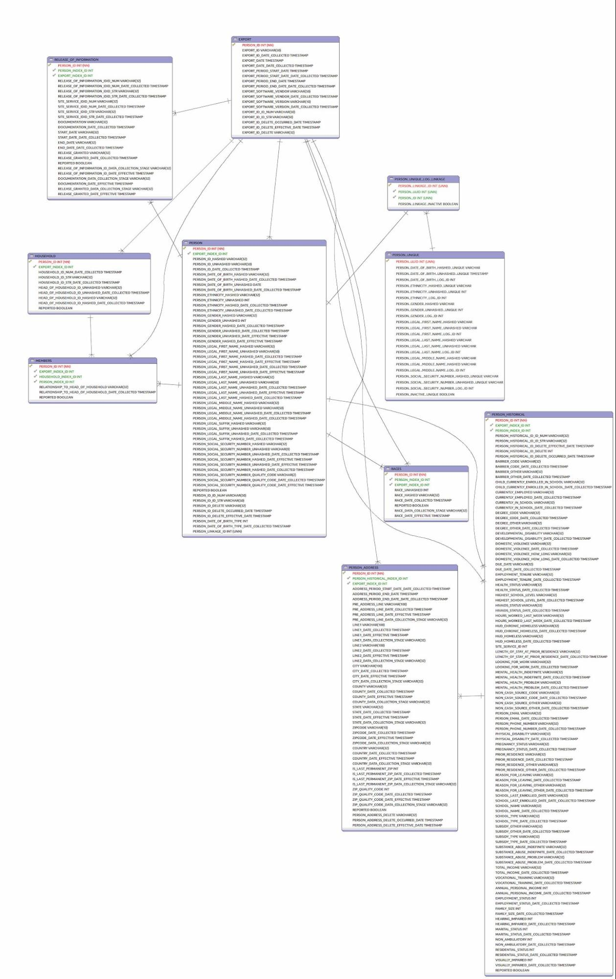
Section of the Synthesis database affected by unduplication changes

For phase one, all the existing client releases of information, site service participations (program/project enrollments), households, etc., will still just link off of the log record. There has not been identified a compelling reason link directly off the unduplicated client table, but more rapid query access would be one possible one. However, these subordinate tables can each be reached through their respective log records, in a rapid enough manner, so for now this phase one scenario should be adequate.

Code Modifications
[need to complete this section]

What will trigger the unduplication algorithm in an operational scenario?
Synthesis relies on different “Reader” adapters to interpret different payload types, like HUD HMIS XML or Health Level 7 Continuity of Care Document. Any given reader creates a new “Person” record in the database, and previously just automatically added the record to the table without any unduplication. So, each reader would need to rely on a new unduplication module that, after the Person log record is inserted, then uses the data newly inserted into the log record to look for matches. So, right after the reader method “shred(self, self.parse_dict, Person)” is called, the unduplication algorithm has the information it needs to perform its unduplication routine and create the given linkages.

Database Unduplication Utility Script Pseudocode (for both operational and utility versions of the module)
(adapted from Technical Guidelines for Unduplicating and De-identifying HMIS Client Records by O. Gutierrez and B. Sokol, 2005, https://www.onecpd.info/resources/documents/TechnicalGuidelinesForUnduplicatingAndDeIdentifyingClientRecords.pdf )

- get newly received Person record from the reader/format adapter module. Retrieve person_id, ssn, first_name, middle_name , last_name, ethnicity, gender, date_of_birth
- Part 1 Data Quality Check. Keep a counter of values, “nullcount”.
  - If nullcount reaches 2 or greater, there is insufficient data
    - if first_name is null: nullcount + 1
    - if last_name is null: nullcount + 1
    - if date_of_birth is null: nullcount + 1
    - if ssn is null: nullcount + 1
  - Else: Sufficient data are present, move on to part 2 for each record passing this data quality check
- Part 2 Further Test Potential Matches - For each record passing Part 1
- if complete SSN matches an existing record’s SSN, flag as a match
- else, check if other identifiers match an existing record’s
  - case when first_name matches (ignore case)
  - case when last_name matches (ignore case)
  - case when date_of_birth matches
    - then flag as a potential match else 0 end

- Part 3 Falsify Potential Matches - for each potential match
  - Delete from potential matches where the counter reaches greater than 1 during this sequence of match falsification checks:
    - group date_of_birth:
- case when month date_of_birth does not match, or
- case when day date_of_birth does not match, or
- case when year date_of_birth does not match: counter ++

- gender
  - case when gender does not match: counter ++

- SSN
  - case when SSN does not match: counter ++

- Part 4 Check for the existence of twins
  - Delete from potential matches if we detect a twin
    - SSN doesn’t match, and
    - first_name doesn’t match and not null, and
    - last_name matches, and
    - date_of_birth difference is less than 18 days

- Part 5 Duplicate Record/ Actual Match
- if the match count is “1”, then make the person id of this record the same as that of the matched record

- Part 6 New Record
  - if the match count is “0”, then insert into a new record

- Part 7 - Multiple Match
  - if the match count is > 1, flag clients

*For the OCC project, so now that OCC is sending consistent and unique IDs. If the ID is the same, that can be used as a sure indicator of a match, along with the other personal identifiers.

Sequence Diagram

UML Model?

Further Considerations
One consideration we need to consider is whether we will allow for unduplication only within a specific agency or even program/projects records. For now, we will not enable this, and the client records will be globally unduplicated. There have not been any compelling arguments for, or even requests for this functionality, but it does exist as a configuration decision we are making. Implementing per user and program authorization in Synthesis would probably be a more requested requirement to fulfill. For now we don’t provide for this, since as middleware, there only are trusted system administrators using the system.

Another issue is determining which agency’s information will be placed into the summary table for the unduplicated client. We will initially implement a policy of relying on the information with the latest timestamp for a given data element, as being that which is shown in the unduplicated summary table. So, any source can overwrite any unduplicated table record by virtue of it being more recently received. We could override this behavior on a per-agency or per program/project basis by following that agency’s log links instead of relying on the preestablished summary table information.

