1. Download or clone this project
2. Open eclipse IDE and install Spring Tool Suite (STS)

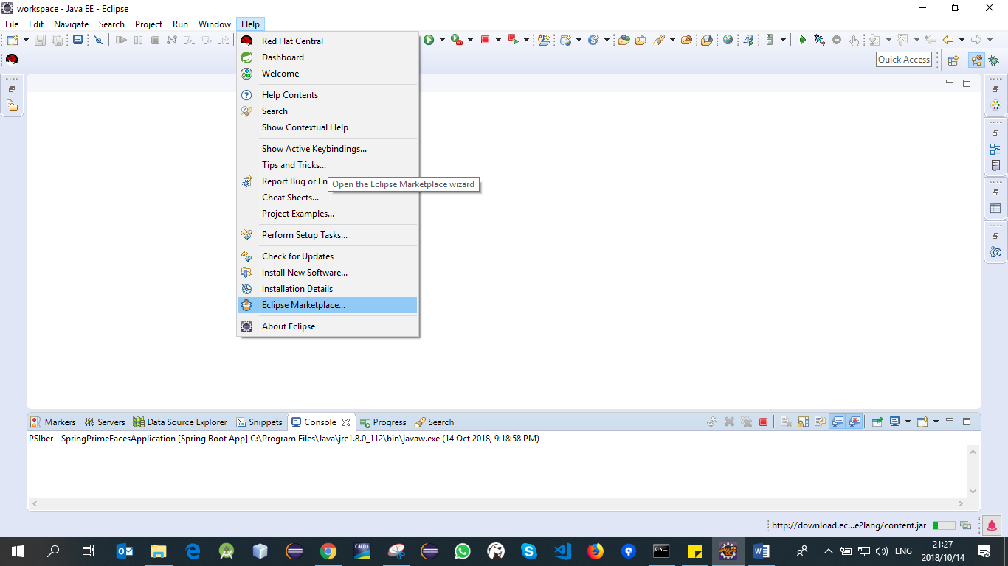

Search STS and click go

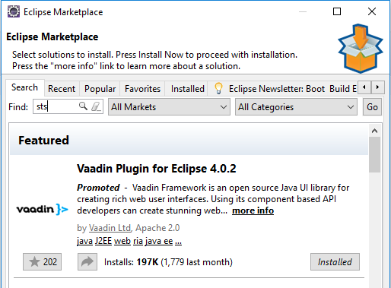

After some few seconds you will see STS solution (See the image below). Note you will not be able to see STS solution if it’s already installed on your eclipse.

STS : 

Click install button, then follow the installation instruction.

1. After successfully installing STS, Import the project as maven project.

Note: the project will download all necessary dependencies (this will take some few minutes).

1. 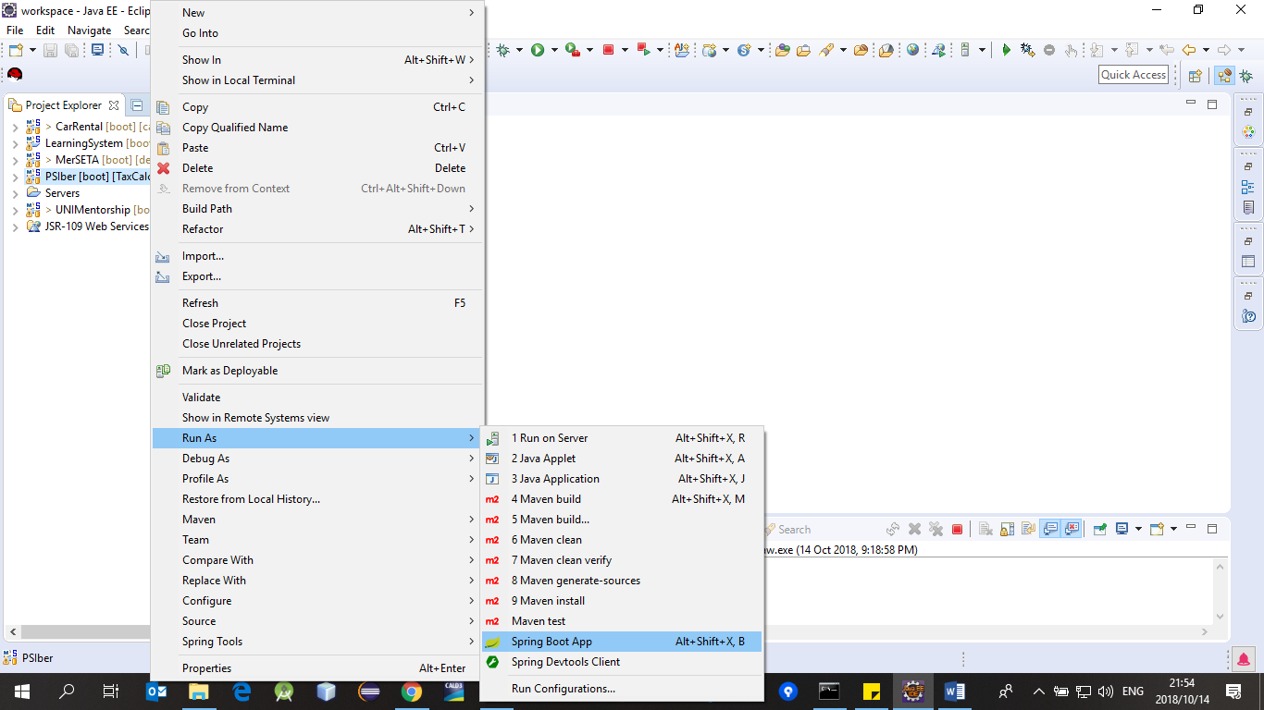After importing the project successfully, right click the project, Run AS, Spring Boot App

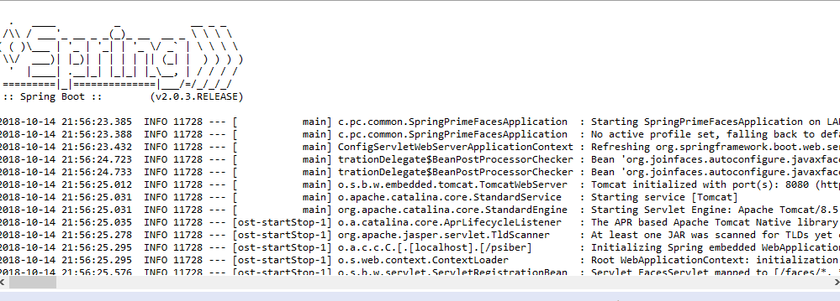

1. On you web browser type <http://localhost:8080/psiber/>

