**E-LIBRARY**

Digital library or NDLI or virtual library or hybrid library.

Digital library/ e library is a book store, where a book or data is stored in electronic form, which can be accessed and read through computers or mobile phones.

**Advantages:**

1. Any book u want from world, then u can get through’ internet , read it and store it in PDF form
2. Its available 24x7 hours.
3. One resource can be used by many users.

**Disadvantages:**

1. ***Violates Copyright:***

eg: poem, story writer has different feelings attached, but through digital medium any one can copy it without much efforts.

1. ***Rate at which it reaches.***

To launch a book, lots of analysis was done before, but if we are launching a book through internet, anyone can copy content of other person without making a proper study which can lead to lots of errors, hence it is said that there is possibility of getting wrong information through internet medium.

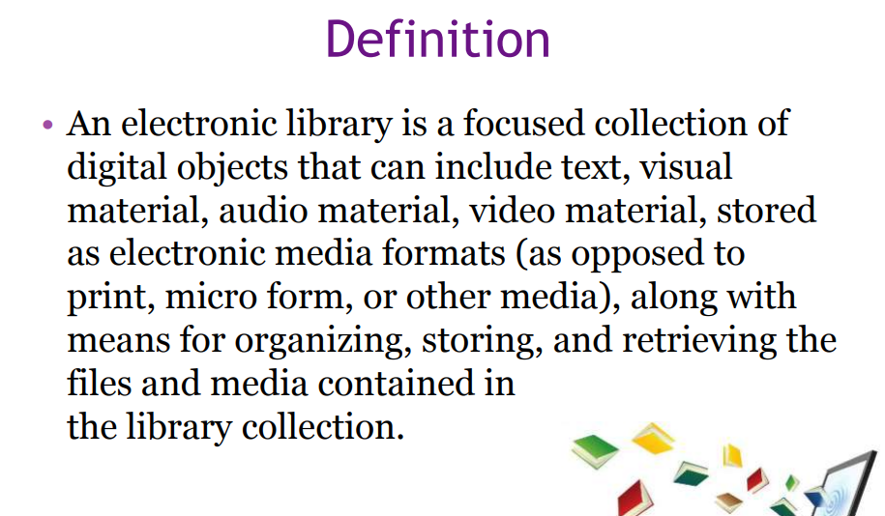

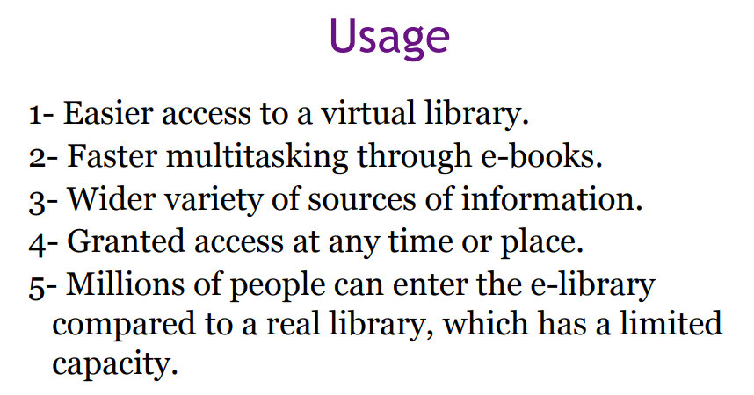

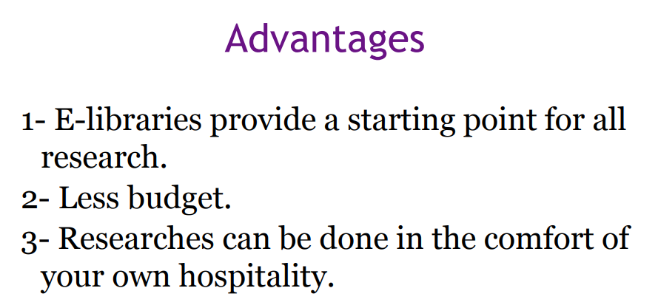

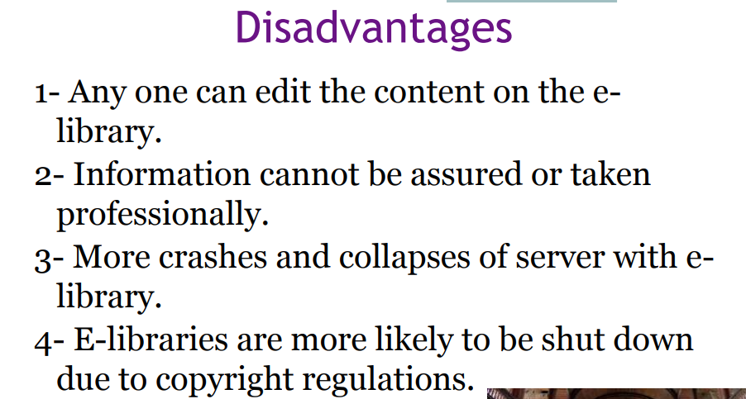

**Example of E-library:**

**The National Digital library of India(NDLI)** is a project under Ministry of Education, The Government of India. The objective is to collect and collate metadata and provide full text index from several national and international digital libraries, as well as other relevant sources.

The Library was **launched** in pilot form in May 2016. The Library was dedicated to the nation on June 19, 2018, by union human resource minister Prakash Javadekar.

Developed by IIT Kharagpur.

As of April 2019, **NDLI** hosts (4.5 crore) items in its repository, with over 1,50,000 volumes in English.

**Headquarters of NDLI:**Kharagpur, India

**Users:**20,00,000+ (January 2019)

**Available in:**10 languages

**Features of NDLI:**

1. Educational materials available from Primary to Postgraduate levels.
2. Educational materials available for all subject areas like Technology, Social Science, Literature, Law, Medical, etc.
3. All types of resources, such as Books, Audio Books/Lectures, Video lectures, Lecture Presentations/Notes, Simulations, Question Papers, Solutions, etc. available
4. Huge volume of Educational materials authored by large number of authors available
5. Content of all languages available.

User interface available in widely used Indian languages

1. Library integrates contents from Institutional Digital Repositories of large number of Indian Educational and Research institutions