TABLE OF CONTENTS
S.No | Chapter Name
1 | Introduction
 | 1.1:Objective
 | 1.2:Overview
 | 1.3: Motivation for Fault-Tolerant Design
2 | Architecture
 | 2.1: Architecture Diagram
 | 2.2: MAC Array Design
 | 2.3: Fault Detection Unit
 | 2.4: Self-Healing FSM Controller
 | 2.5: Remapping Unit
 | 2.6: Spare MAC Units
 | 2.7: Output MUX and Output Buffer
 | 2.8: Data Flow Description
3 | Port Description
 | 3.1: Input ports
 | 3.2: Output ports
 | 3.3: Internal signals
4 | Finite state machines
 | 4.1: what is FSM
 | 4.2: Types of FSM
 | 4.3: Why mealy FSM
 | 4.4: State diagrams
5 | Fault Handling Mechanism
6 | UVM Verification Environment
7 | Key Features
8 | Conclusion
 | 8.1:Outcomes
 | 8.2: Future Scope

ABSTRACT

- The primary objective of this project is to design and implement a fault-tolerant self-healing MAC (Multiply-Accumulate) array architecture capable of maintaining reliable operation even in the presence of hardware faults. As modern VLSI systems integrate a large number of processing elements, the probability of component failures increases, making fault tolerance a critical requirement. This project aims to ensure uninterrupted computation by detecting faults and automatically recovering from them without external intervention.
- Another important objective is to develop an efficient fault detection mechanism that continuously monitors the operation of MAC units and identifies abnormal behavior in real time. Once a fault is detected, the system should quickly isolate the faulty unit and prevent it from affecting the overall computation. This is achieved through a combination of error signals, monitoring logic, and control mechanisms integrated within the architecture.
- The project also focuses on implementing a self-healing mechanism using a Finite State Machine (FSM). The FSM controls different operational states such as normal operation, fault detection, and recovery. When a fault occurs, the FSM transitions to a recovery state and activates the remapping process, where the faulty MAC unit is replaced by a spare MAC unit. This dynamic remapping ensures that the system continues functioning correctly without performance degradation.

1.2: Overview
A self-healing MAC array system utilizing a Finite State Machine (FSM) divides the overall computation and fault recovery process into a sequence of well-defined operational states.
Typically, the FSM includes the following states:
• Idle: The system is in an inactive state, waiting for input data or a start signal to begin MAC operations. All units remain reset or in standby mode.
• Normal Operation: The MAC array performs standard multiply-accumulate operations using input data and weights. Outputs are generated and passed through the normal data path while the fault detection unit continuously monitors system behavior.
• Fault Detection: In this state, the system identifies errors using signals such as error flags or abnormal output conditions. The faulty MAC unit is located based on row and column identification.
• Fault Isolation: Once a fault is detected, the faulty MAC unit is isolated to prevent propagation of incorrect results. The system disables the faulty unit and prepares for recovery.
• Remapping Calculation: The remapping unit determines an available spare MAC unit and generates a new routing address using a mapping table or lookup table (LUT).
• Recovery (Self-Healing): The system redirects input data and control signals to the selected spare MAC unit. The spare unit takes over the computation previously assigned to the faulty unit.
• Output Selection: The output multiplexer selects between the normal MAC output and the remapped spare MAC output based on control signals from the FSM, ensuring correct data is forwarded.
• Verification of Output: The system verifies that the remapped computation produces correct results and that normal operation has been restored.
• Return to Normal: After successful recovery, the FSM transitions back to the normal operation state, allowing continuous processing without interruption.
• Error State: If recovery fails or multiple faults occur beyond system capability, the FSM enters an error state. In this state, the system may halt operation or signal for external intervention.
2:ARCHITECTURE
2.1:ARCHITECTURE DIAGRAM

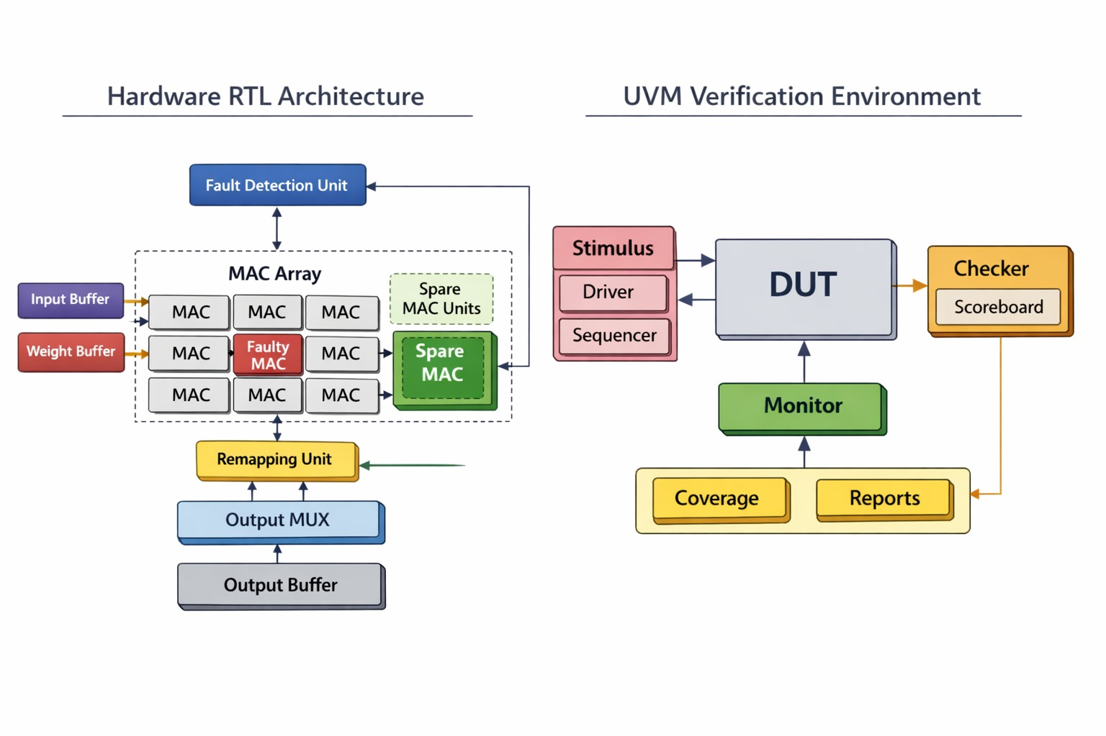
2.2 MAC Array Design
The MAC (Multiply-Accumulate) array is the core computational unit of the system, responsible for performing arithmetic operations. It consists of multiple MAC units arranged in a grid-like structure to enable parallel processing. Each MAC unit performs multiplication of input data with weights and accumulates the result. This parallel architecture improves throughput and reduces computation time. The design supports continuous data flow for high-speed operations. The MAC array is controlled by clock and enable signals for synchronized execution. It is designed to be scalable based on application requirements. Fault detection logic is integrated to monitor each MAC unit during operation.

2.3: Fault Detection Unit
The Fault Detection Unit continuously monitors the operation of each MAC unit to identify errors. It checks for abnormal outputs, timing issues, or mismatched results. The unit generates an error signal whenever a fault is detected. It helps in locating the exact position of the faulty MAC unit within the array. The detection mechanism works in real-time to ensure quick response. It uses comparison logic and status signals to identify faults. This unit plays a crucial role in maintaining system reliability. The detected fault information is passed to the FSM controller for further action.

2.4: Self-Healing FSM Controller
The Self-Healing FSM Controller is the decision-making unit of the system. It controls different states such as idle, normal operation, fault detection, and recovery. Based on input signals, it determines the next action of the system. When a fault is detected, the FSM transitions to a recovery state. It generates control signals for isolating faulty units and activating spare units. The FSM ensures smooth and automatic recovery without stopping the system. It improves system efficiency by reducing downtime. The controller coordinates all modules for proper functioning.

2.5: Remapping Unit
The Remapping Unit is responsible for assigning a spare MAC unit to replace a faulty one. It uses a mapping table or lookup table to track available spare units. Once a fault is identified, the remapping unit generates a new address for data routing. It ensures that input data is redirected to the spare MAC unit. This process happens dynamically without affecting system performance. The remapping unit maintains correct data flow during recovery. It works closely with the FSM controller. This unit enables the self-healing capability of the system.

2.6: Spare MAC Units
Spare MAC units are additional processing elements kept idle during normal operation. They are used only when a fault occurs in the main MAC array. These units act as backups to ensure uninterrupted computation. When activated, they perform the same operations as faulty MAC units. Spare units are controlled by the FSM and remapping logic. The number of spare units depends on system design requirements. They improve system reliability and fault tolerance. Proper allocation of spare units ensures efficient resource utilization.

2.7: Output MUX and Output Buffer
The Output Multiplexer (MUX) selects the correct output between normal MAC units and remapped spare MAC units. It ensures that only valid and correct results are forwarded to the output. The selection is controlled by signals from the FSM controller. The Output Buffer temporarily stores the final results before sending them to the next stage. It helps in maintaining data stability and synchronization. The buffer also reduces timing issues in high-speed operations. Together, MUX and buffer ensure accurate and smooth output delivery. This stage is crucial for maintaining system correctness.

2.8: Data Flow Description
The data flow begins with input data and weights entering the MAC array. Each MAC unit processes the data and produces intermediate results. The Fault Detection Unit continuously monitors these outputs for errors. If no fault is detected, results are directly sent to the output MUX. In case of a fault, the FSM controller activates the remapping unit. The faulty MAC is replaced by a spare MAC unit, and data is redirected accordingly. The corrected output is then selected by the MUX and stored in the output buffer. Finally, the system outputs accurate results while maintaining continuous operation.

3: Port Description
3.1: Input Ports
Name | Description
clk | Clock signal used to synchronize all operations in the system
reset | Resets the system to initial state
input_data | Input data given to MAC units for processing
weights | Weight values used for multiplication in MAC
enable | Enables the operation of the MAC array
start | Starts the computation process
error_inject | Used to inject faults during testing
valid_in | Indicates input data is valid

3.2: Output Ports
Name | Description
result | Final output from MAC computation
valid_out | Indicates output data is valid
done | Indicates completion of operation
busy | Shows system is currently processing
fault_detected | High when fault is detected in MAC array
recovery_done | Indicates fault recovery is completed
error_out | Output error signal for external monitoring
status | Displays current system status

3.3: Internal Signals
Name | Description
state | Holds current FSM state
next_state | Stores next state of FSM
fault_flag | Internal signal indicating fault detection
mux_select | Controls selection of output MUX
map_addr | Address generated for remapping unit
spare_enable | Activates spare MAC units
mac_done | Indicates completion of MAC operation
control_signal | Used for internal control between modules

4.FINITE STATE MACHINES
4.1: What is FSM?
A Finite State Machine (FSM) is a sequential logic model used in digital systems to define a system’s behavior based on a finite number of well-defined conditions or “states.” In an FSM, the system transitions from one state to another depending on inputs and the current state, making it ideal for controlling processes in a predictable and structured manner. In our fault-tolerant self-healing MAC array system, the FSM manages fault detection and recovery operations across multiple well-defined states: Idle, Normal Operation, Fault Detection, Fault Isolation, Remapping Calculation, Recovery, Output Selection, Verification of Output, Return to Normal, and Error State. The system begins in the Idle state, waiting for an input or start signal. Once computation begins, it moves to Normal Operation, where the MAC array processes data while the Fault Detection Unit continuously monitors each MAC unit. If a fault is detected, the FSM transitions to the Fault Detection and Fault Isolation states, disabling the faulty unit. The Remapping Calculation state identifies an available spare MAC unit, and the Recovery state redirects computation to that spare unit. After verifying the output, the FSM returns to Normal Operation, ensuring uninterrupted computation. This FSM-based control ensures that the self-healing process is automatic, structured, and reliable.

4.2: Types of FSM
Mealy FSM:
A Mealy Finite State Machine (Mealy FSM) is a type of finite state machine where the outputs depend on both the current state and the inputs. This means that changes in input can cause immediate changes in the output, even without transitioning to a different state. Because of this, Mealy machines can respond faster to input changes compared to Moore machines, where outputs are updated only after a state transition.

In a Mealy FSM, the output logic is a function of the current state and the external inputs, allowing more compact designs with fewer states in many cases. For example, a single state in a Mealy FSM may produce different outputs depending on the inputs, whereas a Moore FSM might require multiple states to represent each output variation. This efficiency makes Mealy FSMs suitable for real-time and responsive control systems such as traffic lights, vending machines, and protocol controllers.

.Moore FSM:
A *Moore Finite State Machine (Moore FSM)* is a type of FSM in which the *outputs depend only on the current state, and **not on the inputs*. This characteristic makes Moore FSMs more predictable and easier to design, as the outputs remain stable until the system transitions to a new state. In a Moore FSM, outputs are associated directly with states, meaning that whenever the FSM enters a particular state, the corresponding output is automatically activated. This contrasts with a Mealy FSM, where outputs depend on both the current state and the inputs. Because of this state-based output behavior, Moore FSMs often require more states than Mealy FSMs to achieve the same functionality, but they provide more stable and noise-free outputs, which is beneficial insynchronous digital systems. Moore machines are widely used in applications where consistent output behavior is critical, such as control systems, sequence detectors, and communication protocols. In Verilog, Moore FSMs are typically implemented using a state register, a state transition logic block (based on inputs), and an output logic block that depends solely on the current state. Their simplicity and reliability make Moore FSMs a foundational concept in digital design.
4.3: Why Mealy FSM?
The Mealy FSM is chosen for the self-healing MAC array controller because it offers faster and more responsive output generation. In a Mealy FSM, outputs are determined by both the current state and the present inputs, which allows the system to immediately respond to fault signals without waiting for the next clock cycle. This is a critical advantage in fault-tolerant systems where rapid fault isolation and recovery are essential to minimize data corruption and computational errors.
In the context of this project, when a fault signal (error_inject or fault_flag) is asserted, the Mealy FSM can immediately generate control outputs such as spare_enable and mux_select within the same clock cycle, without transitioning to a new state first. This reduces recovery latency and ensures that the faulty MAC unit is isolated and the spare MAC unit is activated as quickly as possible. A Moore FSM, in contrast, would require an additional clock cycle to produce these outputs after the state transition, making it less suitable for real-time fault recovery.
Additionally, Mealy FSMs are generally more compact, requiring fewer states to implement the same logic compared to Moore FSMs. This results in reduced hardware complexity and better resource utilization in VLSI implementations. For these reasons, the Mealy FSM is the preferred choice for the self-healing MAC controller in this project.

4.4: State diagrams

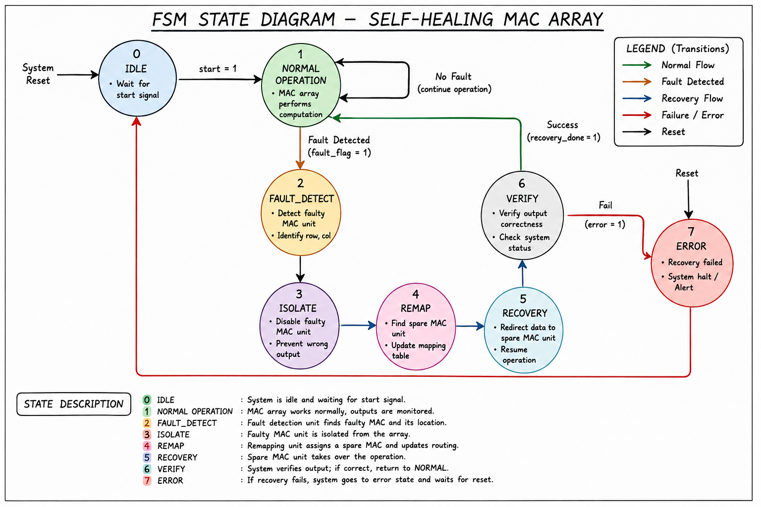

5.Fault Handling Mechanism
The fault handling mechanism is responsible for detecting, isolating, and recovering from faults occurring in the MAC array. The system continuously monitors each MAC unit using error detection signals and status flags. When a fault is detected, the faulty MAC unit is immediately isolated to avoid incorrect computations. The FSM controller then activates the remapping process to assign a spare MAC unit. Input data and control signals are redirected to the spare unit for continued operation. This process happens automatically without stopping the system. The mechanism improves reliability and ensures uninterrupted performance in fault-prone environments.

6.UVM Verification Environment
The UVM verification environment is developed to verify the functionality and reliability of the self-healing MAC array. It provides a standardized and reusable methodology for hardware verification. The environment includes components such as sequencer, driver, monitor, scoreboard, and coverage collector. Test sequences are generated to apply different input conditions and fault scenarios. The monitor captures DUT outputs and sends them to the scoreboard for comparison. Functional and code coverage are measured to ensure complete verification. This environment helps in identifying design errors efficiently and improves verification quality.

7.Key Features
The proposed system contains several advanced features that improve system performance and reliability. The self-healing capability allows automatic recovery from hardware faults. Real-time fault detection helps identify faulty MAC units quickly and accurately. Dynamic remapping ensures that spare MAC units replace faulty units without interrupting computation. The FSM-based controller provides efficient state management and recovery control. The design supports scalable architecture for larger MAC arrays. UVM-based verification further ensures correctness and robustness of the system.

8.Conclusion
This project successfully demonstrates the design and verification of a self-healing MAC array architecture for fault-tolerant VLSI systems. The integration of fault detection, FSM control, remapping logic, and spare MAC units enables automatic recovery from hardware faults. The architecture ensures continuous computation even in the presence of faulty processing elements. The UVM verification environment validates the functionality and reliability of the design through different test scenarios. The project improves system robustness, reliability, and operational efficiency. It also provides a scalable solution for future high-performance computing applications. Overall, the design achieves effective fault tolerance with efficient recovery mechanisms.

8.1: Outcomes
The project achieved successful implementation of a fault-tolerant MAC array system with self-healing capability. Real-time fault detection and isolation mechanisms were developed and tested effectively. The FSM controller successfully managed different operational and recovery states. Dynamic remapping using spare MAC units ensured uninterrupted system functionality. The output multiplexer and buffer correctly handled remapped outputs. UVM verification confirmed proper operation under normal and faulty conditions. High functional reliability and efficient fault recovery were achieved through the proposed architecture.

8.2: Future Scope
The project can be further enhanced by implementing advanced fault prediction techniques using machine learning algorithms. Power optimization methods can be introduced to reduce hardware overhead and energy consumption. The architecture can be extended to support multiple simultaneous fault recoveries. FPGA or ASIC implementation can be performed for real-time hardware deployment. More efficient remapping algorithms can be developed for faster recovery. The system can also be integrated into AI accelerators and DSP processors for high-performance applications. Future work may focus on improving scalability and reducing recovery latency in large MAC arrays.

