MAJOR PROJECT REPORT
(Project Term January - May 2025)

(SANSKRITI YATRA)
(Heritage and culture App)
Under the Guidance of
(Amandeep Kaur Mam)
(Assistant Professor)
Depament of Computer Science
And Engineering
Lovely School of Polytechnic
Lovely Professional University, Phagwara

Submitted by
Yash Raj, Saumya Mihir, Anuskha Ranjan
12201115, 12209560, 12202240
RJK221
Diploma Computer Science and Engineering
TABLE OF CONTENTS

S.No | Description | Page No.
 | DECLARATION | V
 | ACKNOWLEDGEMENT | Vi
 | LIST OF FIGURES | vii - viii
 | LIST OF TABLE | ix
 | PROFILE OF THE PROBLEM | 10
 | EXISTING SYSTEM | 10
2.1. | EXISTING APP | 10 - 11
2.2. | WHAT’S NEW IN THE SYSTEM TO BE DEVELOPED/SCOPE OF WORK | 11 – 12
 | PROBLEM ANALYSIS | 12
3.1. | PROBLEM DEFINATION | 13
3.2. | PROJECT PLAN | 14
3.2.1. | PROJECT OVERVIEW | 14
3.2.2. | KEY DELIVERABLES | 14
3.2.2.1. | USER NAVIGATION SYSTEM | 14
3.2.2.2. | CULTURAL CONTENT MANAGEMENT MODULE | 14
3.2.2.3. | DYNAMIC USER INTERFACE | 14
S.No | Description | Page No
3.2.2.4. | DATABASE INTEGRATION | 14
3.2.2.5. | NOTIFICATION SYSTEM | 15
3.2.3. | DEVELOPMENT PHASES | 15
3.2.3.1. | PLANNING AND REQUIREMENTS ANALYSIS | 15
3.2.3.2. | FRONT-END DEVELOPMENT (FLUTTER AND DART) | 15
3.2.3.3. | BACK-END DEVELOPMENT (REST API AND MONGODB) | 15
3.2.3.4. | TESTING AND QUALITY ASSURANCE | 15
3.2.3.5. | DEPLOYMENT AND DOCUMENTATION | 16
3.2.3.6. | FUTURE ENHANCEMENTS | 16
3.2.3.7. | MAINTENANCE PLAN | 16
3.2.4. | TOOLS AND TECHNOLOGIES | 16
3.2.4.1. | PROGRAMMING LANGUAGES | 16
3.2.4.2. | FRAMEWORKS/LIBRARIES | 16
3.2.4.3. | DATABASE | 16
3.2.4.4. | TOOLS | 17
3.2.5. | TIMELINE | 17
 | SOFTWARE REQUIREMENT ANALYSIS | 17
4.1. | FUNCTIONAL REQUIREMENTS | 17
S.No. | Description | Page No
4.2. | NON – FUNCTIONAL REQUIREMENTS | 18 – 19
4.3. | GENERAL DESCRIPTION | 19
 | DESIGN | 20 – 22
5.1. | ER DIAGRAM OF DATABASE TABLE/TABLE DESIGN | 20 – 22
5.2. | DFD FOR PRESENT SYSTEM/FLOWCHARTS IN BOTH S/W AND H/W PROJECT | 22
 | CODE IMPLEMENTATION | 23
6.1. | CODE LINK. | 23
6.2. | SNAP SHOTS OF THE PROJECT | 23 – 28
 | BIBLIOGRAPHY | 29

DECLARATION

I hereby declare that the project work entitled “Sanskriti Yatra” is an authentic record of my own work carried out as requirements of Major Project for the award of degree of “Diploma Computer Science and Engineering” from Lovely Professional University, Phagwara, under the guidance of “Amandeep Kaur”, during January - May 2025.

Yash Raj
(12201115)

Anuskha Ranjan
(12202240)

Saumya Mihir
(12209560)

Date:_____________.

This is to certify that the above statement made by the student is correct to the best of my knowledge and belief.

(“Amandeep Kaur”, 29517 and Assistant Professor)
Faculty Mentor

ACKNOWLEDGEMENT

I would like to express my profound gratitude to “Dr. Satnam Singh”, Head of School of School of Polytechnic and “Mrs. Sweety Sehgal”, Head of Department of School of Polytechnic, Lovely Professional University for their contributions to the completion of my project “Sanskriti Yatra”.

I would like to express my special thanks to our mentor “Amandeep Kaur” for her time and efforts she provided throughout the year. Your useful advice and suggestions were helpful to me during the project’s completion. In this respect, I am eternally grateful to you.

I would like to acknowledge that this project was completed entirely by me and my team not by someone else.

Signature
Your name

LIST OF FIGURES

Fig. No. | Title | Page No.
 | User | 20
 | State | 20
 | Historical Site | 20
 | Triditional Art | 20
 | Festivals | 21
 | Classical Dance and Music | 21
 | Language and literature | 21
 | Culinary Hertiage | 21
 | ER Diagram | 21
 | Data Flow Diagram (DFD) | 22
 | Starting of app | 23
 | Ask for SignUp/ SignIn | 23
 | SignIn | 24
 | SignUp | 24
 | Dashboard | 25
 | Menu | 25
 | All destination | 26
Fig. No. | Title | Page No.
 | Notifocation | 26
 | Searching for state | 27
 | Inside Stare Name | 27
 | Our Team | 28
 | About App | 28

LIST OF TABLE
Table No. | Table Name
 | User
 | State
 | Historical Site
 | Triditional Art
 | Festivals
 | Classical Dance and Music
 | Language and literature
 | Culinary Hertiage

- PROFILE OF THE PROBLEM:-
India, often referred to as the cradle of civilization, is renowned for its vast and diverse cultural heritage that spans centuries. From ancient architectural marvels and classical dance forms to regional languages and culinary traditions, every corner of the country tells a unique story. However, in the fast-paced world of digital entertainment, globalization, and urbanization, much of this cultural richness is at risk of being sidelined—especially among the younger generation and global audiences. While efforts have been made to document heritage through government websites, textbooks, and occasional cultural events, these resources often fail to capture attention or inspire exploration due to a lack of interactivity, engagement, or personalization. The core problem lies in the absence of a unified, engaging digital platform that seamlessly integrates educational, cultural, and tourism-oriented content; showcases both popular and lesser-known heritage locations and cultural practices; makes Indian culture accessible through multimedia and regional language support; and offers personalized experiences that can attract users across age groups and geographies.
- EXISTING SYSTEM:-
Several digital platforms currently offer travel or cultural content, but none provide a comprehensive and unified solution. Travel apps such as MakeMyTrip and TripAdvisor primarily focus on travel logistics, including bookings, hotel information, and reviews, with minimal or no emphasis on cultural depth. Government portals like the Archaeological Survey of India (ASI) and the Ministry of Tourism provide valuable historical information; however, they lack user interactivity, engaging content formats such as video and audio, regional language support, and mobile responsiveness. Meanwhile, education apps and YouTube channels may offer content related to Indian culture, but it is often scattered, uncategorized, and not curated effectively, making it difficult for users to explore and engage with the rich cultural heritage in a meaningful way.
2.1 EXISTING APP:-
The Incredible India app, developed by the Ministry of Tourism, focuses on promoting tourist destinations and cultural sites across the country. While it provides good information, it offers limited personalization and interactivity. Google Arts & Culture also features an India section that offers virtual tours of monuments, museums, and artworks with high-quality multimedia content; however, it is global in scope and does not focus deeply on India alone. GoUNESCO is a heritage-focused travel challenge app that encourages users to visit UNESCO World Heritage Sites, but it mainly covers major heritage locations, missing out on many local and lesser-known cultural gems. AudioCompass, an audio guide app approved by the Ministry of Tourism, offers audio tours of historical sites in India but lacks rich visual content and structured cultural learning paths. Trodly is a travel and activity booking platform that lists tours and local experiences, though it provides little emphasis on deeper cultural education. Apps like Roposo and Moj feature short videos where some creators share content related to Indian festivals, crafts, and food; however, this content is scattered, uncurated, and not designed for organized cultural exploration or education.

2.2 What’s new in the system to be developed/Scope of work
The proposed system presents a unique and comprehensive platform dedicated to showcasing the cultural and heritage richness of India. Unlike existing heritage apps that often focus on limited aspects, this app covers all 28 states of India with an in-depth exploration across six distinct categories for each state:
- Historical and Heritage Sites
- Traditional Arts and Crafts
- Festivals and Cultural Celebrations
- Classical Dance and Music
- Language and Literature
- Culinary Heritage
This structured categorization ensures users can experience the full spectrum of a state's culture, not just isolated elements. Each section offers detailed descriptions, providing users with educational insights and fostering deeper cultural appreciation.
The app stands out by offering a holistic view of Indian diversity, bringing together ancient monuments, vibrant festivals, traditional art forms, culinary specialties, and linguistic diversity — all in a single, easy-to-navigate platform. It also supports interactive engagement through rich content like images and descriptions, making the learning experience both informative and immersive.
The scope of work includes content development for each state across the six categories, designing an intuitive user interface for smooth navigation, and possibly future enhancements like integrating multimedia content (videos, AR experiences) and personalized cultural journeys. This app is positioned to become a go-to cultural encyclopedia for students, travelers, and heritage enthusiasts.

- PROBLEM ANALYSIS:-
India's vast cultural diversity is a treasure that often remains scattered across different sources, making it difficult for users to find authentic, organized, and complete information in one place. Existing apps and platforms usually focus on limited aspects such as tourist destinations or festivals, leaving out important elements like traditional arts, local languages, classical music, literature, and regional cuisines.
There is a clear gap in providing a comprehensive cultural guide that covers all 28 states of India and highlights every major dimension of their heritage. Additionally, many resources available today are either too academic (making them less engaging for general users) or too commercial (focusing only on popular tourist spots).
The lack of a well-structured, user-friendly platform makes it challenging for students, travelers, and cultural enthusiasts to explore and understand the complete cultural identity of each state. Furthermore, the absence of categorization into key cultural aspects often leads to a fragmented experience, where users miss out on the full richness of Indian traditions.
Thus, there is a strong need for a single platform that not only showcases historical sites but also highlights traditional crafts, culinary traditions, classical arts, festivals, and linguistic heritage in a structured and engaging manner. Addressing this gap can play a significant role in promoting cultural awareness, supporting educational purposes, and preserving the rich diversity of India for future generations.
The proposed app aims to solve this problem by providing an organized, detailed, and holistic cultural guide for each Indian state, making cultural exploration easier, enjoyable, and more meaningful for users.

  - PROBLEM DEFINATION:-
In today’s digital age, although information about Indian culture and heritage is available online, it is often scattered, incomplete, or not categorized properly. Users interested in exploring India’s rich cultural diversity face difficulties in finding a platform that brings together comprehensive and authentic information across different cultural dimensions like historical sites, arts and crafts, festivals, dances, literature, and culinary traditions.

Most existing platforms either focus narrowly on tourism or present limited cultural aspects without providing a full picture. As a result, users are unable to experience the true depth and diversity of each Indian state’s heritage in a structured and engaging way.

There is no dedicated application that systematically organizes information state-wise and further divides it into multiple important cultural categories. This lack leads to fragmented learning, reduced interest among users, and a gap in cultural awareness among younger generations.

The problem, therefore, is the absence of an integrated, user-friendly platform that offers detailed, organized, and category-wise cultural information about all 28 Indian states in one place. Addressing this gap is crucial for promoting cultural education, boosting tourism, and preserving traditional knowledge and practices.

The proposed application aims to solve this issue by providing a single, well-structured platform where users can explore the complete cultural identity of every Indian state through six key categories: Historical and Heritage Sites, Traditional Arts and Crafts, Festivals and Cultural Celebrations, Classical Dance and Music, Language and Literature, and Culinary Heritage. This will make the exploration of Indian culture more accessible, interesting, and meaningful for a wide range of audiences.

3.2 PROJECT PLAN :-
1. Project Overview:
This project aims to create a comprehensive mobile application that showcases the cultural and heritage richness of all 28 Indian states. The app is divided into six major categories for each state: Historical and Heritage Sites, Traditional Arts and Crafts, Festivals and Cultural Celebrations, Classical Dance and Music, Language and Literature, and Culinary Heritage. It provides detailed information in an organized and user-friendly format, making cultural exploration easy and engaging. The goal is to promote cultural awareness, support education, and offer a complete guide for students, travelers, and heritage enthusiasts interested in India's diverse traditions.

2. Key Deliverables:
2.1 User Navigation System:
a. Organized browsing by selecting Indian states.
b. Category-wise navigation for detailed cultural aspects.
2.2 Cultural Content Management Module:
a. Add and update content for all six categories under each state.
b. Maintain structured data for historical sites, arts, festivals, literature, dance/music, and cuisine.
2.3 Dynamic User Interface:
a. Smooth and fast screen transitions for better user experience.
b. Interactive cards or sections for each cultural category.
2.4 Database Integration:
a. Efficient storage and retrieval of cultural data for all 28 states.
b. Backend support for easy future content expansion.
2.5 Notification System:
a. Toast alerts for actions like loading content, errors, or updates.
b. User feedback messages for better interaction and navigation clarity.
3. Development Phases:
3.1 Planning and Requirements Analysis:
a. Define project goals, including multi-category cultural exploration for all Indian states.
b. Collect and organize authentic cultural data for structured input into the system.

3.2 Front-End Development (Flutter and Dart):
a. Develop a responsive and interactive UI using Flutter.
b. Implement state and category selection screens with smooth navigation and animations.
c. Ensure mobile-first, cross-platform compatibility (Android/iOS).

3.3 Back-End Development (REST API and MongoDB):
a. Develop RESTful APIs to fetch, create, update, and delete cultural data.
b. Store all state and cultural category information securely in a MongoDB database.
c. Implement server-side logic for future scalability and performance.

3.4 Testing and Quality Assurance:
a. Conduct unit testing of Flutter widgets and API services.
b. Perform integration testing between the Flutter front-end and REST API backend.
c. Fix bugs, optimize app performance, and ensure data consistency.

3.5 Deployment and Documentation:
a. Deploy the mobile app on Play Store (Android) and App Store (iOS) after final testing.
b. Host backend APIs on cloud servers (e.g., AWS, Heroku, or Vercel).
c. Prepare detailed user guides, developer documentation, and API references.
3.6 Future Enhancements:
a. Integrate features like search functionality, bookmarking favorite states, and offline mode.
b. Add multimedia content such as videos and AR experiences for deeper engagement.
c. Expand to cover Union Territories and cultural updates as needed.
3.7 Maintenance Plan:
a. Regularly update cultural information and app features.
b. Monitor server and database performance, ensuring data security and uptime.
c. Gather user feedback for continuous improvements and feature updates.

4. Tools and Technologies:
4.1 Programming Languages:
a. Dart (for mobile app development)
4.2 Frameworks/Libraries:
a. Flutter (for cross-platform UI development)
b. REST API (for communication between frontend and backend)
4.3 Database:
a. MongoDB (for storing cultural and heritage data)

4.4 Tools:
a. Visual Studio Code (for coding and development)
b. Postman (for API testing)
c. Git and GitHub (for version control)
d. Android Studio Emulator / Physical Device (for app testing)

5. Timeline:
Total Duration: 5 Months
Planning: 2 Week
Development: 3 Months
Testing & Deployment: 5 Week

- Software Requirement Analysis:-
The Cultural Heritage App must meet a set of functional and non-functional requirements to ensure rich content delivery, smooth user experience, and scalability for future updates.

4.1 Functional Requirements
a. State and Category Navigation:
- Users must be able to browse all 28 Indian states.
- Each state should have six major cultural categories: Historical Sites, Arts and Crafts, Festivals, Dance and Music, Language and Literature, Culinary Heritage.

b. Dynamic Data Fetching:
- The app must fetch cultural data dynamically via REST APIs connected to MongoDB database.
c. Multimedia Content Display:
- Images, descriptions, and additional media should load quickly and display correctly for each category.
d. Search and Filter Functionality:
- Users should be able to search states by name and filter based on cultural categories.
e. Bookmarking: (optional future feature)
- Allow users to bookmark favorite states or cultural information for easy access later.

4.2 Non-Functional Requirements
a. Performance:
- The app should load content quickly even with large datasets.
b. Scalability:
- The system must be able to handle the addition of more states, union territories, or categories in the future.
c. Accessibility:
- The app should support accessibility features such as screen readers for visually impaired users.

d. Security:
- REST APIs should be protected with proper authentication for future admin updates.
- User data (if any) must be handled securely.
e. Reliability:
- App must work without crashing even during high traffic or poor internet connections.

4.3 General Description
The Cultural Heritage App is designed to be an educational and engaging platform for users interested in India's rich and diverse traditions. It provides an organized structure where each of the 28 Indian states is explored across six important cultural dimensions, including historical monuments, traditional arts, festivals, culinary experiences, languages, and classical arts.

The platform uses a mobile-first design with Flutter and Dart for fast performance, a REST API for dynamic data retrieval, and MongoDB for efficient, flexible data storage. The app ensures smooth navigation, quick loading, and multimedia-rich content display, making it ideal for learners, travelers, researchers, and culture enthusiasts. The focus remains on usability, accessibility, and performance across devices.

5. DESIGN:-
5.1 ER Diagram Of Database Table/Table Design:-
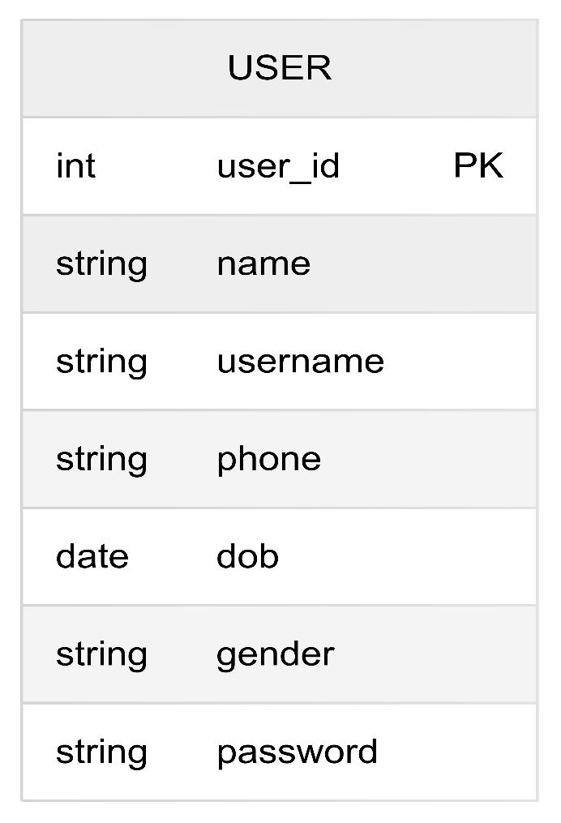

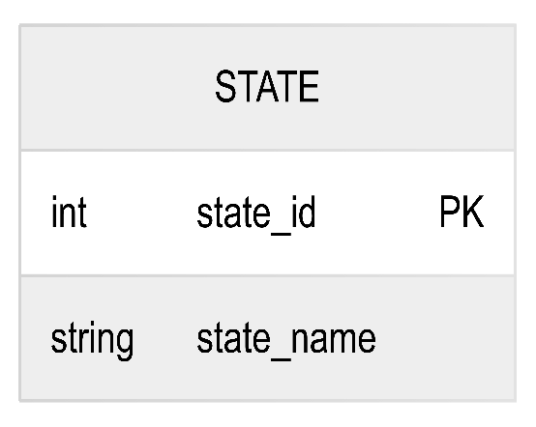

Fig. No. 2

Fig. No. 1
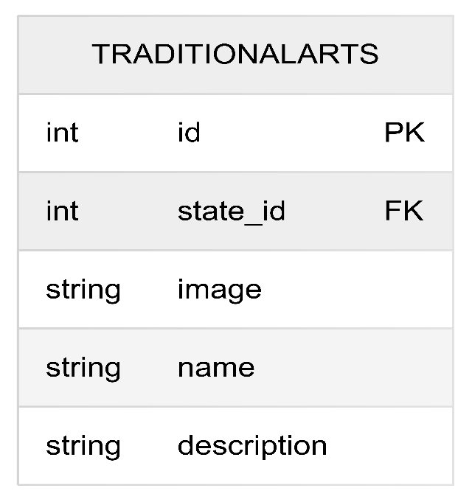
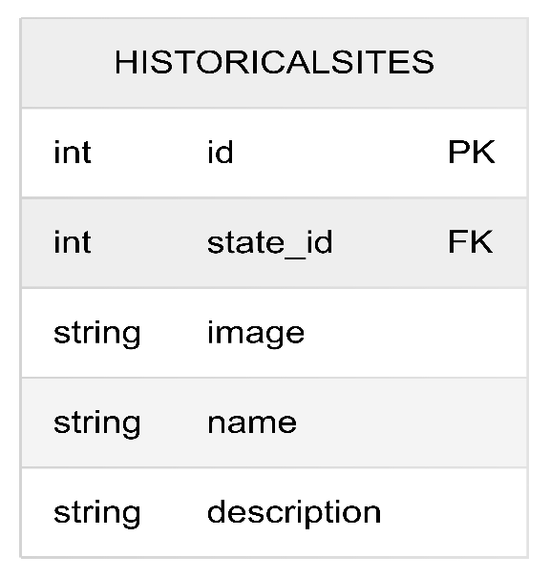
Fig. No. 4
Fig. No. 3
Fig. No. 1
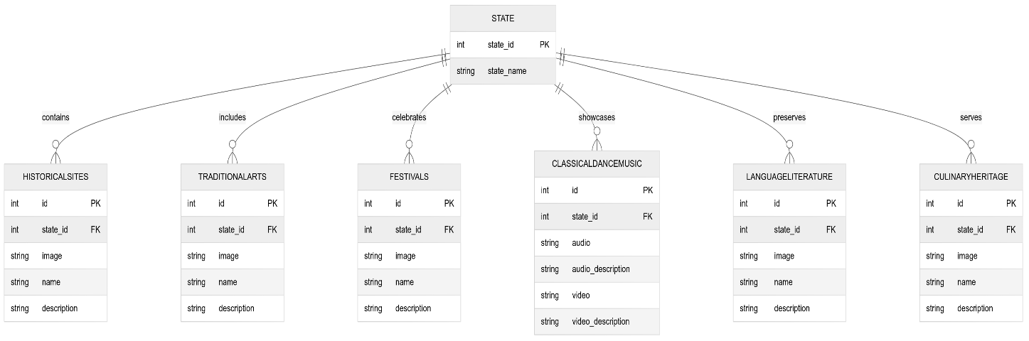
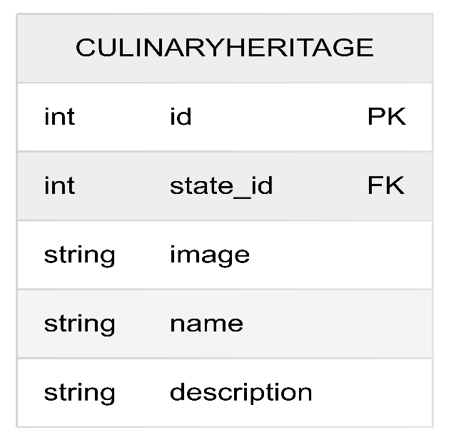
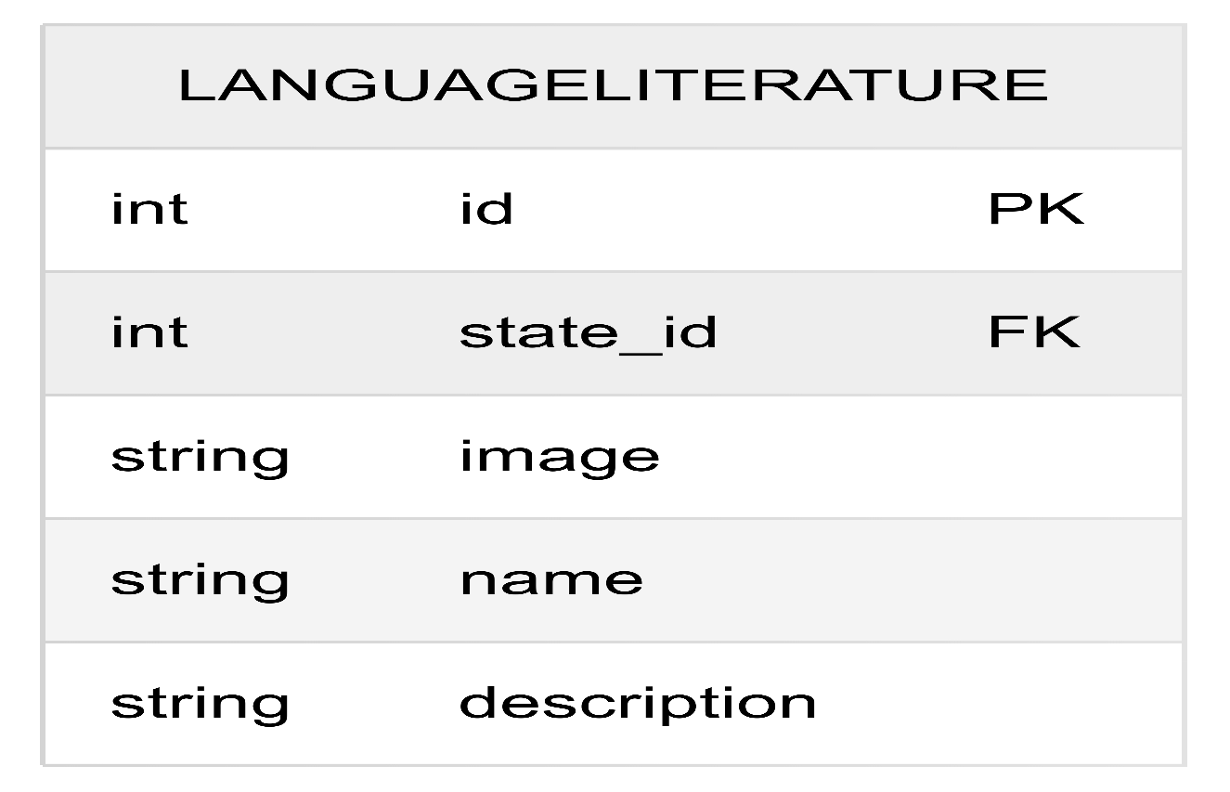
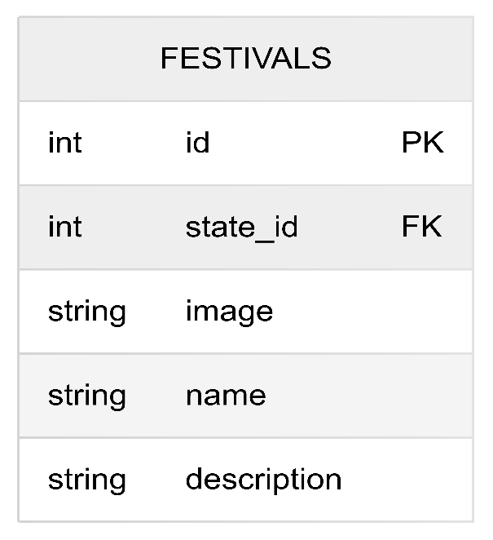
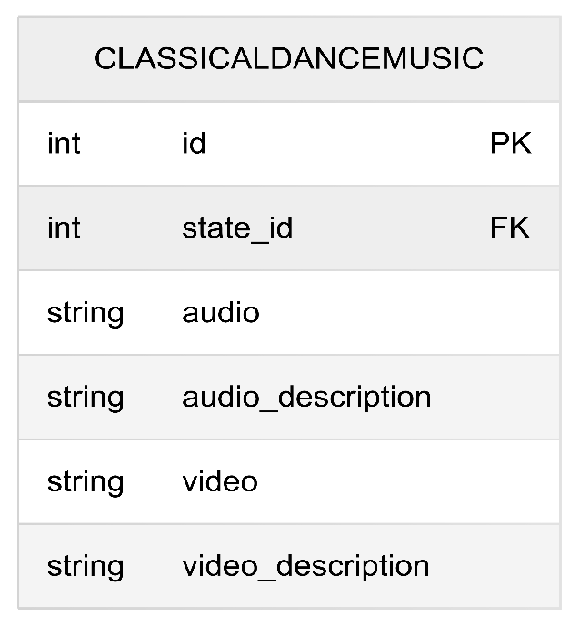
Fig. No. 9
Fig. No. 8
Fig. No. 7
Fig. No. 5
Fig. No. 6
5.2 DFD For Present System/Flowcharts In Both S/W And H/W Project:-
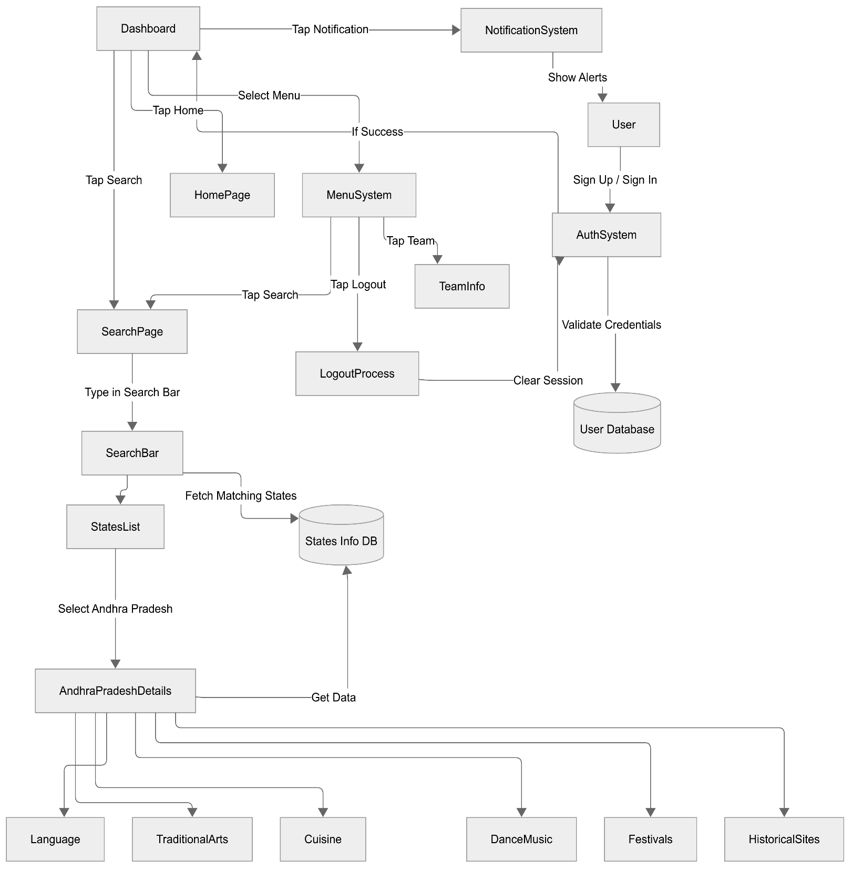
Fig. No. 10
6. CODE IMPLEMENTATION:-
6.1. Code :-
6.2. Snap Shots:-
Image – Splash Screen: "Dive Into a New Era"
- The screen showcases a beautiful sketch-style graphic of a historic Indian monument.
- Theme colors are warm shades of orange, brown, and cream, creating a heritage and cultural vibe.
- The main tagline reads "Dive into a New Era" along with its Hindi translation "एक नए युग में प्रवेश करें", emphasizing cultural integration.
- A single "Go Ahead" button is placed at the bottom, inviting users to move forward.
- Top-right corner displays a tab titled "Discover The Sport", suggesting that the app may relate to exploring sporting or cultural events.
- Design is simple, elegant, and focuses on storytelling through visuals.

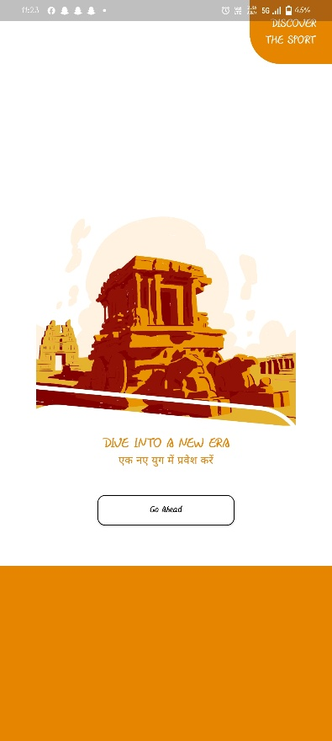
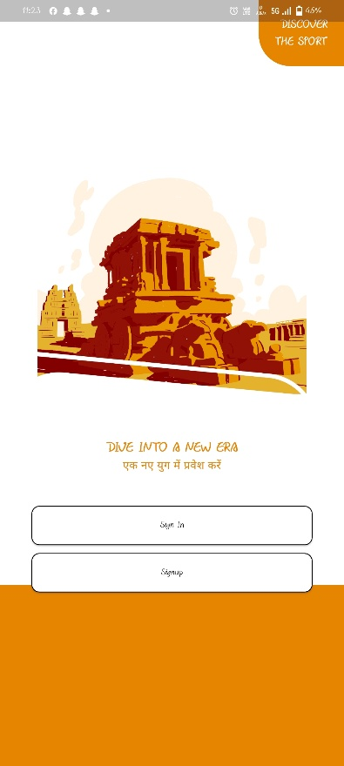
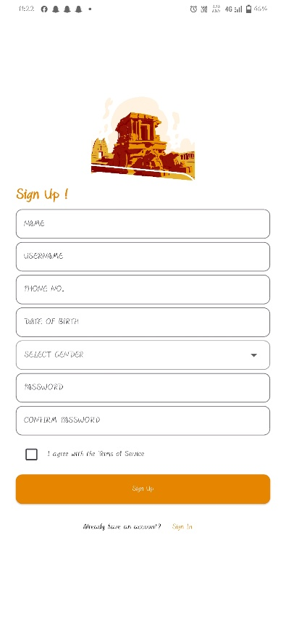
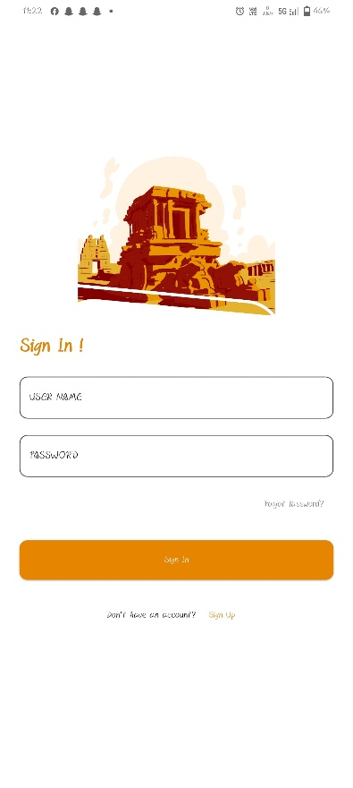
Image – Landing Page (Sign In / Sign Up Options)
- The historic monument graphic is reused, maintaining a strong visual identity and consistency.
- Two primary call-to-action buttons are displayed:
  - "Sign In" button for existing users.
  - "Sign Up" button for new users.
- Both buttons are styled uniformly with outlined borders, giving a neat and clean look.
- The background remains minimalist white, keeping user attention on the action choices.
- The orange branding at the top and bottom frames the screen, creating a cohesive theme.
- The user journey flows intuitively, offering clear next steps.
Fig. No. 12
Fig. No. 11
Image – Sign Up Page
- A detailed registration form collects comprehensive information:
  - Name
  - Username
  - Phone Number
  - Date of Birth
  - Gender (via a dropdown)
  - Password
  - Confirm Password
- A checkbox allows users to agree with Terms of Service, which is a standard practice for app registrations.
- A large orange "Sign Up" button facilitates account creation.
- Bottom prompt: "Already have an account? Sign In" for returning users.
- Like other screens, the monument image and color consistency is preserved.
- The layout is organized, ensuring easy data entry and a pleasant onboarding experience
Image – Sign In Page
- This screen is a login form where users are asked to provide:
- Username
- Password
- "Forgot Password?" is available to assist users who can't recall their credentials.
- A bold orange "Sign In" button is displayed prominently below the form.
- Below the Sign In button, there's a subtle prompt: "Don't have an account? Sign Up", providing easy navigation.
- Consistent use of the monument artwork and color palette ensures design coherence.
- The form is simple, user-friendly, and prioritizes quick access for returning users.
Fig. No. 13
Fig. No. 14
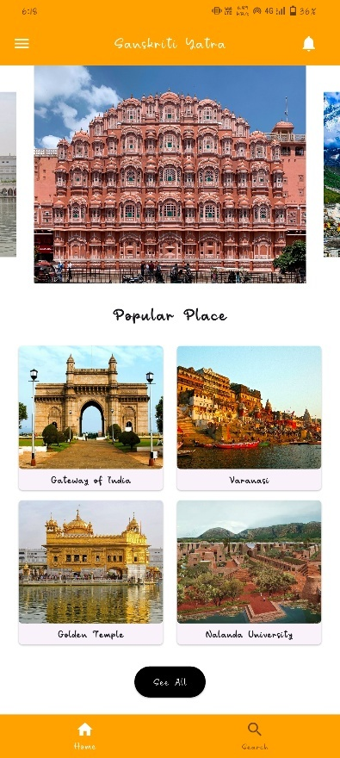
Home Screen
- Top Navigation Bar:
- Background Color: Vibrant orange.
- App Name: Sanskriti Yatra, centered in white font.
- Left: A menu button (hamburger icon) to open the side drawer.
- Right: A notification bell icon.
- Main Image Section:
- A large, beautiful, high-resolution image of Hawa Mahal (Jaipur, Rajasthan) is featured.
- It symbolizes Indian heritage and instantly sets a cultural tone.
- Popular Places Section:
- Title: Popular Places.
- Displays four famous Indian landmarks horizontally:
- Gateway of India (Mumbai, Maharashtra)
- Varanasi (Uttar Pradesh)
- Golden Temple (Amritsar, Punjab)
- Nalanda University (Bihar)
- Each place includes a small image and its name.
- Bottom Navigation Bar:
- Orange colored.
- Contains two icons: Home and Search.

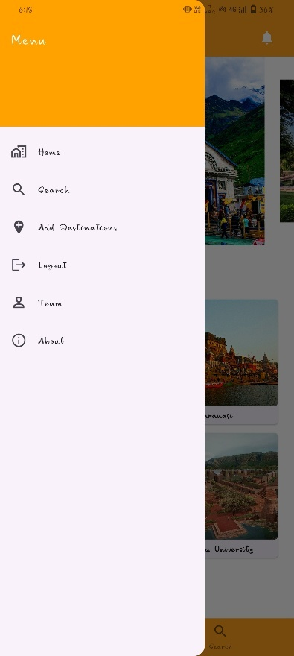
Side Navigation Menu
- Accessed by clicking the hamburger icon.
- Background: White, with black text and icons.
- Menu Options:
  - Home
  - Search
  - Add Destinations
  - Logout
  - Team
  - About
- The simplicity ensures the user is not overwhelmed and can easily navigate.
Fig. No. 16
Fig. No. 15
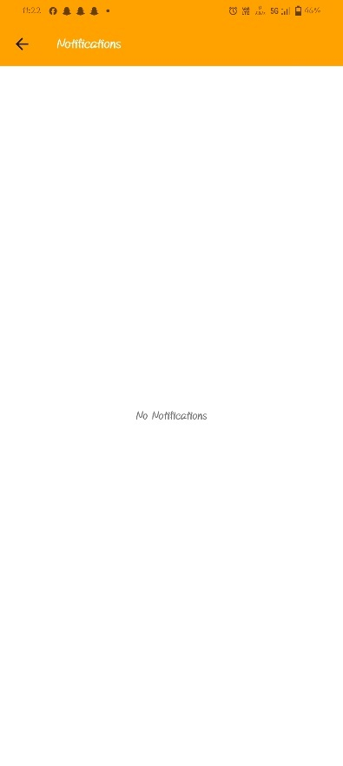
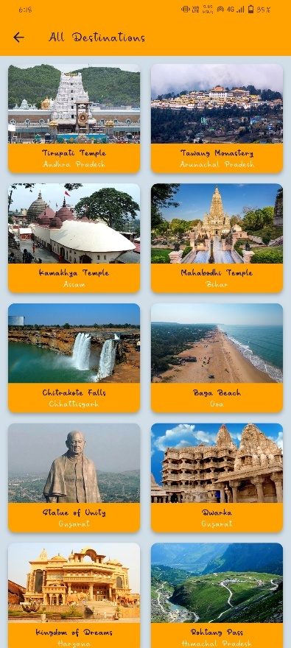
Notifications Screen
- Top Bar: Orange, with the title "Notifications."
- Main Content:
  - A centered message: "No Notifications".
- Very clean and minimalistic design for better focus when notifications are
Fig. No. 18
All Destinations Screen
- Title: All Destinations.
- A vertically scrollable list showing major Indian tourist spots from various states.
- Each destination is displayed in a card format with:
  - A thumbnail image.
  - The name of the place.
  - The state it belongs to.
- Destinations Included (examples):
  - Tirupati Temple (Andhra Pradesh)
  - Tawang Monastery (Arunachal Pradesh)
  - Kamakhya Temple (Assam)
  - Mahakaleshwar Temple (Madhya Pradesh)
  - Chitrakote Falls (Chhattisgarh)
  - Baga Beach (Goa)
  - Statue of Unity (Gujarat)
  - Qutb Complex (Gujarat)
  - Kingdom of Dreams (Haryana)
  - Nathula Pass (Sikkim)
- Visual Style:
  - Modern and colorful.
  - Easy to scroll and explore.
Fig. No. 17
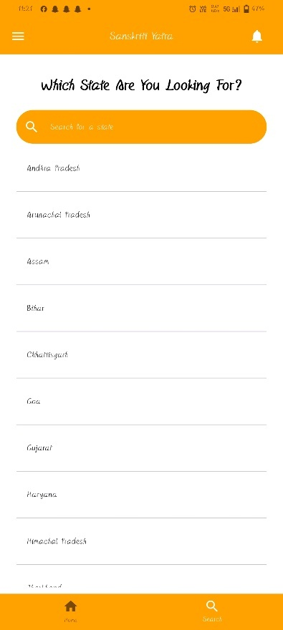
Search Screen
- Heading: "Which State Are You Looking For?"
- Search Bar:
- Allows users to type and find states easily.
- State List:
- A vertically scrollable list of all Indian states.
- Example states shown:
  - Andhra Pradesh
  - Arunachal Pradesh
  - Assam
  - Bihar
  - Chhattisgarh
  - Goa
  - Gujarat
  - Haryana
  - Himachal Pradesh
- Design:
  - Very organized.
- White background with grey dividing lines between states.
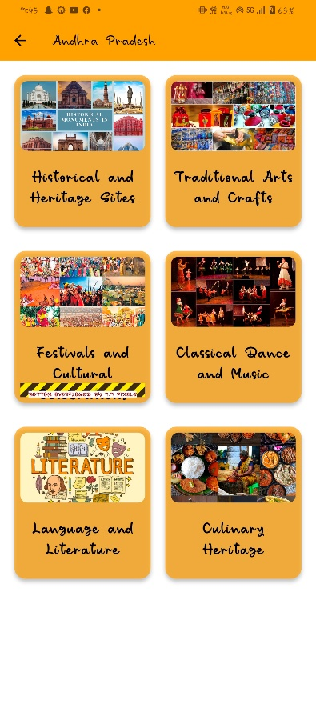
State Categories Screen (Example: Andhra Pradesh)
- After selecting a state like Andhra Pradesh, the user is taken to a categories page.
- Categories include:
  - Historical and Heritage Sites
  - Traditional Arts and Crafts
  - Festivals and Cultural Events
  - Classical Dance and Music
  - Language and Literature
  - Culinary Heritage
- Layout:
  - Each category is displayed in a colorful card format.
  - Each card has a background image relevant to the theme.
- Purpose:
- Allows deep exploration of a state’s culture.
Fig. No. 20
Fig. No. 19
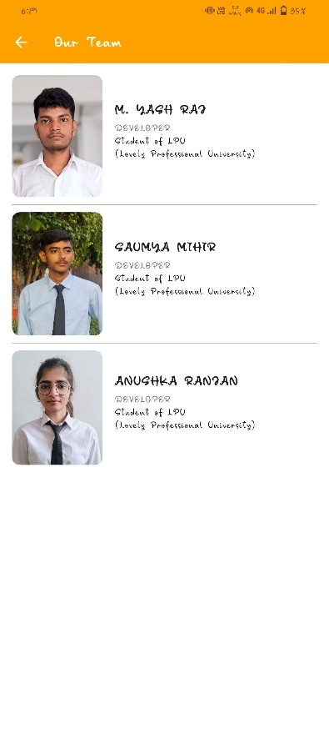
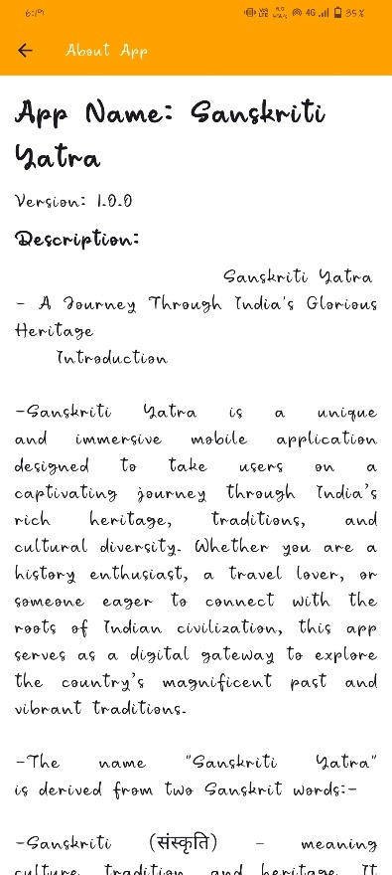
About App Screen
- Title: About App.
- App Name: Sanskriti Yatra.
- Version: 1.0.0.
- Description:
  - Sanskriti Yatra is introduced as an immersive mobile app that acts as a digital guide to India’s rich cultural heritage.
  - Designed for travelers, culture enthusiasts, and anyone who loves exploring Indian traditions.
  - It connects users to historical sites, art, dance, music, literature, and more.
  - The description explains that "Sanskriti Yatra" means "Cultural Journey", reflecting the app's purpose: taking users on a virtual cultural tour across India's diverse states.
- Tone:
  - Formal and inspiring.
  - Emphasizes the vibrancy, diversity, and beauty of Indian culture.
Team Screen
- Title: Our Team.
- Introduces the developers:
  - M. Yash Raj (Developer)
  - Saumya Mihir (Developer)
  - Anushka Ranjan (Developer)
- All are listed as Students of Lovely Professional University (LPU).
- Each member has:
  - A photo
  - Name
  - Role/position
- Design:
- Professional, clean cards for each team member.
Fig. No. 22
Fig. No. 21
7. BIBLIOGRAPHY:-
7.1 Flutter Documentation (https://docs.flutter.dev/)
7.2 Dart Programming Language Documentation (https://dart.dev/guides)
7.3 REST API Tutorials from freeCodeCamp and GeeksforGeeks
7.4 MongoDB Official Documentation (https://www.mongodb.com/docs/)
7.5 Google Scholar (for references related to Indian cultural heritage)
7.6 "Flutter for Beginners" by Alessandro Biessek, Packt Publishing
7.7 "Learning MongoDB" by Saurabh Badhwar, Packt Publishing

