

**DY PATIL INTERNATIONAL UNIVERSITY**

**Project Report**

**On**

**UPI Banking System**

**Software Engineering & Project Management**

**BTECH CSE – 3rd Year (V Sem)**

Submitted By - Sagar Rajkumar Gupta

PRN – 20200802112

Submitted To- Sandhya S Jawale

**1.Abstract -**  After demonetization, there was a massive requirement for currency notes, but the government was unable to provide the required quantity of currency notes, and also Indian government wanted to promote cashless transactions. UPI is built over Immediate Payment Service (IMPS) for transferring funds using Virtual Payment Address (a unique ID provided by the bank). Unified Payments Interface is a payment system launched by (NPCI), which is National Payments Corporation of India, and is regulated by the (RBI) Reserve Bank of India, which provides the facility of instant fund transfer between two bank accounts online through payment apps. Digital transactions by UPI have been made very easy. The UPI service is available 24X7, and it is not like RTGS and NEFT, which do not work on holidays and non-banking hours. This will bring tremendous efficiency to the system and help India become a cashless economy.

Unified Payments Interface (UPI) is a system that have powers to control multiple bank accounts inti a single mobile application or web-based application and merging several banking features, Seamless fund transform and merchant payment into a one place.

**Keywords –** P2P, P2M, Real Time Transactions, VPA, NPCI, RTGS & NEFT, IMPS

**2. Introduction –**

The “Digital India” is the Indian Government’s flagship program with a vision to convert India into a digitally empowered country. “Faceless, Paperless, Cashless” is one of supposed function of digital India.

To avoid the Security Risks and make long payment process and to maintain the data about all the transaction, National Payments Corporation of India (NPCI) has introduced Unified Payments Interface (UPI) instant payment system.

**Types of transactions supported by UPI:**

1. Financial transactions

**Pay Request**: A transaction where the initiating customer ‘pushes’ funds to the intended beneficiary. Payment address includes mobile number and MMID, account number with IFSC, and Virtual ID

**Collect Request**: A transaction where the customer is ‘pulling’ funds from the intended remitter by using a Virtual ID.

1. Non-financial transactions

UPI will support the following types of non-financial transactions on any PSP app.

1. Registration for mobile banking
2. One Time Password (OTP) generation
3. Set/change PIN
4. Transaction status check
5. Raising disputes/queries

**Virtual Private Address –** Virtual Payment Address (VPA) Virtual Payment Address also referred to as VPA is something like an email-ID, which is given to an individual using the Unified Payment Interface (UPI) service to send or receive money. With UPI, fund transfers can be initiated without an IFSC code or bank account number.

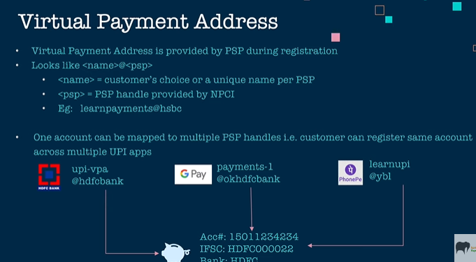

1. **Project Aims & Objectives** – In this we have to make such a UPI app in that user will get all the requirements in a one app such as: -
2. Transaction between different bank merchant with less fee charges
3. To Provide the discounts and cashbacks
4. Digital Record of the transactions
5. One Stop Solutions to pay all bills
6. Helps keep black money under control
7. To provide security for money transaction
8. To provide service all these service 24*7
9. **Background Of Project** –

**The genesis of India’s unified payment solution**

Prior to 2016, India used a number of different systems to transfer money between banks. The traditional forms included RTGS, IMPS and NEFT. With the plethora of systems, rules and growing paper burden, there was a need for a unified system that could automate and standardize India’s payment platforms. In 2016, NPCI set out with a mandate to change the face of India’s payment systems. It developed the Unified Payments Interface (UPI) as an architecture framework with a set of standard Application Programming Interface (API) specifications to facilitate online payments. The aim was to simplify and provide a single interface across all NPCI systems, thereby creating interoperability and a superior customer experience. The pilot program, with 21 member banks, was launched on 11th April, 2016, by Dr. Raghuram G. Rajan, Governor, RBI, in Mumbai. From 25th August, 2016, a growing number of banks started to upload their UPI enabled apps to the Google Play store.

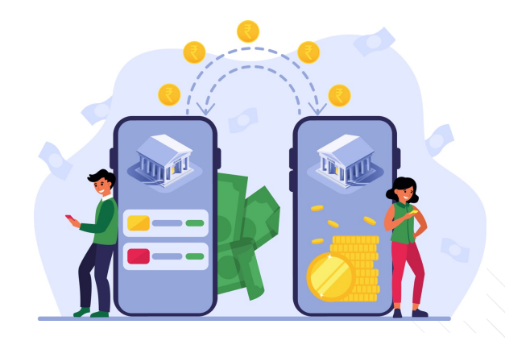

1. **Operational Environment –**
2. Downloading the UPI app
3. Register with your linked bank mobile number
4. Generate the UPI id
5. To complete KYC of your profile
6. Generate the UPI pin
7. To give the security by adding (Fingerprint, Pin, Password)
8. Adding Your bank account
9. To make payment use the Scanner or Direct Mobile Number option

**3.System Analysis –**

* SRS Document -
  1. SRS stands for “Software Requirement Specification”. It is a document prepared by the business analyst or system analyst.
  2. It is describing what will be the features of Software and what will be its behavior.
  3. It is the detail description of software to be developed with its **Functional and Non-Functional** requirement.
  4. In order to get all the details of the software from the customer and to write the SRS document system analyst is required.
  5. SRS document is actually an agreement between the client and Project Manager.

To create the SRS Document, we have two types of requirements: -

1. Functional Requirement of the software
2. Non-Functional Requirement of the software

To brief introduction about Functional & Non-Functional Requirement- All those requirements that a System is supposed to perform or Function to fulfil some business needs are functional requirements and all those requirements which are to enhance or ease users’ capability to perform such functions and are like characteristics of a system come under Non-Functional requirements.

**Functional Requirement: -**

1. Login: User should be able to Login to Our Upi application
2. Complete KYC – User should have to complete their KYC by updating the bank account details, Aadhar card, pan card.
3. Pay: Registered User should be able to Pay money to other user either by Scanning QR code or using Mobile number, or UPI ID,
4. UPI Money Transfer: Registered User should be able to transfer money to any other User using his UPI ID or mobile number.
5. Add Money: Registered User should be able to add money to Our Upi wallet and then can later use that money anytime for various things.
6. Recharge and Pay Bills: Registered User should be able to recharge or pay bills for Prepaid/Postpaid, DTHBroadband/Landline, Electricity, Piped Gas Bill, Book a cylinder, Credit card payments, Insurance/LIC premium, Loan
7. Travel and Flight: Registered User should be able to book any Domestic or international flights and hotels.
8. Balance and History: In this registered user can track their bank account and wallet balance. And User can also track their previous payment history.
9. To get exclusive offer and cashbacks: Here user can get exclusive offers and deals for their payment like to get discount at shopping platform, making recharges, and making payment for the health medicines.

**Non-Functional Requirement –**

* Application should be able to handle large number users transaction without going down.
* To provide the security of the users data of their bank account details, providing we will have 2 Factor Authentication system (External security, OTP Verification).
* Requires iOS 10.0 or up. Compatible with iPhone, iPad and iPod touch. Requires Android 4.1 and up. Compatible with Android smartphone, tablet and web-based software.
* It should only allow 30 transactions in a day and also set the limit the highest limit at 5 Lakh.
* To providing the help support section to the solve customer query by using the Customer Care Number and Chatbot Application.
* To keep adding bonding with the user providing exclusive offer deals notification and also get a chance to receive money from our app by giving the referrals.

**Existing System –**

* **With all payment s with cash: -** In past days there were no trend of digital payment that time people were doing payments with the cash itself.
* Banking cards: Cards are among the most widely used payment methods and come with various features and benefits such as security of payments, convenience, etc. The main advantage of debit/credit or prepaid banking cards is that they can be used to make other types of digital payments. For example, customers can store card information in digital payment apps or mobile wallets to make a cashless payment. Some of the most reputed and well-known card payment systems are Visa, Rupay and MasterCard, among others. Banking cards can be used for online purchases, in digital payment apps, PoS machines, online transactions, etc.
* USSD - Another type of digital payment method, *99#, can be used to carry out mobile transactions without downloading any app. These types of payments can also be made with no mobile data facility. This facility is backed by the USSD along with the National Payments Corporation of India (NPCI). The main aim of this type of digital payment service is to create an environment of inclusion among the underserved sections of society and integrate them into mainstream banking. This service can be used to initiate fund transfers, get a look at bank statements and make balance queries. Another advantage of this type of payment system is that it is also available in Hindi.
* Mobile Banking: Mobile banking is referred to the process of carrying out financial transactions/banking transactions through a smartphone. The scope of mobile banking is only expanding with the introduction of many mobile wallets, digital payment apps and other services like the UPI. Many banks have their own apps and customers can download the same to carry out banking transactions at the click of a button. Mobile banking is a wide term used for the extensive range or umbrella of services that can be availed under this.
* Bharat Interface for Money (BHIM) app: The BHIM app allows users to make payments using the UPI application. This also works in collaboration with UPI and transactions can be carried out using a VPA. One can link his/her bank account with the BHIM interface easily. It is also possible to link multiple bank accounts. The BHIM app can be used by anyone who has a mobile number, debit card and a valid bank account. Money can be sent to different bank accounts, virtual addresses or to an Aadhaar number. There are also many banks that have collaborated with the NPCI and BHIM to allow customers to use this interface.
* Paytm Upi App**:** Paytm was founded on August 2010 with an initial investment of US$2 million by founder Vijay Shekhar Sharma in Noida, India. It started off as a prepaid mobile and DTH recharge platform, and has expanded to a leading digital payments and financial services company, with a diverse range of offerings spanning from partner-based lending to offline devices.

In 2014, the company had launched the Paytm Wallet that stirred the digital payments revolution in the country. Paytm launched BHIM UPI and also became India's first payment app to cross over 10 crore app downloads in 2017. In 2018, the company launched the ‘Paytm for Business’ app for merchants, allowing them to accept money through Paytm Wallet, UPI and card payments directly into their bank accounts at 0% charge.

* Phonepe Upi App**:** PhonePe’s was incorporated in December 2015. In April 2016, the company was acquired by Flipkart and as part of the acquisition, the FxMart license was transferred to PhonePe and rebranded as the PhonePe wallet. PhonePe's founder Sameer Nigam was appointed as the CEO of the company

In August 2016, the company partnered with Yes Bank to launch a UPI-based mobile payment app, based on the government-backed UPI platform.

**Proposed System –** We are designing such a Upi Management app for the android and web-based software, in that user has different category at one place. To solve the previous existing problem by this we are adding new functionality and making previous functionality to next level

* For making KYC full and started merchant business account we are opening more kyc point.
* Quick Help Support to the customer.
* Messaging Feature
* Contact Directory to make payment by the number or searching name.
* the process sometimes gets paused and can sometimes also fail, leaving the money stuck in between the sender and the receiver.
* To minimize the time to make payment.
* Proving the more payment limit and increase the number of payments in a day.
* Providing the ticket booking facility such as (Movie Tickets, Flight Tickets, Train and Bus Ticket).

**Software & Hardware:**

Software Configuration:

* Operating System Windows, Android
* Environment Visual Studio NET 2005 4.6
* Language Visual Basic, MySQL
* Back-end MS Access

Hardware Configuration:

* Processor Pentium III 866 MHz
* RAM 256 MB
* Monitor 15.5’’
* Hard Disk 60 GB
* Keyboard QWERTY Keyboard
* Mouse 2 buttons

**4.System Design -**

* **Table Design:** This is short overview of each module entity like in that what are the features available in that.

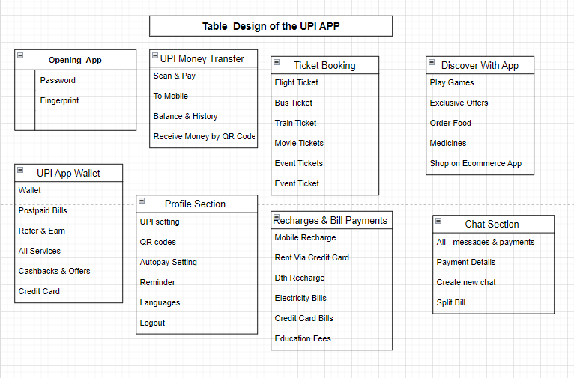

**Er Diagram** – **ER Diagram** stands for Entity Relationship Diagram, also known as ERD is a diagram that displays the relationship of entity sets stored in a database. In other words, ER diagrams help to explain the logical structure of databases. ER diagrams are created based on three basic concepts: entities, attributes and relationships.

ER Diagrams contain different symbols that use rectangles to represent entities, ovals to define attributes and diamond shapes to represent relationships.

At first look, an ER diagram looks very similar to the flowchart. However, ER Diagram includes many specialized symbols, and its meanings make this model unique. The purpose of ER Diagram is to represent the entity framework infrastructure.

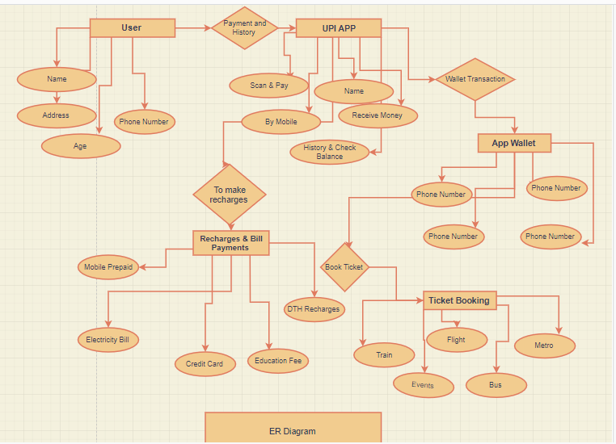

**Gantt Chart - Generalized Activity Normalization Time Table (GANTT) chart** is type of chart in which series of horizontal lines are present that show the amount of work done or production completed in given period of time in relation to amount planned for those projects. It is horizontal bar chart developed by Henry L. Gantt (American engineer and social scientist) in 1917 as production control tool. It is simply used for graphical representation of schedule that helps to plan in an efficient way, coordinate, and track some particular tasks in project.

The purpose of Gantt chart is to emphasize scope of individual tasks. Hence set of tasks is given as input to Gantt chart. Gantt chart is also known as timeline chart. It can be developed for entire project or it can be developed for individual functions. In most of projects, after generation of timeline chart, project tables are prepared. In project tables, all tasks are listed in proper manner along with start date and end date and information related to it.

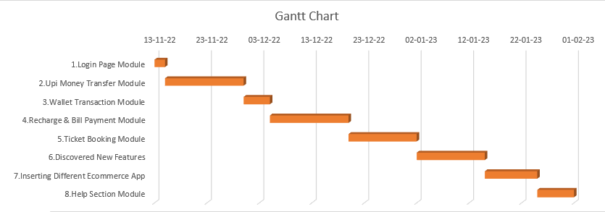

Pert Chart - Project Evaluation and Review Technique (PERT) is a procedure through which activities of a project are represented in its appropriate sequence and timing. It is a scheduling technique used to schedule, organize and integrate tasks within a project. PERT is basically a mechanism for management planning and control which provides blueprint for a particular project. All of the primary elements or events of a project have been finally identified by the PERT.

In this technique, a PERT Chart is made which represent a schedule for all the specified tasks in the project. The reporting levels of the tasks or events in the PERT Charts is somewhat same as defined in the work breakdown structure (WBS).

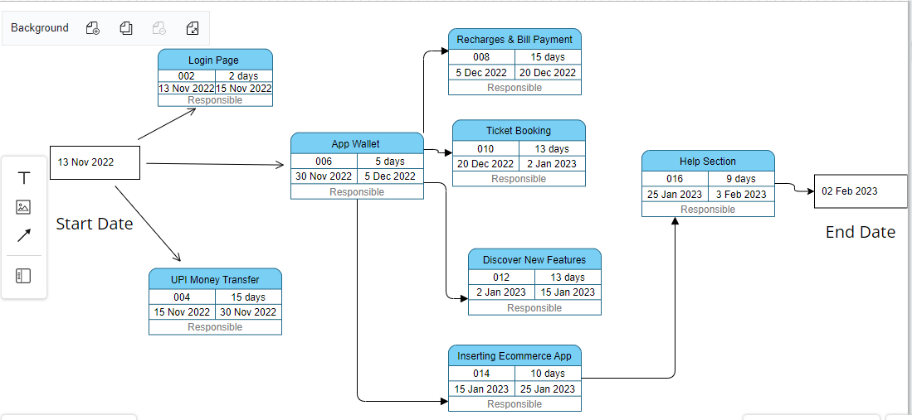

DFD Diagram - **DFD** stands for **Data Flow Diagram**. The flow of data of a system or a process is represented by DFD. It also gives insight into the inputs and outputs of each entity and the process itself. Data Flow Diagram can be represented in several ways. The DFD belongs to structured-analysis modeling tools. Data Flow diagrams are very popular because they help us to visualize the major steps and data involved in software-system processes.

It also known as Bubble Chart.

**Element Of DFD –**

* Source or Links –
* Data Flow –
* Data Store or Database –
* Process-

#### Levels of DFD

DFD uses hierarchy to maintain transparency thus multilevel DFD’s can be created. Levels of DFD are as follows:

* 0-level DFD:
* 1-level DFD:
* 2-level DFD:

**Level 0 :**

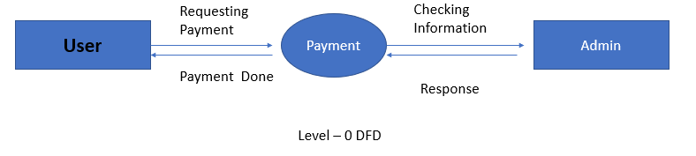

**Level 1:**

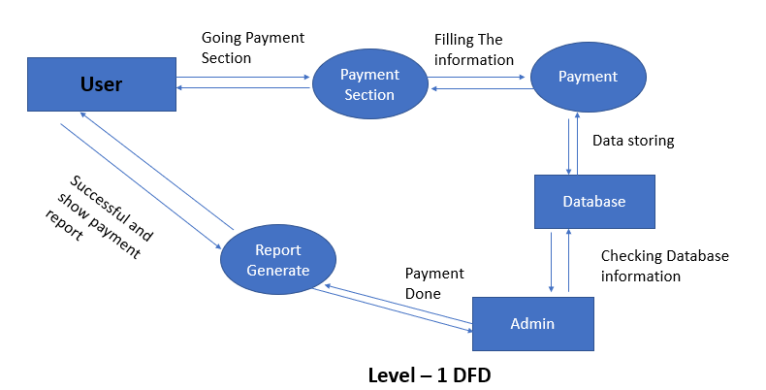

**Level 2:** 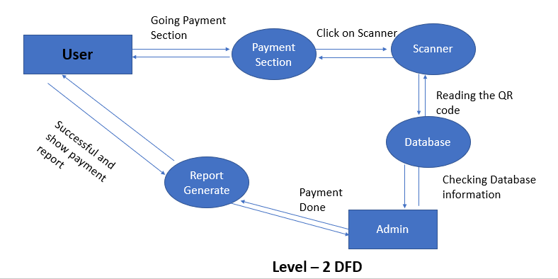

**Difference Between Gantt Chart & Pert Chart:**

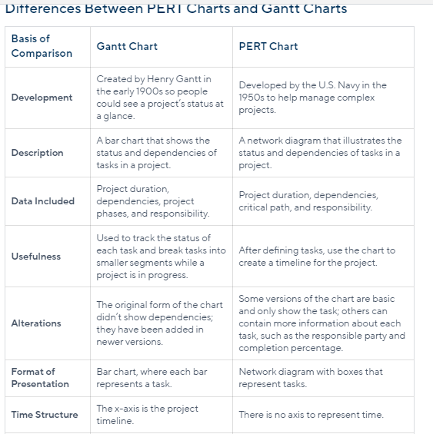

**5.Module Description -**

* **Login Page –** Here in this module user have to register with our software by creating his/her account on the software. Also, it has option like Create Username & Password, Forget, Captcha, Sign In with Google account.

Username

Password

Forget Password

Sign Up 

Sign In 

* **Upi App Transaction –** In this module user can make transaction by Scan & Pay, by mobile number, By Bank Account Details, for getting money receive money option and also check their account balance.

Pay By Scanner

Pay By Mobile Number

Pay By Bank Account

Receive Money

Check Account Balance

* **App Wallet –** In this module user will get facility of app wallet means payment without bank account. And also get the different features like Add money, make different payment, pay later service, Cashback Offers, Automatic Add money, Track transaction by passbook, Set reminder for the payment.

Add Money

Make Different Payment

Cashback Offers

Automatic Add Money

Track Transaction by Passbook

Set Reminder for payment

* **Ticket Booking –** In this module user will get different booking services like Flight, Train, Metro, Event and Bus Booking by both the way like UPI and wallet transaction.

Flight Ticket Booking

Bus Ticketing Booking

Train Ticket Booking

Movie Ticket Booking

* **Recharges & Payments –** Here in this module user will have different types of bill and recharge payments. Like Recharges, Pay Your Home Bills, Financial Bills, Transit, Other Services.

Recharges

Transit

Other Services

Financial Bills

Pay Home Bills

* **Discover** **New Things –** Here we are providing new features to the customer like Different Games, Exclusive Offer Details, Order Food Apps, Medicines Delivery App, Ecommerce Apps.

Ecommerce Apps

Medicine Delivery App

Food Ordering App

Exclusive Offer Deals

Different Games

**6.System Testing:** Software testing can be stated as the process of verifying and validating whether a software or application is bug-free, meets the technical requirements as guided by its design and development, and meets the user requirements effectively and efficiently by handling all the exceptional and boundary cases.

The process of software testing aims not only at finding faults in the existing software but also at finding measures to improve the software in terms of efficiency, accuracy, and usability. It mainly aims at measuring the specification, functionality, and performance of a software program or application.

Different types of testing techniques:

1.**Black Box Testing:** The technique of testing in which the tester doesn’t have access to the source code of the software and is conducted at the software interface without any concern with the internal logical structure of the software is known as black-box testing.

2. **White-Box Testing:** The technique of testing in which the tester is aware of the internal workings of the product, has access to its source code, and is conducted by making sure that all internal operations are performed according to the specifications is known as white box testing.

**Software level testing can be majorly classified into 4 levels:**

1. **Unit Testing:** A level of the software testing process where individual units/components of a software/system are tested. The purpose is to validate that each unit of the software performs as designed.

Testcase 1 – Login Page

|  |  |  |
| --- | --- | --- |
| Test Cases | Expected Result | Test Result |
| 1.Enter Valid Name and Password | Software should display the home page | Successful |
| 2.Enter Valid Password and Invalid username | Software will throw error like wrong credentials | Successful |
| 3.Enter Invalid Password and valid username | Software will throw error like wrong credentials | Successful |
| 4.Forget Password | Password forget and generate new password | Successful |

Testcase 2 – Upi App Payment

|  |  |  |  |  |
| --- | --- | --- | --- | --- |
| Test Cases | Expected Result | | Test Result | |
| 1.Click on scanner | It will detect QR code and make payment successful. | | Successful | |
| 2.Enter Valid Mobile Number | Money Transfer to correct user bank account successfully. | | Successful | |
| 3.Enter Valid Bank details | It will analyze the bank details and give the output like it is being transfer to this user. And also give the message like payment success. | | Successful | |
| 4. Enter Invalid Bank details | It will give the notification like bank account details are wrong. | | Successful | |
| 5.History & Check Balance | | It will give the Our Current bank balance and show the history | | Successful |

Testcase 3 - Ticket Booking

|  |  |  |
| --- | --- | --- |
| Test Cases | Expected Result | Test Result |
| 1.Enter Valid details for the booking flight ticket | It will book the flight tickets | Successful |
| 2.Enter Valid details for Train Ticket | Ticket will be booked | Successful |
| 3.Enter the details about the events | Ticket Will be booked | Successful |

**2.Integration Testing:** A level of the software testing process where individual units are combined and tested as a group. The purpose of this level of testing is to expose faults in the interaction between integrated units.

After completing the unit testing of all the modules, the whole system is integrated with all its dependencies in that module. We integrated the modules one by one and tested the system at each step. This helped in reduction of errors at the time of the system testing.

* 1. **Conclusion -**

UPI has enabled mobile phone to be used as a primary payment device for making and accepting payments. UPI leverages high teledensity in India to enable every bank account holder to make digital transactions using a mobile phone. India, which has a poor merchant payment acceptance infrastructure UPI, enables even the smallest merchant to start accepting digital payments without the need for any POS machine. UPI has done away with the need to know the complicated payment details of the transacting parties, which makes payments easy and seamless for transacting parties.

Compared to all other payment systems it would not be misplaced to say that UPI is the most advanced payment system in the world. With its standard set of APIs, UPI has allowed different banks to communicate with each other and has enabled interoperability between disparate bank payment systems. In UPI there are no intermediaries like in card networks, which allows for low transaction costs and instant settlement.

UPI allows payment to be completed in seconds. UPI works on a safe, secure and robust platform with ample security features to make it more secure than any

extant payment systems. Introduction of biometric authentication in UPI will not only make payments more secure but will also take a huge leap towards integrating

next generation technology with current payments system

**7.Future Scope –** We will give new features in our app to give the user good experience and good connection between us. Tie up with more bank authorities and make system server faster than todays to make payment fast, Regular update with current world scenario and plan deals for customer. To allow for authorize transaction later date and time.

**8. References:**

* **https://www.npci.org.in/what-we-do/upi/product-overview**
* **https://www.npci.org.in/PDF/npci/upi/Product-Booklet.pdf**
* **https://business.paytm.com/docs/upi-solutions/**
* **http://14.99.188.242:8080/jspui/bitstream/123456789/14718/1/1NZ19MBA71.pdf**
* [**http://draw.to/new**](http://draw.to/new)
* **https://www.youtube.com/watch?v=tX7oPYXWwOM&t=1s**
* **https://www.youtube.com/watch?v=83-S5Qu6VP8 ### SRS video reference**
* **https://www.quora.com/What-are-some-functional-and-non-functional-requirements-for-Paytm # Quera Link**
* **https://www.geeksforgeeks.org/how-to-write-a-good-srs-for-your-project/**
* **https://www.researchgate.net/publication/320661583_Unified_Payment_Interface-An_Advancement_in_Payment_Systems**
* [**https://www.ijraset.com/research-paper/upi-challenge-and-direction-in-fund-management-with-banking-sector**](https://www.ijraset.com/research-paper/upi-challenge-and-direction-in-fund-management-with-banking-sector)
* **https://www.instamojo.com/blog/future-of-upi-payments-india-growth-expect/**