Siraaj Wilkinson

Group: B

214068730

Technical Programming 2

Assignment 1

28 February 2016

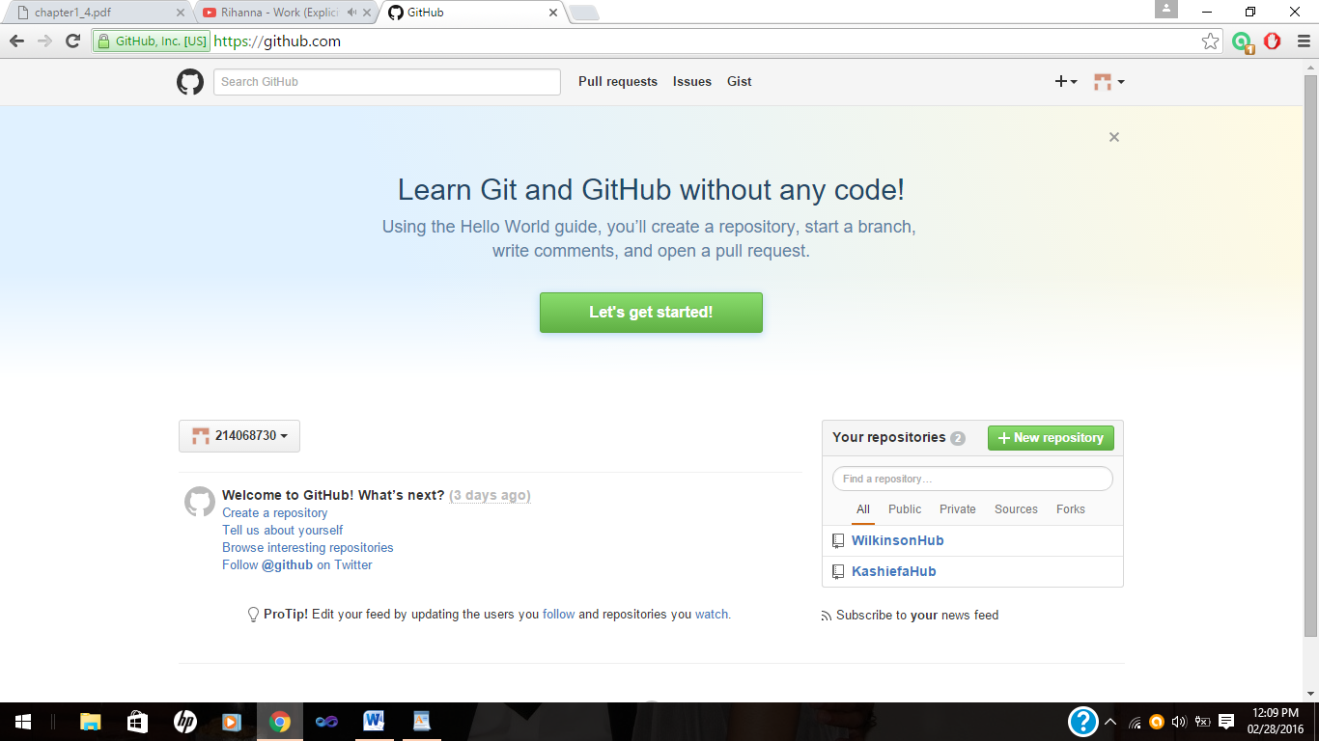1.

Github created.

2.1

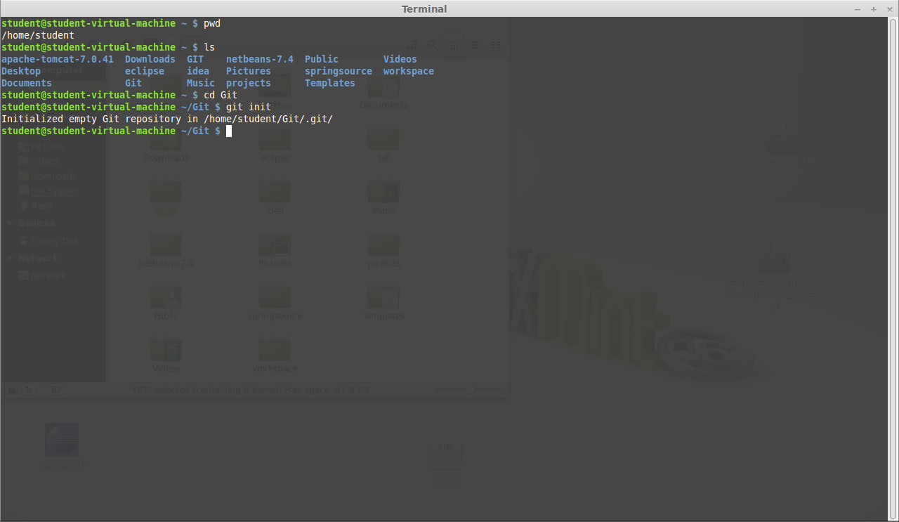Initializing git repository into Git folder.

2.2

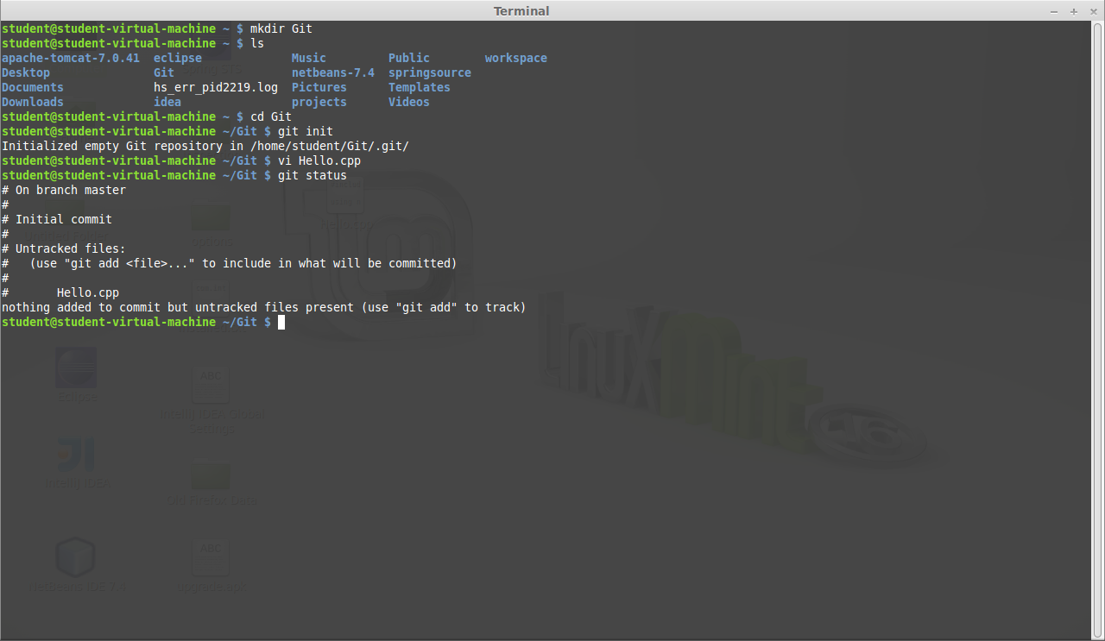

The file is not being tracked by git meaning git cannot check what is being added or removed to the file. The File has not yet been added to the git index

2.3

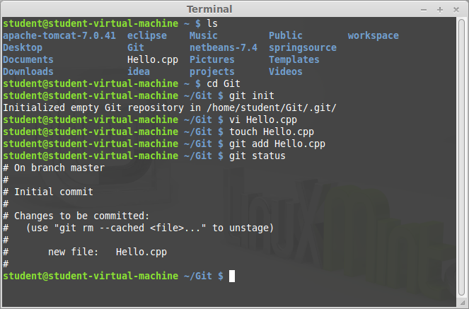

File has been tracked using the git add command the file, the file is tracked and staged to be committed.

2.4

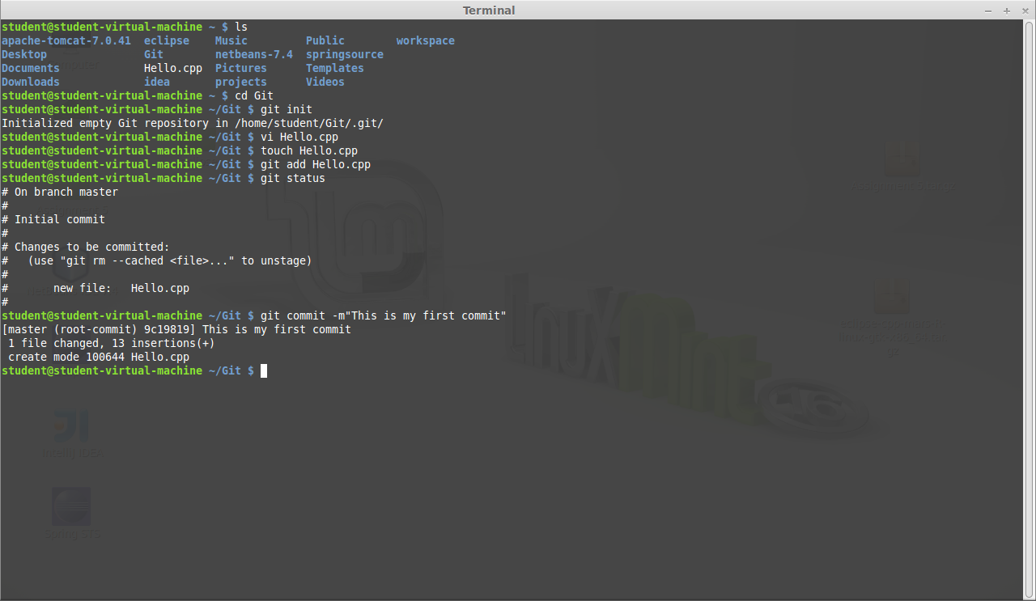File has been committed using the git commit command, the changes made to the file has been recorded to the repository.

2.5

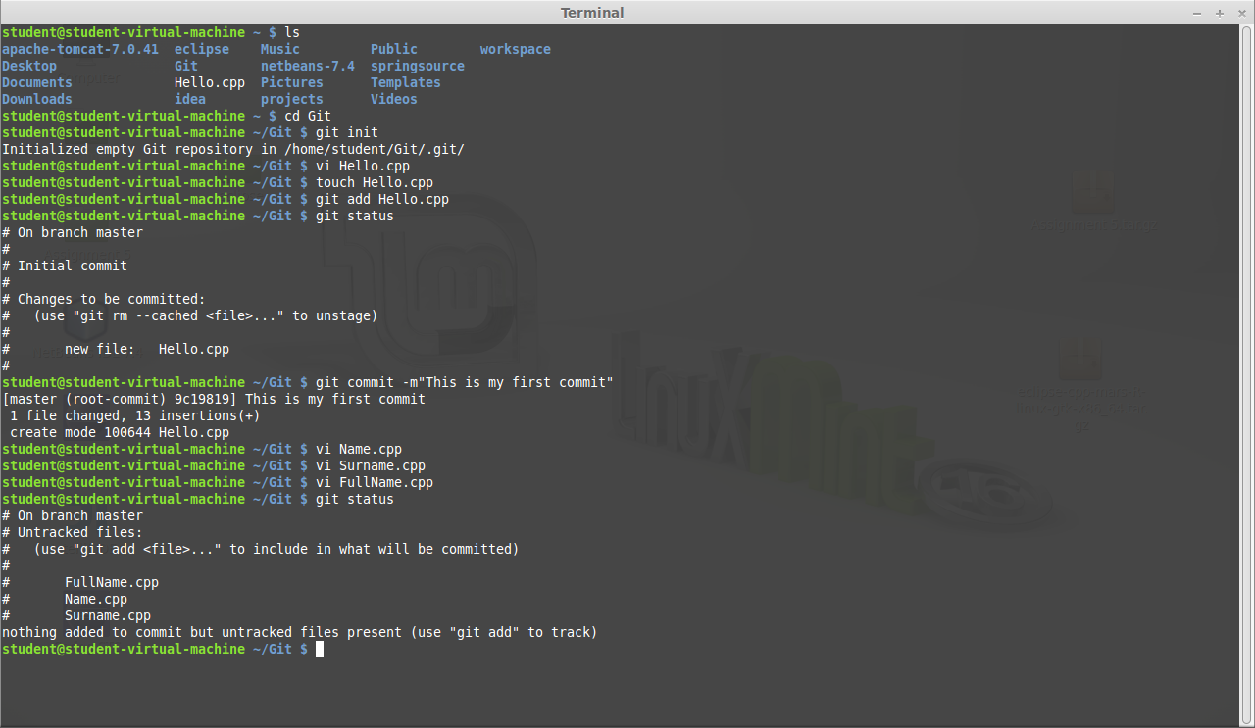

Three files have been created. The files are unstaged because they have not been tracked by git they are not staged to be committed.

2.6

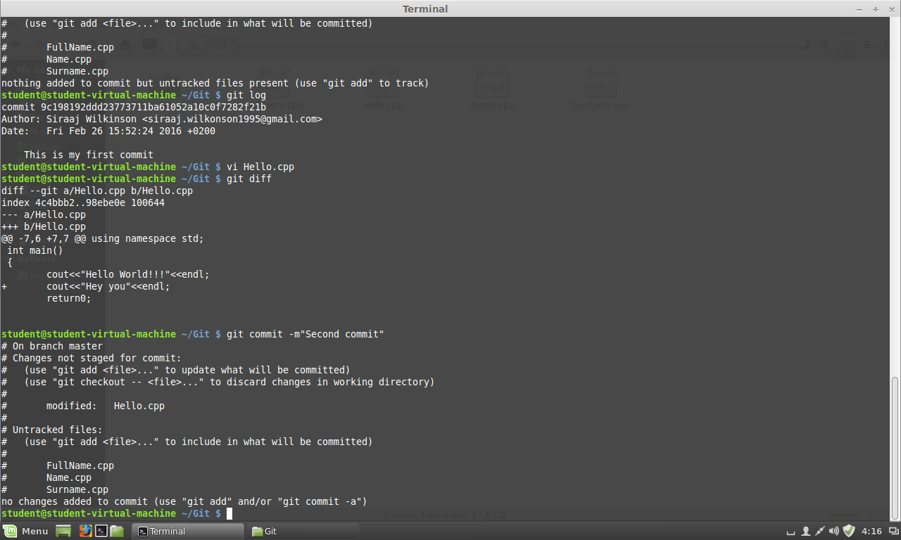

Changes made to the committed file Hello.cpp by using the git diff command you can see what has been added to the tracked file.

2.7

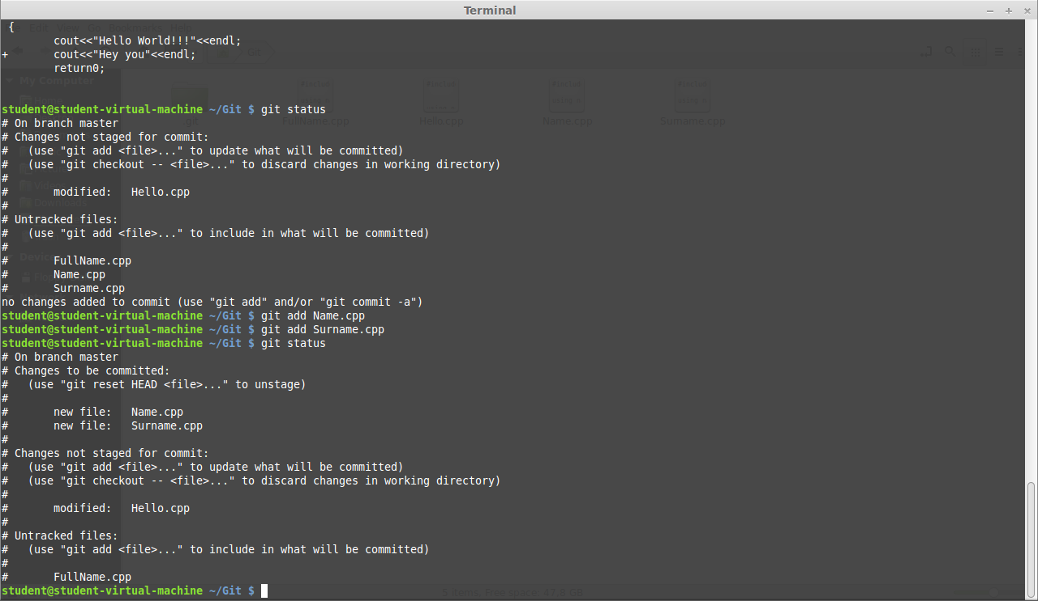

Two files have been tracked by git. The files are staged to be committed, leaving on file that is still untracked.

2.8

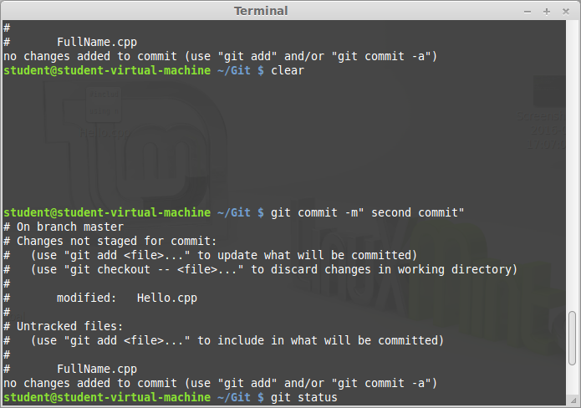

Hello.cpp file had be committed.

2.9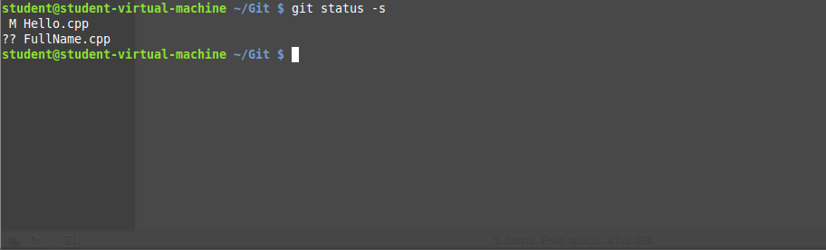

Short status using the git status –s command

2.10 And 2.11

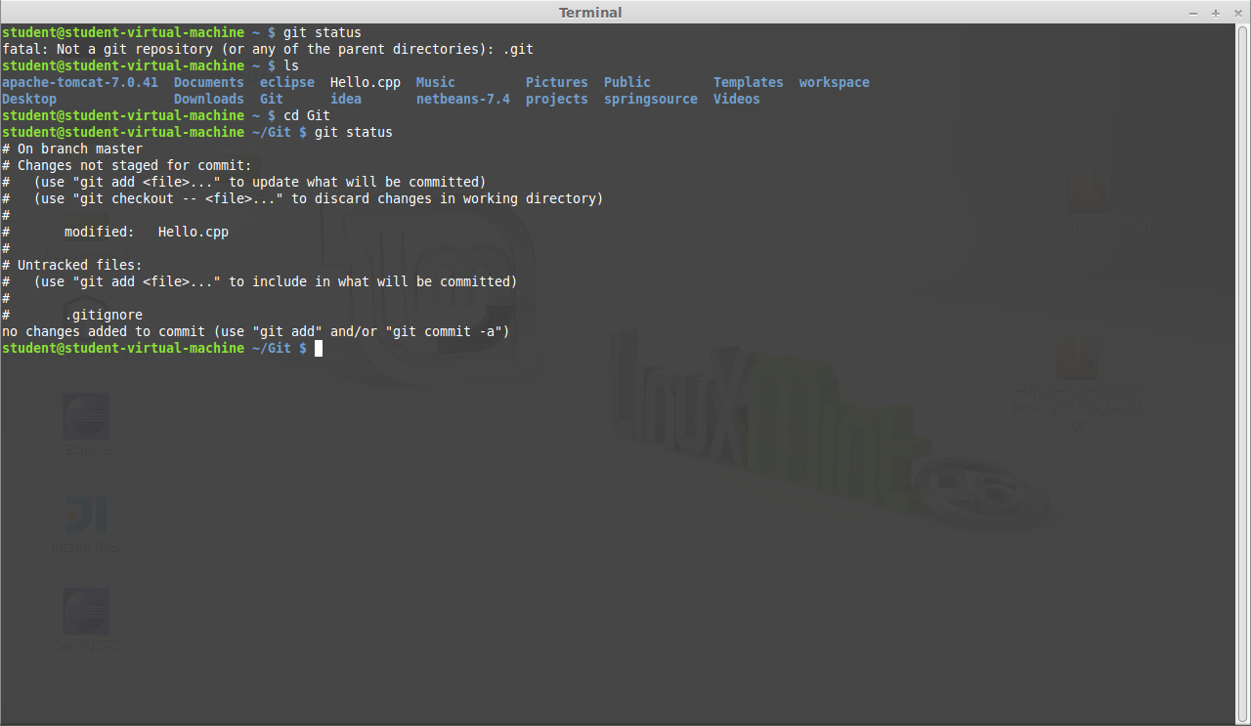

Git ignores the FullName.cpp file.

2.12

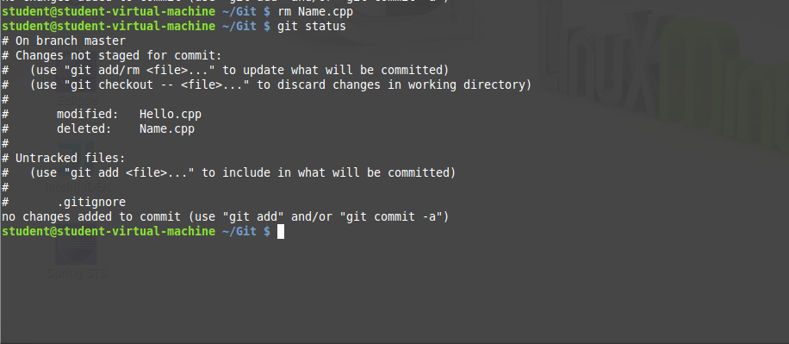

Removing the Name.cpp file for the local repository.

2.13

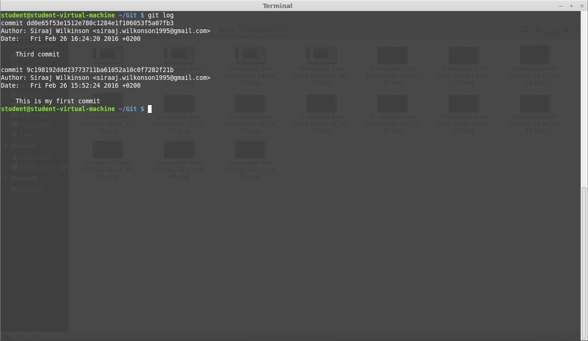

Commit history using the git log command.

3.1

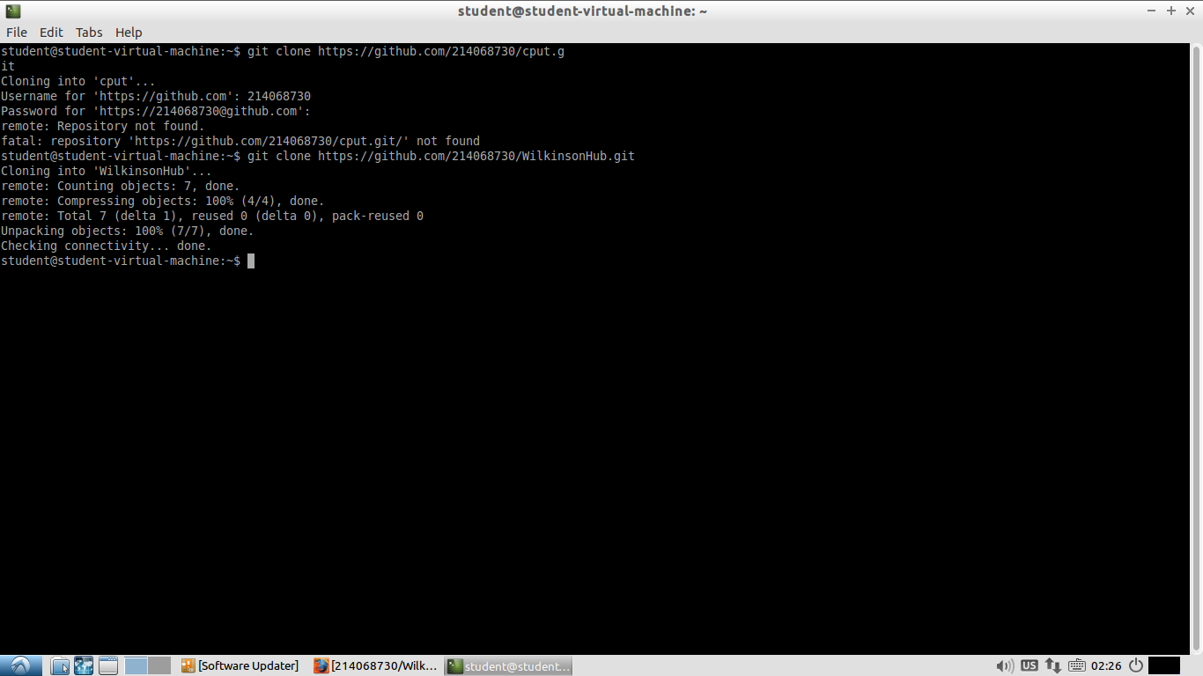

Cloning github repository using the git clone command

3.2

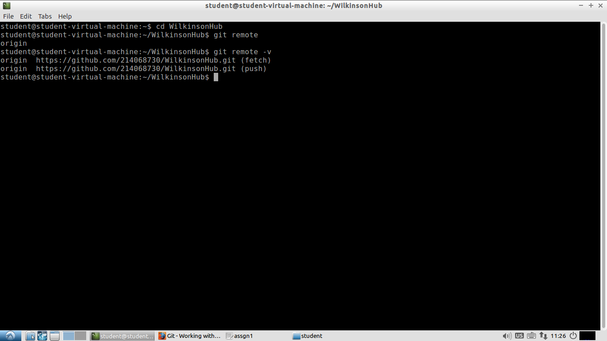

Viewing remote using the git remote and git remote –v commands

3.3

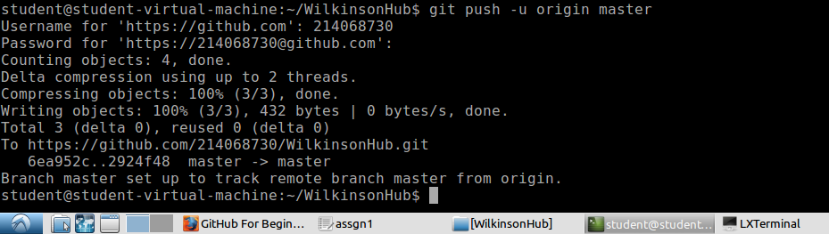

Pushing files to git using git push command

3.4

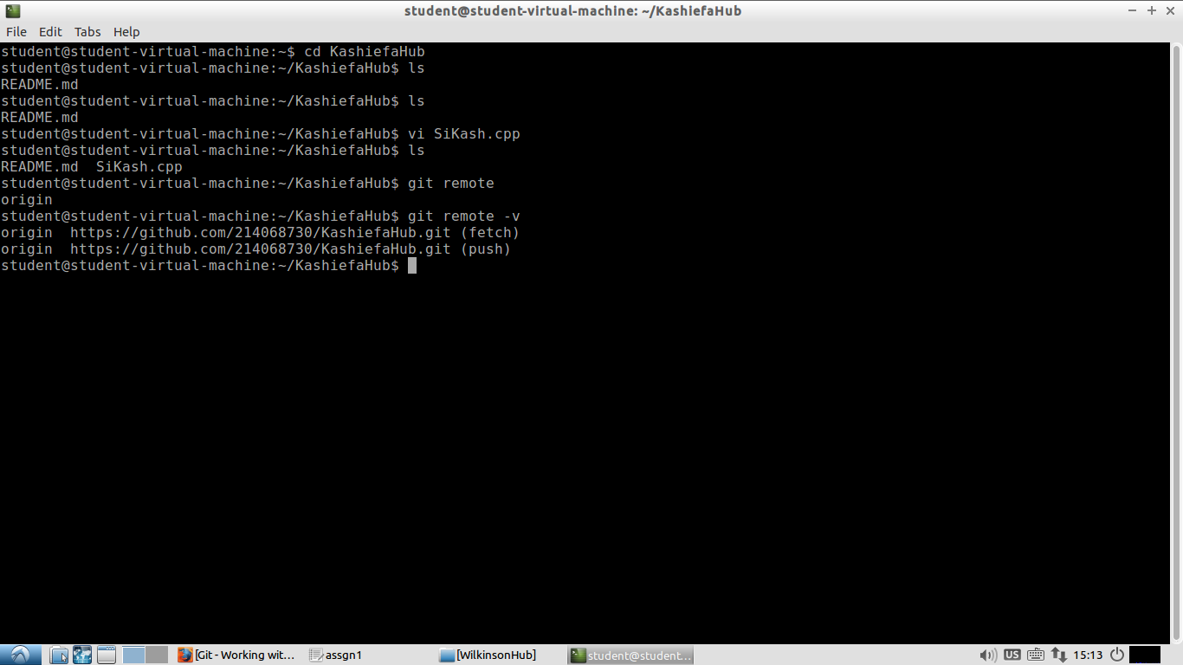

Creating another git repository and files.

3.5

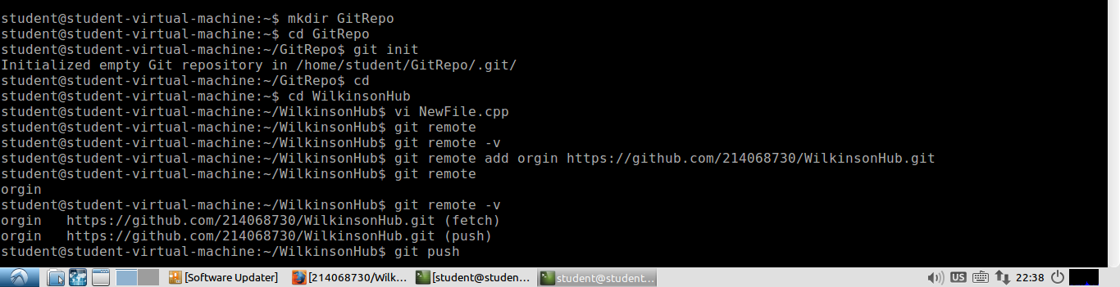

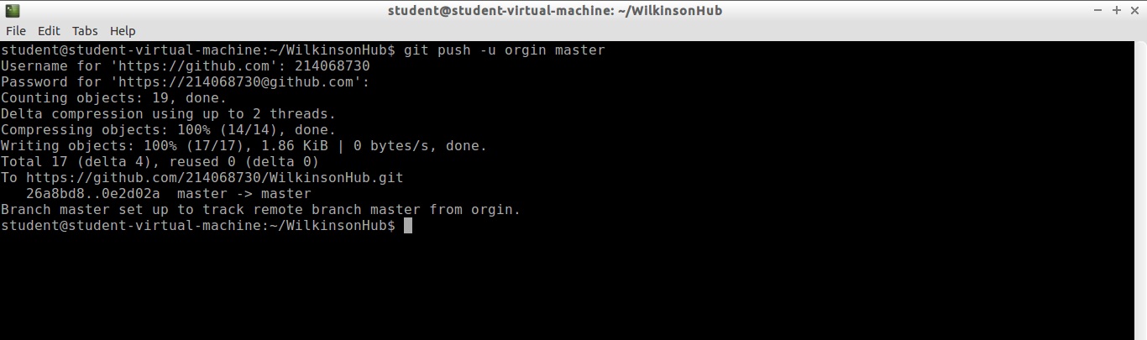

3.6

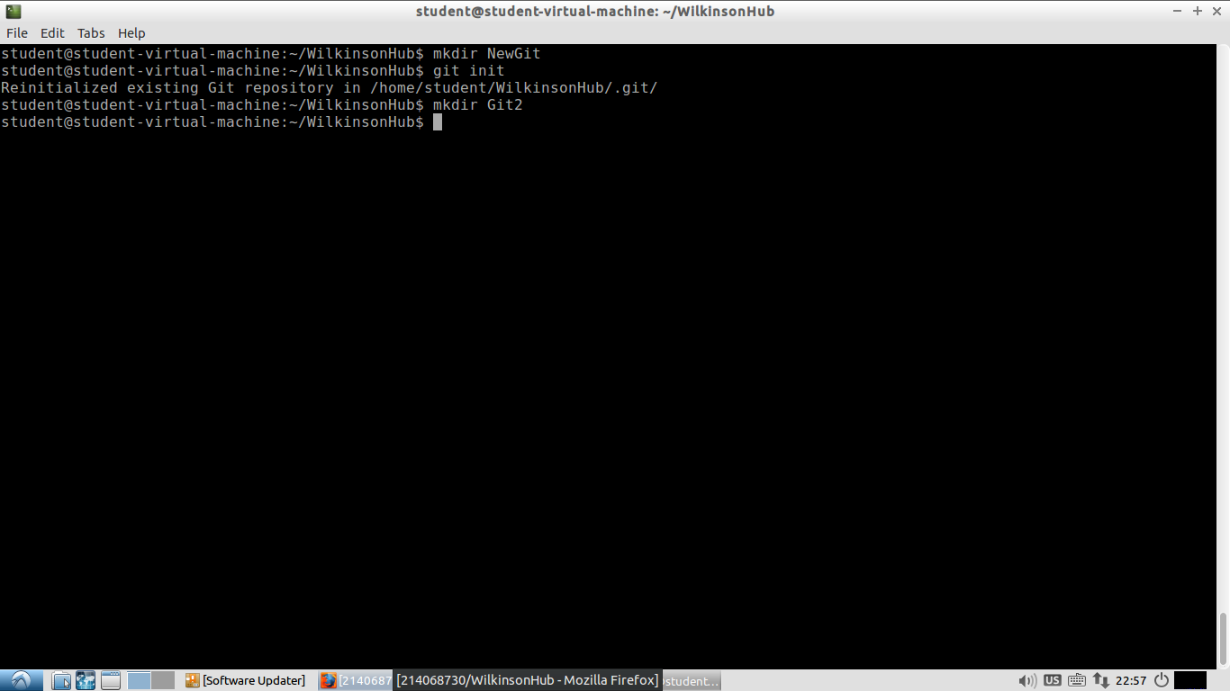

3.8



Removing remote from repository

4

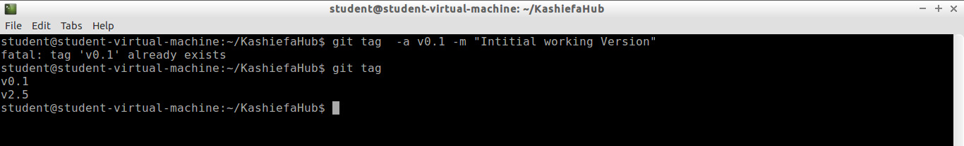

Using tag versions

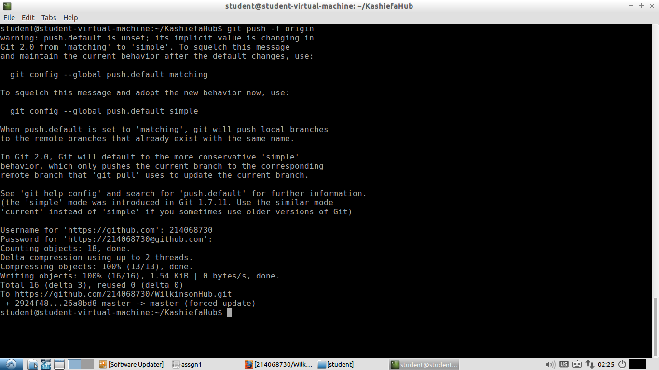

Pushing changes to github.

5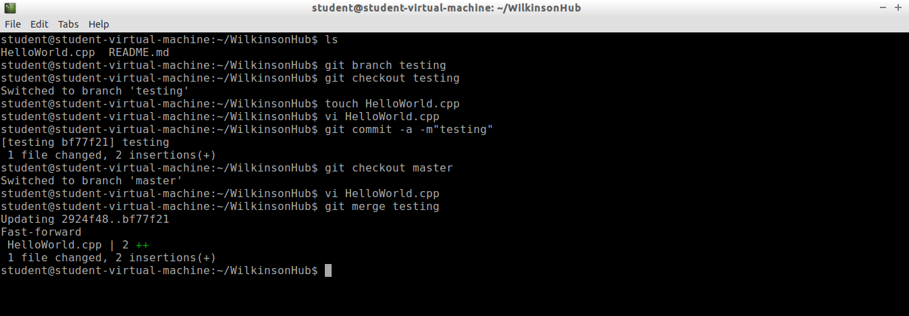

Creating a branch using the git branch command and merge the contents of the testing branch with the master branch.

6

