1. Please describe the architecture of the current chatbot system. Identify the components and check where are they running now.

At parent chatbot system is consist of telegram,radis and pyhton program. When we run the chatbot.py, the program will link to the telegram by the port receiving from applying the chatbot in telegram. When we start the chatting,our python program will catch the message by ‘update.message.text’,then catch the relevant data from redis as the database and send back the result by ‘update.message.reply_text()’. Actually,the chatbot is running in our server.

1. Explain how do your chatbot handle the special command. You need to trace the code and explain that.

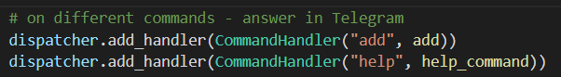

When it scan the special word like the picture,it can classify the special word and run the special function,such def add(). using ‘msg = context.args[0]’ to catch the key and chatbot reply the quest by ‘update.message.reply_text()’.

1. Update your code so that when user type /hello Kevin, it will reply Good day, Kevin!. Write down the change you have made.

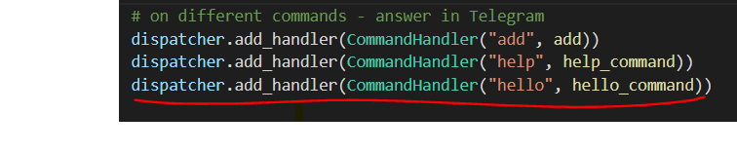

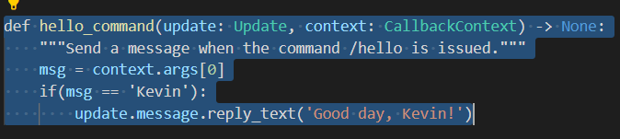

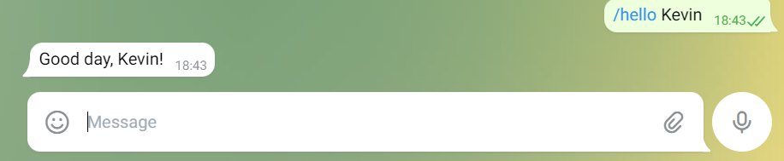

1. Make a few screen caps to prove that you have applied your own Redis account, used it in your chatbot, and push the code on GitHub (at least 2 commits - lab3/lab4).

