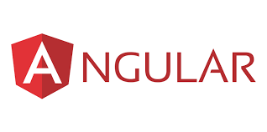 **Software used for our website**

**Frontend used in our website:**

Angular is an open-source, JavaScript framework written in TypeScript. Google maintains it, and its primary purpose is to develop single-page applications. As a framework, Angular has clear advantages while also providing a standard structure for developers to work with.

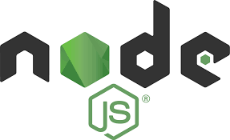**Backend used in our website:**

Node.js (Node) is open sources, cross-platform runtime environment for execution java script code. Node is used extensively for server-side programming, making it possible for developers to use JavaScript for client server and server-side code without needing to learn an additional language. Node is sometimes referred to as a programming language softwaredvelopment  framework, but neither is true; it is strictly a JavaScript .

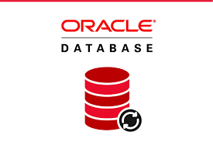**Database used in our website:**

Oracle database services and products offer customers cost-optimized and high-performance versions of Oracle Database, the world's leading converged, multi-model database management system, as well as in-memory,  and MySQL databases. Oracle autonomous database, available on premises via Oracle Cloud Customer or in the Oracle Cloud Infrastructure, enables customers to simplify relational database environments and reduce management workloads.