Question 01:  Implement Stack using Array

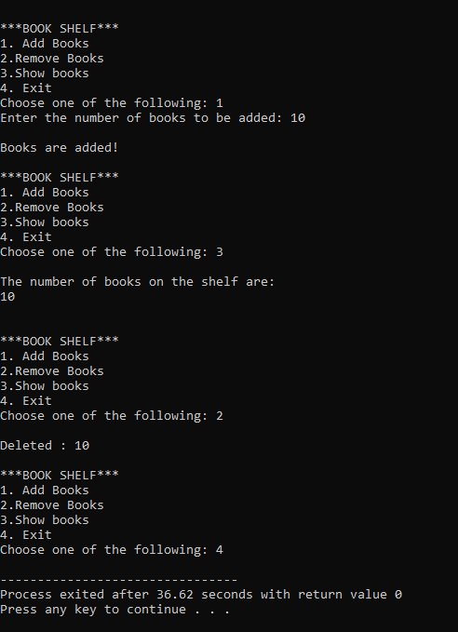

Question 02:  Implement Stack using Linked List

