**MCA273 DBT LAB 11 – Views -SECTION B - COMPONENT 1**

2147241-ANAGHA R

1. Creating a database called “views”

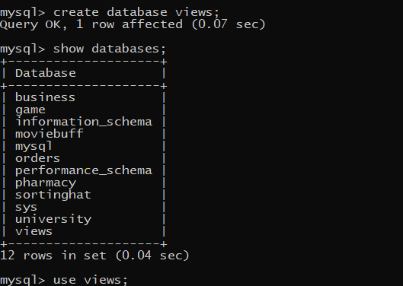

1. Create a relation called “employees”



1. Insert records into the table “employees”

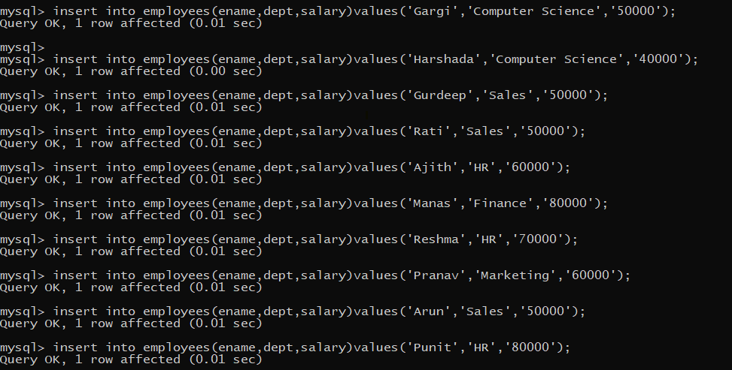

1. Display records from the table “employees”

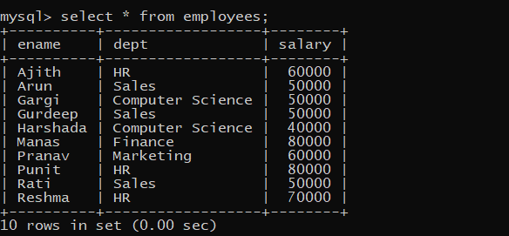

1. View EmployeeNames (with ename as the only attribute)



1. View DeptInfo with fields dept and salary



1. Displaying views ‘EmployeeNames’ and ‘DeptInfo’

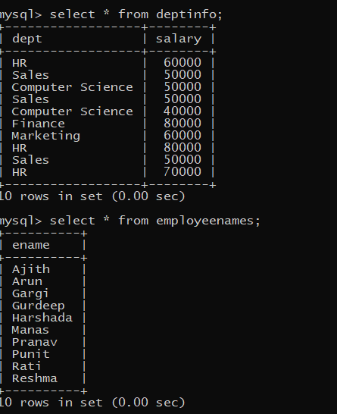

1. CREATE VIEW AToRNames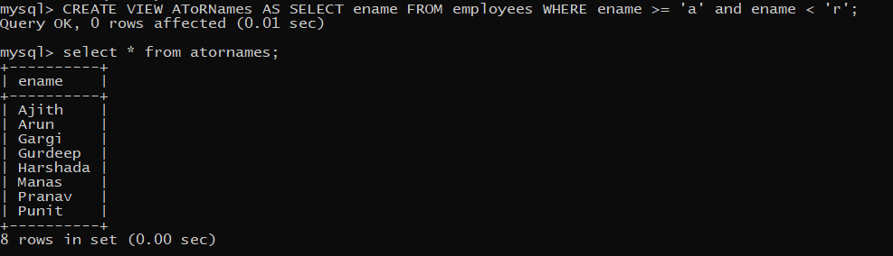
2. CREATE VIEW HowManyNames

