**Online Food Ordering System**

-Dhana Lakshmi A

**Project Explanation:**

The online food ordering system is a web-based platform designed to streamline the process of ordering food from various restaurants. Built using Python and the Django framework, this project aims to provide a user-friendly interface for customers to browse menus, place orders, and make payments, while also offering administrative functionalities for managing restaurants, menu items, orders, and delivery personnel.

**Features:**

1**. Customer Interface:** The system provides a seamless experience for customers to browse menus, add items to their cart, proceed to checkout, and make payments securely. Customers can also track the status of their orders in real-time.

2. **Restaurant Management:** Restaurant owners can register their businesses on the platform and manage their menus, including adding, updating, and removing items. They can also view and manage incoming orders.

3**. Order Management:** Orders placed by customers are efficiently managed, including tracking order status, updating delivery information, and handling cancellations or modifications.

4. **Payment Integration:** Secure payment gateways are integrated to facilitate online transactions, ensuring the safety of customer information and financial transactions.

5. **Administrator Dashboard:** Administrators have access to a centralized dashboard to oversee the entire system, including managing restaurants, menu items, delivery personnel, and resolving any issues that may arise.

6. **Delivery Personnel Management:** The system allows for the management of delivery personnel, including assigning orders, tracking deliveries, and updating delivery statuses.

By leveraging Python's robustness and the Django framework's efficiency in building web applications, this project aims to deliver a reliable and scalable solution for online food ordering, catering to the needs of both customers and restaurant owners. With its intuitive user interface and comprehensive features, the online food ordering system offers convenience, efficiency, and reliability in the food delivery process.

**UML Diagrams**

**1.Use Case Diagram:**

**2.Class Diagram:**

**3.Sequence Diagram:**

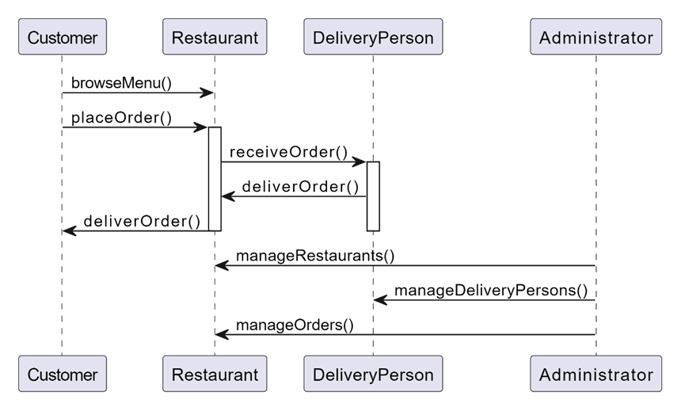

**DFD Diagram**

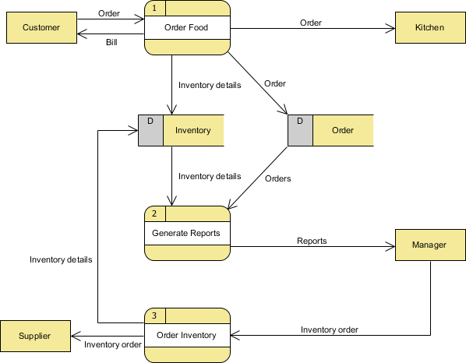

**Software and Hardware Requirements**

**Software Requirements:**

1. **Python:** The project is developed using Python programming language. Ensure that Python is installed on the development environment.

2. **Django:** Django is the web framework used for developing the online food ordering system. Install Django using pip, the Python package manager.

3. **Database Management System (DBMS):** Choose a suitable DBMS such as PostgreSQL, MySQL, SQLite, etc., supported by Django for storing application data.

4. **Integrated Development Environment (IDE):** Any preferred IDE or text editor can be used for coding, such as Visual Studio Code, PyCharm, Sublime Text, etc.

5. **Web Browser:** A modern web browser like Google Chrome, Mozilla Firefox, or Microsoft Edge is required for testing and viewing the web application.

**Hardware Requirements:**

1. **Computer:** A desktop or laptop computer is necessary for development purposes.

2. **Processor:** A processor with at least dual-core capability is recommended for efficient coding and testing.

3. **RAM:** A minimum of 4 GB of RAM is recommended for smooth development and testing processes.

4. **Storage:** Adequate storage space for storing project files, dependencies, and databases.

5. **Internet Connection:** An internet connection is required for installing dependencies, accessing documentation, and testing online features.

These requirements may vary depending on the scale and complexity of the project. It is essential to ensure that the hardware and software meet the minimum requirements for a smooth development and testing experience.