**Java Server Pages**

JSP or Java Server Pages is used to build or create dynamic web pages. By using a JSP tags, a java code can be added in the HTML pages. The use of the tags is to retrieve or restore the data from the database, sharing information from one page to another etc. NetBeansIDE and EclipseIDE are the commonly used IDE’s used for JSP pages.

**1 Life Cycle of JSP**

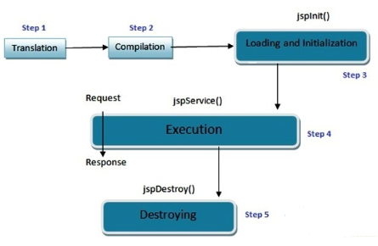

**2.1 Translation**

The first step, JSP document is translated by a web container into a corresponding Java code. The servlet in this is the java code. It is automatically translated by the Web server which validates, locates the correctness and automatically write the servlet on the JSP page.

**2.2 Compilation**

It compiles the java source by the JSP container in order to generate the class file and create the equivalent servlet.

**2.3 Loading and Initialization**

It will load the servlet by the JSP container of the two previous stages. After loading it properly, the JSP container will create an instance of the servlet class.

**2.4 Execution**

The *_jspService()* method is created by the JSP engine. The *_jspService()* method has 2 parameters. HttpservletRequest and HttpServletResponse is created once per request.



**2.5 Destroying**

In this last step it completes the life cycle of JSP. By using the *jspDestroy()* method the JSP is removed by the container.