

DOCUMENTATION MANUAL FOR APACHE HTTP SERVER

ADRIANO, JOHN CARLO

BANGIACAN, MARIA STEPHANIE KRISTINA

LICUDO, MARY ANN

OLIVAS, MARVIN

RAMOS, TATUM EIFFEL DODGE

ZHANG, JASPER ANTHONY

**(2ND PAGE DAPAT TABLE OF CONTENTS)**

**UBUNTU VIRTUAL HOST**

1. After logging in to the server, create a directory where you can place your files in the path, */var/www* with the *mkdir* command and *–p* option

Ours, inside the folder group3a.com we have another folder public_html



1. Issue the command, *chown* to change the ownership of the files and directories in a Linux filesystem. Also affix the proper change mode values. To do so,

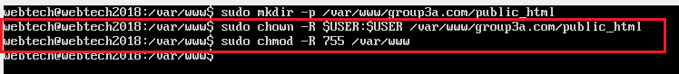

1. Next, go inside your public_html folder and create your html file. In some case where you have your files in an online repository *clone* your repository inside the public_html folder.

We have our files in github and used the git clone command as shown in the highlighted command below.

To check if you successfully clone the repository issue the list command, **ls**

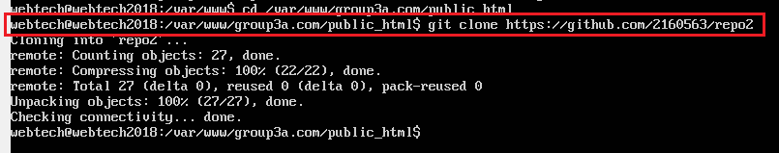

1. Then, configure your virtual host file by entering *cd /etc/apache2* you will be directed to the said directory. Optionally, you can always issue the *ls* command to check files or folders that are present.

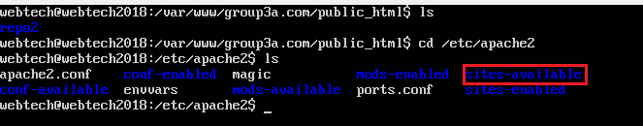

Next, type *cd sites-available* inside sites-available is the default configuration file, named 000-default.conf and default-ssl.conf

But we are not going to use the default one instead provides a virtual host configuration file. We issue the command *cp.*

It means you copied the default configuration file in a new configuration file for your virtual host. Make sure the newly created configuration file is in the list as you issue the *ls* command which in this case is the group3a.com.conf

1. You now edit your group3a.com.conf file, type *sudo nano group3a.com.conf*

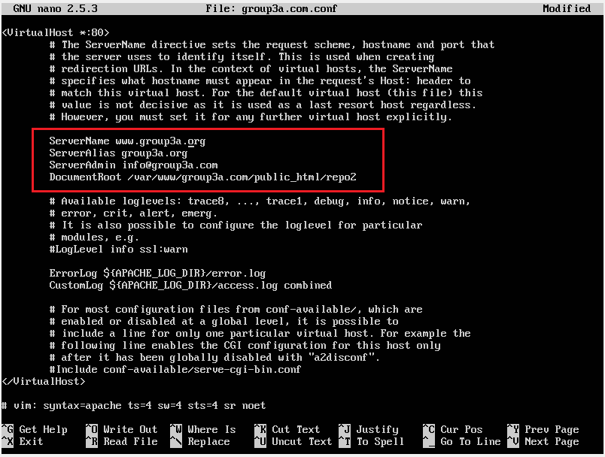

Edit the following

*ServerName, (explain ko pa to if what ito)*

*ServerAlias,*

*ServerAdmin*

*DocumentRoot*

Make sure you entered the right path of your html files and stylesheets in the DocumentRoot, for this will fetch the files in the said path.

Save your file.

1. The next step is to enable your virtual host file.

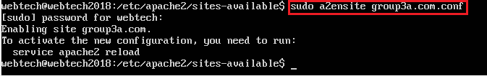

And disable the default one,

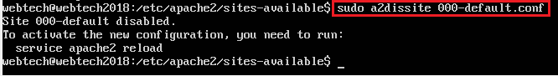

Optionally, you can go to sites-enabled folder to see the list of configuration file that is/are enabled.

1. Restart your apache web server. Issue the command, *sudo service apache2 restart*
2. You now host your website locally via the apache web server. To test, go to

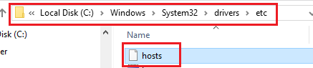

And edit your hosts file; include the IP address taken from your host machine and the domain name of your website (known to be the *ServerName* in your configuration file). Remember to save your hosts file.

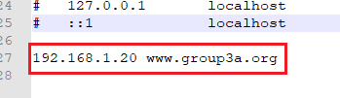

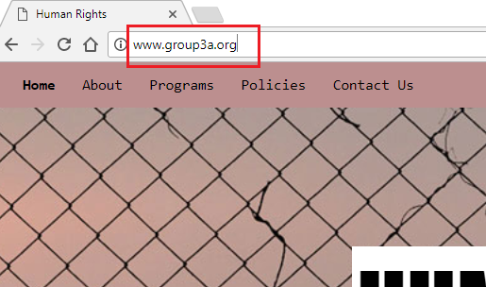Open a web browser and type in the domain name*,* [*www.group3a.org*](http://www.group3a.org) in the address bar.

**ENABLE COMPRESSION**

This shows a step by step procedure in enabling your compression of contents such as *htm*l and *css* files. Assuming you were able to host your websites in the apache web server, you can do the following steps:

Go to the directory apache2, type the command *cd /etc/apache2* and issue *ls* command to check the list of the directory.

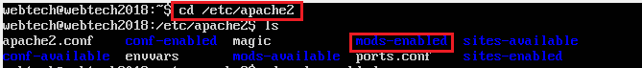

Type *cd mods-enabled*

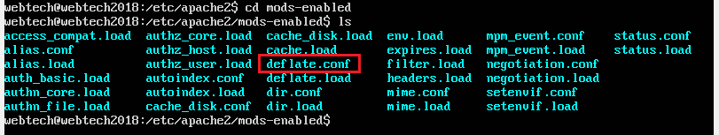

The *deflate.conf* is a file you are going to configure. To do so, type *sudo nano deflate.conf*

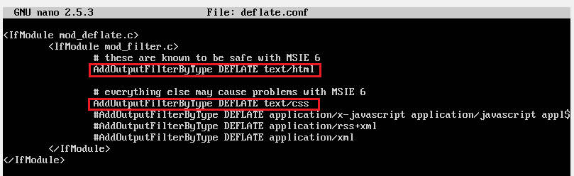

Uncomment the highlighted command above. This enables your html and css files to be compressed or rendered gzip.

Save your file.

Restart your apache web server. Issue the command, *sudo service apache2 restart*

One way to check if your html and css files are rendered in *gzip* format is to browse the website in a browser and *click*

More Tools > Developer Tools > Refresh the webpage

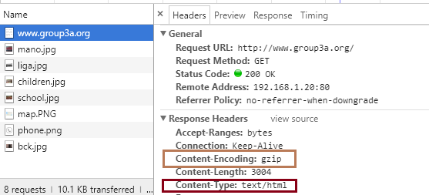

*** Notice the Content – Type: text/html and the Content – Encoding: gzip in the Response Header

**CONTENT CACHING**

These procedures enables the clients to cache PNG, JPG and GIF files for up to 24 hours from the time they are accessed.

First enable the modules for cache and cache_disk, type sudo a2enmod cache and sudo a2enmod cache_disk

Also, type sudo apt-get update and sudo apt-get install apache2-utils.

Go to the directory /etc/apache2/mods-enabled/cache_disk.conf