Name: Dristhee Nursing

ID: 21611027

Live URLs:

Live WP backend: [my-wp-backend](http://my-wp-backend.local/)

Live react frontend: [React App](http://localhost:3001/)

GitHub repo: [21611027/Assignment2_21611027_Dristhee](https://github.com/21611027/Assignment2_21611027_Dristhee)

**This project is a headless CMS implementation using WordPress as the backend and React.js for the frontend. The application presents a swim coaching site with blog posts, informational pages, and custom programs using a Custom Post Type (CPT). The frontend consumes the WordPress REST API, supports dynamic routing, and is deployed on Netlify.**

Posts:

1. Welcome to my swimming blog

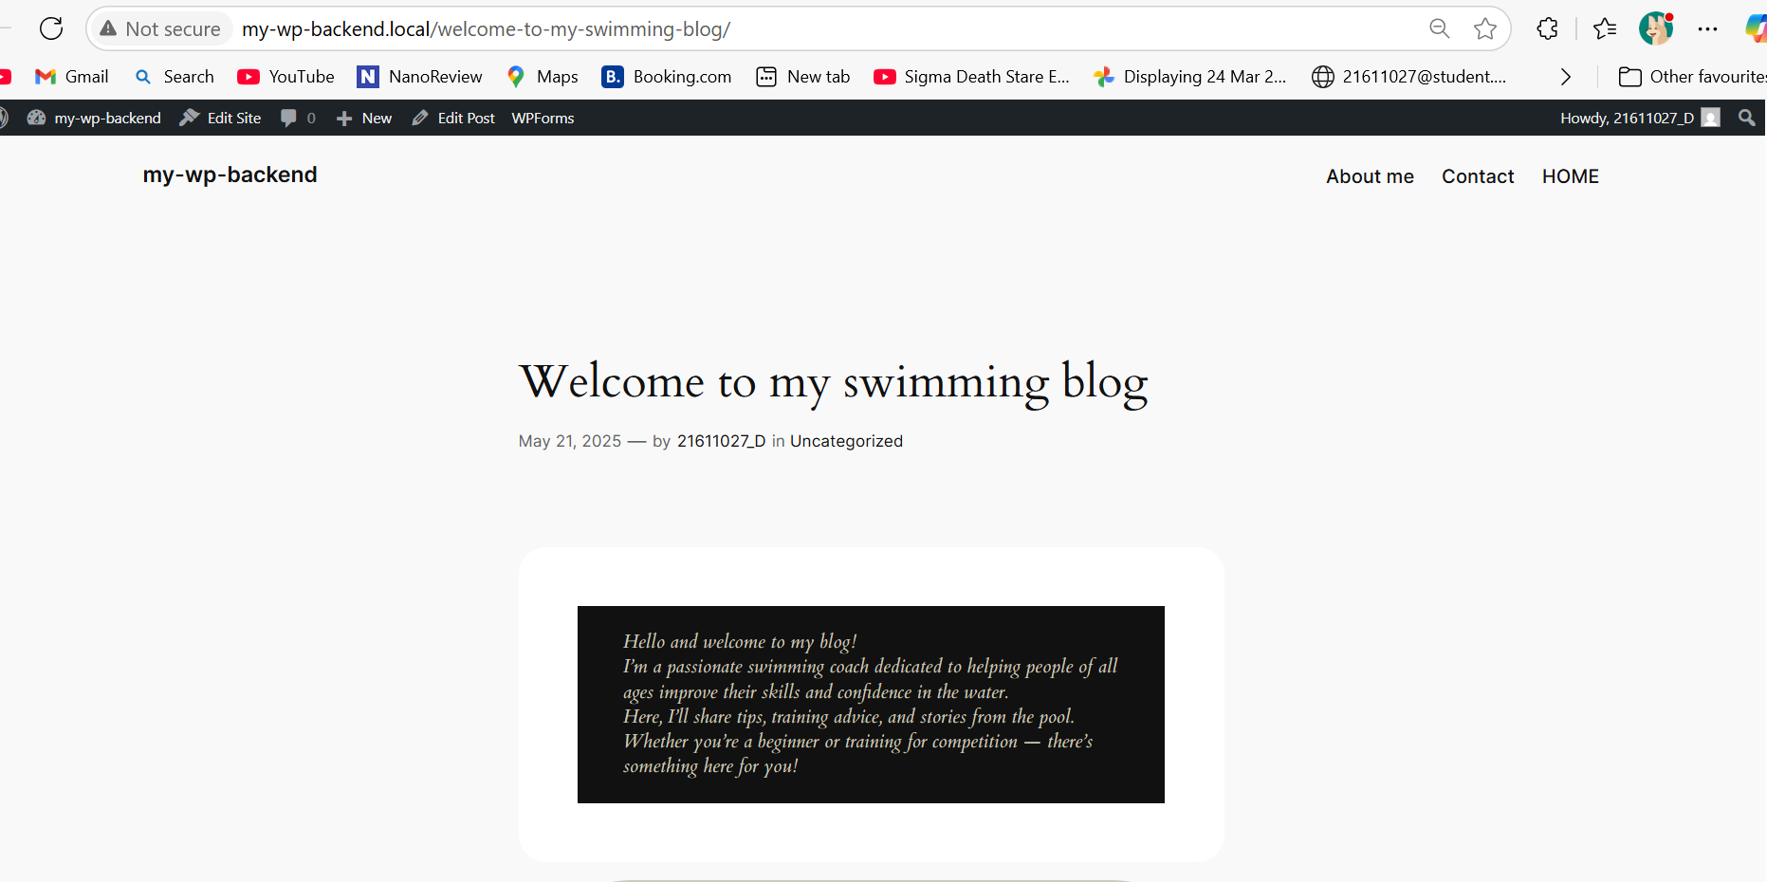

[Welcome to my swimming blog – my-wp-backend](http://my-wp-backend.local/welcome-to-my-swimming-blog/)

1. 5 essential swimming tips for beginners

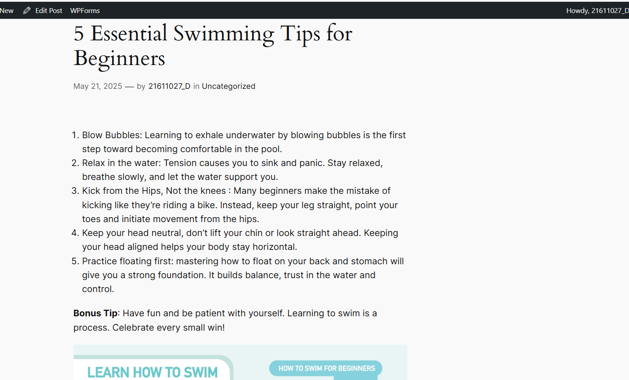

[5 Essential Swimming Tips for Beginners – my-wp-backend](http://my-wp-backend.local/5-essential-swimming-tips-for-beginners/)

1. A little girl swimming success story

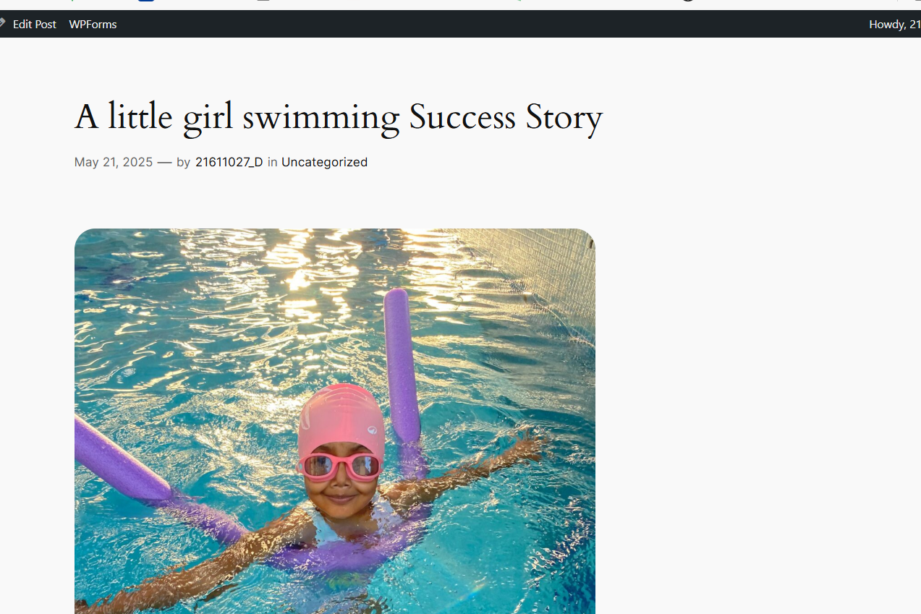

[A little girl swimming Success Story – my-wp-backend](http://my-wp-backend.local/a-little-girl-swimming-success-story/)

Pages:

1. Home

[HOME – my-wp-backend](http://my-wp-backend.local/home/)

1. Contact

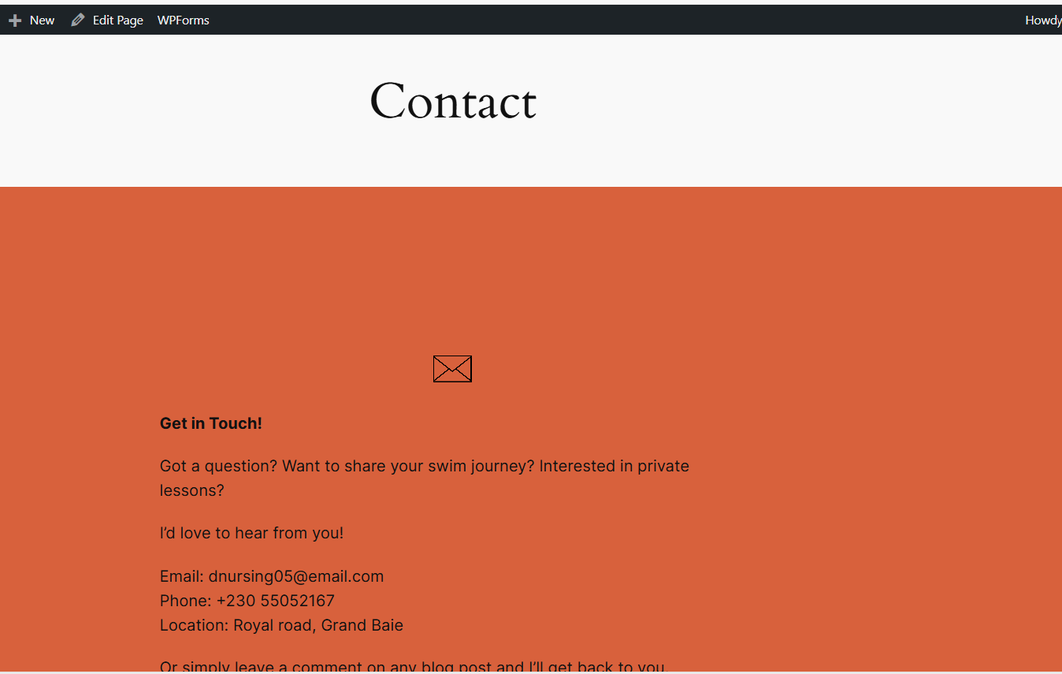

[Contact – my-wp-backend](http://my-wp-backend.local/contact/)

1. About me

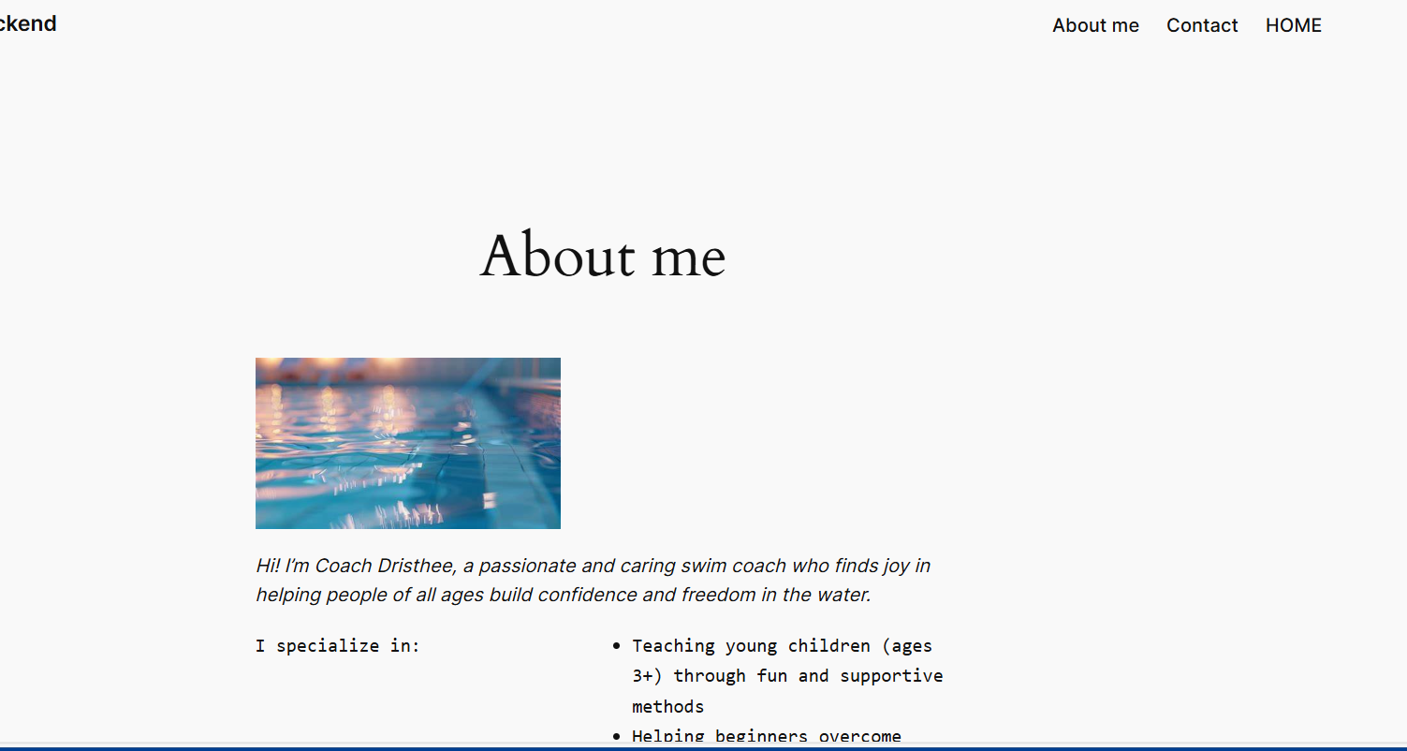

[About me – my-wp-backend](http://my-wp-backend.local/about-me/)

Swimming program

1. Beginner swim lessons

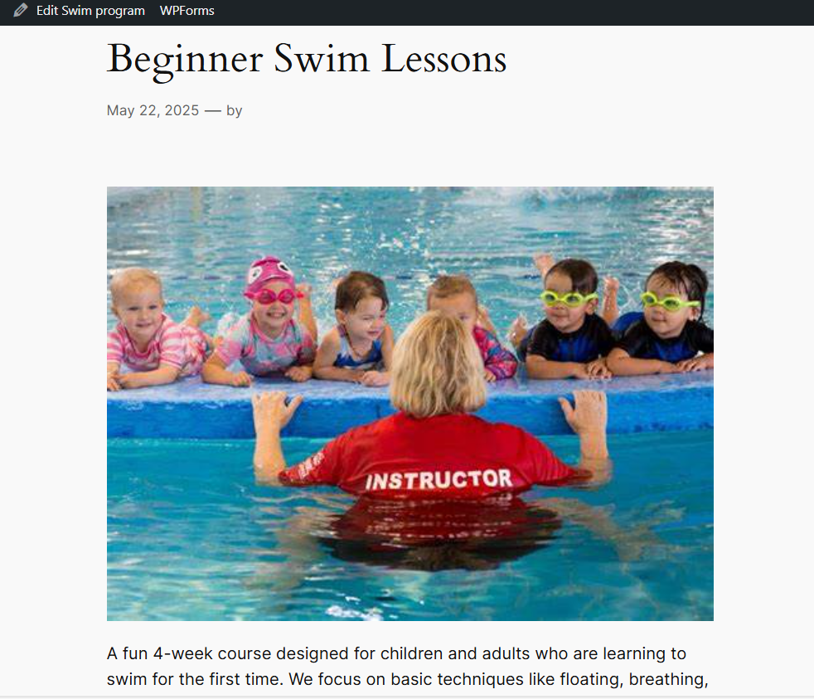

[Beginner Swim Lessons – my-wp-backend](http://my-wp-backend.local/swim_program/beginner-swim-lessons/)

1. Recovery Swim Program

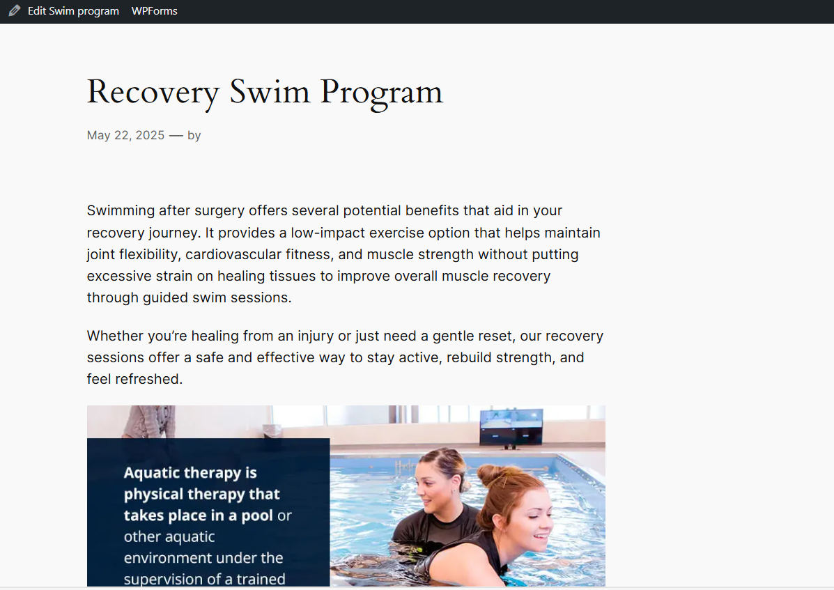

[Recovery Swim Program – my-wp-backend](http://my-wp-backend.local/swim_program/recovery-swim-program/)

Used of AI

I used AI tools like ChatGPT for:

* Writing API integration code
* Creating boilerplate React components
* Structuring the README and final report
* Solving technical errors (e.g., routing, component structure)

I actively participated in understanding, editing, and implementing all AI-generated suggestions, ensuring the final solution reflects my own learning.