

Deliverable #3

Revised Design

Class Code: 9343A

Group no. 3

1:00-2:00 TF

Banina, Michael John R.

Buse, Victoria Bendi O.

Cacho,YZ Drazen S.

Codod, Andre Filipe D.

Comaad, Cleverjean Moises A.

Gonzales, Darlene Joyce B.

Marzan, Mark Kenneth P.

Mascardo, Naider N.

Paguio, Tanya Anjelica R.

Taasin, Jargon Ray F.

Ulep, Benjie A.

Date of Submission: February 6, 2018

Table of Contents

**Entity Relationship Diagram (ERD)3**

**Relational Database Scheme4**

**Tables with Sample Data5**

**User Interface Design10**

Users 10

Home Page10

Sign-up (Initial)11

Sign-up User Details12

Profile Page13

Events 14

Payment Options 15

Contact Us 16

Admin 17

Home Page17

Events 18

Adding of Events 19

Payment Status21

View Members 22

Member Info22

Incentives 24

Adding of Incentives 25

Chefs 26

Outputs 27

1. **Entity Relationship Diagram (ERD)**

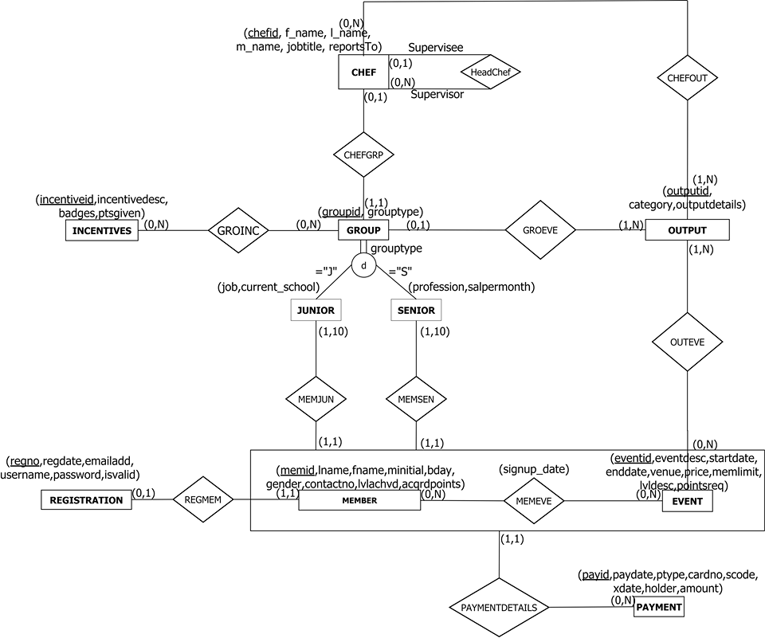

1. **Relational Database Scheme**

CHEF (chefid, f_name, l_name, m_name, jobtitle, reportsTo)

FK reportsTo REFERENCES CHEF NULLS ALLOWED,

DELETE RESTRICT, UPDATE CASCADE

CHEFOUT (chefid, outputid)

FK chefid REFERENCES CHEF NULLS ALLOWED,

DELETE RESTRICT UPDATE CASCADE

FK outputid REFERENCES OUTPUT NULLS NOT ALLOWED,

DELETE CASCADE UPDATE CASCADE

EVENT (eventid, eventdesc, startdate, enddate, venue, price, memlimit, lvldesc, pointsreq)

FK memid REFERENCES MEMBER NULLS NOT ALLOWED,

DELETE RESTRICT UPDATE CASCADE

FK incentiveid REFERENCES INCENTIVES NULLS NOT ALLOWED,

DELETE RESTRICT UPDATE RESTRICT

GROUP (groupid, grouptype, chefid)

FK chefid REFERENCES OUTPUT NULLS ALLOWED,

DELETE RESTRICT UPDATE RESTRICT

GROINC (groupid, incentiveid)

FK groupid REFERENCES GROUP NULLS NOT ALLOWED,

DELETE CASCADE, UPDATE CASCADE

FK incentive REFERENCES INCENTIVE NULLS NOT ALLOWED,

DELETE CASCADE, UPDATE CASCADE

INCENTIVES (incentiveid, incentivedesc, badges, ptsgiven)

JUNIOR (groupid, memid, eventid, job, current_school)

FK memid + eventid REFERENCES MEMEVE, NULLS NOT ALLOWED,

DELETE RESTRICT UPDATE CASCADE

MEMBER (memid, lname, fname, mininital, bday, gender, contactno, lvlachvd, acqrdpoints, regno)

FK regno REFERENCES REGISTRATION NULLS NOT ALLOWED

DELETE RESTRICT, UPDATE CASCADE

MEMEVE (memid, eventid, signup_date)

FK memid REFERENCES MEMBER NULLS NOT ALLOWED,

DELETE RESTRICT, UPDATE CASCADE

FK eventid REFERENCES EVENT NULLS NOT ALLOWED,

DELETE RESTRICT, UPDATE CASCADE

OUTEVE (outputid, eventid)

FK outputid REFERENCES OUTPUT NULLS NOT ALLOWED,

DELETE CASCADE, UPDATE CASCADE

FK eventid REFERENCES EVENT NULLS NOT ALLOWED,

DELETE CASCADE, UPDATE CASCADE

OUTPUT (outputid, category, outputdetails, groupid)

FK groupid REFERENCES GROUP NULLS NOT ALLOWED,

DELETE CASCADE, UPDATE CASCADE

PAYMENT (payid, paydate, ptype, cardno, scode, xdate, holder, amount, memid, eventid)

FK memid + eventid REFERENCES MEMEVE NULLS NOT ALLOWED,

DELETE RESTRICT, UPDATE CASCADE

REGISTRATION (regno, regdate, emailadd, username, password, isvalid)

SENIOR (groupid, memid, eventid, profession, salpermonth)

FK memid + eventid REFERENCES MEMEVE NULLS NOT ALLOWED,

DELETE RESTRICT UPDATE CASCADE

1. **TABLES WITH SAMPLE DATA**

|  |  |  |  |  |  |
| --- | --- | --- | --- | --- | --- |
| **CHEF** | | | | | |
| **chefid** | **f_name** | **l_name** | **m_name** | **jobtitle** | **ReportsTo** |
| C01 | DARLENE | GONZALES | ALONZO | HEAD CHEF | NULL |
| C02 | CLEVER | COMAAD | DELA PENA | CHEF | C01 |
| C03 | JARGON | TAASIN | RESERVA | CHEF | C01 |
| C04 | YZ | CACHO | PAGAR | CHEF | C01 |

|  |  |  |
| --- | --- | --- |
| **CHEFOUT** | | |
| **Chefid** | **outputid** |
| C01 | O1 |
| C02 | O2 |
| C03 | O3 |
| C04 | O4 |

|  |  |  |  |  |
| --- | --- | --- | --- | --- |
| **EVENT** | | | | |
| **eventid** | **eventdesc** | **startdate** | **enddate** | **venue** |
| E01 | Cooking Tutorial | 11/29/2017 | 11/29/2017 | Hotel Supreme |
| E02 | Pinnacle Grill | 1/13/2018 | 1/15/2018 | Convention Center |
| E03 | Master Chef Challenge | 1/15/2018 | 1/18/2018 | Amare La Cucina |
| E04 | BBQ Cookout | 11/26/2017 | 11/26/2017 | Camp John Hay |
| E05 | Cooking Seminar | 12/15/2017 | 1/15/2018 | Albergos Hotel |

|  |  |  |  |
| --- | --- | --- | --- |
| **EVENT (continuation)** | | | |
| **memlimit** | **price** | **lvldesc** | **pointsreq** |
| 80 | ₱300.00 | Foundation | 0 |
| 80 | ₱310.00 | Intermediate | 150 |
| 90 | ₱350.00 | Advanced | 300 |
| 100 | ₱250.00 | Master | 500 |
| 80 | ₱200.00 | Foundation | 0 |

|  |  |  |
| --- | --- | --- |
| **GROUP** | | |
| **groupid** | **grouptype** | **chefid** |
| G01 | senior | C01 |
| G02 | junior | C02 |
| G03 | junior | C03 |
| G04 | senior | C04 |

|  |  |  |
| --- | --- | --- |
| **GROINC** | | |
| **groupid** | **incentiveid** |
| G01 | I003 |
| G02 | I002 |
| G03 | I004 |
| G04 | I001 |

|  |  |  |  |
| --- | --- | --- | --- |
| **INCENTIVES** | | | |
| **incentiveid** | **incentivedesc** | **badges** | **ptsgiven** |
| I001 | (highest points for the year/month/week) | GROUP OF THE WEEK | 70 |
| I002 | Won Gold Award on a competition | 1ST RUNNER UP | 60 |
| I003 | Won Silver Award on a competition | 2ND RUNNER UP | 55 |
| I004 | Won Bronze Award on a competition | 3RD RUNNER UP | 47 |
| I005 | Successfully participated on a competition | PARTICIPANT | 45 |

|  |  |  |  |  |
| --- | --- | --- | --- | --- |
| **JUNIOR** | | | | |
| **groupid** | **memid** | **eventid** | **job** | **current_school** |
| G01 | M0002 | E01 | jollibee assistant | University of Cordilleras |
| G02 | M0001 | E02 | jollibee assistant | Saint Louis University Baguio City |
| G03 | M0003 | E04 | mcdo part time job | University of Baguio |

|  |  |  |  |  |  |  |
| --- | --- | --- | --- | --- | --- | --- |
| **MEMBER** | | | | | | |
| **memid** | **lname** | **fname** | **minitial** | **bday** | **gender** | **contactno** |
| M0001 | BENJIE | ULEP | A. | 8/7/2001 | M | +639162357690 |
| M0002 | ANDRE | CODOD | D. | 1/11/1989 | M | +639494165894 |
| M0003 | PAGUIO | TANYA | R. | 2/14/2003 | F | +639214625394 |
| M0004 | MARZAN | MARK KENNETH | P. | 7/17/1987 | M | +639185672342 |

|  |  |  |
| --- | --- | --- |
| **MEMBER (continuation)** | | |
| **lvlachvd** | **acqrpoints** | **regno** |
| 2 | 250 | R0001 |
| 2 | 160 | R0002 |
| 3 | 50 | R0003 |
| 4 | 200 | R0004 |

|  |  |  |
| --- | --- | --- |
| **MEMEVE** | | |
| **memid** | **eventid** | **signup_date** |
| M0001 | E03 | 1/10/2020 |
| M0002 | E01 | 12/09/2023 |
| M0003 | E02 | 02/11/2021 |
| M0004 | E04 | 11/10/2020 |

|  |  |  |
| --- | --- | --- |
| **OUTEVE** | | |
| **outputid** | **eventid** |
| O1 | E02 |
| O2 | E01 |
| O3 | E04 |
| O4 | E03 |

|  |  |  |  |
| --- | --- | --- | --- |
| **OUTPUT** | | | |
| **outputid** | **category** | **outputdetails** | **groupid** |
| O1 | Meat | Beef Short Rib | G03 |
| O2 | Meat | Salisburry Steak | G02 |
| O3 | Pasta | Fettuccine Alfredo | G01 |
| O4 | Meat | Chicken Divan | G04 |

|  |  |  |  |  |  |
| --- | --- | --- | --- | --- | --- |
| **PAYMENT** | | | | | |
| **payid** | **paydate** | **ptype** | **cardno** | **scode** | **xdate** |
| P0001 | 12/10/2017 | credit card | 5500 0000 0000 0004 | 7987987640 | 1/10/2020 |
| P0002 | 12/11/2017 | paypal | 1230 456 3743 7891 | 8461846468 | 12/11/2023 |
| P0003 | 12/13/2017 | paypal | 3213 5691 8972 5611 | 4987064618 | 2/9/2021 |
| P0004 | 12/13/2017 | credit card | 3000 0000 0000 0434 | 7819498798 | 11/10/2020 |

|  |  |  |  |
| --- | --- | --- | --- |
| **PAYMENT (continuation)** | | | |
| **holder** | **amount** | **eventid** | **memid** |
| BENJO ULEP | ₱2,500.00 | E03 | M0001 |
| ANDRE CODOD | ₱3,100.00 | E01 | M0002 |
| LAWRENCE ANGELO | ₱3,300.00 | E02 | M0003 |
| MARK KENNETH MARZAN | ₱3,000.00 | E04 | M0004 |

|  |  |  |  |  |  |
| --- | --- | --- | --- | --- | --- |
| **REGISTRATION** | | | | | |
| **regno** | **regdate** | **emailadd** | **username** | **password** | **isvalid** |
| R0001 | 11/24/2017 | benjiulep@email.com | benjulep | chariheart | TRUE |
| R0002 | 11/24/2017 | andrecodod@email.com | andrecods | janmii143 | TRUE |
| R0003 | 11/25/2017 | tanyapaguio@email.com | tanyaanj | tanyapags1 | TRUE |
| R0004 | 11/26/2017 | kenmarzan@email.com | markken | ken123 | TRUE |

|  |  |  |  |  |
| --- | --- | --- | --- | --- |
| **SENIOR** | | | | |
| **groupid** | **memid** | **eventid** | **profession** | **salpermonth** |
| G02 | M0005 | E03 | Cook | 6,000 |
| G01 | M0007 | E02 | Baker | 8,000 |
| G04 | M0008 | E01 | Cook | 5,0000 |

1. **USER INTERFACE**

**USER SIDE**

1. 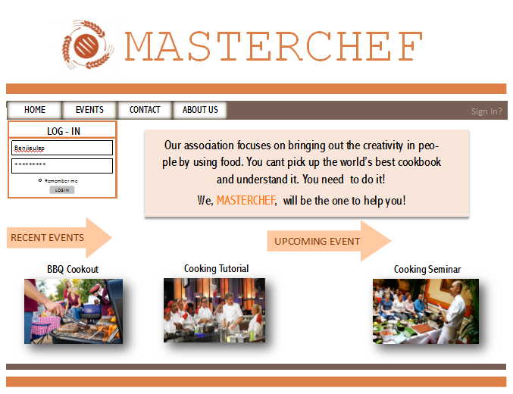Homepage

Master Chef’s home page contains the details about the enthusiast group like a short detail about the page and the association, recent events and upcoming events. There are 4 tabs on the upper portion of the web page which are Home, Events, Contact and About Us that the users could navigate through. They could either sign up by clicking on the Sign in button or Log-in by entering their username and password to access their accounts, join events, earn points, level up and get a chance to be one of the master chefs.

**Queried Tables:**

NONE

**DML Results:**

NONE

1. Sign-up – Initial

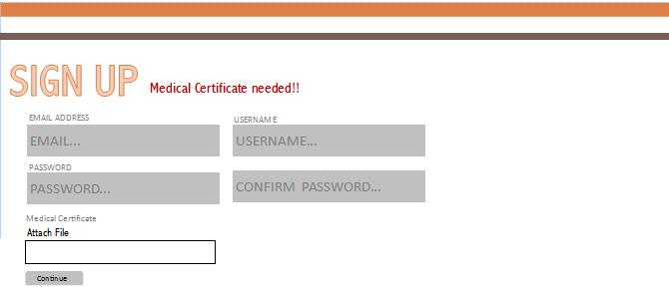

Master Chef Association is concerned with the health of each member of the group. Medical certificate along with their full name is needed for registering an account. This medical certificate should be uploaded in a form of a readable file which may be a picture or a document for the staff to verify their health condition.

**Queried Tables:**

NONE

**DML Results:**

Registration

***CONTINUE***

**[+]REGISTRATION**

|  |  |  |  |  |  |
| --- | --- | --- | --- | --- | --- |
| **REGISTRATION** | | | | | |
| **regno** | **regdate** | **emailadd** | **username** | **password** | **isvalid** |
| R0001 | 11/24/2017 | benjiulep@email.com | benjulep | chariheart | TRUE |
| R0002 | 11/24/2017 | [andrecodod@email.com](mailto:andrecodod@email.com) | andrecods | janmii143 | TRUE |
| R0003 | 11/25/2017 | [tanyapaguio@email.com](mailto:tanyapaguio@email.com) | tanyaanj | tanyapags1 | TRUE |
| R0004 | 11/26/2017 | [kenmarzan@email.com](mailto:kenmarzan@email.com) | markken | ken123 | TRUE |

1. Sign-up – User Details

To proceed with the registration, the user should enter his or her personal details. These details will be used for identifying each member in the association. It will also serve as a record for account confirmation upon logging into the site.

**Queried Tables:**

NONE

**DML Results:**

Member

***CONTINUE***

|  |  |  |  |  |  |  |
| --- | --- | --- | --- | --- | --- | --- |
| **MEMBER** | | | | | | |
| **memid** | **lname** | **fname** | **minitial** | **bday** | **gender** | **contactno** |
| M0001 | BENJIE | ULEP | A. | 8/7/2001 | M | +639162357690 |
| M0002 | ANDRE | CODOD | D. | 1/11/1989 | M | +639494165894 |
| M0003 | PAGUIO | TANYA | R. | 2/14/2003 | F | +639214625394 |
| M0004 | MARZAN | MARK KENNETH | P. | 7/17/1987 | M | +639185672342 |

**[+]MEMBER**

|  |  |  |  |  |
| --- | --- | --- | --- | --- |
| **MEMBER (continuation)** | | | | |
| **lvlachvd** | **acqrpoints** | **groupid** | **regno** | **eventid** |
| 2 | 250 | G02 | R0001 | E02 |
| 2 | 160 | G01 | R0002 | E01 |
| 3 | 50 | GO3 | R0003 | E04 |
| 4 | 200 | GO4 | R0004 | E03 |

***CONTINUE***

**[+]JUNIOR**

|  |  |  |  |  |
| --- | --- | --- | --- | --- |
| **JUNIOR** | | | | |
| **groupid** | **memid** | **eventid** | **job** | **current school** |
| G01 | M0002 | E01 | jollibee assistant | University of Cordilleras |
| G02 | M0001 | E02 | jollibee assistant | Saint Louis University Baguio City |
| G03 | M0003 | E04 | mcdo part time job | University of Baguio |
| ***CONTINUE***  **[+]SENIOR** |  |  |  |  |
| **SENIOR** | | | | |
| **groupid** | **memid** | **eventid** | **profession** | **salpermonth** |
| G02 | M0005 | E03 | Cook | 6000 |
| G01 | M0007 | E02 | Baker | 4500 |
| G04 | M0008 | E01 | Cook | 5800 |
|  |  |  |  |  |

1. User Account Information

A screenshot of a cell phone

Description generated with very high confidence

After logging in to the site, the user can see his or her account details. It includes the users’ personal details, group number, points earned, best dish, badges and events joined. The badges that the user earned were the incentives that he or she received for winning the competitions.

**Queried Tables:**

Member Event

Group

Incentives

**DML Results:** NONE

1. Events Page

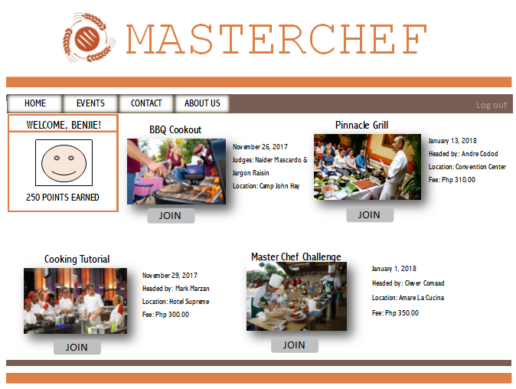

The event page consists of the events which the user could join and participate to. Each Event will have its own details, this includes the name of the event, the date and time it will start, the head and the fee to which users will pay when they want to . By clicking join below the images per event, a window will pop out to the screen for signing up for that event.

A screenshot of a cell phone

Description generated with very high confidence

**Queried Tables:**

Member

Event

**DML Results:**

Memeve

***JOIN***

**[+]MEMEVE**

|  |  |
| --- | --- |
| **MEMEVE** | |
| **memid** | **eventid** |
| M0001 | E03 |
| M0002 | E01 |
| M0003 | E02 |
| M0004 | E04 |
|  |  |

1. Payment Options 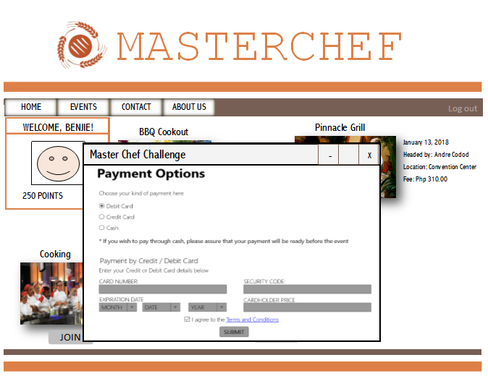

After clicking on the JOIN button, the user can now choose the mode of payment for the event fee. He or she can either use Debit Card, Credit Card or cash. If the user wishes to pay through debit or credit card, he or she will need to enter his or her card details. Choosing the cash option, the user should assure that their payment will be ready before the event. The user should read the terms and condition and tick the checkbox to agree. By clicking on SUBMIT button, the user is now officially an event participant.

**Queried Tables:**

NONE

**DML Results:**

Payments

***SUBMIT***

**[+]PAYMENT**

|  |  |  |  |  |  |
| --- | --- | --- | --- | --- | --- |
| **PAYMENT** | | | | | |
| **payid** | **paydate** | **ptype** | **cardno** | **scode** | **xdate** |
| P0001 | 12/10/2017 | credit card | 5500 0000 0000 0004 | 7987987640 | 1/10/2020 |
| P0002 | 12/11/2017 | paypal | 123 456 743 789 139 | 8461846468 | 12/11/2023 |
| P0003 | 12/13/2017 | paypal | 321 564 897 561 123 | 4987064618 | 2/9/2021 |
| P0004 | 12/13/2017 | credit card | 3000 0000 0000 04 | 7819498798 | 11/10/2020 |

|  |  |  |  |
| --- | --- | --- | --- |
| **PAYMENT (continuation)** | | | |
| **holder** | **amount** | **eventid** | **memid** |
| BENJO ULEP | ₱2,500.00 | E03 | M0001 |
| ANDRE CODOD | ₱3,100.00 | E01 | M0002 |
| LAWRENCE ANGELO | ₱3,300.00 | E02 | M0003 |
| MARK KENNETH MARZAN | ₱3,000.00 | E04 | M0004 |

1. Contact Us

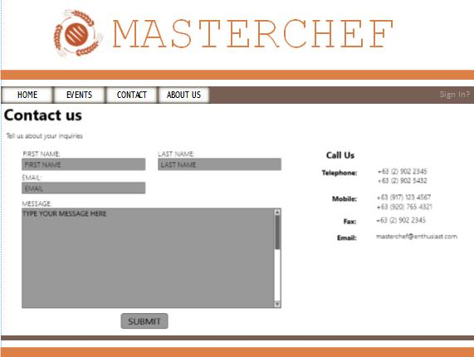

The contact page will contain the email address and contact number of our support team/admin. Users may send us an email where they can ask questions or have any inquiries that needs to be addressed. Any questions will be sent directly to the support teams/admin, and may answer the questions or inquiries needed. Any questions that have already been answered in the FAQ will not be entertain.

**Queried Tables:**

NONE

**DML Results:**

NONE

**ADMIN SIDE**

1. Home Page

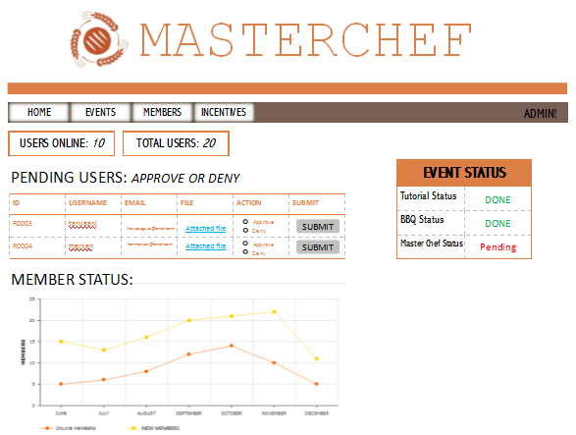

On the home page of the admin, he/she is able to view how many users are online and the total count of the members. The pending users table are for the ones who want to register in MASTERCHEF, it includes their id number and email. Attached is the medical certificate of the registrant, then admin will then check ‘approved’ or ‘deny’. The member status graph will inform the admin the progress of the newly registered members and the members who are going online.

**Queried Tables:**

Member

Registration

**DML Results:**

Registration

***SUBMIT***

**[+] REGISTRATION**

|  |  |  |  |  |  |
| --- | --- | --- | --- | --- | --- |
| **REGISTRATION** | | | | | |
| **regno** | **regdate** | **emailadd** | **username** | **password** | **isvalid** |
| R0001 | 11/24/2017 | benjiulep@email.com | benjulep | chariheart | TRUE |
| R0002 | 11/24/2017 | [andrecodod@email.com](mailto:andrecodod@email.com) | andrecods | janmii143 | TRUE |
| R0003 | 11/25/2017 | [tanyapaguio@email.com](mailto:tanyapaguio@email.com) | tanyaanj | tanyapags1 | TRUE |
| R0004 | 11/26/2017 | [kenmarzan@email.com](mailto:kenmarzan@email.com) | markken | ken123 | TRUE |

1. 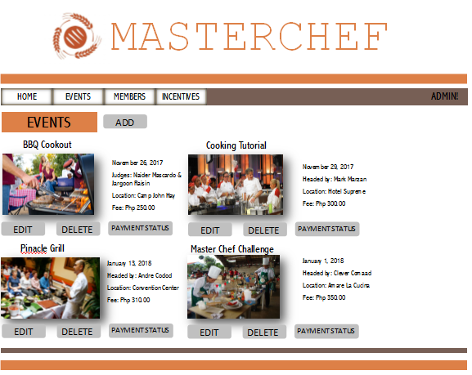Events

The admin is able to view the events that are done and that are to be done. He/she are also able to add future events and delete events that are already done. By clicking the payment status, he/she would be redirected to the payment status page and could also know participants of the events through the payment status of the members.

**Queried Tables:**

Event

**DML Results:**

NONE

1. Adding of Events

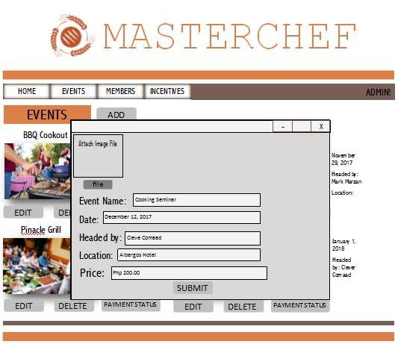

For adding of events, the admin will just click on the add button then will fill-up the needed details for the events (image, event name, date, etc) and by clicking submit the event will then be added.

**Queried Tables:**

NONE

**DML Results:**

Event

***SUBMIT***

**[+]EVENT**

|  |  |  |  |  |  |  |  |
| --- | --- | --- | --- | --- | --- | --- | --- |
| **EVENT** | | | | | | | |
| **eventid** | **eventdesc** | **startdate** | **enddate** | **venue** | **price** | **lvldesc** | **points** |
| E01 | Cooking Tutorial | 11/29/2017 | 11/29/2017 | Hotel Supreme | ₱300.00 | Foundation | 0 |
| E02 | Pinnacle Grill | 1/13/2018 | 1/15/2018 | Convention Center | ₱310.00 | Intermediate | 150 |
| E03 | Master Chef Challenge | 1/15/2018 | 1/18/2018 | Amare La Cucina | ₱350.00 | Advanced | 300 |
| E04 | BBQ Cookout | 11/26/2017 | 11/26/2017 | Camp John Hay | ₱250.00 | Master | 500 |
| E05 | Cooking Seminar | 12/15/2017 | 1/15/2018 | Albergos Hotel | ₱200.00 | Foundation | 0 |

***SUBMIT*  
[+]GROINC**

|  |  |
| --- | --- |
| **GROINC** | |
| **groupipd** | **incentiveid** |
| **G001** | **I003** |
| **G002** | **I003** |
| G003 | **I002** |
| G004 | **I004** |
| G005 | **I002** |
|  |  |

***SUBMIT*  
[+]CHEFOUT**

|  |  |
| --- | --- |
| **CHEFOUT** | |
| **chefid** | **outputid** |
| C01 | O1 |
| C02 | O2 |
| C03 | O3 |
| C04 | O4 |

1. Payment Status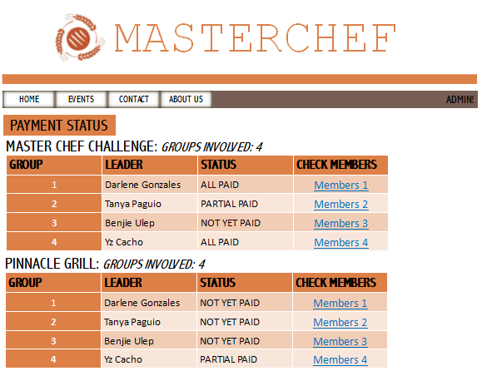

Upon pressing the ‘payment status’, it will direct the admin to the payments of each group including the group number and leader per group. It is also indicated if how many groups are in that specific season of the show. Under the status column, it will indicate ‘ALL PAID’ if all members of the group have paid already, ‘PARTIAL PAID’ if half of the members have paid and ‘NOT YET PAID’ if none of the members have paid yet.

**Queried Tables:**

Group

Member

Payment

**DML Results:**

NONE

1. Member

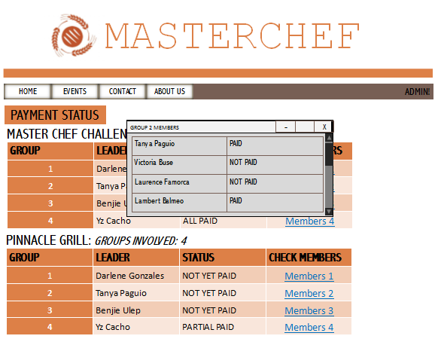

By clicking the members link below the CHECK MEMBERS, a window will pop out showing the list of members of that specific group.

**Queried Tables:**

Member  
Payment Status

**DML Results:**

NONE

1. Member Information

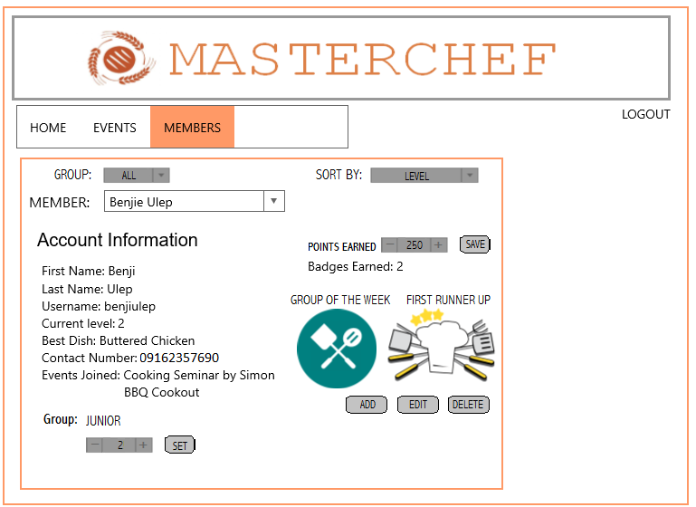

The admin can view information about each members. Since members receives badges, the admin is the one in charge for that. He/she can add or delete badges for each member.

**Queried Tables:**

Member

Group

Event

Meminc

Incentive

**DML Results:**

Meminc

***+* Or *-***

**[+]MEMBER**

|  |  |  |  |  |  |  |
| --- | --- | --- | --- | --- | --- | --- |
| **MEMBER** | | | | | | |
| **memid** | **lname** | **fname** | **minitial** | **bday** | **gender** | **contactno** |
| M0001 | BENJIE | ULEP | A. | 8/7/2001 | M | +639162357690 |
| M0002 | ANDRE | CODOD | D. | 1/11/1989 | M | +639494165894 |
| M0003 | PAGUIO | TANYA | R. | 2/14/2003 | F | +639214625394 |
| M0004 | MARZAN | MARK KENNETH | P. | 7/17/1987 | M | +639185672342 |

|  |  |  |  |  |
| --- | --- | --- | --- | --- |
| **MEMBER (continuation)** | | | | |
| **lvlachvd** | **acqrpoints** | **groupid** | **regno** | **eventid** |
| 2 | 250 | G02 | R0001 | E02 |
| 2 | 160 | G01 | R0002 | E01 |
| 3 | 50 | GO3 | R0003 | E04 |
| 4 | 200 | GO4 | R0004 | E03 |

***SET***

**[+]GROUP**

|  |  |  |
| --- | --- | --- |
| **GROUP** | | |
| **groupid** | **grouptype** | **chefid** |
| G01 | senior | C01 |
| G02 | junior | C02 |
| G03 | junior | C03 |
| G04 | senior | C04 |

1. Incentives

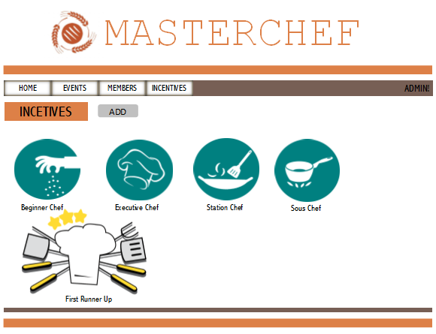

The admin is able to view different kinds of badges that can be given to the members. He/she is may add additional incentives or badges by clicking the add button.

**Queried Tables:**

Incentives

**DML Results:**

NONE

1. Adding of Incentives

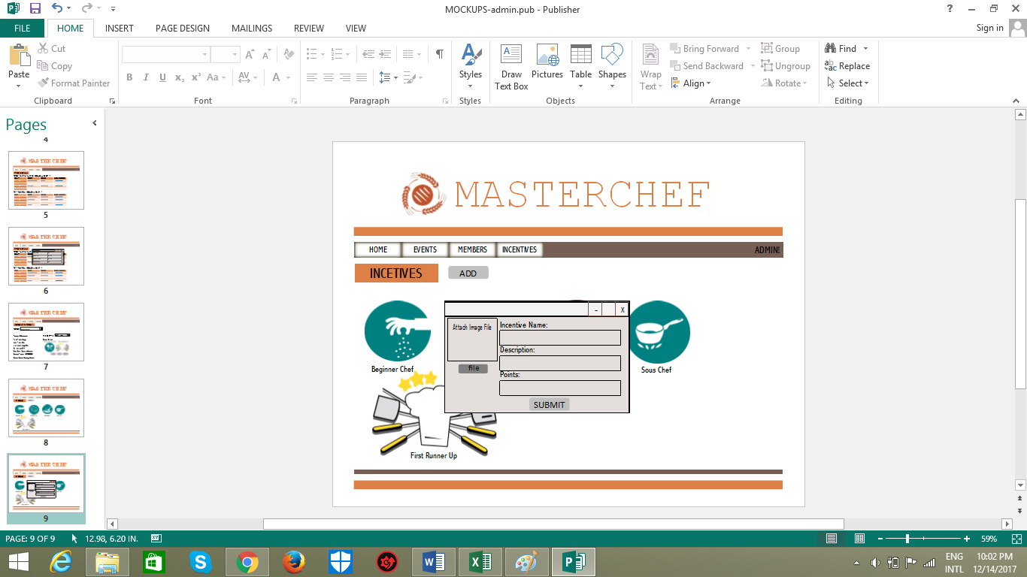

The admin can add incentives by pressing the add button in the incentives page. The admin will just provide an image and the incentive name after that the incentive will be added to the page.

**Queried Tables:**

NONE

**DML Results:**

Incentives

***SUBMIT***

**[+]INCENTIVES**

|  |  |  |  |  |
| --- | --- | --- | --- | --- |
| **INCENTIVES** | | | | |
| **incentiveid** | **incentivedesc** | **badges** | **ptsgiven** | **eventid** |
| I001 | (highest points for the year/month/week) | GROUP OF THE WEEK | 70 | E01 |
| I002 | Won Gold Award on a competition | 1ST RUNNER UP | 60 | E02 |
| I003 | Won Silver Award on a competition | 2ND RUNNER UP | 55 | E03 |
| I004 | Won Bronze Award on a competition | 3RD RUNNER UP | 47 | E04 |
| I005 | Successfully participated on a competition | PARTICIPANT | 45 | E05 |

1. Chefs

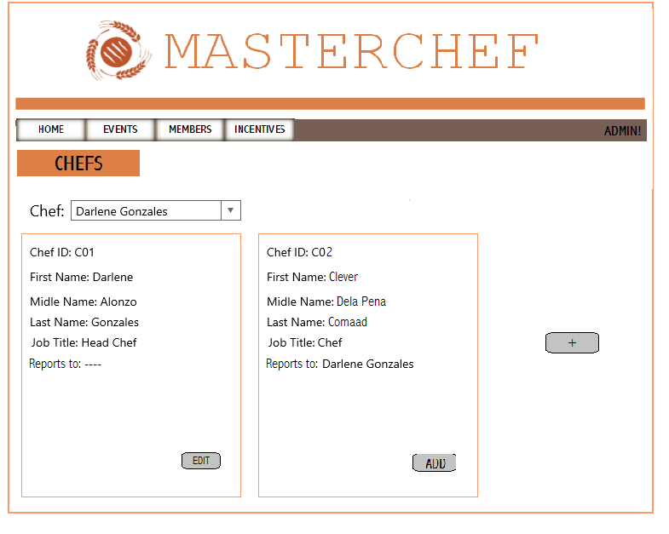

Admin can also view the chefs and the head chef. The different chefs reports to one head chef.

**Queried Tables:**

Chef

**DML Results:** Chef

***EDIT***

**[+]CHEF**

|  |  |  |  |  |  |
| --- | --- | --- | --- | --- | --- |
| **CHEF** | | | | | |
| **chefid** | **f_name** | **l_name** | **m_name** | **jobtitle** | **reportsTo** |
| C01 | DARLENE | GONZALES | ALONZO | HEAD CHEF |  |
| C02 | CLEVER | COMAAD | DELA PENA | CHEF | C01 |
| C03 | JARGON | TAASIN | RESERVA | CHEF | C01 |
| C04 | YZ | CACHO | PAGAR | CHEF | C01 |

***ADD***

**[+]CHEF**

|  |  |  |  |  |  |
| --- | --- | --- | --- | --- | --- |
| **CHEF** | | | | | |
| chefid | f_name | l_name | m_name | jobtitle | reportsTo |
| C01 | DARLENE | GONZALES | ALONZO | HEAD CHEF |  |
| C02 | CLEVER | COMAAD | DELA PENA | CHEF | C01 |
| C03 | JARGON | TAASIN | RESERVA | CHEF | C01 |
| C04 | YZ | CACHO | PAGAR | CHEF | C01 |

1. Outputs

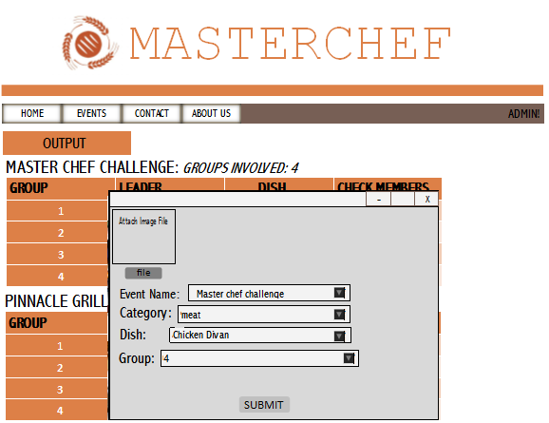

The outputs that each group did for an event can also be viewed. The admin can input the different dishes that the group made for a specific category and event.

**Queried Tables:**

Output

**DML Results:** Output

***SUBMIT***

**[+]OUTPUT**

|  |  |  |  |  |
| --- | --- | --- | --- | --- |
| **OUTPUT** | | | | |
| **outputid** | **category** | **outputdetails** | **groupid** | **eventid** |
| O1 | Meat | Beef Short Rib pho | G03 | E02 |
| O2 | Meat | Salisburry Steak | G02 | E01 |
| O3 | Pasta | Fettuccine Alfredo | G01 | E04 |
| O4 | Meat | Chicken Divan | G04 | E03 |

|  |  |  |
| --- | --- | --- |
| **OUTEVE** | | |
| **outputid** | **eventid** |
| O1 | E02 |
| O2 | E01 |
| O3 | E04 |
| O4 | E03 |