# To build and debug

Run Visual Studio 2015 as Administrator

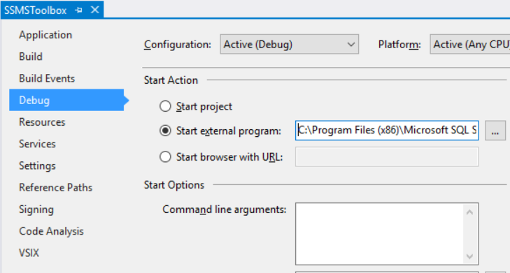

Path to external program (SSMS 2016):

C:\Program Files (x86)\Microsoft SQL Server\130\Tools\Binn\ManagementStudio\Ssms.exe

Remove command line arguments!

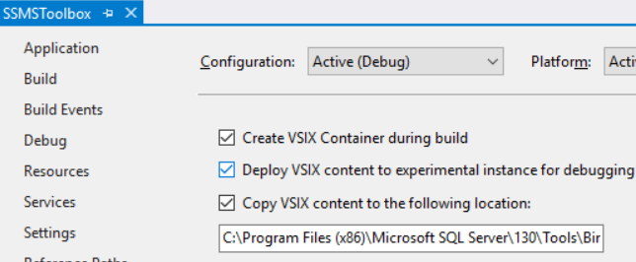

Check “Copy VSIX content…”

Path: C:\Program Files (x86)\Microsoft SQL Server\130\Tools\Binn\ManagementStudio\Extensions\SqlCeToolbox