WEB漏洞扫描软件调研

警告：一切扫描渗透行为需经过委托方的授权，否则一切后果自负！

警告：一切扫描渗透行为需经过委托方的授权，否则一切后果自负！

警告：一切扫描渗透行为需经过委托方的授权，否则一切后果自负！

1.xray（官网：https://xray.cool/）:
准备xray安装包：xray_linux_amd64.zip
创建xray文件夹：sudo mkdir /home/ubuntu/xray
解压zip文件：unzip xray_linux_amd64.zip -d /home/ubuntu/xray
安装xray: ./xray_linux_amd64 (可能需要执行，第一次因为没有xray.yaml文件会报错，需再执行一次)
使用说明: ./xray_linux_amd64 --help
Example:
扫描公司官网： https://www.nullmax.cn/
先生成ca证书： ./xray_linux_amd64 genca
扫描： ./xray_linux_amd64 webscan --url https://www.nullmax.cn/ --html-output outcome.html
*如果没有扫到漏洞是不会生成html文件的

2.nessus（官网： https://www.tenablecloud.cn/products/nessus）:
参考文档：https://blog.csdn.net/qq_50247813/article/details/144314168
1.访问官网下载nessus：
https://www.tenablecloud.cn/products/nessus?utm_source=baidu&utm_medium=CPC&utm_campaign=Nessus_PC&utm_content=nessus&utm_term=nessus%20%E5%AE%98%E7%BD%91
Bash
curl --request GET \
> --url 'https://www.tenable.com/downloads/api/v2/pages/nessus/files/Nessus-10.8.3-debian10_amd64.deb' \
> --output 'Nessus-10.8.3-debian10_amd64.deb'
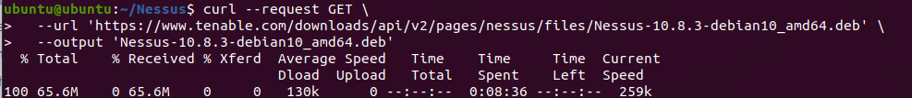
2.安装nessus，去到安装包文件夹下，使用dpkg -i Nessus-10.8.3-ubuntu1604_amd64.deb
1.）根据提示启动nessusd服务： systemctl start nessusd.service
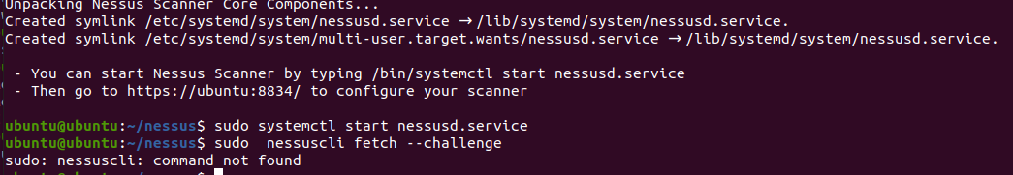
2.）访问提示的网站： https://ubuntu:8834/

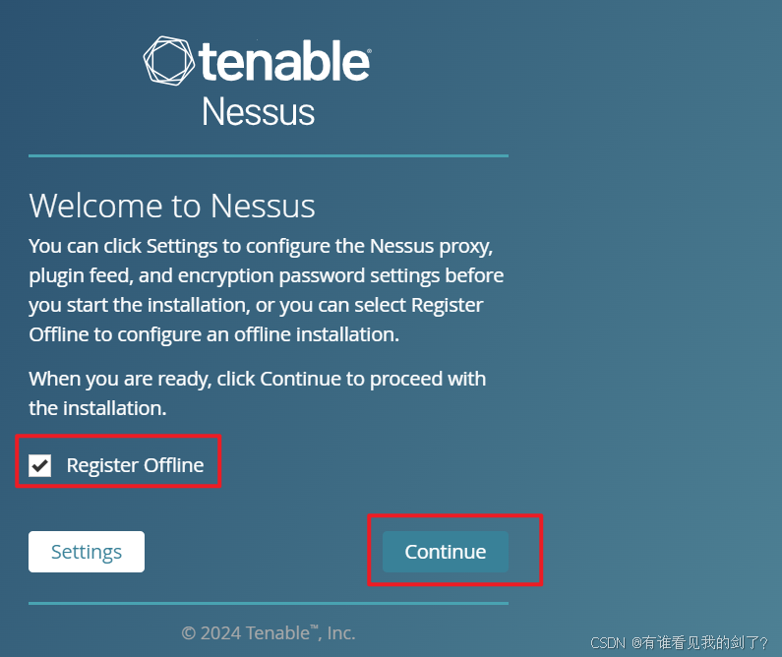

选最后一个Managed Scanner：

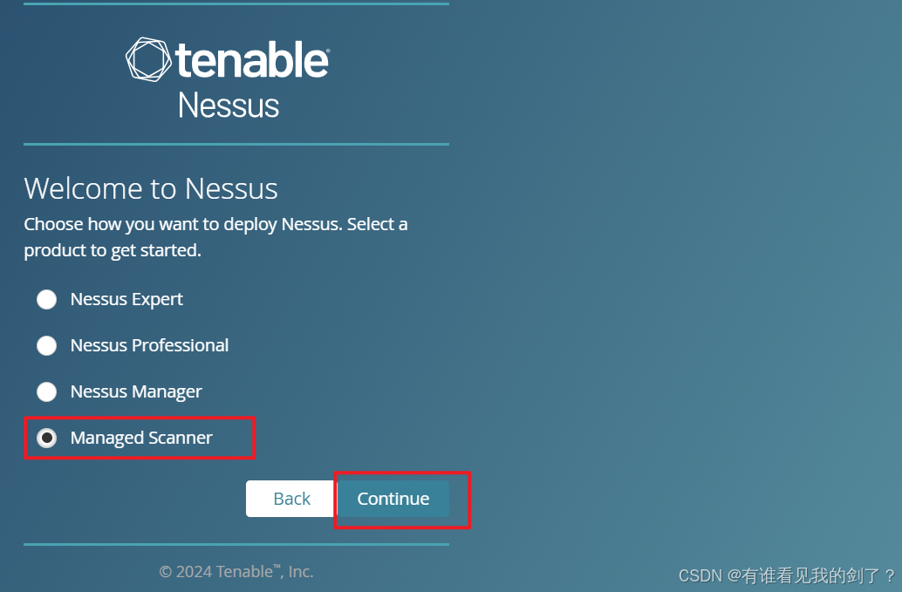
然后选择Tenable Security Center
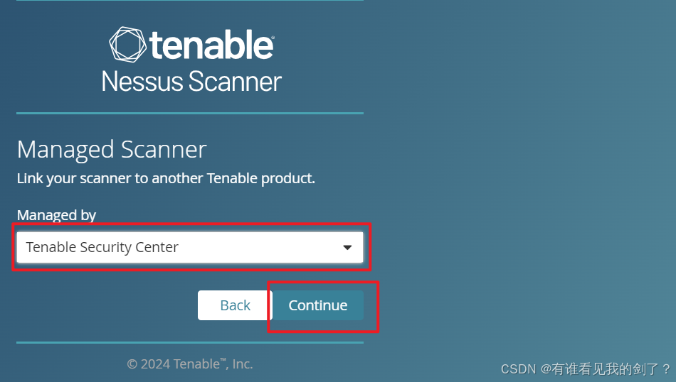
注册账号
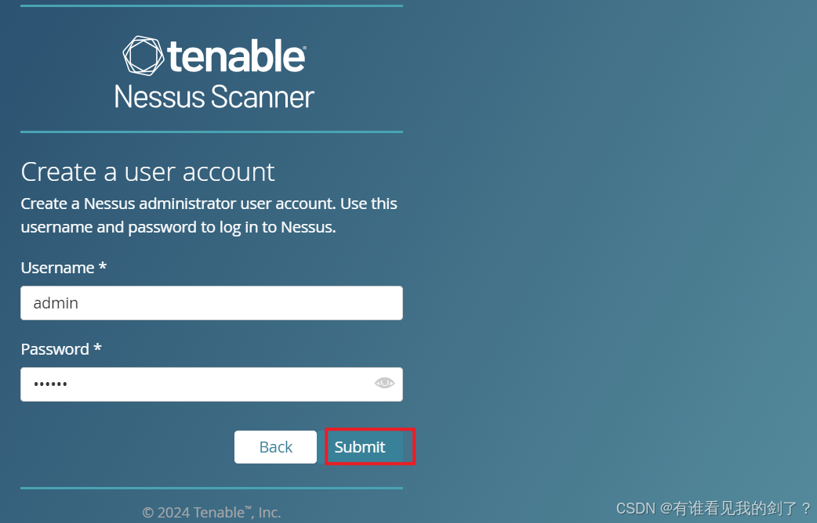
激活Nessus:
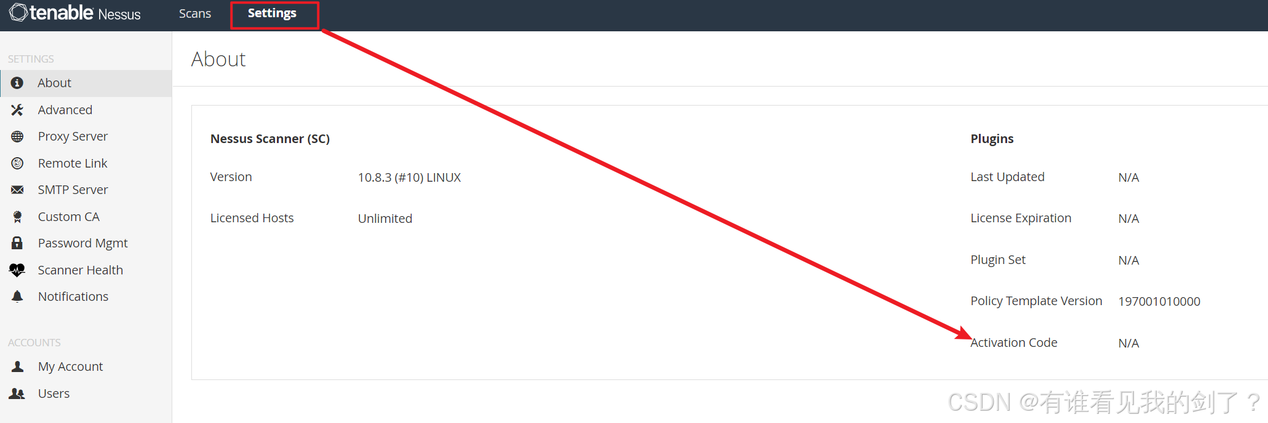
Bash
root@localhost:~# sudo /opt/nessus/sbin/nessuscli fetch --challenge
Challenge code: f45689d2a6ed72661729d67ab7536c2de092fb56
You can copy the challenge code above and paste it alongside your
Activation Code at:
https://plugins.nessus.org/v2/offline.php
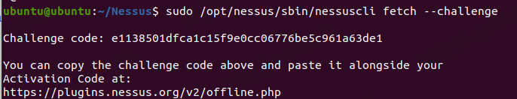
获取activation code
https://www.tenable.com/products/nessus/nessus-essentials
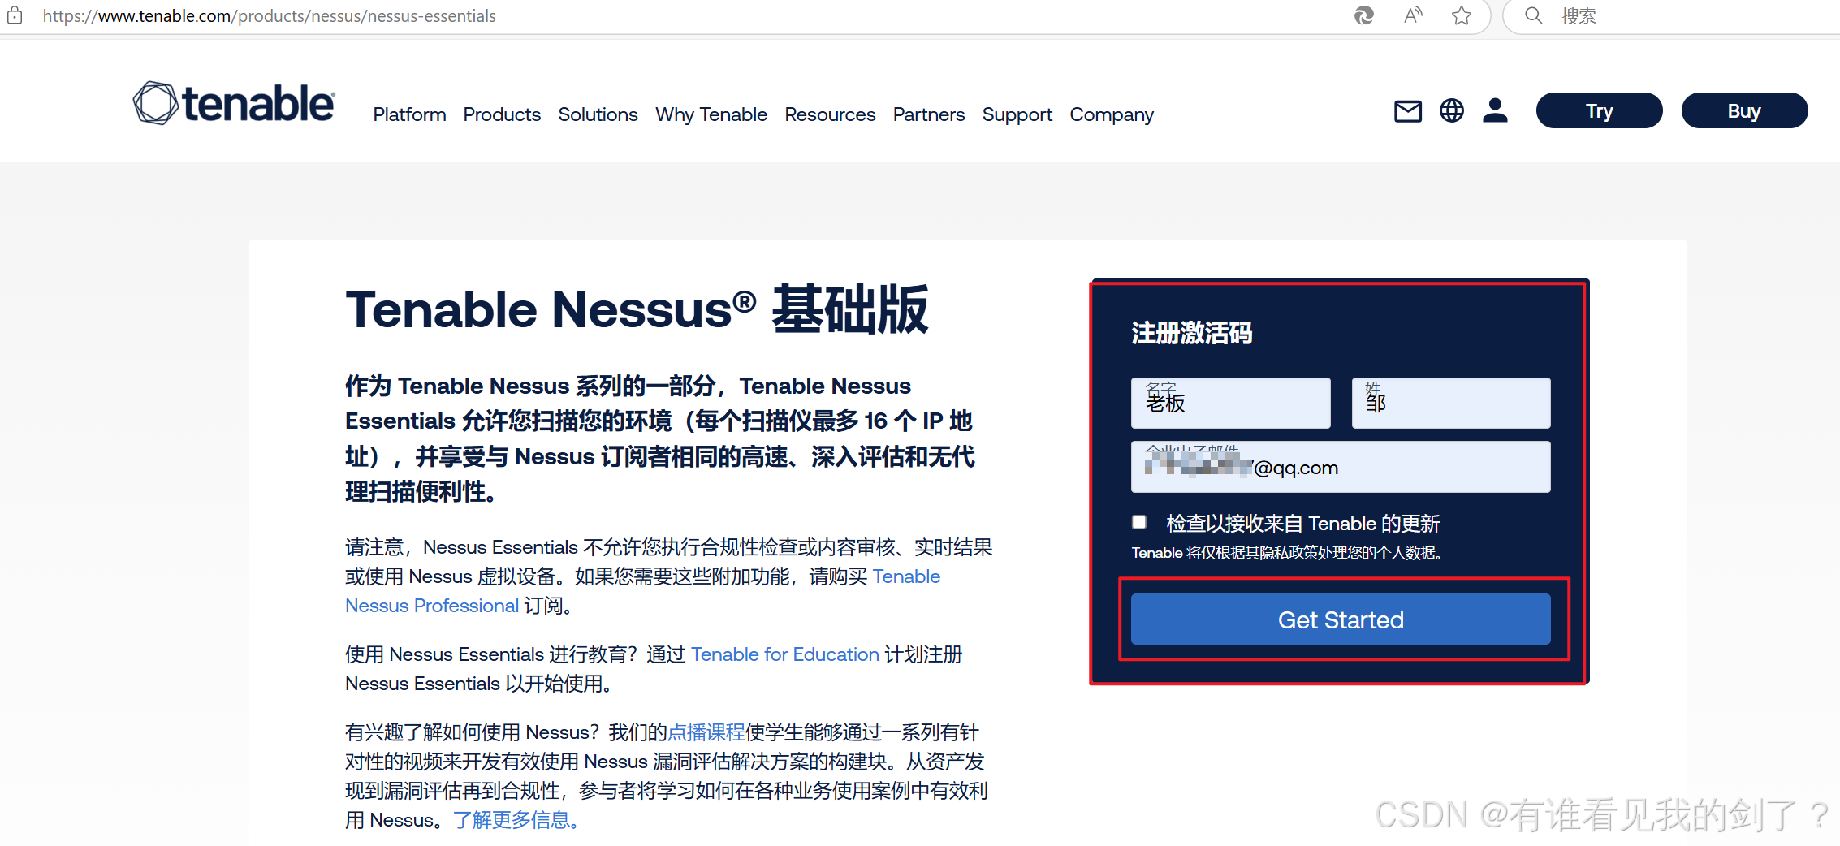

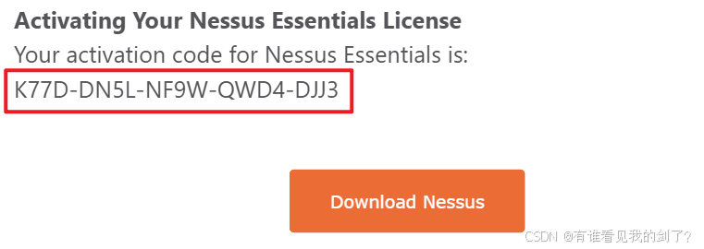
- 获取 LICENSE 和 插件压缩包
https://plugins.nessus.org/v2/offline.php
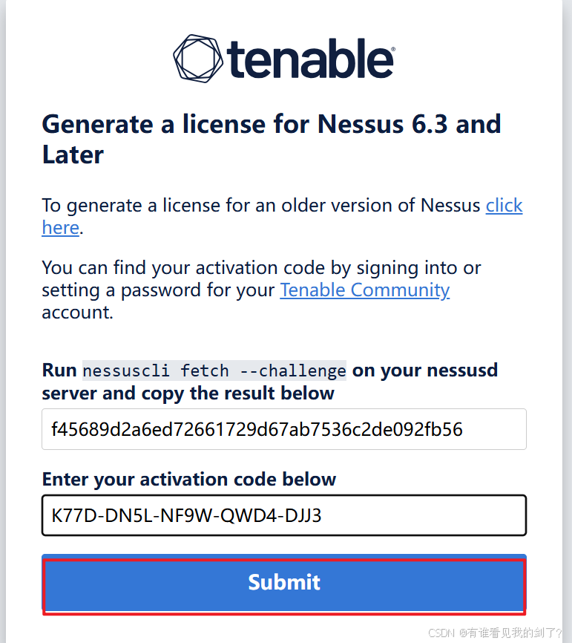
nessus.license: 创建license文件把下面的code粘贴进去
Bash
-----BEGIN TENABLE LICENSE-----
Z1NPZXE4blAyQXIyblp4MUIvSjJvMmFJbHY5UlJna0h1bGxrTk93N1FaU1pjQXhvMDAvbVdna1dB
SDRIOWFBQ2U5QlQra3NuQnNDOXJTQTA1b3NvVFhlb3BMTzZBUHFxVlVxQ3JVRjV2TWQzSVR3bVU2
RnErYmxqK1Y3Y2VFMEJyRFpyRW9QUTJOcUhVM0ZqRzRYMkFrQ2NVdXFUcUxrSGxQcFplUWNoOHBu
ZW5vV3VvL0c4L2NyWmtMV1JRVXBnRmpGTzVaWFl4U2Z4WEc1aGJZZm5jR0FPUk05U1pQYkdlL08z
Q2psSmMrSFV1NVIvZ3Jpd2plZmxPZ0hqb05GYzMycldwVWo3U3ptSTN2cVR5alJadk1qTEFIcjNK
SXRyYVdqQ1VzZ0k2dmJIYkJUQndPM3NKZ0ZicC96eFZVeGRwYTZyQUJTRmkvbS9TYlBoYzNYcmNi
V1Jsa01GMWVaYXhLbUtuL3dTbEp6TXFhaWtSbllJeC9DNEJkc09BVkVTUCs5SGRZd2RvRzdTbWdT
UzhXbTNLcDZkdkZROXpFZmNkUGI5QmdtanBhalg4R3JaNjBJN2ZxeDBKVldaMFRGZktmYW41NVZw
UjBYS0NBS0RiK3pCdGwzZ1ppQXFHa1pWMFByVVM4MCs0ZGJaQThGZnZXTGdNQkE4cERHcUliUWhW
amxhSVpkeWc3N01yeVk5TTZXbWVaVGZYbk85SzYrdHBwbVRya0Rqc2h0RzZvTDE0Qnk3VHIzeEpl
YnB0aUNrNUxUS051amN6Q0RBVnUrMHF2Rjk2MEtKYjVkWGc4QTNsMXF1dll5KzhQeENSRXVmQ2pC
MURmTG5aUVhVSFZ2Tm1mLyt5VWZtWlpLWXRUNEdFd2h3eWNoOFhDaFh4TmtSaGFJQ1pVWDZUd009
DQp7ImFjdGl2YXRpb25fY29kZSI6IkQ4WjktOEFUNy1GUDVILTU0M1otVTdEOSIsInVwZGF0ZV9w
YXNzd29yZCI6ImE1OWNhMGZmODFjOTZiNmVjYjY0ZTgzNzBlOTEwN2M5IiwicGVuZG9fYXBpX2tl
eSI6ImE3YzhkNWM0LWI2YWUtNDg2Ny03ZGFiLTY5YTkyYTA4NDdlMSIsIm5hbWUiOiJOZXNzdXMg
SG9tZSIsInR5cGUiOiJob21lIiwiZXhwaXJhdGlvbl9kYXRlIjoxODk4MTI4ODA5LCJjdXN0b21l
cl9pZCI6MCwiaXBzIjoxNiwidXBkYXRlX2xvZ2luIjoiM2Y0ZDU0MjRhMTA1Y2Q5YzA1OWYwMDcy
YmEyNWE2YmMiLCJkcm0iOiI1NTgzNmNiNDZjODFmOWE5NjQwZWYzNzgzNGVmODk2NiJ9
-----END TENABLE LICENSE-----
4.获取插件压缩包
丢到浏览器里面下载
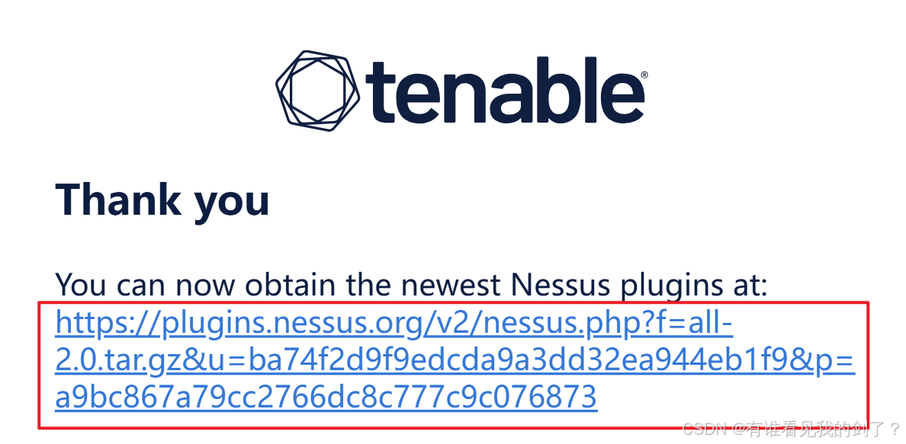
下载LICENSE证书，将 LICENSE 和 插件压缩包上传到服务器
Bash
root@localhost:~# ls -1
Nessus-10.8.3-ubuntu1604_amd64.deb
all-2.0.tar.gz
nessus.license
使用LICENSE 离线激活 Nessus
Bash
root@localhost:~# sudo /opt/nessus/sbin/nessuscli fetch --register-offline nessus.license
Warning! Performing this action will delete plugins. Do you want to continue? (y/n) [n]: y
Your Activation Code has been registered properly - thank you.
Nessus is offline and cannot do software updates via the feed.
导入插件
Bash
root@localhost:~# sudo /opt/nessus/sbin/nessuscli update all-2.0.tar.gz
[info] Copying templates version 202411212059 to /opt/nessus/var/nessus/templates/tmp
[info] Finished copying templates.
[info] Moved new templates with version 202411212059 from plugins dir.
[info] Moved new pendo client with version 2.169.1
from plugins dir.
* Update successful. The changes will be automatically processed by Nessus.
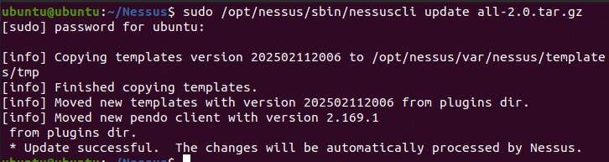

Bash
#重启nessus服务
root@localhost:~# systemctl restart nessusd
登入Nessus
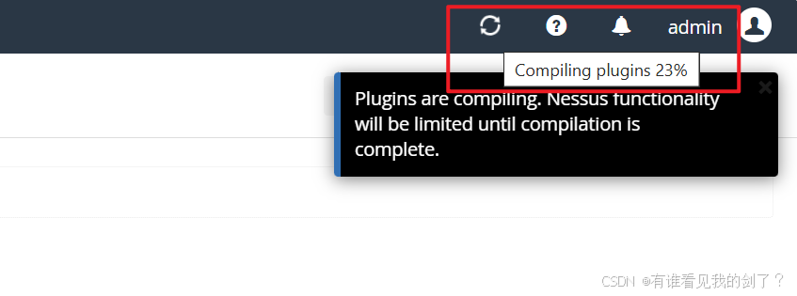
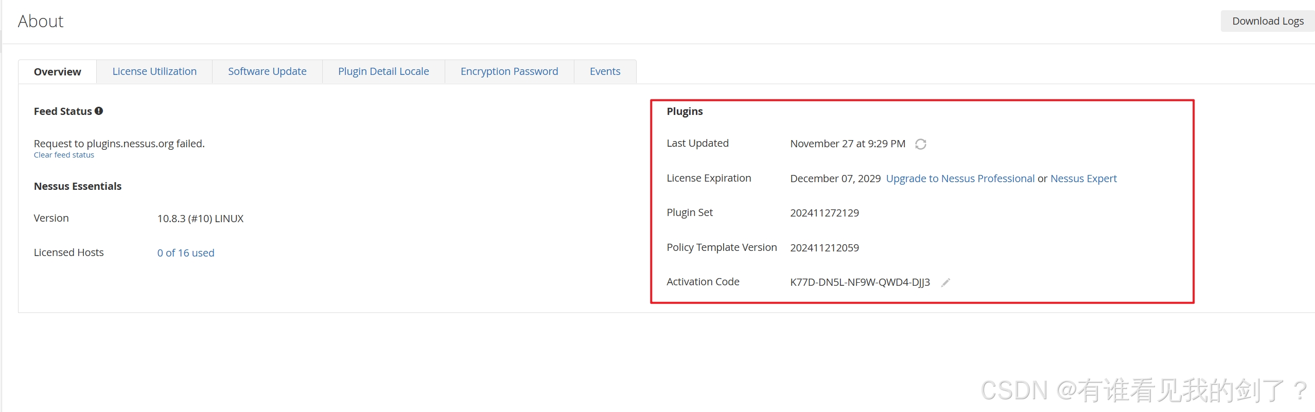

FFUV-VQYQ-MXTA-UGSF-TRCH

3.EZ（官网-绿盟：https://msec.nsfocus.com/）
1.官网注册，然后申请证书（免费30天），然后下载证书
2.下载EZ
3. sudo mkdir /home/ubuntu/ez 创建ez文件夹
4. unzip ez_linux_amd64.zip 解压zip文件
5. 将下载好的证书移到ez文件夹中
6. 运行EZ: ./ez_linux_amd64 webscan 生成.yaml配置文件
7. 使用./ez_linux_amd64 web 开启web服务
8. 输入http://10.10.6.204:8888,之后报错invalid request，再按下面提示的url访问： pleases visit....
9. 官方使用文档： https://docs.ezreal.cool/docs/intro/
10. 渗透测试需要可控：
1. 选择测试范围：网络地址、域名范围、端口
2. 不要选择测试内外主机
3. 枚举尽量不选

