Kubernetes部署基础nginx服务

一、编写nginx服务yaml文件

1.编写deployment.yaml文件
Bash
sudo mkdir /etc/nginx
sudo nano /etc/nginx/nginx-deployment.yaml

Bash
#复制粘贴到文件中
apiVersion: apps/v1
kind: Deployment
metadata:
name: nginx-deployment
namespace: nginx
labels:
app: nginx
spec:
replicas: 1
selector:
matchLabels:
app: nginx
template:
metadata:
labels:
app: nginx
spec:
containers:
- name: nginx
image: nginx
ports:
- containerPort: 80

2.编写service.yaml文件
Bash
sudo nano /etc/nginx-service.yaml

Bash
apiVersion: v1
kind: Service
metadata:
name: nginx-service
labels:
app: nginx
spec:
selector:
app: nginx
ports:
- protocol: TCP
port: 80
targetPort: 80
type: LoadBalancer

3.启动服务
Bash
#创建命名空间
kubectl create namespace nginx
#创建ni=gnix pod
kubectl create -f nginx-deployment.yaml
kubectl create -f nginx-service.yaml

4.合并文件

1.模板-01
Bash
cat << EOF > /etc/nginx/nginx-deployment.yaml
---
apiVersion: apps/v1
kind: Deployment
metadata:
name: nginx-deployment
namespace: nginx
labels:
app: nginx
spec:
replicas: 2
selector:
matchLabels:
app: nginx
template:
metadata:
labels:
app: nginx
spec:
containers:
- name: nginx
image: registry.docker.io:5000/nginx
ports:
- containerPort: 80
---
apiVersion: v1
kind: Service
metadata:
name: nginx-service
labels:
app: nginx
spec:
selector:
app: nginx
ports:
- protocol: TCP
port: 80
targetPort: 80
type: LoadBalancer
EOF

2.模板-02
Bash
#nginx_deployment_service.yaml
cat << EOF > /etc/nginx/nginx-deployment.yaml
apiVersion: v1
kind: Namespace
metadata:
name: kube-nginx
---
apiVersion: apps/v1
kind: Deployment
metadata:
name: nginx
namespace: kube-nginx
spec:
selector:
matchLabels:
app: nginx
template:
metadata:
labels:
app: nginx
spec:
containers:
- name: nginx
image: registry.docker.io:5000/nginx
ports:
- name: http
containerPort: 80
---
apiVersion: v1
kind: Service
metadata:
namespace: metallb-system
name: nginx
spec:
ports:
- name: http
port: 80
protocol: TCP
targetPort: 80
selector:
app: nginx
type: LoadBalancer
EOF

5.查看服务是否对外暴露
Bash
kubectl get service nginx -n kube-nginx -o wide
上面没有外部IP因为缺少两个组件以及没有配置地址池

二、下载METALLB

1.下载配置文件
Bash
#使用metallb插件
#参考官网
https://metallb.io/installation/

Bash
sudo mkdir /etc/metallb
cd /etc/metallb
wget https://raw.githubusercontent.com/metallb/metallb/v0.14.9/config/manifests/metallb-native.yaml
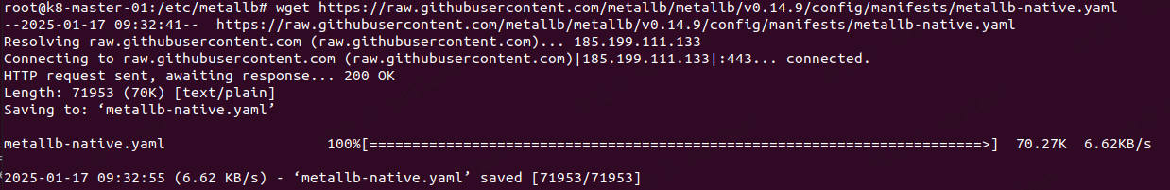

2.查看配置文件镜像
Bash
#查看文件所需镜像
grep image /etc/metallb/metallb-native.yaml
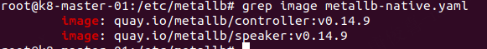

3.下载镜像并打标签上传到私有仓库
Bash
#使用docker下载镜像并上传到私服仓库
sudo docker pull quay.io/metallb/controller:v0.14.9
sudo docker tag quay.io/metallb/controller:v0.14.9 registry.docker.io:5000/controller:v0.14.9
sudo docker push registry.docker.io:5000/controller:v0.14.9
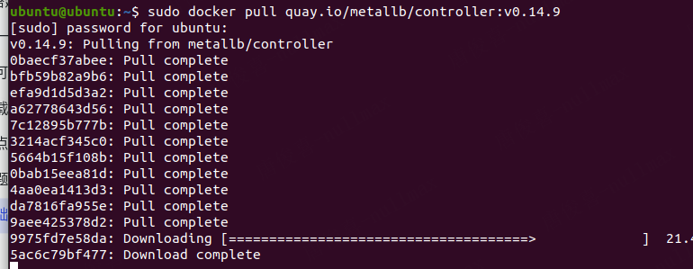

4.修改镜像
Bash
#修改镜像
sed -i 's@quay.io/metallb/@registry.docker.io:5000/@g' /etc/metallb/metallb-native.yaml

5.启用metallb
Bash
kubectl create -f /etc/metallb/metallb-native.yaml

6.查看metallb是否正常工作
Bash
kubectl get pods -n metallb-system
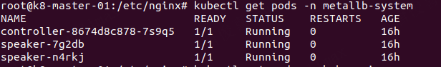

7.配置暴露服务文件
Bash
#
#nginx_deployment_service.yaml
cat << EOF > /etc/nginx/nginx-deployment.yaml
apiVersion: metallb.io/v1beta1
kind: IPAddressPool
metadata:
name: ip-pool-01
namespace: metallb-system
spec:
addresses:
- 192.168.100.10-192.168.100.250
---
apiVersion: metallb.io/v1beta1
kind: L2Advertisement
metadata:
name: level2-advertisement
namespace: metallb-system
spec:
ipAddressPools:
- ip-pool-01
# nodeSelectors:
# - matchLabels:
# kubernetes.io/hostname: k8-slave-01
EOF

8.再起重启nginx服务
Bash
kubectl delete -f /etc/nginx/nginx-delployment.yaml
kubectl create -f /etc/nginx/nginx-delployment.yaml

9.访问宿主机IP：
