**Kubernetes搭建问题解决手册**

**一、权限问题**

1、执行命令kubectl get node

|  |
| --- |
| Bash kubectl get * |

|  |
| --- |
| Bash 报错：  E0109 19:18:43.889496 5921 memcache.go:265] couldn't get current server API group list: Get "http://localhost:8080/api?timeout=32s": dial tcp [::1]:8080: connect: connection refused |

2、执行命令

|  |
| --- |
| Bash export KUBECONFIG=/etc/kubernetes/admin.conf |

|  |
| --- |
| Bash #全局永久 echo "export KUBECONFIG=/etc/kubernetes/admin.conf" >> /etc/profile source /etc/profile |

3、退出，重新执行kubectl get *

**二、Token过期**

1.执行命令

|  |
| --- |
| Bash kubeadm join 192.168.135.145:6443 --token abcdef.0123456789abcdef \  --discovery-token-ca-cert-hash sha256:d77d919dca4a5a9b79362ca70ca2a4d819a0e87b813f56fdffa7df68d865d476 |

2.问题

|  |
| --- |
| Bash 工作节点加入报错：  error execution phase preflight: unable to fetch the kubeadm-config ConfigMap: failed to get config |

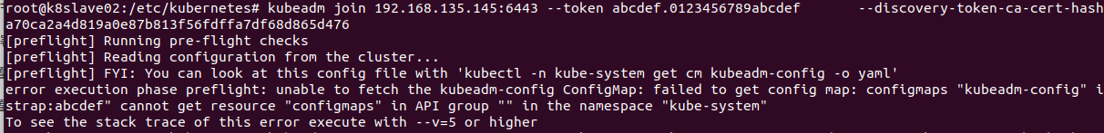

2.更新token重新加入

|  |
| --- |
| Bash #在k8-master-03上执行 kubeadm token create #重新生成token |



|  |
| --- |
| Bash #工作节点重新加入 #不需要更新token-ca-cert-hash #原token加入 kubeadm join 192.168.135.145:6443 --token abcdef.0123456789abcdef \  --discovery-token-ca-cert-hash sha256:d77d919dca4a5a9b79362ca70ca2a4d819a0e87b813f56fdffa7df68d865d476   #新token加入 kubeadm join 192.168.135.145:6443 --token pcqnsp.kf8y83cujplol0sg \  --discovery-token-ca-cert-hash sha256:d77d919dca4a5a9b79362ca70ca2a4d819a0e87b813f56fdffa7df68d865d476 |

**三、负载均衡器都进入MASTER状态**

1.问题

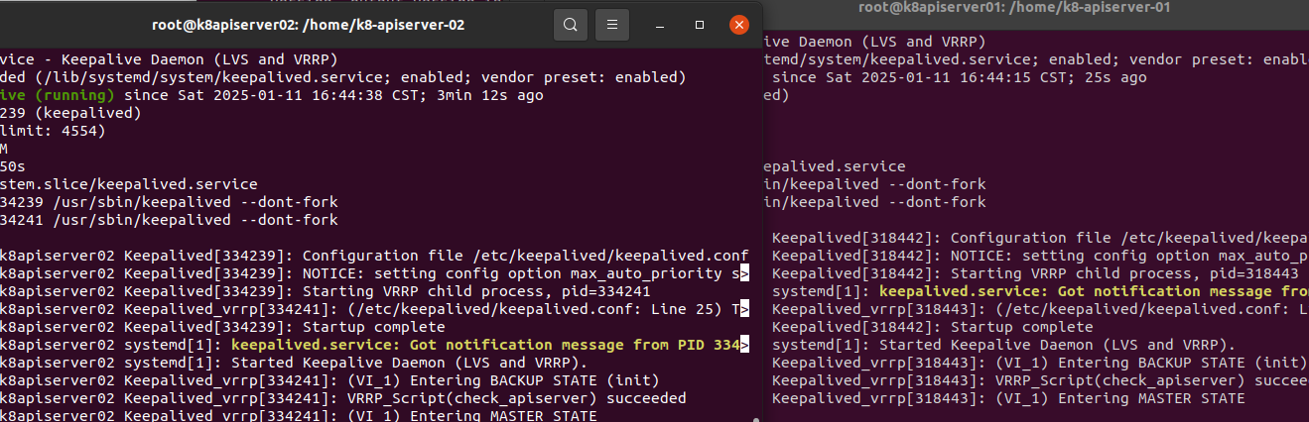

1.网络互通的话大概率配置文件的问题没别的

**五、crictl拉不到镜像**

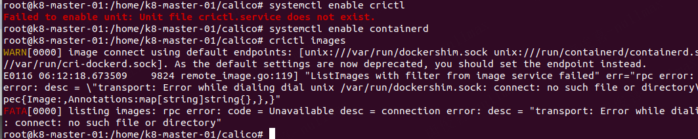

|  |
| --- |
| Bash 想试试containerd运行k8s，结果报错还在找dockershim，网上找了解决方法 crictl依次查找容器运行时，当查找第一个 unix:///var/run/dockershim.sock 没有找到，所以报错了，需要你手动指定当前kubernetes的容器运行时，使用什么，例如： kubernetes 1.24+ 之后，dockershim已经变成了cri-docker，所以你需要执行： crictl config runtime-endpoint unix:///var/run/cri-dockerd.sock 如果你的容器运行时，已经换成了containerd，则换成containerd的，如： crictl config runtime-endpoint unix:///var/run/containerd/containerd.sock 之后，你在执行就好了。 另外：生成的配置在cat /etc/crictl.yaml，可以随时修改。 |

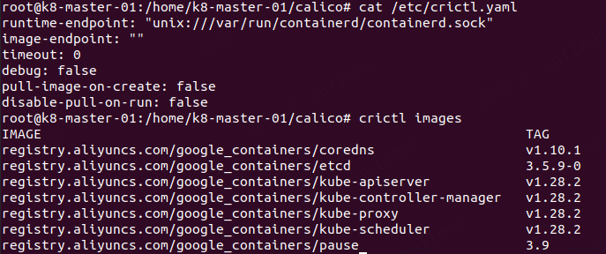



**六、子节点使用calico**



|  |
| --- |
| Bash 无论是calico-3.27.3.yaml还是calico-custom-resources.yaml都必须使用create不要使用apply生效创建资源，否则会报错 官方文档有写：Due to the large size of the CRD bundle, kubectl apply might exceed request limits. Instead, use kubectl create or kubectl replace. |

**七、Calico custom-resources.yaml文件配置错误**

|  |
| --- |
| Bash Successfully assigned kube-nginx/nginx-7854ff8877-vtssb to k8-slave-01  Warning FailedCreatePodSandBox 3m35s kubelet Failed to create pod sandbox: rpc error: code = Unknown desc = failed to setup network for sandbox "916e5ddf2ec54d16cac90a36e4096c266d1ec776fdefd75e575000f98ec0d810": plugin type="calico" failed (add): cannot find a qualified ippool  Warning FailedCreatePodSandBox 3m35s kubelet Failed to create pod sandbox: rpc error: code = Unknown desc = failed to setup network for sandbox "0d32d045009412ef9269926800993b717a1fc64d815d35a69cc056967547aba6": plugin type="calico" failed (add): cannot find a qualified ippool  Warning FailedCreatePodSandBox 3m19s kubelet Failed to create pod sandbox: rpc error: code = Unknown desc = failed to setup network for sandbox "a7423559d6068c33bec278951cbdca23d77c33d779b350aa73679bf67a5830f8": plugin type="calico" failed (add): cannot find a qualified ippool  Warning FailedCreatePodSandBox 3m5s kubelet Failed to create pod sandbox: rpc error: code = Unknown desc = failed to setup network for sandbox "05b66245aae7ecf31f5aa10a01f98b3cc2494d122834d03d2815b4b70da700bb": plugin type="calico" failed (add): cannot find a qualified ippool  Warning FailedCreatePodSandBox 2m52s kubelet Failed to create pod sandbox: rpc error: code = Unknown desc = failed to setup network for sandbox "82075641fb23a538b372641afc1c0da2ed6f0ee7e48451512c2da2fbd85e9b57": plugin type="calico" failed (add): cannot find a qualified ippool  Warning FailedCreatePodSandBox 2m39s kubelet Failed to create pod sandbox: rpc error: code = Unknown desc = failed to setup network for sandbox "9862b31a55ecb190ec78c3eaf86371cef962bfd6383df4ef2e37da2075016d69": plugin type="calico" failed (add): cannot find a qualified ippool  Warning FailedCreatePodSandBox 2m27s kubelet Failed to create pod sandbox: rpc error: code = Unknown desc = failed to setup network for sandbox "27852483c46ebf402a59444c2056ae42a2bbca9ca92ad0156850fac2340c065b": plugin type="calico" failed (add): cannot find a qualified ippool  Warning FailedCreatePodSandBox 2m14s kubelet Failed to create pod sandbox: rpc error: code = Unknown desc = failed to setup network for sandbox "342b5cc7541adb077ba63a73baf8ac9c3f8bdf430a2e3c214ad7f28261ead988": plugin type="calico" failed (add): cannot find a qualified ippool  Warning FailedCreatePodSandBox 2m kubelet Failed to create pod sandbox: rpc error: code = Unknown desc = failed to setup network for sandbox "553c09bdf1a0e567903cfc6876854bdf880a5c25969613b1aea3594ad7632955": plugin type="calico" failed (add): cannot find a qualified ippool  Warning FailedCreatePodSandBox 10s (x8 over 106s) kubelet (combined from similar events): Failed to create pod sandbox: rpc error: code = Unknown desc = failed to setup network for sandbox "5ba6f74c3148ea1c84c3cd7c244ba47ffbef251e1efa79b78596f94428675fb0": plugin type="calico" failed (add): cannot find a qualified ippool |

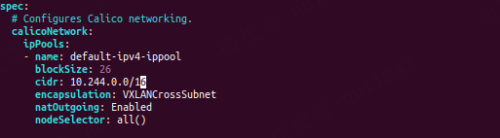

把IP改成kubernetes的Pod网段

**八、calico找不到clusterinformations.crd.projectcalico.org**

|  |
| --- |
| Bash 这个错误表明系统在尝试访问 Kubernetes 集群中的 clusterinformations.crd.projectcalico.org 资源时，无法找到名为 "default" 的该资源实例。ClusterInformation 是 Calico 网络插件用来跟踪集群网络信息的自定义资源定义（CRD）。 解决方法： 确认 Calico 网络插件是否已正确安装在 Kubernetes 集群中。 如果 Calico 已安装，确保 ClusterInformation 资源存在。可以使用 kubectl get clusterinformations -n kube-system 查看是否有该资源。 如果资源不存在，可能需要重新创建或修正配置，以确保 Calico 能正确地部署和识别所需的 ClusterInformation 资源。 如果是在进行集群升级或迁移时遇到此问题，确保按照相关文档进行操作，以保持 Calico 资源的一致性。 如果问题依旧存在，检查 Kubernetes 集群的日志和状态，查找更详细的错误信息，或者考虑重新部署 Calico 网络插件。 |

使用mainfest部署下载calico.yaml文件并启用