EECS 4312  SOFTWARE REQUIREMENTS ENGINEERING | INSTRUCTOR: Maleknaz Nayebi
Lab 6: Specification III (DURATION: 50 min)

Family Name: _____________________________________________
First Name(s): _____________________________________________
Student Number: _______________________

Signature: _____________________________________________

This Lab is to be done individually and in-person during your designated lab time.
- You need to be present in the lab on time, finish and submit all your material by the end of the lab.
- Based on your group your required task and submission may differ.
- Follow the steps sequentially and do not move to the next task before finishing the previous one.
- All your response to different questions must be recorded in this booklet and hand in to your TA at the end.
- All the code related artifacts must be committed to the GitHub Repository.
- If you have a question, raise your hand and a TA will come to you.

All the responses should be in this booklet.

Ensure that the papers remain intact; refrain from separating them and keep all pages securely stapled and bound together.

Good luck!

Lab Overview (put a check mark to the steps you finish)

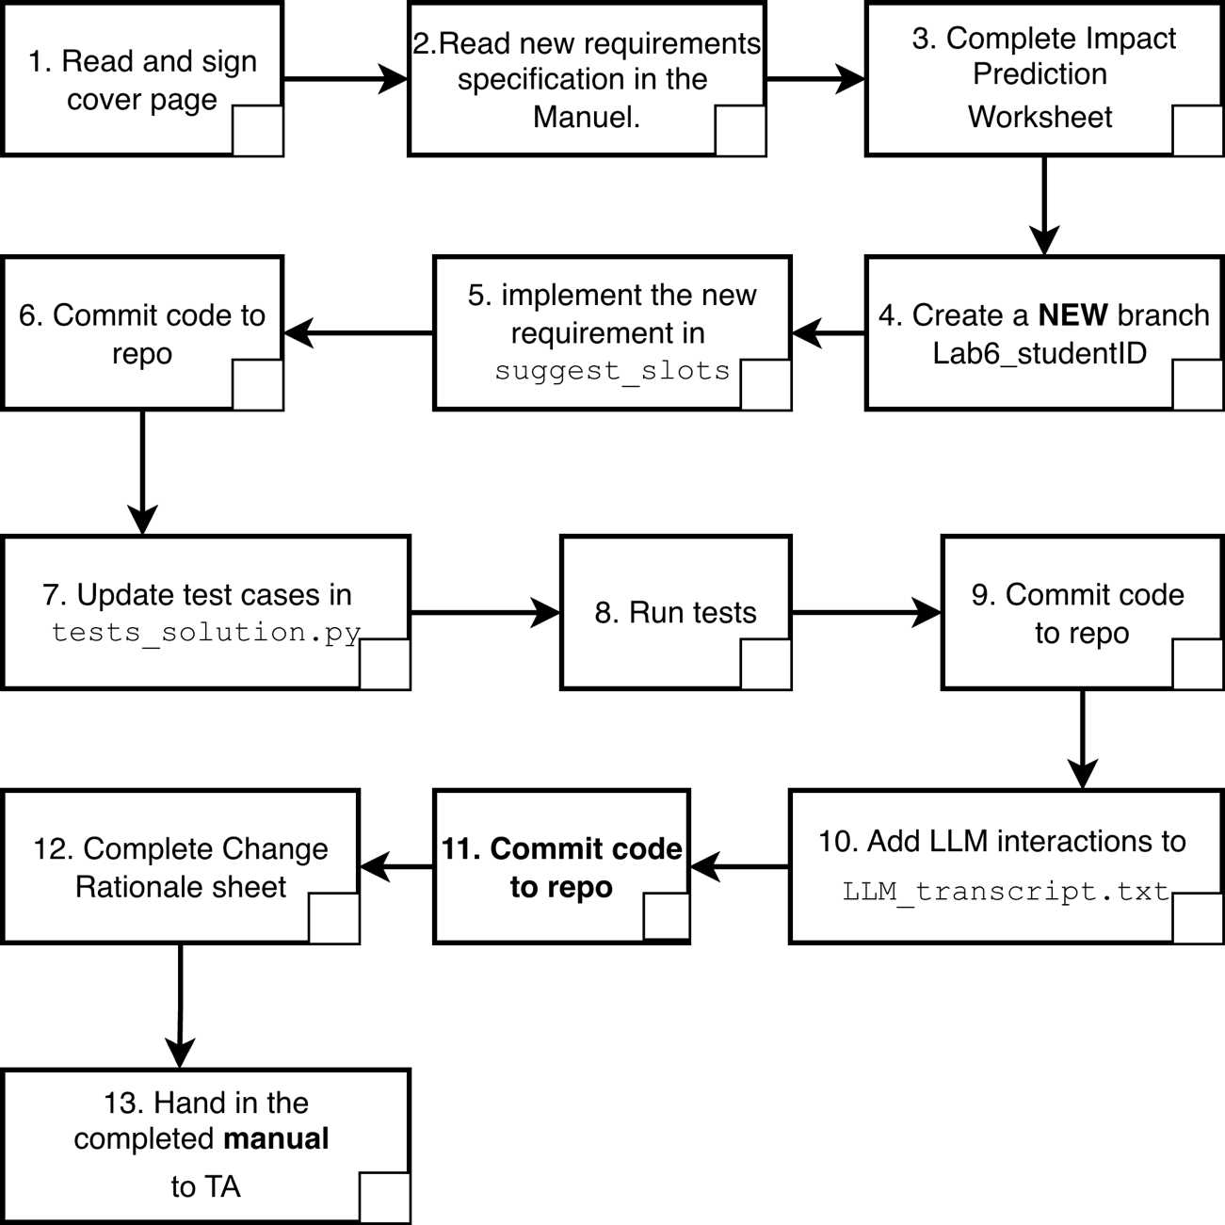

Lab Exercise: Change in Requirements Specification and LLM-Assisted Development

This handout guides you through Phase 2 of the requirements specifications lab, where a new requirement for your scheduling system is being introduced. The goal is to evaluate how requirement changes affect your solution and your understanding of the system. You must reason about its impact, update your solution, and explain your changes.
Step 1. Read This New Requirement
Meetings scheduled on Fridays must not start after 15:00. This requirement applies in addition to all previously described behavior. If a meeting would otherwise be valid but starts after 15:00 on a Friday, it must be excluded from the returned results. Update your solution, tests and documents to incorporate this requirement.

Step 2. Impact Prediction Worksheet

1. Do you think your current solution satisfies the new requirement?
☐ Yes ☐ No ☐ Not Sure

2. Which scenarios or cases do you expect to fail under the new requirement?

3. What is the most likely cause of failure?
☐ missing constraint ☐ invariant violation ☐ tie-breaking/ordering
☐ parsing/format assumption ☐ other: ___________________________

4. Which artifacts do you expect to update? (check all that apply)
☐ requirements/spec (if you have one) ☐ code ☐ tests
☐ prompt strategy ☐ other: ___________________________
5. In your own words, restate the new requirement in one clear sentence.

Step3. Step‑by‑Step Development Instructions
- Set up the environment:
  - Open your forked version of repository in Visual Studio Code IDE.
  - Create a new branch titled: Lab6_studentID. You will continue your development in this branch.
  - Make sure the branch is visible on your repository and EECS4312TeachingTeam is added as collaborator.
- Implement and test:
  - Update the suggest_slots function in solution.py with new requirement.
  - You may use ChatGPT to assist with brainstorming, writing code, or generating tests, but you must understand and verify everything the LLM produces and save your interactions including all your prompts and responses with ChatGPT in LLM_transcript.txt file.
  - Update your test cases in tests_solution.py to test for new requirements.
- Interact with the public test suite: Run the provided tests_solution.py using pytest or another test runner. Fix any failing tests.

Step 4. Change Rationale - After completing your changes, answer the following:
            - Did you copy pasted all the interactions in the “LLM_transcript.txt”?
☐ Yes ☐ No (If you have not, please do so, it’s part of your grade!)
            - How many new tests cases did you create? _____________
            - Why did you choose these specific test cases? (select all that apply).
☐ To cover typical/normal input scenarios ☐ To test boundary and edge cases
☐ To check invalid/unexpected inputs ☐ To reflect examples given in the specification
☐ To cover all functional requirements ☐ To expose potential failure points
☐ To maximize code coverage. ☐ Random selection
☐ Other: _______________________________________________
3. How does your updated solution enforce the new requirement?

4. What edge case might still cause issues?

5. We will be testing your implementation using a complete set of hidden tests. To what extent are you confident that your implementation will pass the complete set of hidden tests?
☐ Not confident at all (0-20%) ☐ Slightly confident (21-40%)
☐ Moderately confident (41-60%) ☐ Very confident (61- 80%)
☐ Extremely confident (81-100%)

Step5. Submission Checklist--Make sure you have:
☐ Added EECS4312TeachingTeam as collaborator.
☐ Committed your Updated solution.py implementing the new requirement.
☐ Committed tests_solution.py with new test cases.
☐ Committed the Transcript of all LLM prompts and responses (paste into a plain‑text called LLM_transcript.txt). No screenshot! Copy and paste your question and LLMs responses to your new branch in the repository.
☐ Completed the worksheets on this manual
☐ Signed the cover page of this manual.

To submit follow these steps:
- Commit everything to your GitHub repository and add EECS4312TeachingTeam as collaborator (make sure you see the word collaborator).
- Hand in the manual and prediction sheet.
Please adhere to academic honesty. This lab should be done individually. Your code, tests, specification, and documentation must be your own. We will be using additional test cases to test your implementation so make sure your test cases covers all the requirements of the system. Do not share test cases or seek hidden tests.

