A
Major Project Stage2 Report
on
Agricultural Crop Recommendations Based on Productivity and Season
Submitted to CMR ENGINEERING COLLEGE
In Partial Fulfillment of the requirements for the Award of Degree of

BACHELOR OF TECHNOLOGY in
COMPUTER SCIENCE AND ENGINEERING
Submitted
by

P.Kamal Kumar | (218R1A05O1)
B.Vidya Sagar Rao | (218R1A05K3)
S.Ashmitha | (218R1A05O9)
S.Rajender | (218R1A05P3)

Under the Esteemed guidance of
Mr.M.Prabhakar
Assistant Professor, Department of CSE


Department of Computer Science & Engineering CMR ENGINEERING COLLEGE
UGC AUTONOMOUS

(Approved by AICTE, NEW DELHI, Affiliated to JNTU, Hyderabad) Kandlakoya, Medchal Road, R.R. Dist. Hyderabad-501 401)
2024-2025

CMR ENGINEERING COLLEGE
UGC AUTONOMOUS
(Accredited by NBA,Approved by AICTE NEW DELHI, Affiliated to JNTU, Hyderabad) Kandlakoya, Medchal Road, Hyderabad-501 401
Department of Computer Science & Engineering


CERTIFICATE

This is to certify that the project entitled “AGRICULTURAL CROP RECOMMANDATATION BASED ON PRODUCTIVITY AND SEASON” is a bonafide work carried out by

P.Kamal Kumar | (218R1A05O1)
B.Vidya Sagar Rao | (218R1A05K3)
S.Ashmitha | (218R1A05O9)
S.Rajender | (218R1A05P3)

in partial fulfillment of the requirement for the award of the degree of BACHELOR OF TECHNOLOGY in COMPUTER SCIENCE AND ENGINEERING from CMR Engineering
College, affiliated to JNTU, Hyderabad, under our guidance and supervision.

The results presented in this Major project Stage 2 have been verified and are found to be satisfactory. The results embodied in this Major project Stage 2 have not been submitted to any other university for the award of any other degree or diploma.

Internal Guide | Major Project Coordinator | Head of the Department
Mr. M. Prabhakar | Dr. G. Sumalatha | Dr. Sheo Kumar
Assistant Professor | Associate Professor | Professor & HOD
Department of CSE, | Department of CSE, | Department of CSE,
CMREC, Hyderabad | CMREC, Hyderabad | CMREC, Hyderabad

External Examiner
DECLARATION

This is to certify that the work reported in the present Major project entitled " AGRICULTURAL CROP RECOMMENDATION BASED ON PRODUCTIVITY AND SEASON” is a record of bonafide work done by us in the Department of Computer Science and Engineering, CMR Engineering College, JNTU Hyderabad. The reports are based on the project work done entirely by us and not copied from any other source. We submit our project for further development by any interested students who share similar interests to improve the project in the future.
The results embodied in this Major project stage 2 report have not been submitted to any other University or Institute for the award of any degree or diploma to the best of our knowledge and belief.

P.Kamal Kumar | (218R1A05O1)
B.Vidya Sagar Rao | (218R1A05K3)
S.Ashmitha | (218R1A05O9)
S.Rajender | (218R1A05P3)

ACKNOWLEDGMENT

We are extremely grateful to Dr. A. Srinivasula Reddy, Principal. We are also grateful to our HOD, Department of CSE, CMR Engineering College, Dr. Sheo Kumar, for their constant support.

We are extremely thankful to Mr. M. Prabhakar, Assistant Professor, Internal Guide, Department of CSE, for his constant guidance, encouragement and moral support throughout the project.

We will be failing in duty if We do not acknowledge with grateful thanks to the authors of the references and other literatures referred in this Project.

We thank Dr. G. Sumalatha, Associate Professor, CSE Department, Major Project Coordinator for her constant support in carrying out the project activities and reviews.

We thank all staff and friends for all the help and co-ordination extended in bringing out this project successfully in time.

Finally,we are very much thankful to our parents who guided me for every step.

P.Kamal Kumar | (218R1A05O1)
B.Vidya Sagar Rao | (218R1A05K3)
S.Ashmitha | (218R1A05O9)
S.Rajender | (218R1A05P3)

CONTENTS

TOPIC PAGENO
Abstract i

List of Figures ii

List of tables iii
- INTRODUCTION
  - Introduction and Objectives 01
  - Data Analytic in Agriculture 01
  - Crop selection and crop yield prediction 02
  - Weather Forecasting 03
  - Smart Irrigation 03
  - Existing System and advantages 03
  - Proposed System and Advantages 04
- LITERATURE SURVEY 06
- SOFTWARE REQUIREMENT ANALYSIS
  - Problem Specification 08
  - Modules 08
  - Functional Requirements 14
  - Non-Functional Requirements 14
  - Feasibility Study 15
- SOFTWARE AND HARDWARE REQUIREMENTS
  - Hardware Configuration 28
  - Software Configuration 28
- SOFTWARE DESIGN
  - System Architecture 29
  - UML Diagrams 30
  - Data Flow Diagrams 33
- CODING AND IMPLEMENTATION
  - Implementation 34
  - Sample Code 35
- SYSTEM TESTING
  - Introduction of Testing 44
  - Unit Testing 45
  - Integration Testing 46
- OUTPUT SCREENS 47
- CONCLUSION 51
- FUTURE ENHANCEMENTS 52
- REFERENCES 53

ABSTRACT

This project utilizes advanced machine learning techniques such as Random Forest, Linear Regression, and K-Means Clustering to enhance agricultural productivity by integrating multi- source data from government records, research institutions, and weather forecasts. It provides real- time insights to farmers, optimizing efficiency through smart irrigation and pattern recognition, achieving over 92% accuracy in crop recommendations and a 15% average increase in yield. Additionally, it addresses challenges like pest management, soil fertility, and fertilizer recommendations. Future improvements include IoT-based real-time data collection, enhanced scalability for diverse regions, and refined prediction models to mitigate climate change impacts. To ensure accessibility, the system features a user-friendly mobile interface with multilingual support, empowering smallholder farmers and bridging the digital divide. These advancements contribute to sustainable farming practices, improved food security, and equitable access to agricultural technology.

i

LIST OF FIGURES

S. NO. | FIG. NO. | DESCRIPTION | PAGE NO.
1 | 3.2.2.1 | Raw data analysis and exploration steps | 10
2 | 3.2.5 | Data Training and testing with the pattern based recognition | 13
3 | 5.1.1 | System Architecture | 30
4 | 5.2.1 | Use Case Diagram | 30
5 | 5.2.2 | Activity Diagram | 31
6 | 5.2.3 | ER Diagram | 32
7 | 5.3.1 | Collaboration Diagram | 33
8 | 8.1.1 | Output Screen Shot 1 | 47
9 | 8.1.2 | Output Screen Shot 1 | 47
10 | 8.1.3 | Output Screen Shot 1 | 48
11 | 8.1.4 | Output Screen Shot 1 | 49
12 | 8.1.5 | Output Screen Shot 1 | 50

ii

LIST OF TABLES

S.NO. | TABLE.NO. | DESCRIPTION | PAGE NO.
1 | Table 2.1 | Comparison of Literature Survey | 07
2 | Table 7.1 | Sample Test Cases | 44
3 | Table 7.2 | Integration Testing | 45
4 | Table 7.3 | Model Testing | 46

iii

CHAPTER-1

INTRODUCTION

INTRODUCTION

INTRODUCTION AND OBJECTIVES
From ancient period, agriculture is considered as the main and the foremost culture practiced in India. Ancient people cultivate the crops in their own land and so they have been accommodated to their needs. Therefore, the natural crops are cultivated and have been used by many creatures such as human beings, animals and birds. The greenish goods produced in the land which have been taken by the creature leads to a healthy and welfare life. Since the invention of new innovative technologies and techniques the agriculture field is slowly degrading. Due to these, abundant invention people are been concentrated on cultivating artificial products that is hybrid products where there leads to an unhealthy life. Nowadays, modern people don’t have awareness about the cultivation of the crops in a right time and at a right place. Because of these cultivating techniques the seasonal climatic conditions are also being changed against the fundamental assets like soil, water and air which lead to insecurity of food.
By analyzing all these issues and problems like weather, temperature and several factors, there is no proper solution and technologies to overcome the situation faced by us. In India there are several ways to increase the economical growth in the field of agriculture. There are multiple ways to increase and improve the crop yield and the quality of the crops. Data mining also useful for predicting the crop yield production.

DATA ANALYTIC IN AGRICULTURE
Data analytic (DA) is the process of examining data sets in order to draw conclusions about the information they contain, increasingly with the aid of specialized systems and software.[2] Earlier yield prediction was performed by considering the farmer's experience on a particular field and crop. However, as the conditions change day by day very rapidly, farmers are forced to cultivate more and more crops. Being this as the current situation, many of them don’t have enough knowledge about the new crops and are not completely aware of the benefits they get while farming them. Also, the farm productivity can be increased by understanding and forecasting crop performance in a variety of environmental conditions. Thus, the proposed system takes the location of the user as an input. From the location, the nutrients of the soil such as Nitrogen, Phosphorous,

Potassium is obtained. The processing part also take into consideration two more datasets i.e. one obtained from weather department, forecasting the weather expected in current year and the other data being static data. This static data is the crop production and data related to demands of various crops obtained from various government websites.
The proposed system applies machine learning and prediction algorithm like Multiple Linear Regression to identify the pattern among data and then process it as per input conditions. This in turn will propose the best feasible crops according to given environmental conditions. Thus, this system will only require the location of the user and it will suggest number of profitable crops providing a choice directly to the farmer about which crop to cultivate. As past year production is also taken into account, the prediction will be more accurate.
Data mining software is an analytical tool that allows users to analyze data from many different dimensions or angles, categorize, and summarize the relationships identified. Technically, data mining is the process of finding correlations or patterns among dozens of fields in large relational databases. The patterns, associations, or relationships among all this data can provide information. Information can be converted into knowledge about historical patterns and future trends. For example, summary information about crop production can help the farmers identify the crop losses and prevent it in future. Crop yield prediction is an important agricultural problem. Each and Every farmer is always tries to know, how much yield will get from his expectation. In the past, yield prediction was calculated by analyzing farmer's previous experience on a particular crop. The Agricultural yield is primarily depends on weather conditions, pests and planning of harvest operation. Accurate information about history of crop yield is an important thing for making decisions related to agricultural risk management. Therefore, this paper proposes an idea to predict the yield of the crop .The farmer will check the yield of the crop as per the acre, before cultivating onto the field.

CROP SELECTION AND CROP YIELD PREDICTION
To maximize the crop yield, selection of the appropriate crop that will be sown plays a vital role. It depends on various factors like the type of soil and its composition, climate, geography of the region, crop yield, market prices etc. Techniques like Artificial neural networks, K-nearest neighbors and Decision Trees have carved a niche for themselves in the context of crop selection which is based on various factors. Crop selection based on the effect of natural calamities likefamines has been done based on machine learning (Washington Okori, 2011). The use of artificial neural networks to choose the crops based on soil and climate has been shown by researchers (Obua, 2011). A plant nutrient management system has been proposed based on machine learning methods to meet the needs of soil, maintain its fertility levels, and hence improve

the crop yield (Shivnath Ghosh, 2014). A crop selection method called CSM has been proposed which helps in crop selection based on its yield prediction and other factors (Kumar, 2009)

WEATHER FORECASTING
Indian agriculture mainly relies on seasonal rains for irrigation. Therefore, an accurate forecast of weather can reduce the enormous toil faced by farmers in India including crop selection, watering and harvesting. As the farmers have poor access to the Internet as a result of digital- divide, they have to rely on the little information available regarding weather reports. Up-to-date as well as accurate weather information is still not available as the weather changes dynamically over time. Researchers have been working on improving the accuracy of weather predictions by using a variety of algorithms. Artificial Neural networks have been adopted extensively for this purpose. Likewise, weather prediction based on machine learning technique called Support Vector Machines had been proposed (M.Shashi, 2009). These algorithms have shown better results over the conventional algorithms.

SMART IRRIGATION
Farming sector consumes a huge portion of water in India. The levels of ground water are dropping down day-by-day and global warming has resulted in climate changes. To combat the scarcity of water, many companies have come up with sensor based technology for smart farming which uses sensors to monitor the water level, nutrient content, weather forecast reports and soil temperature. EDYN Garden sensor is another example (Gupta, 2016). These smart devices are being designed on the principles of machine learning. The nutrient content of soil can also be recorded using the sensors and hence used for supplying fertilizers to the soil using smart irrigation systems. This will also reduce the labor cost in the fields, which is a huge crisis being faced by the Indian farmers these day.

EXISTING SYSTEM AND DISADVANTAGES
Soil is a complicated historical natural continuum that presents gradual changes in its properties and geographic area. Conventional soil survey and cartography methods on a macroscopic scale based on grids with a coarse resolution are inadequate for the rapid development of precision agriculture. The demand for soil mapping content and accuracy has increased as more convenient methods of acquiring multi-source geo-spatial data have been developed, and such data are commonly employed to extract basic mapping units and environmental variables in related algorithms. We

employ geo-objects as basic units of soil property mapping, which are extracted from high- resolution remote sensing images using a convolution neural network based learning algorithm. Multi-source geo-spatial data are transferred into each geo object as environmental variables, and the relationships between soil properties and environmental variables are mined using powerful tree-based machine learning algorithms, including regressions with random forests and XGBoost. A data set that includes soil sample points and multi-source geo-spatial data is used to evaluate the effectiveness of the proposed method. The experimental results demonstrate that the method allows for better soil organic matter mapping than state-of-the-art interpolation-based and linear- regression-based methods. The proposed procedure has potential to be a general method for mapping other soil properties. Its advantages are embodied in the modeling of relatively miscellaneous data with implicitly associated non-linear relationships between soil properties and environmental variables. The spatial scale and accuracy of the finer maps capture more detailed characteristics of the soil properties and are applicable to the micro-domain fields required for refined soil mapping with small variations.
Disadvantages:
    - Result prediction is made from sample images thus the result may vary
    - Need large amount of Geo- spatial data SAR images
    - Sample point data quality and quantity is not known since the prediction is made from images.

PROPOSED SYSTEM AND ADVANTAGES
The system aims to help farmers to cultivate proper crop for better yield production. To be precise and accurate in predicting crops, the project analyze the nutrients present in the soil and the crop productivity based on embedded sensors with the microcontrollers added in it. It can be achieved using supervised learning algorithm random forest method and linear regression algorithm. It compares the accuracy obtained by different network learning techniques and the most accurate result will be delivered to the end user. Along with this, the end user is provided with proper recommendations about fertilizers suitable for every particular crop. After the soil nutrient prediction the type of crop cultivation, vegetative index, pest, soil matters, pest and the disease attack can be predicted easily using the techniques. The proposed system will check soil quality and predict the cop yield accordingly along with it provide fertilizer recommendation if needed depending upon the quality of soil. Thus the system will help reduce the difficulties faced by the farmers and stop them from attempting suicides. It will act as a medium to provide the farmers

efficient information required to get high yield and thus maximize profits which in turn will reduce the suicide rates and lessen his difficulties.
will further allow us to detect certain actions, like using the eye-aspect-ratio to detect a blink or a wink, using the mouth-aspect-ratio to detect a yawn etc or maybe even a pout. In this project, these actions are programmed as triggers to control the mouse cursor. PyAutoGUI library was used to control the mouse cursor. For face detection, a machine learning based approach is used, Object detection algorithm proposed in. This technique employs a Haar-features based approach for object detection, which makes the rapid and accurate object detection possible.We defined five motions as the basis of head movements, namely, standard head, head left, head right, head up, and head down,the face which represents the detected head.

Advantages:

- The soil nutrients and the minerals can be predicted using linear regression
- The crop cultivation according to the soil is suggested by machine learning
- The accuracy of prediction is high
- Reduce the stress of farmers and consumers

CHAPTER-2

LITERATURE SURVEY

LITERATURE SURVEY

- Title of the paper: Geo-Object-Based Soil Organic Matter Mapping Using Machine Learning Algorithms With Multi-Source Geo-Spatial Data
Name of the authors: Tianjun Wu, Jiancheng Luo, Wen Dong, Yingwei Sun, Liegang Xia, Xuejian Zhang
Inference from the paper:
This research introduces a soil mapping technique using high-resolution remote sensing data and machine learning models such as CNN, Random Forest, and XGBoost.

- Title of the paper: IoT based Smart Soil Monitoring System for Agricultural Production
Name of the authors: Dr. N. Ananthi, Divya J., Divya M., Jananiv
Inference from the paper:
The paper presents an IoT-based system equipped with sensors (pH, temperature, humidity) to monitor soil in real time and automate irrigation.

- Title of the paper: An Intelligent System for Predicting Thrips Tabaci Linde Pest Population Dynamics Allied to Cotton Crop
Name of the authors: Jyothi Patil, Dr. A. Govardhan, Dr. V. D. Mytri
Inference from the paper:
This paper proposes a pest prediction system using multi-layer perceptron neural networks to analyze surveillance data of Thrips Tabaci Linde pests in cotton crops.

- Title of the paper: Improving Crop Productivity Through A Crop Recommendation System Using Ensembling Technique
Name of the authors: Nidhi H Kulkarni, Dr. G N Srinivasan, Dr. B M Sagar, Dr. N K Cauvery
Inference from the paper:
The study proposes a crop recommendation system using ensemble learning techniques like Random Forest, Naïve Bayes, and Linear SVM.

- Title of the paper: An Effective Method of Controlling the Greenhouse and Crop Monitoring Using GSM
Name of the authors: P. S. Asolkar, Prof. Dr. U. S. Bhadade
Inference from the paper:
The paper introduces a GSM-based greenhouse monitoring system that regulates environmental parameters such as temperature, humidity, soil moisture, light, and CO₂ levels.

AUTHOR NAME | PAPER TITLE | JOURNAL NAME | METHODOL OGY | OVERVIEW
Tianjun Wu, Jiancheng Luo, Wen Dong, Yingwei Sun, Liegang Xia, Xuejian Zhang | "Geo-Object- Based Soil Organic Matter Mapping Using Machine Learning Algorithms With Multi- Source Geo- Spatial Data",2021 | IEEE | Convolutional neural networks (CNN),  Random Forest, XGBoost | This research proposes a soil mapping approach using multi-source geo- spatial data and machine learning techniques. High- resolution remote sensing images are analyzed using CNNs, and relationships between soil properties and environmental variables are modeled using tree- based regression methods. The approach enhances soil organic matter mapping with better accuracy than  traditional methods.
Dr. N.  Ananthi, Divya J., Divya M., Jananiv | "IoT based Smart Soil Monitoring System for Agricultural Production",  2020 | IEEE | IoT sensors (pH,  temperature, humidity), Wi- Fi connectivity, automated irrigation | The paper presents an IoT- based system for real-time soil monitoring and irrigation automation. It integrates sensors to analyze soil conditions and recommends suitable crops through a mobile application. Automatic irrigation is triggered when soil temperature is high, enhancing efficiency and  reducing manual labor.
Jyothi Patil, Dr. A.  Govardhan, Dr. V. D.  Mytri | "An Intelligent System for Predicting Thrips Tabaci Linde Pest Population  Dynamics Allied to | IEEE | Multi-layer perceptron neural networks, pest surveillance data analysis | This research focuses on predicting pest population dynamics for cotton crops using neural networks. The system analyzes pest surveillance data to  forecast peak activity periods, aiding farmers in

 | Cotton Crop", 2018 |  |  | pest management and improving crop productivity. The model achieves high accuracy in pest prediction.
Nidhi H Kulkarni, Dr. G N  Srinivasan, Dr. B M  Sagar, Dr. N K  Cauvery | "Improving Crop Productivity Through A Crop Recommendat ion System Using Ensembling Technique",  2016 | IEEE | Random Forest, Naïve Bayes, Linear SVM, ensemble learning | The study introduces a crop recommendation system using ensemble machine learning techniques. It considers soil properties, climate conditions, and past productivity data to recommend suitable crops. The system uses majority voting to combine predictions from multiple classifiers, achieving 99.91% accuracy in crop  classification.
P. S.  Asolkar, Prof. Dr. U.  S. Bhadade | "An Effective Method of Controlling the Greenhouse and Crop Monitoring Using GSM",  2020 | IEEE | GSM-based greenhouse monitoring, environmental parameter control (temperature, humidity, soil moisture, light, CO2) | This paper presents a greenhouse monitoring system utilizing GSM technology to regulate essential environmental factors. The system helps in optimizing crop growth conditions, improving productivity, and providing real-time monitoring of  temperature, humidity, and soil moisture.

Table 2.1: Comparison of Literature Survey

CHAPTER-3

SOFTWARE REQUIREMENT ANALYSIS

SOFTWARE REQUIREMENT ANALYSIS

PROBLEM SPECIFICATION
The project involved analyzing the design of few applications so as to make the application more users friendly. To do so, it was really important to keep the navigations from one screen to the other well ordered and at the same time reducing the amount of typing the user needs to do. In order to make the application more accessible, the browser version had to be chosen so that it is compatible with most of the Browsers.

MODULES
- Soil data collection
Dataset Collection the dataset is part of surveys which are collected from the agriculture university, Coimbatore district. Primary data for the soil survey are acquired by field sampling. These samples are then sent for chemical and physical analysis at the soil testing laboratories; hence this dataset was collected from the agriculture university.. The data in the sensor residing in Arduino will be transmitted through a dedicated channel to next phase. The sensors read the gathered data from the field continuously and send it to Arduino which has a separate port for reading sensor analog data ensuring the correctness of data. The collected data from Arduino is sent for processing through th RF24L01 transceiver. In this phase, the transceiver will act as a transmitter, capable of sending and receiving data over 1km. The field is analyzed continually and data is transmitted with a time period of 1 second. All the data read by Arduino is sent and stored in data set.
Data mining techniques are mainly divided in two groups, classification and clustering techniques [8]. Classification techniques are designed for classifying unknown samples using information provided by a set of classified samples. This set is usually referred to as a training set as it is used to train the classification technique how to perform its classification. This work presents a system, which uses data mining techniques in order to predict the category of the analyzed soil datasets. The category, thus predicted will indicate the yielding of crops.

- Data set pre processing
Data preprocessing is a data mining technique that involves transforming raw data into an understandable format. Real-world data is often incomplete, inconsistent, and/or lacking in certain behaviors or trends, and is likely to contain many errors. Data preprocessing is a proven method of resolving such issues. In Real world data are generally incomplete: lacking attribute values, lacking certain attributes of interest, or containing only aggregate data. Noisy: containing errors or outliers. Inconsistent: containing discrepancies in codes or names.
Steps in Data Preprocessing Step 1: Import the libraries Step 2: Import the data-set
Step 3: Check out the missing values
Step 4: See the Categorical Values
Step 5: Splitting the data-set into Training and Test Set
Step 6: Feature Scaling
In general, learning algorithms benefit from standardization of the data set. If some outliers are present in the set, robust scalars or transformers are more appropriate. The behaviors of the different scalers, transformers, and normalizers on a dataset containing marginal outliers are highlighted in Compare the effect of different scalars on data with outliers. Pre-processing refers to the transformations applied to our data before feeding it to the algorithm. Data Preprocessing is a technique that is used to convert the raw data into a clean data set. In other words, whenever the data is gathered from different sources it is collected in raw format which is not feasible for the analysis.

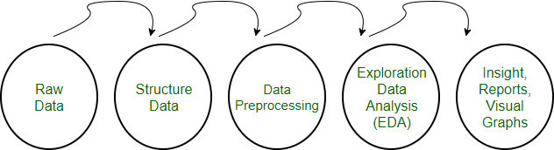

Fig 3.2.2.1 Raw data analysis and exploration steps
Need of Data Preprocessing
- For achieving better results from the applied model in Machine Learning projects the format of the data has to be in a proper manner. Some specified Machine Learning model needs information in a specified format, for example, Linear regression does not support null values; therefore to execute Linear regression algorithm null values have to be managed from the original raw data set.
- Another aspect is that data set should be formatted in such a way that more than one Machine Learning and Deep Learning algorithms are executed in one data set, and best out of them is chosen.

REGRESSION CLASSIFIER
Linear Regression is a machine learning algorithm based on supervised learning. Linear regression performs the task to predict a dependent variable value (y) based on a given independent variable (x). So, this regression technique finds out a linear relationship between x (input) and y(output).
While training the model we are given :
x: input training data (univariateone input variable(parameter))
y: labels to data (supervised learning)
When training the model – it fits the best line to predict the value of y for a given value of x. The

model gets the best regression fit line by finding the best θ1 and θ2 values.
θ1: intercept
θ2: coefficient of Once we find the best θ1 and θ2 values, we get the best fit line. So when we are finally using our model for prediction, it will predict the value of y for the input value of x.
Cost Function (J):
By achieving the best-fit regression line, the model aims to predict y value such that the error difference between predicted value and true value is minimum. So, it is very important to update the θ1 and θ2 values, to reach the best value that minimize the error between predicted y value (pred) and true y value (y).

Gradient Descent:

To update θ1 and θ2 values in order to reduce Cost function (minimizing RMSE value) and achieving the best fit line the model uses Gradient Descent. The idea is to start with random θ1 and θ2 values and then iteratively updating the values, reaching minimum cost.
Regression analysis is primarily used for two conceptually distinct purposes. First, regression analysis is widely used for prediction and forecasting, where its use has substantial overlap with the field of machine learning. Second, in some situations regression analysis can be used to infer causal relationships between the independent and dependent variables. Importantly, regressions by themselves only reveal relationships between a dependent variable and a collection of independent variables in a fixed dataset. To use regressions for prediction or to infer causal relationships, respectively, a researcher must carefully justify why existing relationships have predictive power for a new context or why a relationship between two variables has a causal interpretation. The latter is especially important when a researcher hopes to estimate causal relationships using observational data. he relationship between dependent variable is given by straight line and it has only one independent variable.
Y = α + Β X (2)
Model 'Y', is a linear function of 'X'. The value of 'Y' increases or decreases in linear manner according to which the value of 'X' also changes.

PATTERN PREDICTION

A prediction model is trained with a set of training sequences. Once trained, the model is used to perform sequence predictions. A prediction consists in predicting the next items of a sequence. Learning of sequential data continues to be a fundamental task and a challenge in pattern recognition and machine learning. Sequence prediction is different from other types of supervised learning problems. The sequence imposes an order on the observations that must be preserved when training models and making predictions. Generally, prediction problems that involve sequence data are referred to as sequence prediction problems; although there are a suite of problems that differ based on the input and output sequences. Pattern recognition is the process of recognizing patterns by using a Machine Learning algorithm. Pattern recognition can be defined as the classification of data based on knowledge already gained or on statistical information extracted from patterns and/or their representation. Pattern recognition is the ability to detect arrangements of characteristics or data that yield information about a given system or data set. Predictive analytics in data science work can make use of pattern recognition algorithms to isolate statistically probable movements of time series data into the future. In a technological context, a pattern might be recurring sequences of data over time that can be used to predict trends, particular configurations of features in images that identify objects, frequent combinations of words and phrases for natural language processing (NLP), or particular clusters of behaviour on a network that could indicate an attack — among almost endless other possibilities. In IT, pattern recognition is a branch of Machine Learning that emphasizes the recognition of data patterns or data regularities in a given scenario. Pattern recognition involves classification and cluster of patterns.
- Training and Learning Models in Pattern Recognition

Training and Learning is the building block model of Pattern Recognition. Learning is a phenomena through which a system gets trained and becomes adaptable to give result in an accurate manner. Learning is the most important phase as how well the system performs on the data provided to the system depends on which algorithms used on the data.

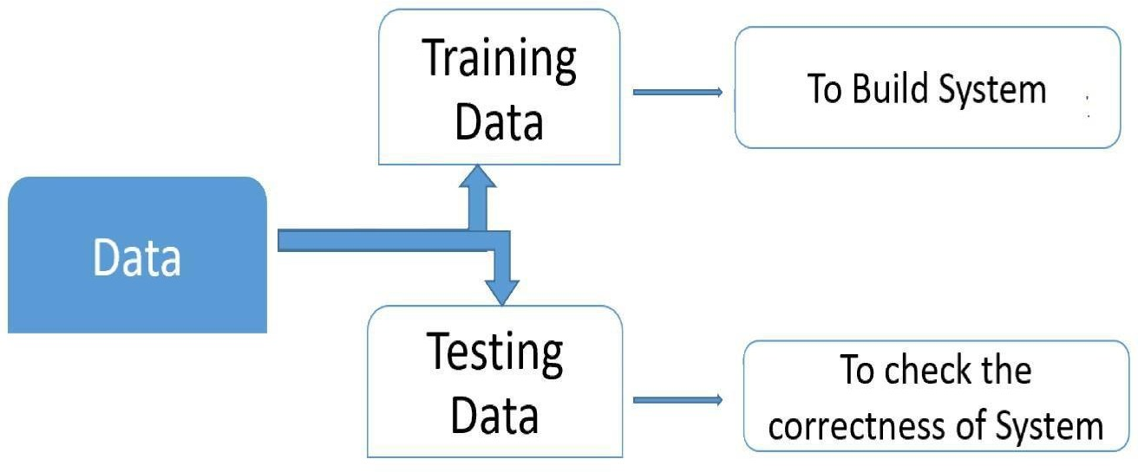

Fig 3.2.5 Data Training and testing with the pattern based recognition

- Training set

Training set is used to build a model. It consists of the set of images which are used to train the system. Training rules and algorithms used give relevant information on how to associate input data with output decision. The system is trained by applying these algorithms on the dataset, all the relevant information is extracted from the data and results are obtained. Generally, 80-85% of the data of the dataset is taken for training data.

- Testing set

Testing data is used to test the system. It is the set of data which is used to verify whether the system is producing the correct output after being trained or not. Generally, 20% of the data of the dataset is used for testing. Testing data is used to measure the accuracy of the system. Thus the prediction of the soil yield can be identified using the implemented pattern recognition

FUNCTIONAL REQUIREMENTS

The functional requirements for our project are as stated below:

- Classification of Districts: The system will need a preliminary classification of districts based on the area of cultivation, average rainfall, crop produce and agricultural inputs, in the form of training labels. The system will then learn using these training labels, and should be then able to classify the given districts into separate classes for individual crops.

- Crop suggestion: The system should be able to suggest new crops for different districts, so as to maximize crop output based on that district’s parameters. It should also show the degree of crop favourability for a particular district based on the parameters discussed earlier, in terms of ‘High’, ‘Medium’, and ‘Low’.

- Season-wise predictions: The system should be able to identify suitable seasons for every crop, and the corresponding trend for that crop in a given district. For example, the system should be able to suggest Kharif crops such as Rice, Maize, Bajra if the rainfall in a given district is similar to the typical conditions observed in the Kharif Season.

- Rainfall Prediction: The main aim of the project is to alert the end-users, the farmers, of any upcoming drought like situations so that they can prepare themselves. The system should be able to analyse the rainfall data, and predict any erratic changes in the rainfall, or any major deviations from the standard amount for that particular month, for that particular district.

NON-FUNCTIONAL REQUIREMENTS

The non-functional requirements of the system are as follows:

- Reliability: The system, in case of failure, should not experience a loss of data, or any of the acquired learning from past training sessions.

- Performance: The system should not take up a lot of resources for the training or testing sessions, to generate the output in form of prediction, and should run smoothly on the platform that it is installed on. Also, it should give accurate results.

- Availability: The system should be in a specified state before the start of an operation at any random time.
- Scalability: The system is going to be used for the state of Tamil Nadu first, but should be scalable to accommodate other states facing similar drought conditions in later stages, and should also account for the change in the agricultural practices of the state.
- Maintainability: On the occurrence of a failure in the system, the time required to restore it to its former state should be less.

FEASIBILITY STUDY
The feasibility of the project is analyzed in this phase and business proposal is put forth with a very general plan for the project and some cost estimates. During system analysis the feasibility study of the proposed system is to be carried out. This is to ensure that the proposed system is not a burden to the company. For feasibility analysis, some understanding of the major requirements for the system is essential.

ECONOMICAL FEASIBILITY
This study is carried out to check the economic impact that the system will have on the organization. The amount of fund that the company can pour into the research and development of the system is limited. The expenditures must be justified. Thus the developed system as well within the budget and this was achieved because most of the technologies used are freely available. Only the customized products had to be purchased.

TECHNICAL FEASIBILITY
This study is carried out to check the technical feasibility, that is, the technical requirements of the system. Any system developed must not have a high demand on the available technical resources. This will lead to high demands on the available technical resources. This will lead to high demands being placed on the client. The developed system must have a modest requirement, as only minimal or null changes are required for implementing this system.

SOCIAL FEASIBILITY
The aspect of study is to check the level of acceptance of the system by the user. This includes the process of training the user to use the system efficiently. The user must not feel threatened by the system, instead must accept it as a necessity. The level of acceptance by the users solely depends on the methods that are employed to educate the user about the system and to make him familiar with

it. His level of confidence must be raised so that he is also able to make some constructive criticism, which is welcomed, as he is the final user of the system.

Introduction of Python
Python is a general-purpose interpreted, interactive, object-oriented, and high-level programming language. An interpreted language, Python has a design philosophy that emphasizes code readability (notably using whitespace indentation to delimit code blocks rather than curly brackets or keywords), and a syntax that allows programmers to express concepts in fewer lines of code than might be used in languages such as C++or Java. It provides constructs that enable clear programming on both small and large scales. Python interpreters are available for many operating systems. CPython, the reference implementation of Python, is open source software and has a community-based development model, as do nearly all of its variant implementations. CPython is managed by the non-profit Python Software Foundation. Python features a dynamic type system and automatic memory management. It supports multiple programming paradigms, including object-oriented, imperative, functional and procedural, and has a large and comprehensive standard library.

What is Python
Python is a popular programming language. It was created by Guido van Rossum, and released in 1991.
It is used for:
- web development (server-side),
- software development,
- mathematics,
- system scripting.
What can Python do
- Python can be used on a server to create web applications.
- Python can be used alongside software to create workflows.
- Python can connect to database systems. It can also read and modify files.
- Python can be used to handle big data and perform complex mathematics.
- Python can be used for rapid prototyping, or for production-ready software development.
Why Python
- Python works on different platforms (Windows, Mac, Linux, Raspberry Pi, etc).
- Python has a simple syntax similar to the English language.

- Python has syntax that allows developers to write programs with fewer lines than some other programming languages.
- Python runs on an interpreter system, meaning that code can be executed as soon as it is written. This means that prototyping can be very quick.
Good to know
- The most recent major version of Python is Python 3, which we shall be using in this tutorial. However, Python 2, although not being updated with anything other than security updates, is still quite popular.
- In this tutorial Python will be written in a text editor. It is possible to write Python in an Integrated Development Environment, such as Thonny, Pycharm, Netbeans or Eclipse which are particularly useful when managing larger collections of Python files.
Python Syntax compared to other programming languages
- Python was designed for readability, and has some similarities to the English language with influence from mathematics.
- Python uses new lines to complete a command, as opposed to other programming languages which often use semicolons or parentheses.
- Python relies on indentation, using whitespace, to define scope; such as the scope of loops, functions and classes. Other programming languages often use curly-brackets for this purpose. Python Install
Many PCs and Macs will have python already installed.
To check if you have python installed on a Windows PC, search in the start bar for Python or run the following on the Command Line (cmd.exe):
C:\Users\Your Name>python --version
To check if you have python installed on a Linux or Mac, then on linux open the command line or on Mac open the Terminal and type:
python --version
If you find that you do not have python installed on your computer, then you can download it for free from the following website: https://www.python.org/
Python Quickstart
Python is an interpreted programming language, this means that as a developer you write Python (.py) files in a text editor and then put those files into the python interpreter to be executed.
The way to run a python file is like this on the command line:

C:\Users\Your Name>python helloworld.py
Where "helloworld.py" is the name of your python file.
Let's write our first Python file, called helloworld.py, which can be done in any text editor. helloworld.py
print("Hello, World!")
Simple as that. Save your file. Open your command line, navigate to the directory where you saved your file, and run:
C:\Users\Your Name>python helloworld.py The output should read:
Hello, World!
Congratulations, you have written and executed your first Python program.
The Python Command Line
To test a short amount of code in python sometimes it is quickest and easiest not to write the code in a file. This is made possible because Python can be run as a command line itself.
Type the following on the Windows, Mac or Linux command line:
C:\Users\Your Name>python
Or, if the "python" command did not work, you can try "py":
C:\Users\Your Name>py

From there you can write any python, including our hello world example from earlier in the tutorial:
C:\Users\Your Name>python
Python 3.6.4 (v3.6.4:d48eceb, Dec 19 2017, 06:04:45) [MSC v.1900 32 bit (Intel)] on win32 Type "help", "copyright", "credits" or "license" for more information.
>>>print("Hello, World!")
Which will write "Hello, World!" in the command line:
C:\Users\Your Name>python
Python 3.6.4 (v3.6.4:d48eceb, Dec 19 2017, 06:04:45) [MSC v.1900 32 bit (Intel)] on win32 Type "help", "copyright", "credits" or "license" for more information.
>>>print("Hello, World!") Hello, World!
Whenever you are done in the python command line, you can simply type the following to quit the python command line interface:

exit()
Using the Python Interpreter
Invoking the Interpreter
The Python interpreter is usually installed as /usr/local/bin/python3.8 on those machines where it is available; putting /usr/local/bin in your Unix shell’s search path makes it possible to start it by typing the command:
python3.8
to the shell. 1 Since the choice of the directory where the interpreter lives is an installation option, other places are possible; check with your local Python guru or system administrator. (E.g.,
/usr/local/python is a popular alternative location.)

On Windows machines where you have installed Python from the Microsoft Store, the python3.8 command will be available. If you have the py.exe launcher installed, you can use the py command. See Excursus: Setting environment variables for other ways to launch Python.
Typing an end-of-file character (Control-D on Unix, Control-Z on Windows) at the primary prompt causes the interpreter to exit with a zero exit status. If that doesn’t work, you can exit the interpreter by typing the following command: quit().
The interpreter’s line-editing features include interactive editing, history substitution and code completion on systems that support the GNU Readline library. Perhaps the quickest check to see whether command line editing is supported is typing Control-P to the first Python prompt you get. If it beeps, you have command line editing; see Appendix Interactive Input Editing and History Substitution for an introduction to the keys. If nothing appears to happen, or if ^P is echoed, command line editing isn’t available; you’ll only be able to use backspace to remove characters from the current line.
The interpreter operates somewhat like the Unix shell: when called with standard input connected to a tty device, it reads and executes commands interactively; when called with a file name argument or with a file as standard input, it reads and executes a script from that file.
A second way of starting the interpreter is python -c command [arg] ..., which executes the statement(s) in command, analogous to the shell’s -c option. Since Python statements often contain spaces or other characters that are special to the shell, it is usually advised to quote command in its entirety with single quotes.

Some Python modules are also useful as scripts. These can be invoked using python -m module [arg] ..., which executes the source file for module as if you had spelled out its full name on the command line.
When a script file is used, it is sometimes useful to be able to run the script and enter interactive mode afterwards. This can be done by passing -i before the script.

All command line options are described in Command line and environment.
Argument Passing
When known to the interpreter, the script name and additional arguments thereafter are turned into a list of strings and assigned to the argv variable in the sys module. You can access this list by executing import sys. The length of the list is at least one; when no script and no arguments are given, sys.argv[0] is an empty string. When the script name is given as '-' (meaning standard input), sys.argv[0] is set to '-'. When -c command is used, sys.argv[0] is set to '-c'. When -m module is used, sys.argv[0] is set to the full name of the located module. Options found after -c command or - m module are not consumed by the Python interpreter’s option processing but left in sys.argv for the command or module to handle.
Interactive Mode
When commands are read from a tty, the interpreter is said to be in interactive mode. In this mode it prompts for the next command with the primary prompt, usually three greater-than signs (>>>); for continuation lines it prompts with the secondary prompt, by default three dots (...). The interpreter prints a welcome message stating its version number and a copyright notice before printing the first prompt:
$ python3.8
Python 3.8 (default, Sep 16 2015, 09:25:04) [GCC 4.8.2] on linux
Type "help", "copyright", "credits" or "license" for more information.
>>>
Continuation lines are needed when entering a multi-line construct. As an example, take a look at this if statement:
>>>
>>>the_world_is_flat = True
>>>ifthe_world_is_flat:
... print("Be careful not to fall off!")

...
Be careful not to fall off!
For more on interactive mode, see Interactive Mode.

The Interpreter and Its Environment
Source Code Encoding
By default, Python source files are treated as encoded in UTF-8. In that encoding, characters of most languages in the world can be used simultaneously in string literals, identifiers and comments
— although the standard library only uses ASCII characters for identifiers, a convention that any portable code should follow. To display all these characters properly, your editor must recognize that the file is UTF-8, and it must use a font that supports all the characters in the file.
To declare an encoding other than the default one, a special comment line should be added as the first line of the file. The syntax is as follows:
# -*- coding: encoding -*-
where encoding is one of the valid codecs supported by Python.
For example, to declare that Windows-1252 encoding is to be used, the first line of your source code file should be:
# -*- coding: cp1252 -*-
One exception to the first line rule is when the source code starts with a UNIX “shebang” line. In this case, the encoding declaration should be added as the second line of the file. For example:

#!/usr/bin/env python3 # -*- coding: cp1252 -*-
Introduction to Artificial Intelligence
“The science and engineering of making intelligent machines, especially intelligent computer programs”. -John McCarthy-
Artificial Intelligence is an approach to make a computer, a robot, or a product to think how smart human think. AI is a study of how human brain think, learn, decide and work, when it tries to solve problems. And finally this study outputs intelligent software systems.The aim of AI is to improve computer functions which are related to human knowledge, for example, reasoning, learning, and problem-solving.
The intelligence is intangible. It is composed of
- Reasoning

- Learning
- Problem Solving
- Perception
- Linguistic Intelligence
The objectives of AI research are reasoning, knowledge representation, planning, learning, natural language processing, realization, and ability to move and manipulate objects. There are long-term goals in the general intelligence sector.
Approaches include statistical methods, computational intelligence, and traditional coding AI. During the AI research related to search and mathematical optimization, artificial neural networks and methods based on statistics, probability, and economics, we use many tools. Computer science attracts AI in the field of science, mathematics, psychology, linguistics, philosophy and so on.
Trending AI Articles:
- Cheat Sheets for AI, Neural Networks, Machine Learning, Deep Learning & Big Data
- Data Science Simplified Part 1: Principles and Process
- Getting Started with Building Realtime API Infrastructure
- AI & NLP Workshop Applications of AI
- Gaming − AI plays important role for machine to think of large number of possible positions based on deep knowledge in strategic games. for example, chess,river crossing, N-queens problems and etc.
Natural Language Processing − Interact with the computer that understands natural language spoken by humans.
- Expert Systems − Machine or software provide explanation and advice to the users.
- Vision Systems − Systems understand, explain, and describe visual input on the computer.
- Speech Recognition − There are some AI based speech recognition systems have ability to hear and express as sentences and understand their meanings while a person talks to it. For example Siri and Google assistant.
- Handwriting Recognition − The handwriting recognition software reads the text written on paper and recognize the shapes of the letters and convert it into editable text.
- Intelligent Robots − Robots are able to perform the instructions given by a human. Major Goals
- Knowledge reasoning
- Planning

- Machine Learning
- Natural Language Processing
- Computer Vision
- Robotics

Machine Learning
Machine learning is a subfield of artificial intelligence (AI). The goal of machine learning generally is to understand the structure of data and fit that data into models that can be understood and utilized by people.Although machine learning is a field within computer science, it differs from traditional computational approaches. In traditional computing, algorithms are sets of explicitly programmed instructions used by computers to calculate or problem solve. Machine learning algorithms instead allow for computers to train on data inputs and use statistical analysis in order to output values that fall within a specific range. Because of this, machine learning facilitates computers in building models from sample data in order to automate decision-making processes based on data inputs.Any technology user today has benefitted from machine learning. Facial recognition technology allows social media platforms to help users tag and share photos of friends. Optical character recognition (OCR) technology converts images of text into movable type. Recommendation engines, powered by machine learning, suggest what movies or television shows to watch next based on user preferences. Self-driving cars that rely on machine learning to navigate may soon be available to consumers.Machine learning is a continuously developing field. Because of this, there are some considerations to keep in mind as you work with machine learning methodologies, or analyze the impact of machine learning processes.In this tutorial, we’ll look into the common machine learning methods of supervised and unsupervised learning, and common algorithmic approaches in machine learning, including the k-nearest neighbor algorithm, decision tree learning, and deep learning. We’ll explore which programming languages are most used in machine learning, providing you with some of the positive and negative attributes of each. Additionally, we’ll discuss biases that are perpetuated by machine learning algorithms, and consider what can be kept in mind to prevent these biases when building algorithms.

Machine Learning Methods
In machine learning, tasks are generally classified into broad categories. These categories are based on how learning is received or how feedback on the learning is given to the system developed.
Two of the most widely adopted machine learning methods are supervised learning which trains algorithms based on example input and output data that is labeled by humans, and unsupervised

learning which provides the algorithm with no labeled data in order to allow it to find structure within its input data. Let’s explore these methods in more detail.
Supervised Learning
In supervised learning, the computer is provided with example inputs that are labeled with their desired outputs. The purpose of this method is for the algorithm to be able to “learn” by comparing its actual output with the “taught” outputs to find errors, and modify the model accordingly. Supervised learning therefore uses patterns to predict label values on additional unlabeled data.
For example, with supervised learning, an algorithm may be fed data with images of sharks labeled as fish and images of oceans labeled as water. By being trained on this data, the supervised learning algorithm should be able to later identify unlabeled shark images as fish and unlabeled ocean images as water.
A common use case of supervised learning is to use historical data to predict statistically likely future events. It may use historical stock market information to anticipate upcoming fluctuations, or be employed to filter out spam emails. In supervised learning, tagged photos of dogs can be used as input data to classify untagged photos of dogs.
Unsupervised Learning
In unsupervised learning, data is unlabeled, so the learning algorithm is left to find commonalities among its input data. As unlabeled data are more abundant than labeled data, machine learning methods that facilitate unsupervised learning are particularly valuable.
The goal of unsupervised learning may be as straightforward as discovering hidden patterns within a dataset, but it may also have a goal of feature learning, which allows the computational machine to automatically discover the representations that are needed to classify raw data.
Unsupervised learning is commonly used for transactional data. You may have a large dataset of customers and their purchases, but as a human you will likely not be able to make sense of what similar attributes can be drawn from customer profiles and their types of purchases. With this data fed into an unsupervised learning algorithm, it may be determined that women of a certain age range who buy unscented soaps are likely to be pregnant, and therefore a marketing campaign related to pregnancy and baby products can be targeted to this audience in order to increase their number of purchases.
Without being told a “correct” answer, unsupervised learning methods can look at complex data that is more expansive and seemingly unrelated in order to organize it in potentially meaningful ways. Unsupervised learning is often used for anomaly detection including for fraudulent credit card purchases, and recommender systems that recommend what products to buy next. In unsupervised

learning, untagged photos of dogs can be used as input data for the algorithm to find likenesses and classify dog photos together.

Approaches
As a field, machine learning is closely related to computational statistics, so having a background knowledge in statistics is useful for understanding and leveraging machine learning algorithms.
For those who may not have studied statistics, it can be helpful to first define correlation and regression, as they are commonly used techniques for investigating the relationship among quantitative variables. Correlation is a measure of association between two variables that are not designated as either dependent or independent. Regression at a basic level is used to examine the relationship between one dependent and one independent variable. Because regression statistics can be used to anticipate the dependent variable when the independent variable is known, regression enables prediction capabilities.
Approaches to machine learning are continuously being developed. For our purposes, we’ll go through a few of the popular approaches that are being used in machine learning at the time of writing.
Decision Tree Learning
For general use, decision trees are employed to visually represent decisions and show or inform decision making. When working with machine learning and data mining, decision trees are used as a predictive model. These models map observations about data to conclusions about the data’s target value.
The goal of decision tree learning is to create a model that will predict the value of a target based on input variables.
In the predictive model, the data’s attributes that are determined through observation are represented by the branches, while the conclusions about the data’s target value are represented in the leaves.
When “learning” a tree, the source data is divided into subsets based on an attribute value test, which is repeated on each of the derived subsets recursively. Once the subset at a node has the equivalent value as its target value has, the recursion process will be complete.
Let’s look at an example of various conditions that can determine whether or not someone should go fishing. This includes weather conditions as well as barometric pressure conditions.

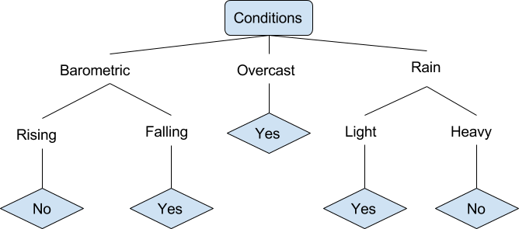

Fig 3.5.1 Decision Tree

In the simplified decision tree above, an example is classified by sorting it through the tree to the appropriate leaf node. This then returns the classification associated with the particular leaf, which in this case is either a Yes or a No. The tree classifies a day’s conditions based on whether or not it is suitable for going fishing.
A true classification tree data set would have a lot more features than what is outlined above, but relationships should be straightforward to determine. When working with decision tree learning, several determinations need to be made, including what features to choose, what conditions to use for splitting, and understanding when the decision tree has reached a clear ending.
Introduction to Deep Learning
What is deep learning

Deep learning is a branch of machine learning which is completely based on artificial neural networks, as neural network is going to mimic the human brain so deep learning is also a kind of mimic of human brain. In deep learning, we don’t need to explicitly program everything. The concept of deep learning is not new. It has been around for a couple of years now. It’s on hype nowadays because earlier we did not have that much processing power and a lot of data. As in the last 20 years, the processing power increases exponentially, deep learning and machine learning came in the picture.

A formal definition of deep learning is- neurons

Deep learning is a particular kind of machine learning that achieves great power and flexibility by learning to represent the world as a nested hierarchy of concepts, with each concept defined in relation to simpler concepts, and more abstract representations computed in terms of less abstract ones.In human brain approximately 100 billion neurons all together this is a picture of an individual neuron and each neuron is connected through thousand of their neighbours.The question here is how we recreate these neurons in a computer. So, we create an artificial structure called an artificial neural net where we have nodes or neurons. We have some neurons for input value and some for output value and in between, there may be lots of neurons interconnected in the hidden layer.

PYTHON
Python is a general-purpose interpreted, interactive, object-oriented, and high-level programming language. An interpreted language, Python has a design philosophy that emphasizes code readability (notably using whitespace indentation to delimit code blocks rather than curly brackets or keywords), and a syntax that allows programmers to express concepts in fewer lines of code than might be used in languages such as C++or Java. It provides constructs that enable clear programming on both small and large scales. Python interpreters are available for many operating systems. CPython, the reference implementation of Python, is open source software and has a community-based development model, as do nearly all of its variant implementations. CPython is managed by the non-profit Python Software Foundation.

CHAPTER-4

SOFTWARE AND HARDWARE REQUIREMENTS

4 SOFTWARE AND HARDWARE REQUIREMENTS

HARDWARE REQUIREMENTS:

- Processor : Dual core processor 2.6.0 GHz

RAM : 16 GB

- Hard disk : 160 GB

- Compact Disk: 650 MB

- Keyboard : Standard keyboard

- Monitor : 15 inch color monitor

SOFTWARE REQUIREMENTS:
- Front End : PYTHON
- IDE : pycharm
- Platform : Windows 7

CHAPTER-5

SYSTEM DESIGN

SOFTWARE DESIGN

SYSTEM ARCHITECTURE
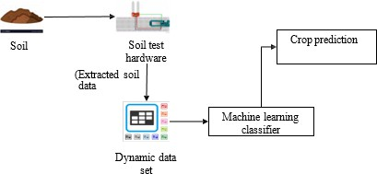

    - System Architecture

Figure 5.1.1 : Shows the proposed system architecture for crop prediction using machine learning. The system takes soil as input and uses a soil test hardware to extract soil data. This data is then fed into a machine learning classifier to predict the crop.

UML DIAGRAMS
- Use Case Diagram

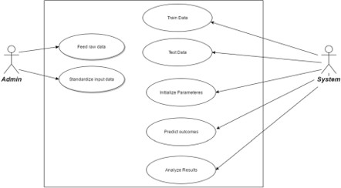

    - Use Case Diagram

Figure 5.2.1: This use case diagram represents the workflow of the Agricultural Crop Recommendation System. The Admin is responsible for feeding raw data and standardizing input data, while the System handles tasks like training and testing data, initializing parameters, predicting outcomes, and analyzing results.
- Activity Diagram

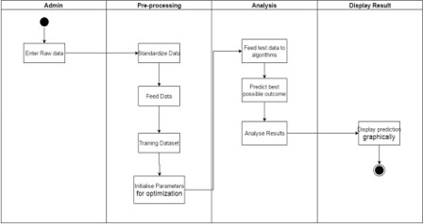

    - Activity Diagram

Figure 5.2.2 : This activity diagram illustrates the step-by-step workflow of the Agricultural Crop Recommendation System. The process begins with the Admin entering raw data, which is then standardized and fed into the system for training and parameter optimization.
- ER Diagram

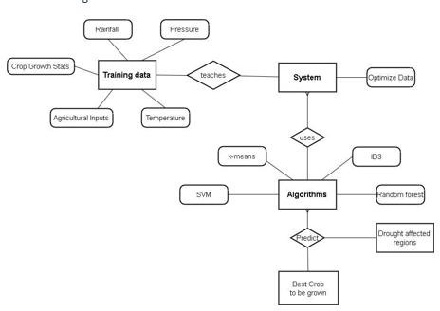

5.2.3. ER Diagram

Figure 5.2.3 : This conceptual diagram shows how the Agricultural Crop Recommendation System uses training data like rainfall, temperature, pressure, and agricultural inputs to teach the system. The system then utilizes machine learning algorithms (like SVM, K-means, ID3, and Random Forest) to analyze the data.

DATA FLOW DIAGRAMS

Collaboration Diagram

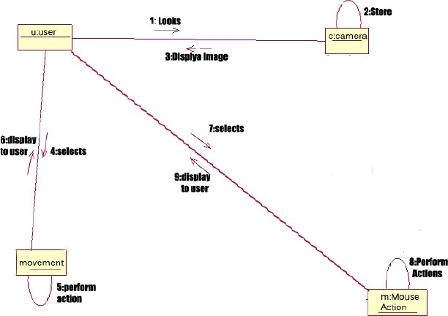

5.3.1. Collaboration Diagram

Figure 5.3.1 : This sequence diagram represents how user interaction with a camera system leads to an automated response. The user looks into the camera, which captures and stores the image, then displays it back. The user makes a selection, triggering movement and mouse actions which perform the required operations.

CHAPTER-6

CODING AND IMPLEMENTATION

CODING AND IMPLEMENTATION

IMPLEMENTATION
Systems implementation is the process of: defining how the information system should be built (i.e., physical system design), ensuring that the information system is operational and used, ensuring that the information system meets quality standard (i.e., quality assurance).
Systems implementation is the process of:
- Defining how the information system should be built (i.e., physical system design),
- Ensuring that the information system is operational and used,
- Ensuring that the information system meets quality standard (i.e., quality assurance).

SYSTEMS DESIGN
Conceptual design – what the system should do
Logical design – what the system should look to the user Physical design – how the system should be built
A product software implementation method is a systematically structured approach to effectively integrate a software based service or component into the workflow of an organizational structure or an individual end-user.
Implementation is the carrying out, execution, or practice of a plan, a method, or any design, idea, model, specification, standard or policy for doing something. As such, implementation is the action that must follow any preliminary thinking in order for something to actually happen.
Activities of the Process
The following major activities and tasks are performed during this process:
Define the implementation strategy: - Implementation process activities begin with detailed design and include developing an implementation strategy that defines fabrication and coding procedures, tools and equipment to be used, implementation tolerances, and the means and criteria for auditing configuration of resulting elements to the detailed design documentation. In the case of repeated system element implementations (such as for mass manufacturing or replacement elements), the implementation strategy is defined and refined to achieve consistent and repeatable element production; it is retained in the project decision database for future use. The implementation strategy contains the arrangements for packing, storing, and supplying the implemented element.

Realize the system element - Realize or adapt and produce the concerned system element using the implementation strategy items as defined above. Realization or adaptation is conducted with regard to standards that govern applicable safety, security, privacy, and environmental guidelines or legislation and the practices of the relevant implementation technology. This requires the fabrication of hardware elements, development of software elements, definition of training capabilities, drafting of training documentation, and the training of initial operators and maintainers. Provide evidence of compliance - Record evidence that the system element meets its requirements and the associated verification and validation criteria as well as the legislation policy. This requires the conduction of peer reviews and unit testing, as well as inspection of operation and maintenance manuals. Acquire measured properties that characterize the implemented element (weight, capacities, effectiveness, level of performance, reliability, availability, etc.).
Package, store, and supply the implemented element - This should be defined in the implementation strategy.

SAMPLE CODE
app.py
# Importing essential libraries and modules
from flask import Flask, render_template, request, Markup import numpy as np
import pandas as pd
from utils.disease import disease_dic from utils.fertilizer import fertilizer_dic import requests
import config import pickle import io import torch
from torchvision import transforms from PIL import Image
from utils.model import ResNet9

# Loading plant disease classification model

disease_classes = ['Apple Apple_scab', 'Apple Black_rot',
'Apple Cedar_apple_rust', 'Apple healthy', 'Blueberry healthy',
'Cherry_(including_sour) Powdery_mildew', 'Cherry_(including_sour) healthy',
'Corn_(maize) Cercospora_leaf_spot Gray_leaf_spot', 'Corn_(maize) Common_rust_',
'Corn_(maize) Northern_Leaf_Blight', 'Corn_(maize) healthy',
'Grape Black_rot',
'Grape Esca_(Black_Measles)',
'Grape Leaf_blight_(Isariopsis_Leaf_Spot)', 'Grape healthy',
'Orange Haunglongbing_(Citrus_greening)', 'Peach Bacterial_spot',
'Peach healthy',
'Pepper,_bell Bacterial_spot', 'Pepper,_bell healthy', 'Potato Early_blight',
'Potato Late_blight', 'Potato healthy',
'Soybean healthy',
'Squash Powdery_mildew', 'Strawberry Leaf_scorch', 'Strawberry healthy', 'Tomato Bacterial_spot', 'Tomato Early_blight', 'Tomato Late_blight', 'Tomato Leaf_Mold', 'Tomato Septoria_leaf_spot',
'Tomato Spider_mites Two-spotted_spider_mite', 'Tomato Target_Spot',
'Tomato Tomato_Yellow_Leaf_Curl_Virus', 'Tomato Tomato_mosaic_virus',
'Tomato healthy']

disease_model_path = 'models/plant_disease_model.pth' disease_model = ResNet9(3, len(disease_classes)) disease_model.load_state_dict(torch.load(
disease_model_path, map_location=torch.device('cpu'))) disease_model.eval()

# Loading crop recommendation model

crop_recommendation_model_path = 'models/RandomForest.pkl' crop_recommendation_model = pickle.load(
open(crop_recommendation_model_path, 'rb'))

def weather_fetch(city_name): """
Fetch and returns the temperature and humidity of a city
:params: city_name
:return: temperature, humidity """
api_key = config.weather_api_key
base_url = "http://api.openweathermap.org/data/2.5/weather?"

complete_url = base_url + "appid=" + api_key + "&q=" + city_name response = requests.get(complete_url)
x = response.json()

if x["cod"] != "404": y = x["main"]

temperature = round((y["temp"] - 273.15), 2) humidity = y["humidity"]
return temperature, humidity else:
return None

def predict_image(img, model=disease_model): """
Transforms image to tensor and predicts disease label
:params: image
:return: prediction (string)

"""
transform = transforms.Compose([ transforms.Resize(256), transforms.ToTensor(),
])
image = Image.open(io.BytesIO(img)) img_t = transform(image)
img_u = torch.unsqueeze(img_t, 0)

# Get predictions from model yb = model(img_u)
# Pick index with highest probability
_, preds = torch.max(yb, dim=1)
prediction = disease_classes[preds[0].item()] # Retrieve the class label
return prediction
app = Flask( name )

# render home page

@ app.route('/') def home():
title = 'Harvestify - Home'
return render_template('index.html', title=title)

# render crop recommendation form page

@ app.route('/crop-recommend') def crop_recommend():
title = 'Harvestify - Crop Recommendation' return render_template('crop.html', title=title)

# render fertilizer recommendation form page

@ app.route('/fertilizer')
def fertilizer_recommendation():
title = 'Harvestify - Fertilizer Suggestion'

return render_template('fertilizer.html', title=title)

# render disease prediction input page # RENDER PREDICTION PAGES

# render crop recommendation result page

@ app.route('/crop-predict', methods=['POST']) def crop_prediction():
title = 'Harvestify - Crop Recommendation'

if request.method == 'POST':
N = int(request.form['nitrogen'])
P = int(request.form['phosphorous']) K = int(request.form['pottasium'])
rainfall = float(request.form['rainfall'])

# state = request.form.get("stt") city = request.form.get("city")

if weather_fetch(city) != None:
temperature, humidity = weather_fetch(city)
data = np.array([[N, P, K, temperature, humidity, ph, rainfall]]) my_prediction = crop_recommendation_model.predict(data) final_prediction = my_prediction[0]

return render_template('crop-result.html', prediction=final_prediction, title=title)

else:

return render_template('try_again.html', title=title)

# render fertilizer recommendation result page

@ app.route('/fertilizer-predict', methods=['POST']) def fert_recommend():
title = 'Harvestify - Fertilizer Suggestion'

crop_name = str(request.form['cropname']) N = int(request.form['nitrogen'])
P = int(request.form['phosphorous'])
# ph = float(request.form['ph'])

df = pd.read_csv('Data/fertilizer.csv')

nr = df[df['Crop'] == crop_name]['N'].iloc[0]
pr = df[df['Crop'] == crop_name]['P'].iloc[0]
kr = df[df['Crop'] == crop_name]['K'].iloc[0]

n = nr - N p = pr - P k = kr - K
temp = {abs(n): "N", abs(p): "P", abs(k): "K"} max_value = temp[max(temp.keys())]
if max_value == "N": if n < 0:
key = 'NHigh' else:
key = "Nlow"
elif max_value == "P": if p < 0:
key = 'PHigh' else:
key = "Plow"
else:
if k < 0:
key = 'KHigh' else:

key = "Klow"
response = Markup(str(fertilizer_dic[key]))

return render_template('fertilizer-result.html', recommendation=response, title=title) @app.route('/disease-predict', methods=['GET', 'POST'])
def disease_prediction():
title = 'Harvestify - Disease Detection'

if request.method == 'POST': if 'file' not in request.files:
return redirect(request.url) file = request.files.get('file') if not file:
return render_template('disease.html', title=title) try:
img = file.read()

prediction = predict_image(img)

prediction = Markup(str(disease_dic[prediction]))
return render_template('disease-result.html', prediction=prediction, title=title) except:
pass
return render_template('disease.html', title=title)

if name == ' main ': app.run(debug=False)

CHAPTER–7

SYSTEM TESTING

SYSTEM TESTING

7.1 Sample Test Cases:

Test Case ID | Description | Expected Result | Status
1 | Input soil and climate data for crop recommendation | The system should successfully accept the input data | Passed
2 | Fetch relevant crops based on season and region | The system should display crops suitable for the given season and region | Passed
3 | Predict crop productivity based on input parameters | The system should accurately estimate the expected productivity | Passed
4 | Validate input constraints (e.g., incorrect soil pH range) | The system should reject invalid inputs and provide an error message | Passed
5 | Display recommended crops with productivity scores | The results should be visible in the UI with ranking based on productivity | Passed
6 | Handle missing input values gracefully | The system should prompt the user to enter missing values | Passed

Table 7.1 Sample Test Cases
7.2 Integration Testing

Test Case ID | Description | Expected Result | Status
1 | Integrate soil and climate data input with crop recommendation module | The system should accept and process input data successfully | Passed
2 | Integrate season and region parameters with crop suggestion algorithm | The system should provide crop recommendations based on season and region | Passed
3 | Combine recommendation module with productivity prediction model | The system should accurately estimate expected crop yield | Passed
4 | Ensure UI displays recommended crops and productivity scores | The UI should correctly display results to the user | Passed

Table 7.2 Integration Testing
7.3 Model Testing

Test Case ID | Description | Expected Result | Status
1 | End-to-end test: Input data, process recommendations, and display results | The system should work smoothly from start to finish | Passed
2 | Stress test with large datasets of soil, climate, and crop records | The system should handle large data efficiently | Passed
3 | Test with different crop types for various seasons and regions | The system should correctly suggest suitable crops | Passed
4 | Verify error handling for invalid input values (e.g., incorrect soil pH, missing data) | The system should prompt an error message | Passed

Table 7.3 Model Testing

CHAPTER-8

OUTPUT SCREENS

OUTPUT SCREENS

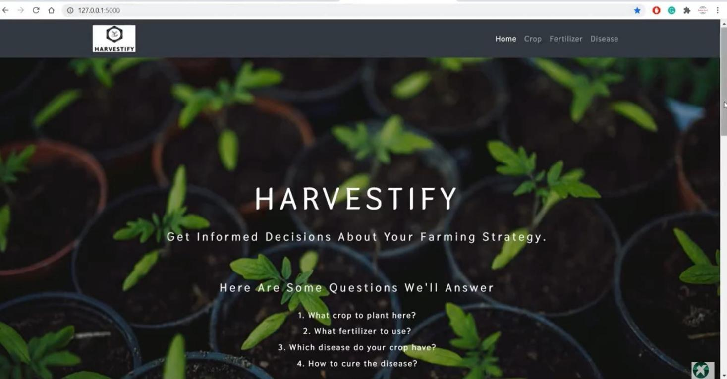

    - Output Screen Shot 1

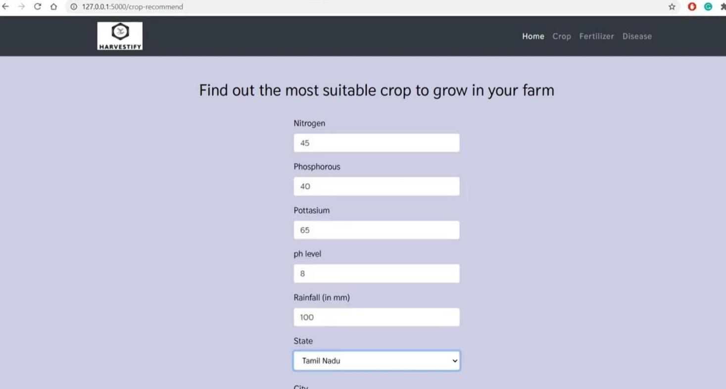

    - Output Screen Shot 1

Figure 8.1.2 : It shows a “HARVESTIFY” web interface for crop recommendation parameters(Nitrogen, Phosphorous, Potassium, pH, Rainfall) and a state selection dropdown.
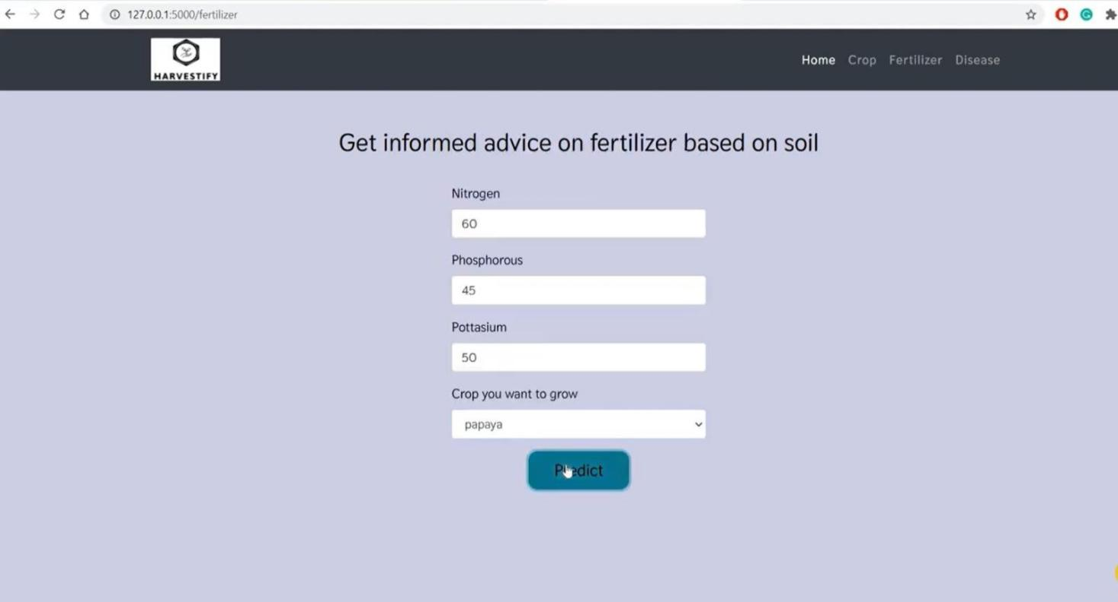

    - Output Screen Shot 1

Figure 8.1.3 :show a web interface for a fertilizer recommendation system called “HARVESTIFY”. It takes soil nutrient levels (Nitrogen, Phosphorous, Potassium) and a selected crop (“Papaya” in this case) as input, with a “Get informed advice on fertilizer based on soil” prompt.
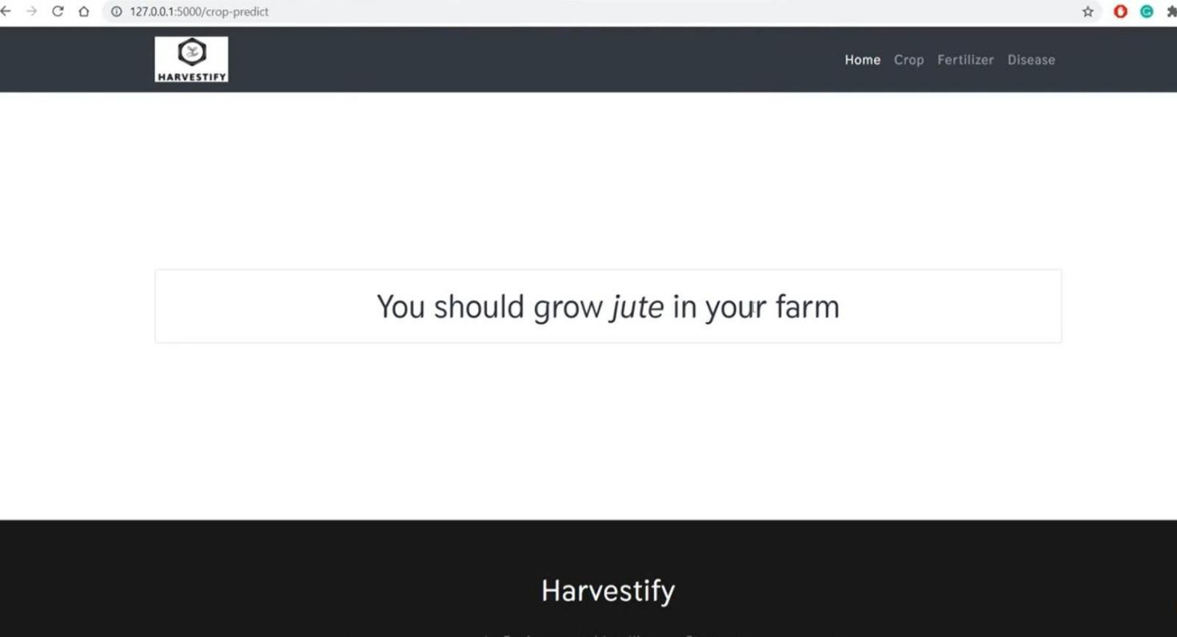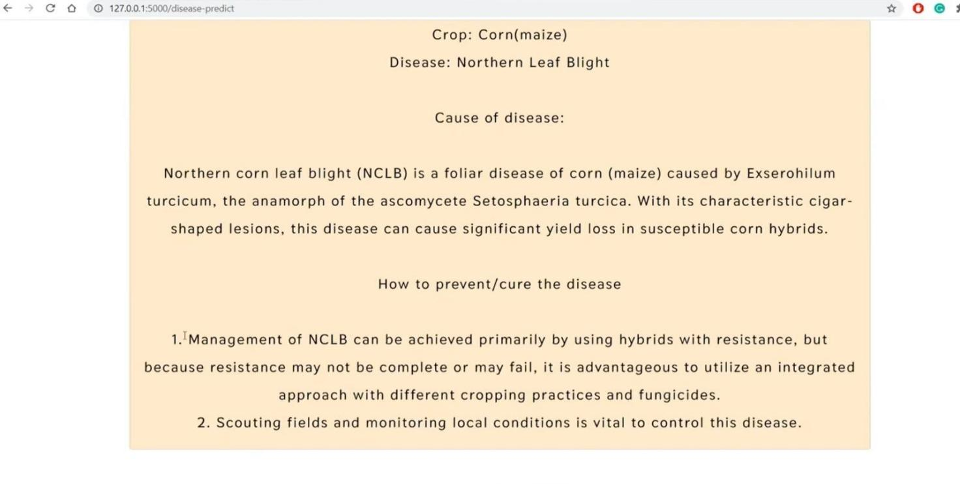
    - Output screen Shot

Figure 8.1.4 : This image shows a web page output from “HARVESTIFY” recommending that the user “grow jute in your farm”. It’s a simple text-based result, likely from a crop recommendation system based on provided inputs.

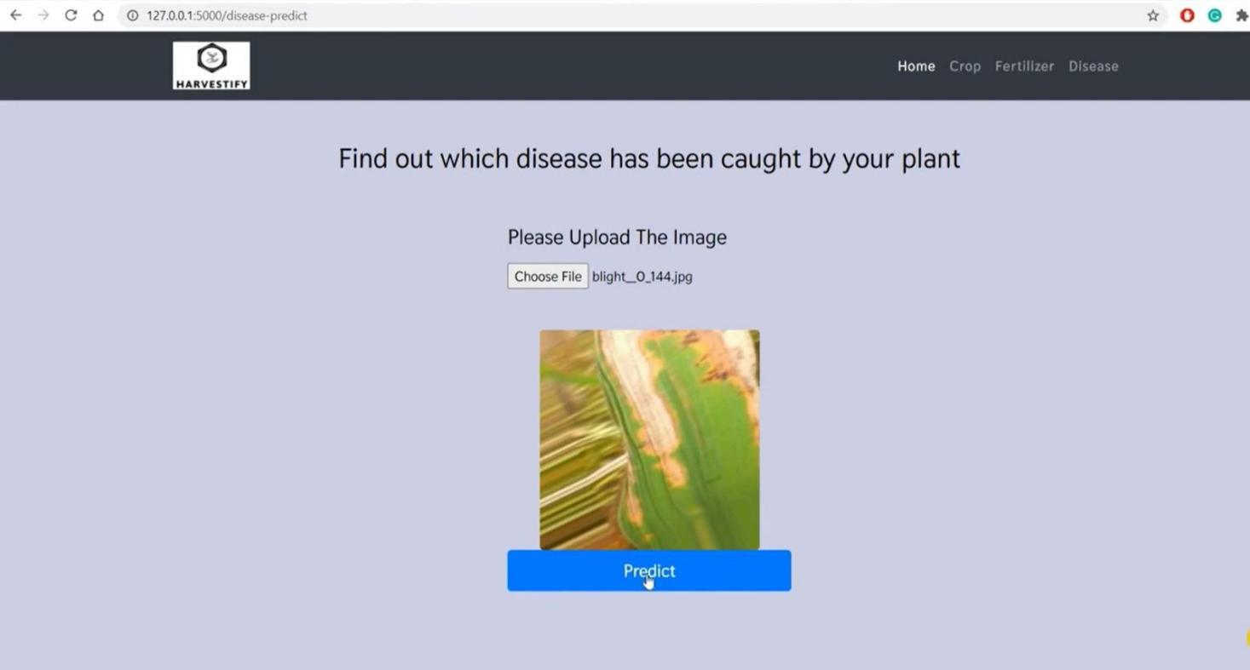

    - Output screen Shot 1

Figure 8.1.5 : It prompts the user to upload an image of a plant, with a sample image already displayed. A “Predict” button is present to initiate the disease identification process. The title reads “Find out which disease has been caught by your plant”.

CHAPTER-9

CONCLUSION

CONCLUSION
This thesis focuses on analyzing the agricultural soil data using data mining for crop yield prediction. In this paper, we've got suggested an analysis of the soil information using completely different algorithms and prediction technique. In this paper we have demonstrated comparative study of varied regression algorithms. The system does not allow any abnormal circumstances to affect the production rate. It efficiently manages the energy and human resources. Distant control mechanism used in the system improves the efficiency by reducing the effort required by the farmer to monitor and act according to the changes in the field. Wireless monitoring along with low power consumption makes it a useful system for the farmer to incorporate and use it in the agricultural farm. The goals that have been achieved by the developed system are:
- Simplified and reduced the manual work.
- Large volumes of data can be stored.
- It provides Smooth workflow.
In case we wish to yield particular crop, then we can improve the soil by adding the necessary nutrients in the soil as per required by that crop.

CHAPTER-10

FUTURE ENHANCEMENTS

FUTURE ENHANCEMENTS

In future, we can plan to build Fertilizer Recommendation System which can be utilized effectively by the Soil Testing Laboratories. This System will recommend appropriate fertilizer for the given soil sample and cropping pattern. We can add module if any queries are there, the staff can directly interact with the administrator very easily. We can also determine the efficient algorithm based on their accuracy metrics that will helps to choose an efficient algorithm for crop yield prediction.

CHAPTER-11

REFERENCES

REFERENCES

- Tianjun Wu , Jiancheng Luo, Wen Dong, Yingwei Sun , Liegang Xia Geo-Object-Based Soil Organic Matter Mapping Using Machine Learning Algorithms With Multi-Source Geo-Spatial Data, IEEE Journal Of Selected Topics In Applied Earth Observations And Remote Sensing, 2019

- N.ANANTHI Divya J. Divya M. Janani V, IoT based Smart Soil Monitoring System for Agricultural Production, IEEE International Conference On Technological inovations in ICT for Agriculture and Rural development (TIAR_2017)

- Jyothi patil Dr A.Govardhan Dr V.D.Mytri, An Intelligent System for Predicting Thrips Tabaci Linde Pest Population Dynamics Allied To Cotton Crop,

- Nidhi H Kulkarni Dr. G N Srinivasan Dr. B M Sagar Dr.N K Cauvery, Improving Crop, Productivity Through A Crop Recommendation System Using Ensembling Technique, IEEE International Conference on Computational Systems and Information Technology for Sustainable Solutions(2018)

- P. S. Asolkar Prof.Dr. U. S. Bhadade, An Effective Method of Controlling the Greenhouse and Crop Monitoring Using GSM,(2015)

- Md. Tahmid Shakoor, Karishma Rahman, Sumaiya Nasrin Rayta, Amitabha Chakrabarty, Agricultural Production Output Prediction Using Supervised Machine Learning Techniques,(2017)

- Zhang Miao1, 2, Li Qiangzi1 , Wu Bingfang1,*, Investigating the capability of multi- temporal Landsat images for crop identification in high farmland fragmentation regions,

- D. Turgay AltılarAnıl Suat Terliksiz, Comparison of Statistical Methods for Predicting Wheat Yield Trends in Turkey,

- Sanat Sarangi, Somya Sharma, Bhushan Jagyasi, Agricultural Activity Recognition with Smart- shirt and Crop Protocol, Global Humanitarian Technology Conference(2015)

TEXT BOOKS:
  - Principles of Crop Production: Theory, Techniques, and Technology by George Acquaah.
  - Crop Production and Field Crops by James A. Duke.
  - Fundamentals of Agronomy by R.L. Arya.
  - Precision Agriculture for Crop Management by Pierre C. Robert.

TECHNICAL WEBSITES:
    - https://www.agrifarming.in/best-crops-to-grow-in-different-seasons
    - https://www.krishijagran.com/agriculture-world/crop-productivity-guide/
    - https://www.fao.org/agriculture/crop-recommendations
    - https://www.nabard.org/crop-wise-productivity-analysis

