

**Project Message Dispatcher**

1)Messages are sent via postman to http://a9a541b0b001b447193123656f3ea836-1951893946.us-east-1.elb.amazonaws.com:8080/publishc2cmessageiotcore

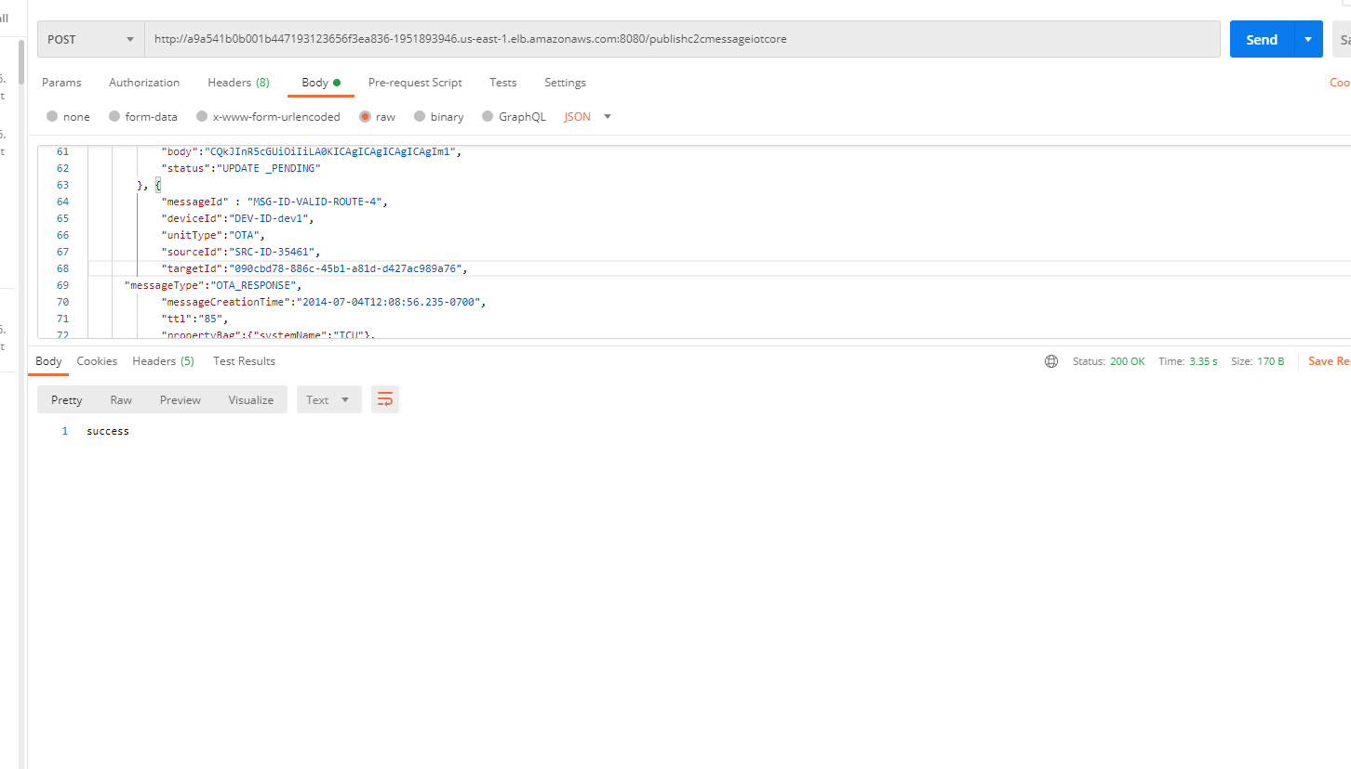

2)All the messages reach s3 bucket

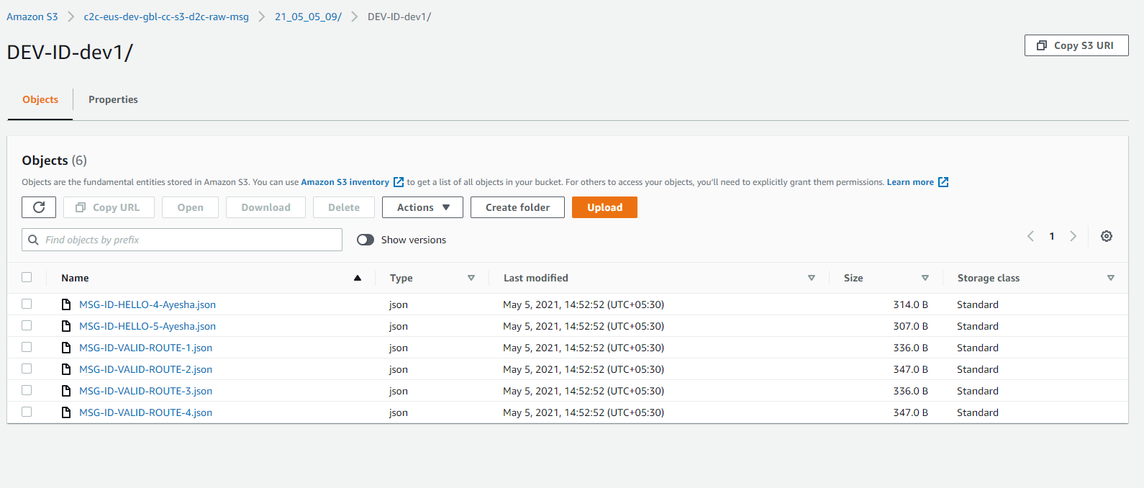

3)All the messages reach Kinesis Stream

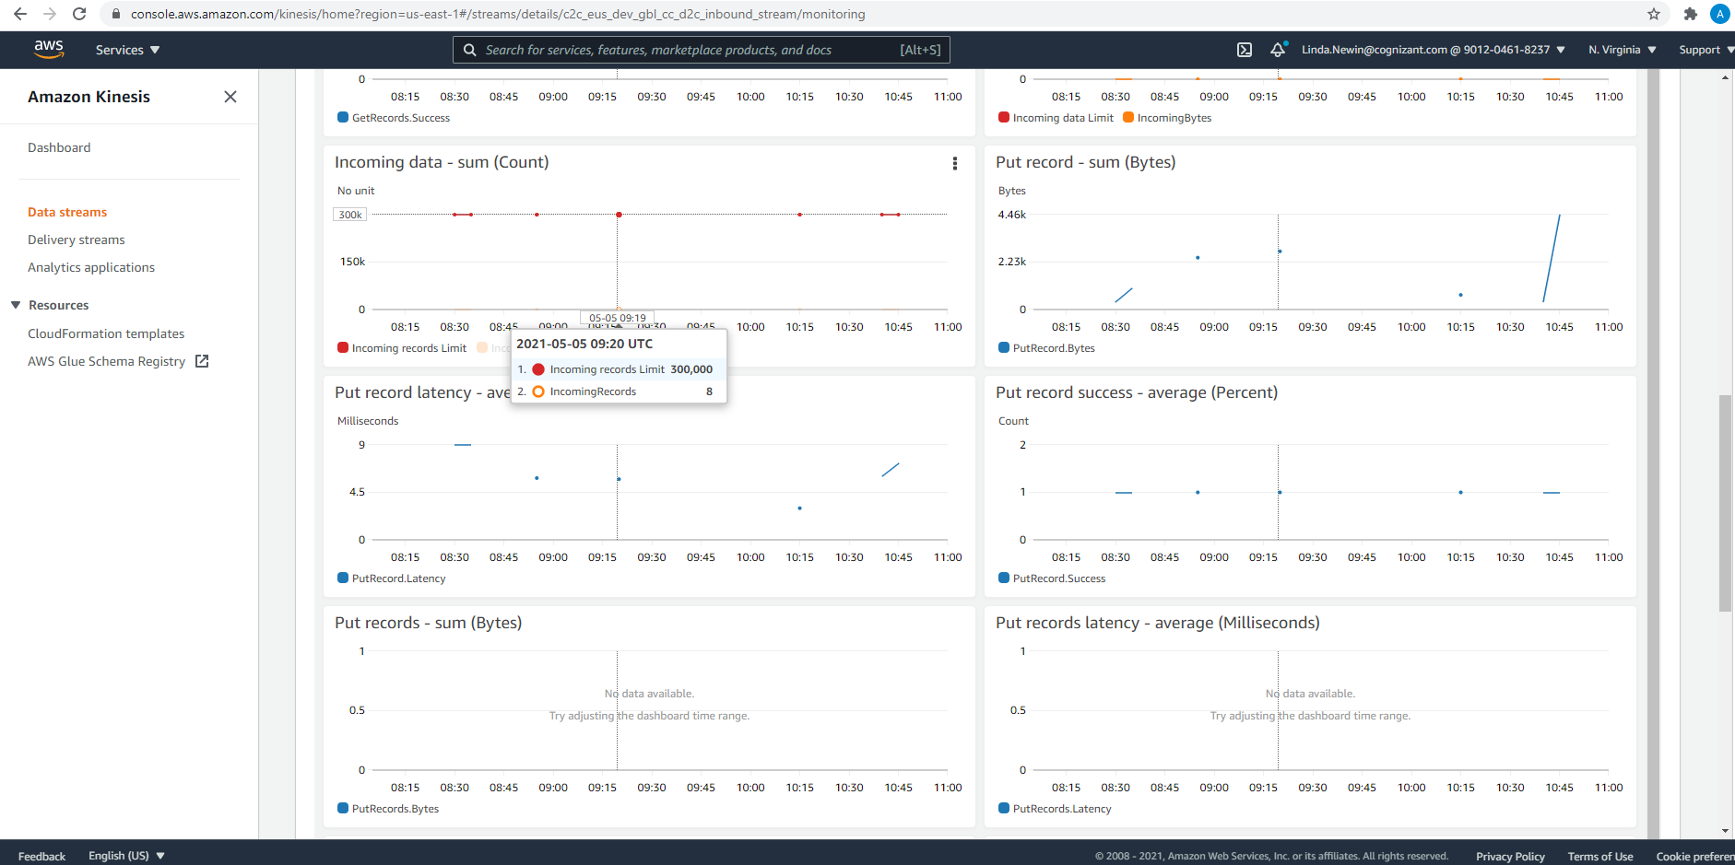

4)All valid messages reach the database

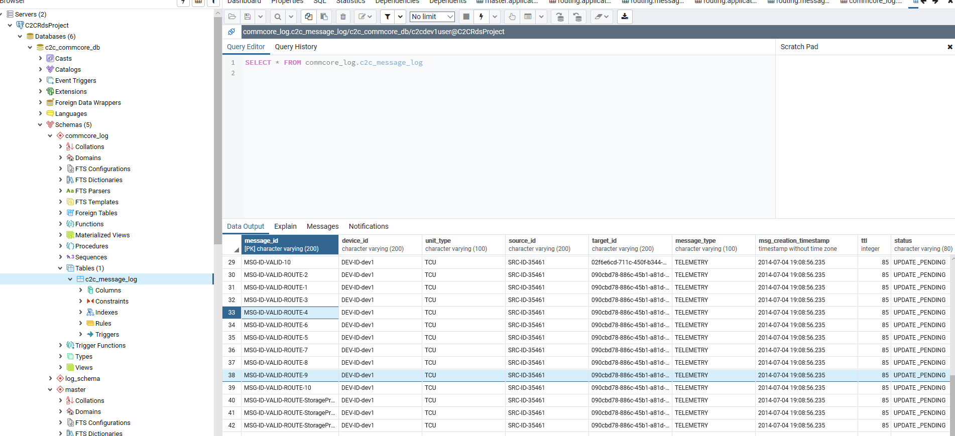

5)All invalid messages reach another invalid message storage s3 bucket

