

**Qualcomm Car-to-Cloud Platform**

**Certificate Manager**

**Version No.**

|  |  |  |  |
| --- | --- | --- | --- |
|  | **Prepared By / Last Updated By** | **Reviewed By** | **Approved By** |
| **Name** | Shipra Sinha | Hareesh G Nair |  |
| **Role** | PAT | Lead |  |
| **Signature** |  |  |  |
| **Date** | July 27, 2021 |  |  |

Table of Contents

1. Purpose…………………………………………………………………………. 3
2. Functional Overview…………………………………………………………….3
3. Technical Overview……………………………………………………………. 3
4. Deployment Overview…………………………………………………………..4
5. **Purpose**

The purpose of this document is to describe the high-level functionality, technical and deployment overview of the Certificate Manager Module of Qualcomm- Car to Cloud platform.

1. **Functional overview**

Certificate Manager handles the certificate creation for incoming device and pushing all the certificate data to the queue.

1. **Technical Overview**

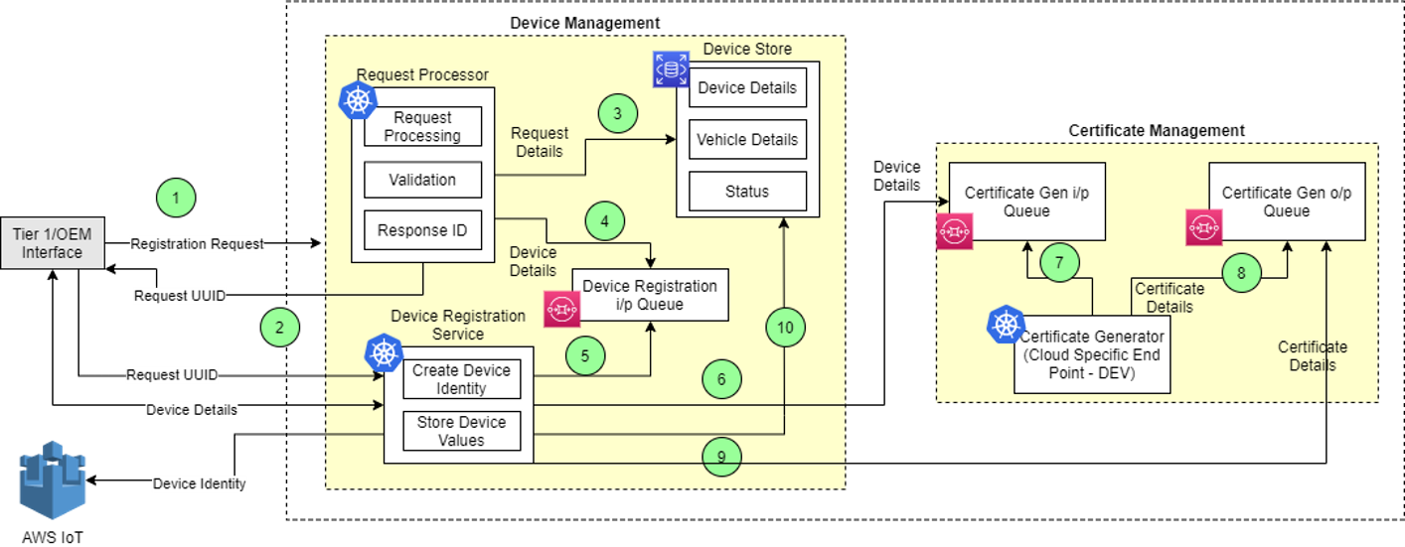

The main classes in this module are given below. The functionality of the class and functional methods are specified in functionality columns.

|  |  |
| --- | --- |
| **Class** | **Functionality** |
| CertificateManagerService | Service class to create a certificate for the incoming device and push  the certificate data to the queue.   * generateCertificateAndPushToOutputQueue- Method to create certificate for the device in requestDto and push the data to certificate response queue. * generateCertificate- Method to create certificate for the device. * describeCertificate- Method to provide the certificate data. * pushToOutputQueue- Method to push the generated certificate to the output queue. * setCertificateValues- Method to set the certificate values in CertificateDto. |
| QueryService | Service class for publishing messages to the queue.   * publish- Method to publish the data to the SQS queue. |

1. **Deployment Overview**

The main deployment requirements in this module are given below.

|  |  |
| --- | --- |
| **Environment** | **Functionality** |
| AWS | Queues used:   * c2c_eus1_dev_gbl_dm_sq_devicecertreqqueue * c2c_eus1_dev_gbl_dm_sq_devicecertrespqueue |