

**Qualcomm Car-to-Cloud Platform**

**Provisioning Query Service**

**Version No.**

|  |  |  |  |
| --- | --- | --- | --- |
|  | **Prepared By / Last Updated By** | **Reviewed By** | **Approved By** |
| **Name** | Shipra Sinha |  |  |
| **Role** | PAT |  |  |
| **Signature** |  |  |  |
| **Date** | July 27, 2021 |  |  |

Table of Contents

1. Purpose…………………………………………………………………………… 3
2. Functional Overview………………………………………………………………3
3. Technical Overview……………………………………………………………… 4
4. Deployment Overview…………………………………………………………… 5
5. **Purpose**

The purpose of this document is to describe the high-level functionality, technical and deployment overview of the Provisioning Query Service of Qualcomm- Car to Cloud platform.

1. **Functional overview**

Provisioning Query Service processes the provisioning query message initiated by the device to be rehomed to a particular region. It validates the provisioning query message and invokes the services required to register that device to the given region. After the completion of regional registration, it responds to the device based on the status of registration. It also updates the status of the device stored in the database accordingly.

1. **Technical Overview**

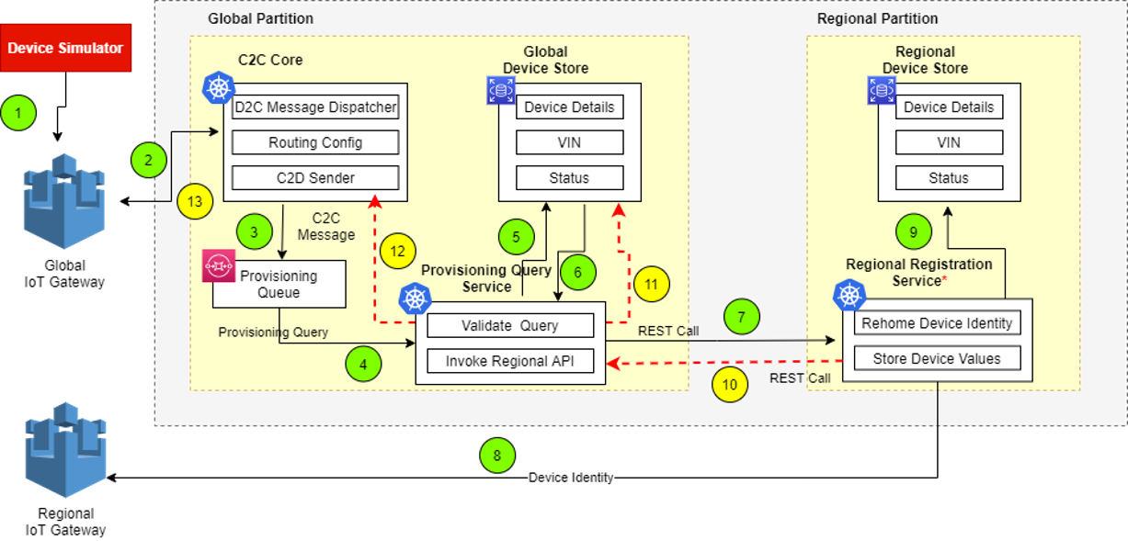

The main classes in this module are given below. The functionality of the class and functional methods are specified in functionality columns.

|  |  |
| --- | --- |
| **Class** | **Functionality** |
| DeviceProvisioningController | Controller class to push regional partition details to queue   * publishProvisioningQueryResponse- Method to publish regional partition details to provisioning output queue. |
| ProvisioningQueryProcessorService | Service class to process Device provisioning query.   * processDeviceProvisioningQuery- Method to process the provision query. * updateDevice- Method to update the device table with values from the provision query. * acknowledgeIfAlreadyRegistered- Method to acknowledge if device is already registered. * updateVehicle- Method to update vehicle table. * getUrlForDevice- Method to fetch the regional API URL for the given region. * requestBodyBuilder- Method to build the request body for the rest call with values from the device entity. * validateDevice- Method to validate system name. |
| ProvisioningQueryQueueService | Service class for publishing messages to the queue.   * publish- Method to publish queue message. |
| ProvisioningQueryResponseService | Service class to publish regional partition details to output queue and to update the device table.   * publishProvisioningResult- Method to publish details to provisioning output queue. * publishProvisioningResult- Method to invoke publish method to publish details to provisioning output queue and update status in device table. * publishProvisioningError- Method to map error to the CommunicationCoreMessage. * insertToProvisioningQueryMessage- Method to insert the CommunicationCoreMessage data into ProvisioningQueryMessage table. * updateCommunicationCoreMessage- Method to update the CommunicationCoreMessage response. |
| RegionalApiService | Utility class to build URL connection and invoke API.   * invokeRegionalApi- Method to invoke the regional provisioning API. |

1. **Deployment Overview**

The main deployment requirements in this module are given below.

|  |  |
| --- | --- |
| **Environment** | **Functionality** |
| PostgreSQL | Database to store the details.   * c2c-eus-dev-gbl-dm-rds-database.cwhhlpvisa4k.us-east-1.rds.amazonaws.com:5432/c2c_reg_pro_db |
| AWS | Queues used:   * c2c_eus1_dev_gbl_core_sq_device_provisioning_request * c2c_eus1_dev_gbl_core_sq_device_provisioning_response |