

**Qualcomm Car-to-Cloud Platform**

**Provisioning Service**

**Version No.**

|  |  |  |  |
| --- | --- | --- | --- |
|  | **Prepared By / Last Updated By** | **Reviewed By** | **Approved By** |
| **Name** | Shipra Sinha |  |  |
| **Role** | PAT |  |  |
| **Signature** |  |  |  |
| **Date** | July 27, 2021 |  |  |

Table of Contents

1. Purpose…………………………………………………………………………… 3
2. Functional Overview……………………………………………………………... 3
3. Technical Overview………………………………………………………………. 4
4. Deployment Overview……………………………………………………………. 4
5. **Purpose**

The purpose of this document is to describe the high-level functionality, technical and deployment overview of the Provisioning Service of Qualcomm- Car to Cloud platform.

1. **Functional overview**

Provisioning Service processes the device provisioning message initiated by the device to complete the provisioning flow. It validates the message and updates the database with the provided device and vehicle data. It forwards the message for chipset onboarding and responds back to the device based on the status.

1. **Technical Overview**

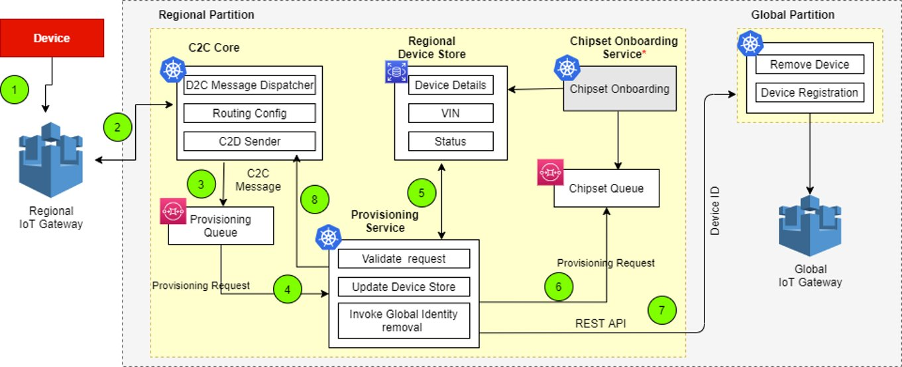

The main classes in this module are given below. The functionality of the class and functional methods are specified in functionality columns.

|  |  |
| --- | --- |
| **Class** | **Functionality** |
| ProvisioningProcessorService | Service class for Provisioning Service.   * provisionDevice- Method to process the provision message. * updateDeviceAndVehicleData- Method to update device and vehicle data in database. * respondToQueueAndDeleteThing- Method to publish to provision response queue and chipset onboarding queue and also invoke the thing deletion API. * provisionVehicle- Method to populate vehicle entity and save to table. * validateProvisionMessageDto- Method to validate the provision message. * validateProvisionMessageFields- Method to check if there is any special characters in the string. * validateDevice- Method to validate device. * fetchDevice- Method to retrieve data from database based on system id. * updateDevice- Method to update values to the device table. * buildDeviceProvisionResponse- Method to build the response message to device. * buildDeviceEntity- Method to build device entity. |
| QueueService | Service class for publishing messages to the queue.   * publishToResponseQueue- Method to publish queue message to response queue. * publishToChipsetQueue- - Method to publish queue message to chipset queue. |
| RegionalApiService | Utility class to build URL connection and invoke API.   * invokeDeleteThingApi- Method to invoke the regional provisioning API. |

1. **Deployment Overview**

The main deployment requirements in this module are given below.

|  |  |
| --- | --- |
| **Environment** | **Functionality** |
| PostgreSQL | Database to store the details.   * c2c-wus-dev-reg-dm-rds-database-psql.cleveog6mrob.us-west-1.rds.amazonaws.com:5432/c2c_reg_pro_db |
| AWS | Queues used:   * c2c_wu1_dev_rg_core_sq_device_certificate_request * c2c_wu1_dev_rg_core_sq_device_provisioning_response * c2c_wu1_dev_rg_core_sq_device_certificate_response |