

**Qualcomm Car-to-Cloud Platform**

**Request Processor**

**Version No.**

|  |  |  |  |
| --- | --- | --- | --- |
|  | **Prepared By / Last Updated By** | **Reviewed By** | **Approved By** |
| **Name** | Shipra Sinha | Hareesh G Nair |  |
| **Role** | PAT | Lead |  |
| **Signature** |  |  |  |
| **Date** | July 27, 2021 |  |  |

Table of Contents

1. Purpose……………………………………………………………………………. 3
2. Functional Overview……………………………………………………………… 3
3. Technical Overview……………………………………………………………… 3
4. Deployment Overview……………………………………………………………. 4
5. **Purpose**

The purpose of this document is to describe the high-level functionality, technical and deployment overview of the Request Processor Module of Qualcomm- Car to Cloud platform.

1. **Functional overview**

Request Processor processes the registration request initiated by the client or the device provisioning query service. It validates the requests and chunk the bulk request into feasible chunks and then forward each chunk for registration in the deployed region.

1. **Technical Overview**

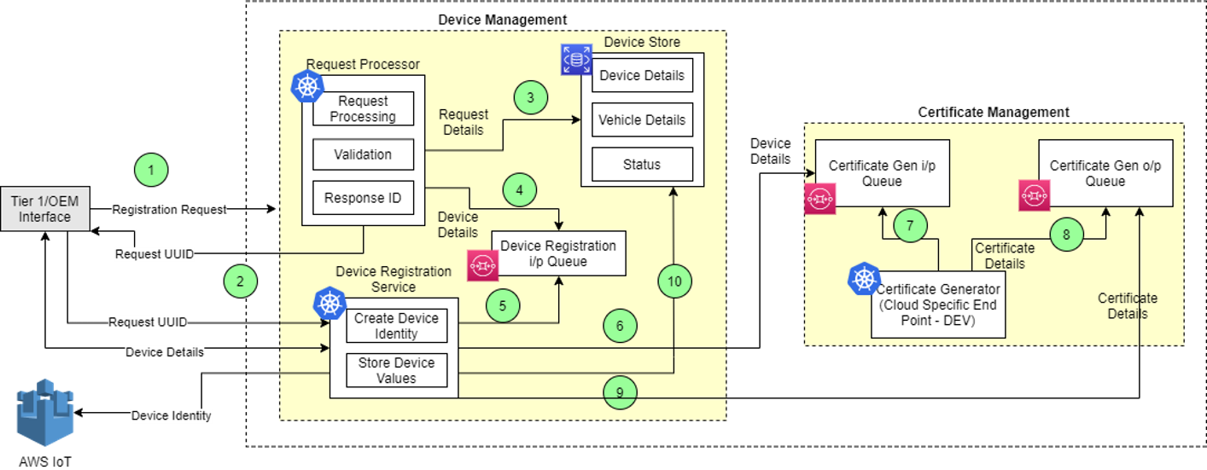

The main classes in this module are given below. The functionality of the class and functional methods are specified in functionality columns.

|  |  |
| --- | --- |
| **Class** | **Functionality** |
| DeviceController | Controller class for request processor.   * registerDevice- Method to register the device requests. |
| RegistrationService | Service class to handle device requests.   * registerDevice- Method to register device requests. * validate- Method to validate list of device requests. * validateDeviceRequest- Method to validate list of device requests on different parameters. |
| QueryService | Service class for publishing messages to the queue.   * publish- Method to publish queue message. |
| RegistrationValidationUtil | Util class to validate regex and pattern.   * validateCreator- Method to validate creator given in request. |

1. **Deployment Overview**

The main deployment requirements in this module are given below.

|  |  |
| --- | --- |
| **Environment** | **Functionality** |
| AWS | Queues used:  **Global-**   * c2c_eus1_dev_gbl_dm_sq_deviceregreqqueue   **Regional-**   * c2c_wu1_dev_rg_core_sq_device_registration_request |