

**Qualcomm Car-to-Cloud Platform**

**Registration Service**

**Version No.**

|  |  |  |  |
| --- | --- | --- | --- |
|  | **Prepared By / Last Updated By** | **Reviewed By** | **Approved By** |
| **Name** | Shipra Sinha | Sumesh Kumar S |  |
| **Role** | PAT | Lead |  |
| **Signature** |  |  |  |
| **Date** | July 27, 2021 |  |  |

Table of Contents

1. Purpose……………………………………………………………………………. 3
2. Functional Overview……………………………………………………………….3
3. Technical Overview………………………………………………………….…… 5
4. Deployment Overview……………………………………………………………. 6
5. **Purpose**

The purpose of this document is to describe the high-level functionality, technical and deployment overview of the Registration Service Module of Qualcomm- Car to Cloud platform.

1. **Functional overview**

Device Registration Service processes the chunk of device requests and creates thing for each device so that they can communicate with the cloud.

* It manages the authentication and authorization by attaching certificate and policy to the thing created.
* It handles API calls to get the status of registration requests.
* **Download**- To get list of devices as downloadable json file.
* **Status**- To get the details of registration request as per the status.
* **Overall**-**Status**- To get the count details of registration request
* It stores the data of each device along with credentials required to communicate with the cloud in a database.

1. **Technical Overview**

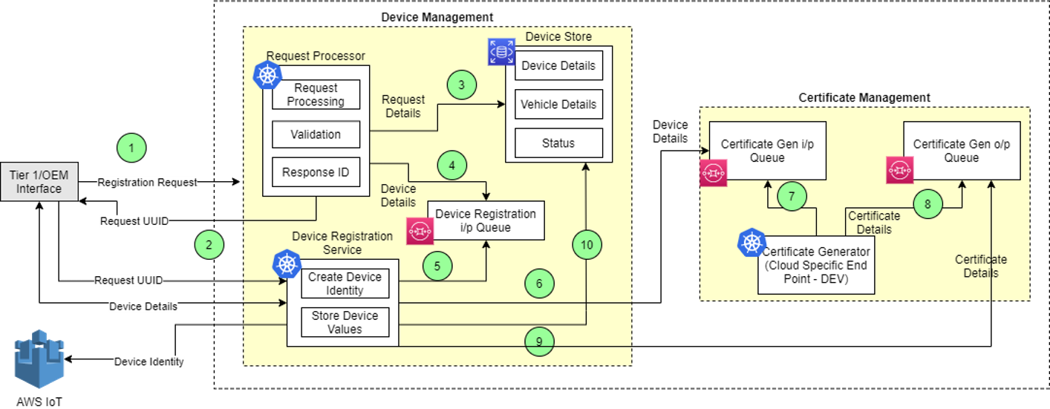

The main classes in this module are given below. The functionality of the class and functional methods are specified in functionality columns.

|  |  |
| --- | --- |
| **Class** | **Functionality** |
| DeviceRegistrationController | Controller class for device registration service   * getDeviceDetails- Method to get device details. It returns the DTO response object according to the status table. * getDeviceData- Method to get overall status of a device. It returns the DTO response object according to the requestId from PostgreSQL table. * downloadDeviceDetail- Method to get list of devices as downloadable json file. * deleteThing- Method to delete device from cloud. |
| DeviceRegistrationService | Service class to handle device registration:   * createDevicesInCloud- Method to create devices in cloud. * updateRegistrationRequest- Method to update the Registration Request in the PostgreSQL table. * getDetailStatus- Method to get the detailed status of a device. * findRequestStatus- Method to return the DTO response according to the requestId from PostgreSQL table. * buildDeviceStatusResponseDto- Method to build the deviceStatusResponseDto. * updateDevice- Method to update the device in the PostgreSQL table. * downloadDeviceDetails- Method returns a byte array containing device response DTO based on requestId and status. * deleteDeviceFromCloud- Method to delete device from cloud. |
| ProvisioningQueryService | * acknowledgeProvisioningQuery- Method to acknowledge provisioning query. * invokeProvisioningQueryApi- Method to invoke provisioning query API. |
| QueueService | Service class for publishing messages to the queue.   * publish- Method to publish queue message. |
| RegistrationProcessorService | Service class for processing device registration   * processDeviceRegistration- Method to invoke required methods based on the availability of certificate. * processDetails- Method to process the details of device present in deviceDto. * processDeviceWithCertificate- Method to process device having certificate. * processDeviceWithoutCertificate- Method to process device which does not have certificate. * saveRegistrationCount- Method to save device count. * generateSystemId- Method to generate SystemId. * saveDevice- Method to create device entity and save it to the device table. * checkDeviceStatus- Method to check the device status. * assignDeviceIdIfNotPresent- Method to generate deviceId if its not present in deviceDto. * publishToCertificateGenerationQueue- function to push the deviceDto to the queue for certificate generation |
| CertificateMapper | Util class to perform the mapping between Certificate and CertificateKey entities and CertificateResponseDto.   * certificateMapper- Method to convert the CertificateDto to Certificate. * certificateKeyMapper- Method to convert the CertificateDto to CertificateKey. * certificateResponseMapper- Method to convert the Certificate and CertificateKey to CertificateResponseDto. |
| DeviceMapper | A Class to perform the mapping between Device entity and various other entities like DeviceResponseDto,DeviceStatusResponseDto.   * deviceResponseMapper- Method to convert the Device entity to DeviceResponseDto. * deviceMapper- Method to convert the DeviceDto to Device entity. * requestMapper- Method to convert DeviceDto to RegistrationRequest entity. |

1. **Deployment Overview**

The main deployment requirements in this module are given below.

|  |  |
| --- | --- |
| **Environment** | **Functionality** |
| PostgreSQL | Database to store the device details.   * **Global Database**- c2c-eus-dev-gbl-dm-rds-database.cwhhlpvisa4k.us-east-1.rds.amazonaws.com:5432/c2c_reg_pro_db * **Regional Database**- c2c-wus-dev-reg-dm-rds-database-psql.cleveog6mrob.us-west-1.rds.amazonaws.com:5432/c2c_reg_pro_db |
| AWS | Queues used:  **Global-**   * c2c_eus1_dev_gbl_dm_sq_devicecertreqqueue * c2c_eus1_dev_gbl_dm_sq_devicecertrespqueue * c2c_eus1_dev_gbl_dm_sq_deviceregreqqueue   **Regional-**   * c2c_wu1_dev_rg_core_sq_device_certificate_request * c2c_wu1_dev_rg_core_sq_device_certificate_response * c2c_wu1_dev_rg_core_sq_device_registration_request |