Wroclaw 11.10.2018

Secure Systems and Networks

Laboratory No. 1
Wiktor Lagiewka 219226

1. Check ping, traceroute, mtr -- what kind of packets do they send to discover the intermediate routers? Is it ICMP, TCP, UDP? What features they use to find routers?

Ping – use ICMP protocol and send first ICMP echo Request and receive ICMP echo Replay
Usually servers that have public access serve ICMP echo Request and answer them, but not all hosts should respons and serve this packet. It depends on configuration r.g. firewall.

ING google.com (216.58.215.110) 56(84) bytes of data.
64 bytes from 216.58.215.110: icmp_seq=1 ttl=55 time=27.9 ms
64 bytes from 216.58.215.110: icmp_seq=2 ttl=55 time=54.3 ms
64 bytes from 216.58.215.110: icmp_seq=3 ttl=55 time=19.5 ms
64 bytes from 216.58.215.110: icmp_seq=4 ttl=55 time=40.7 ms

--- google.com ping statistics ---
4 packets transmitted, 4 received, 0% packet loss, time 3004ms
rtt min/avg/max/mdev = 19.587/35.664/54.365/13.161 ms

Fig. Example of a google server response for ping command

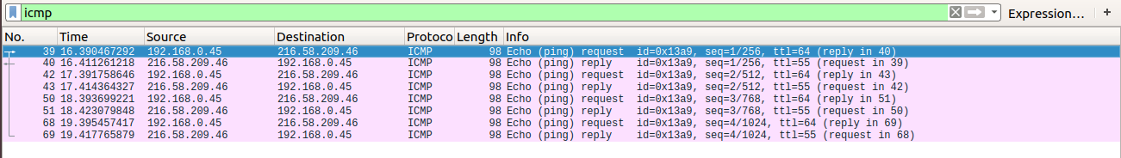
Fig. Results from wireshark for ping command 4 ICMP request and 4 responses.

When ICMP echo Request send via ping command do not receive any ICMP echo Response it either does not mean that we have problem with connection nor server is switched off. Example below show testing private company server site.

PING eshare.gemalto.com (91.241.42.157) 56(84) bytes of data.

--- eshare.gemalto.com ping statistics ---
4 packets transmitted, 0 received, 100% packet loss, time 3077ms
ping exited with status code 1

Fig. Example of testing private server site via ping command.

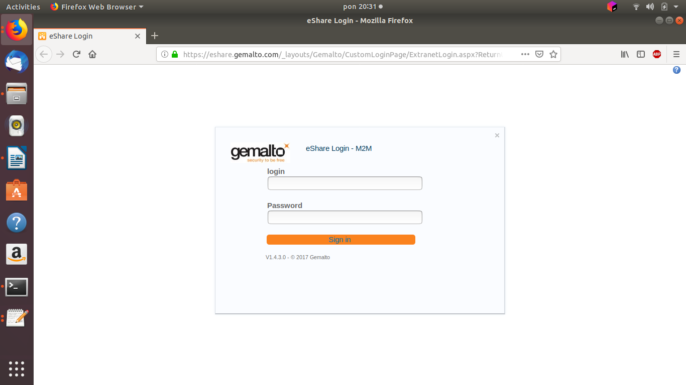

Fig. Login panel to private company server site.

Above example depict that server is either not switched off nor our connection is failed, but it does not serve ICMP protocol.

2. Traceroute - program which is use to search for the route of packets in network.
Program sends packet with TTL field equal to 1 to the first router on the road. When time will reach 0, packet is rejected and router send back ICMP response with IP address. In the next step program send packet with TTL equal to 2, when it reach first router decrease this value to 1 and forward it to the next router on the road. The mechnizm is repeatet over and over again and it depends on the number of nodes.
In the Linux based systems when the packet sent by the tracerout reach the destination host, information “Port Unrechable” is send back. Program wants to get that information, so intentionally send UDP packt with port number over 30000. It is very low probability that any devices work on that port.

To check out how it works below command was used:

# traceroute www.pwr.edu.pl

traceroute to www.pwr.edu.pl (156.17.16.240), 64 hops max
1 192.168.0.1 3,376ms 2,723ms 1,859ms
2 * * 84.116.253.129 17,805ms
3 84.116.253.129 17,858ms 19,715ms 84.116.253.205 16,471ms
4 84.116.253.205 21,084ms 20,131ms 84.116.253.209 18,698ms
5 84.116.253.209 17,449ms 23,963ms 62.179.3.242 17,808ms
6 62.179.3.242 18,635ms 20,100ms 156.17.250.215 25,400ms
7 156.17.250.215 25,009ms 22,609ms 156.17.254.112 20,086ms
8 156.17.254.112 20,088ms 19,182ms 156.17.254.140 17,443ms
9 156.17.254.140 19,997ms 17,299ms 156.17.18.244 19,337ms
10 156.17.18.244 18,739ms 18,973ms *

Wildcards in above example can be cause by firewall settings, or overload of network.

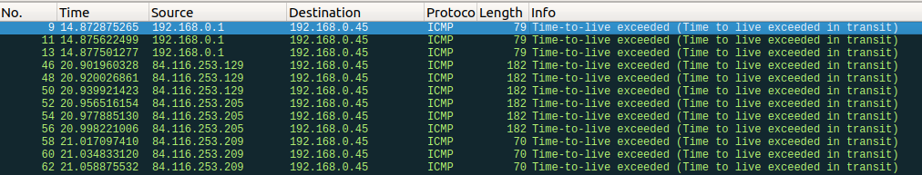
Fig. Result of capturing ICMP packets for traceroute comand

3. MTR - combines the functions of the traceroute and ping programs in one network diagnostic tool. It relies on ICMP packets coming back from routers, or ICMP Echo Reply packets when the packets have hit their destination host. MTR also has a UDP mode execute with -u option.

To run the program I used # mtr -r pwr.edu.pl command :

HOST: wiktor-Lenovo-B51-80 Loss% Snt Last Avg Best Wrst StDev
1.|-- compalhub.home 0.0% 10 3.7 2.6 2.1 3.7 0.6
2.|-- 84.116.254.140 50.0% 10 6103. 6172. 5730. 6375. 269.8
3.|-- pl-ktw01a-rc1-ae18-0.aort 0.0% 10 20.8 21.7 18.3 27.0 2.8
4.|-- pl-wro02a-ra2-ae10-2120.a 10.0% 10 17.9 19.8 17.2 24.2 2.1
5.|-- pl-wro02a-ra1-ae0-1430.ao 0.0% 10 30.1 22.0 18.6 30.1 3.5
6.|-- chello062179003242.chello 0.0% 10 21.6 21.7 17.5 30.1 4.4
7.|-- 156.17.250.215 0.0% 10 17.2 20.9 17.2 25.4 2.9
8.|-- rolnik2-karkonosz.wask.wr 0.0% 10 18.2 20.8 17.8 26.5 3.1
9.|-- wazniak-rolnik.wask.wroc. 0.0% 10 19.3 22.3 19.3 28.1 2.7
10.|-- z-wask2-do-pwr2.pwrnet.pw 0.0% 10 17.3 19.6 17.3 23.0 1.6

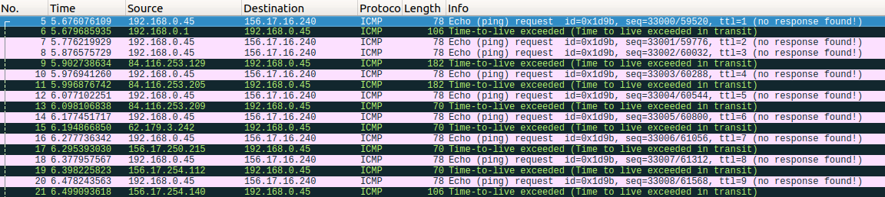
Fig. Capturing ICMP packets fot MTR program execution.

Log in to some FTP site

e.g ftp.icm.edu.pl or ftp.pwr.wroc.pl using "anonymous" acount, find out how this password information is sent over the network, use wireshark filters to get just the interesting packets, not all the rubbish that you can listen to on the network.

ftp> open ftp.pwr.wroc.pl
Connected to ftp.pwr.wroc.pl.
220 .. :: Welcome on ftp.pwr.wroc.pl mirror server, provided by Wroclaw Centre of Networking and Supercomputing :: ..
Name (ftp.pwr.wroc.pl:wiktor): anonymous
331 Please specify the password.
Password:
230 Login successful.
Remote system type is UNIX.
Using binary mode to transfer files.

Fig. Wireshark captured FTP packet during connecting to ftp.pwr.wroc.pl server

Above screenshot depict that I used ‘anonymous’ username and password ‘wiktor’. Both names are visible during communication.

Access a password protected WWW

site: http://dream.ict.pwr.wroc.pl/ssn/secure/ -- use username "ssn" and password "secure". You may of course use a different password and see it fail. Observe how this user/pass information is sent from the web browser to the server.

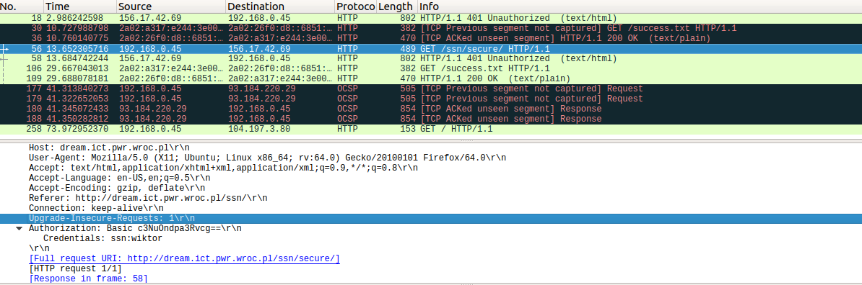
Fig. Wireshark captured HTTP packets during connecting to http://dream.ict.pwr.wroc.pl/ssn/secure/ server site with wrong password.

Above screenshot from wireshark depict situation when I typed ‘ssn’ as a username and ‘wiktor’ as a password. Connection fail, but password which I typed is visible in Authorization section.

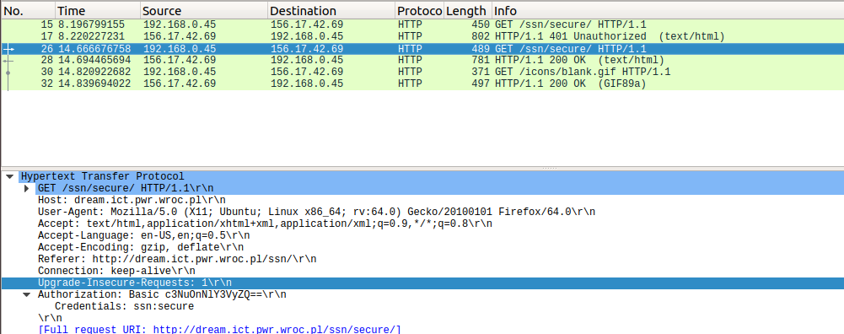
Fig. Wireshark captured HTTP packets during connecting to http://dream.ict.pwr.wroc.pl/ssn/secure/ server site with correct password.

